Lab Exercise Template

**Name:** 陈梓涵(Chen Zihan)

**SID:** 11910507

**E1 Code & Result**

* **Code**

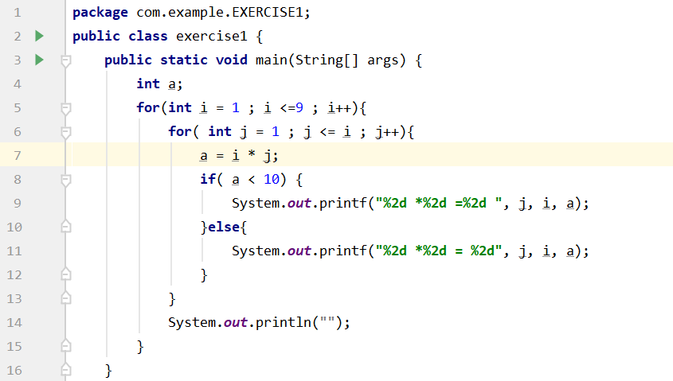

* **Result**

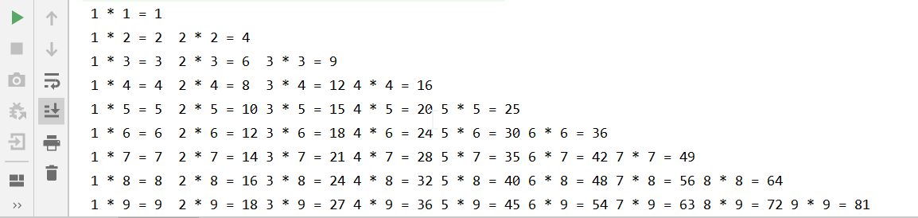

**E2 Code & Result**

* **Code**

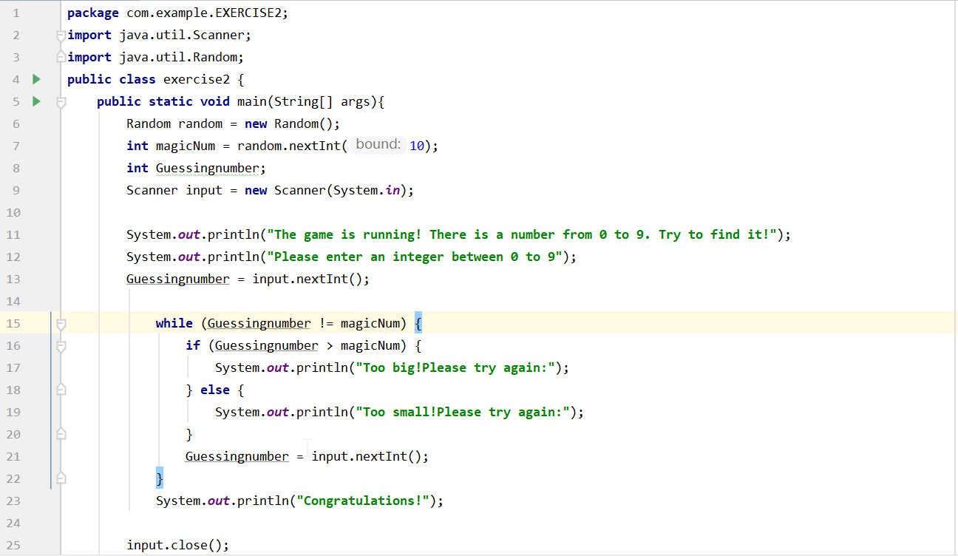

* **Result**

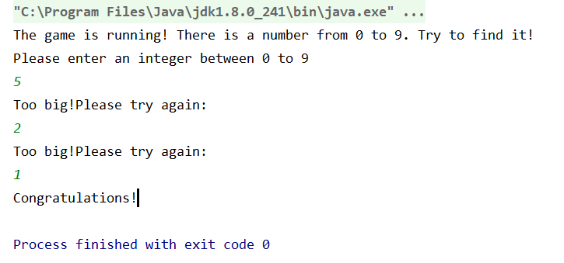

**E3（1） Code & Result**

* **Code**

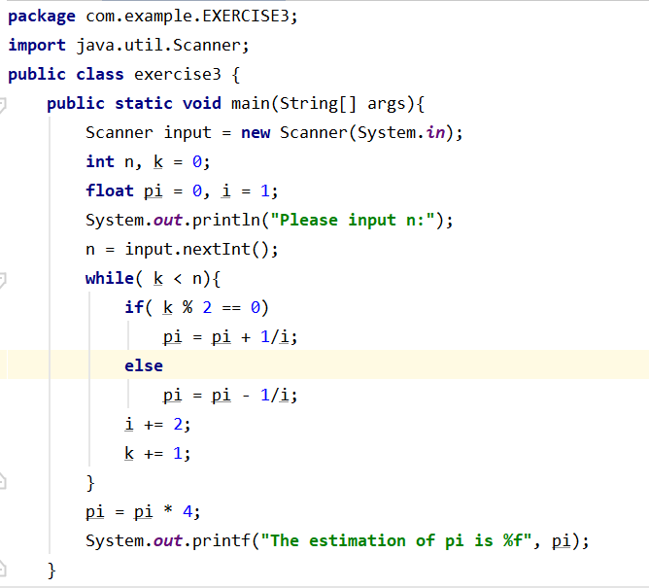

* **Result**

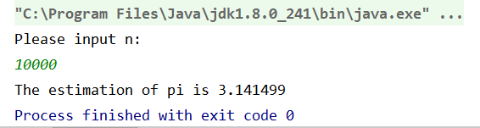

**E3（2） Code & Result**

* **Code**

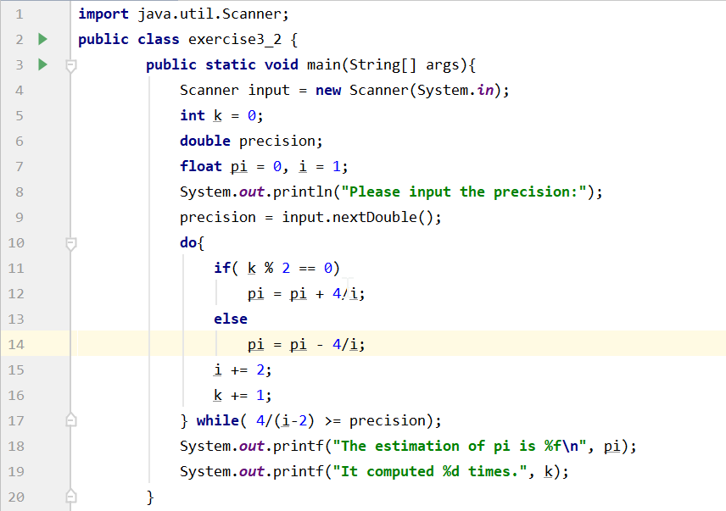

* **Result**

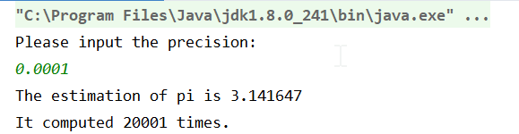

**E4（1） Code & Result**

* **Code**

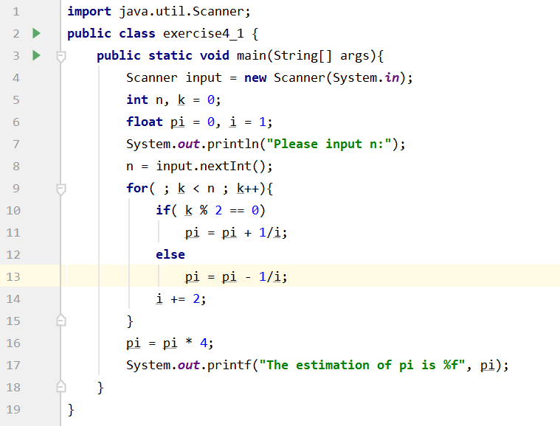

* **Result**

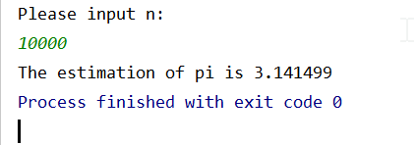

**E4（2） Code & Result**

* **Code**

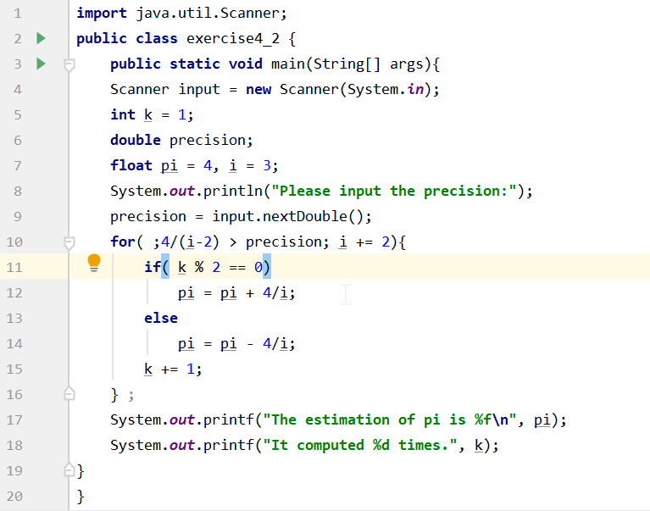

* **Result**

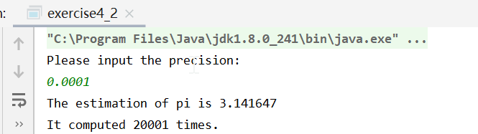

**E5 Code & Result**

* **Code**

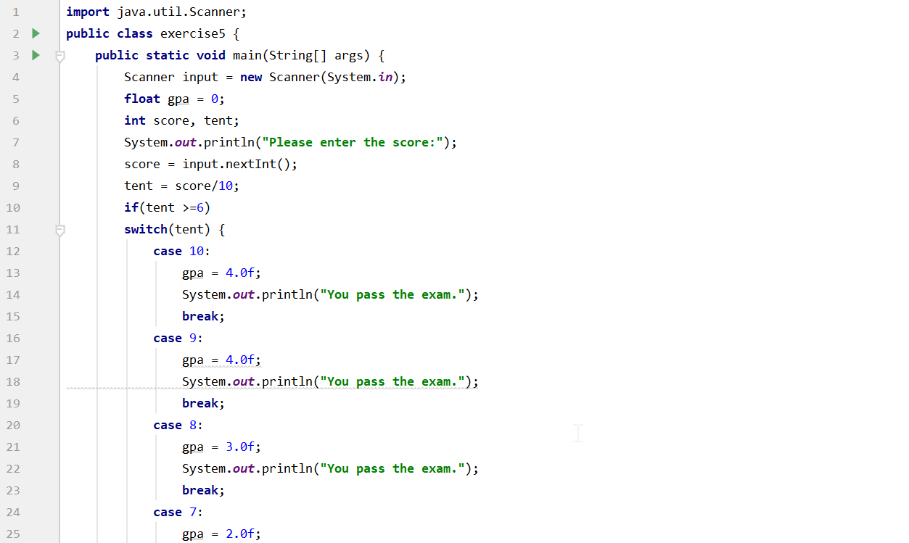

* **Result**

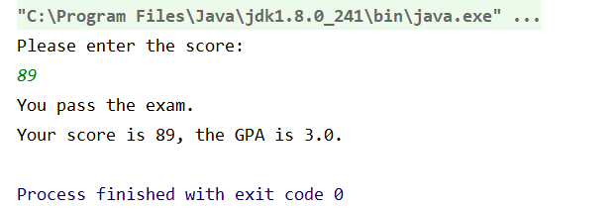

**E6 Code & Result**

* **Code**
* **import** java.util.Scanner;  
  **public class** exercise6 {  
   **public static void** main(String[] args) {  
   Scanner input = **new** Scanner(System.***in***);  
   **int** year, month, yu, yu2, days, run = 0;  
   String monthname;  
   System.***out***.println(**"Please enter the year and month: "**);  
   year = input.nextInt();  
   month = input.nextInt();  
   yu = year % 4;  
   yu2 = year % 400;  
   **if**( yu == 0 && yu2 == 400)  
   run = 1;  
   **switch**(month){  
   **case** 1:  
   days = 31;  
   monthname = **"January"**;  
   System.***out***.printf(**"%s of %d has %d days.\n"**, monthname, year, days);  
   **break**;  
   **case** 2:  
   monthname = **"February"**;  
   **switch**(run){  
   **case** 1:  
   days = 29;  
   System.***out***.printf(**"%s of %d has %d days.\n"**, monthname, year, days);  
   **break**;  
   **case** 0:  
   days = 28;  
   System.***out***.printf(**"%s of %d has %d days.\n"**, monthname, year, days);  
   **break**;  
   }  
   **break**;  
   **case** 3:  
   days = 31;  
   monthname = **"March"**;  
   System.***out***.printf(**"%s of %d has %d days.\n"**, monthname, year, days);  
   **break**;  
   **case** 4:  
   days = 30;  
   monthname = **"April"**;  
   System.***out***.printf(**"%s of %d has %d days.\n"**, monthname, year, days);  
   **break**;  
   **case** 5:  
   days = 31;  
   monthname = **"May"**;  
   System.***out***.printf(**"%s of %d has %d days.\n"**, monthname, year, days);  
   **break**;  
   **case** 6:  
   days = 30;  
   monthname = **"June"**;  
   System.***out***.printf(**"%s of %d has %d days.\n"**, monthname, year, days);  
   **break**;  
   **case** 7:  
   days = 31;  
   monthname = **"July"**;  
   System.***out***.printf(**"%s of %d has %d days.\n"**, monthname, year, days);  
   **break**;  
   **case** 8:  
   days = 31;  
   monthname = **"August"**;  
   System.***out***.printf(**"%s of %d has %d days.\n"**, monthname, year, days);  
   **break**;  
   **case** 9:  
   days = 30;  
   monthname = **"September"**;  
   System.***out***.printf(**"%s of %d has %d days.\n"**, monthname, year, days);  
   **break**;  
   **case** 10:  
   days = 31;  
   monthname = **"October"**;  
   System.***out***.printf(**"%s of %d has %d days.\n"**, monthname, year, days);  
   **break**;  
   **case** 11:  
   days = 30;  
   monthname = **"November"**;  
   System.***out***.printf(**"%s of %d has %d days.\n"**, monthname, year, days);  
   **break**;  
   **case** 12:  
   days = 31;  
   monthname = **"December"**;  
   System.***out***.printf(**"%s of %d has %d days.\n"**, monthname, year, days);  
   **break**;  
    
   }  
    
   }  
  }
* **Result**

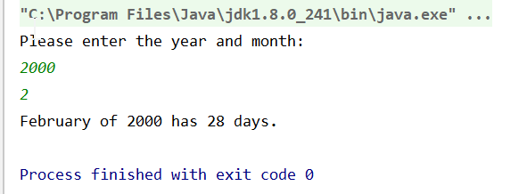

**E7 Code & Result**

* **Code**
* **Result**