Lab1 Exercise Template

**Name:** 陈梓涵（Chen Zihan）

**SID:** 11910507

**E1 Exercise**

* **Code**

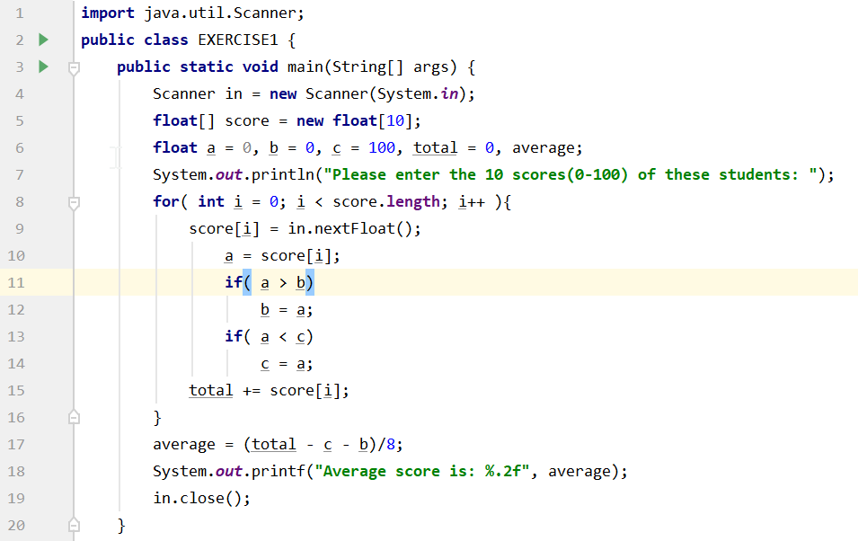

**For I don’t learn about return and 函数, I choose not to make the choice to recognize if the score is 0-100;**

* **Result**

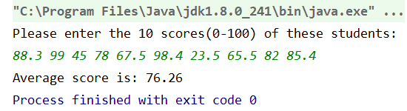

**E2 Exercise**

* **Code**

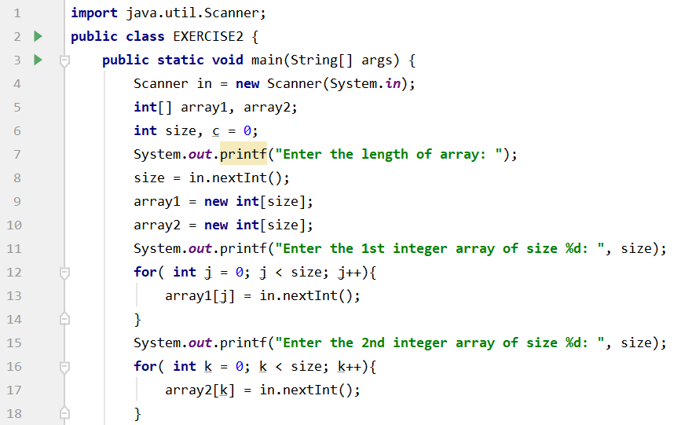

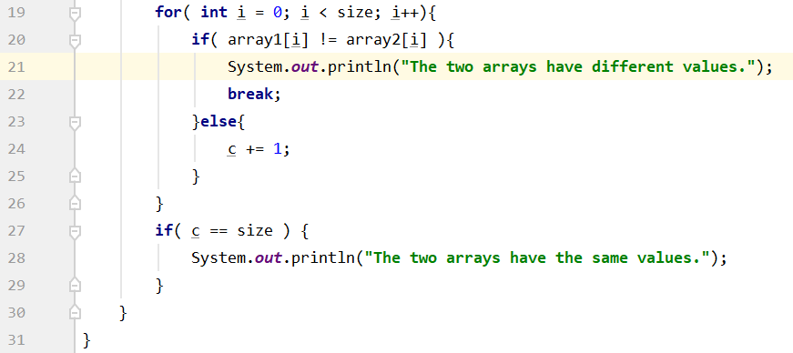

* **Result**

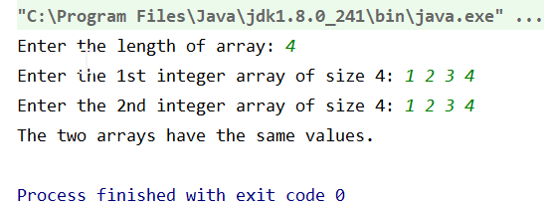

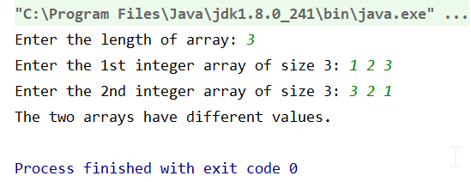

**E3 Exercise**

* **Code**

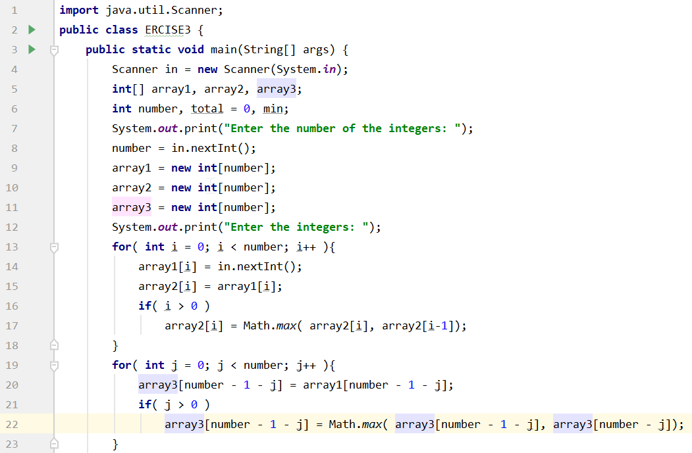

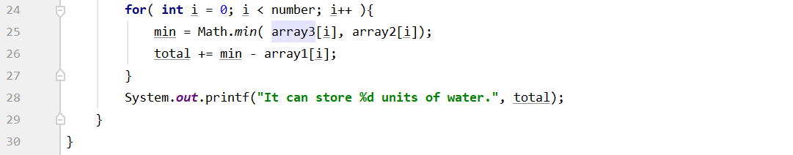

* **Result**

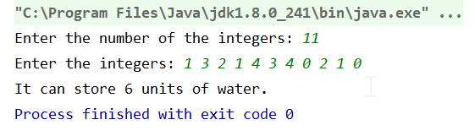

**E4 Exercise**

* **Code**

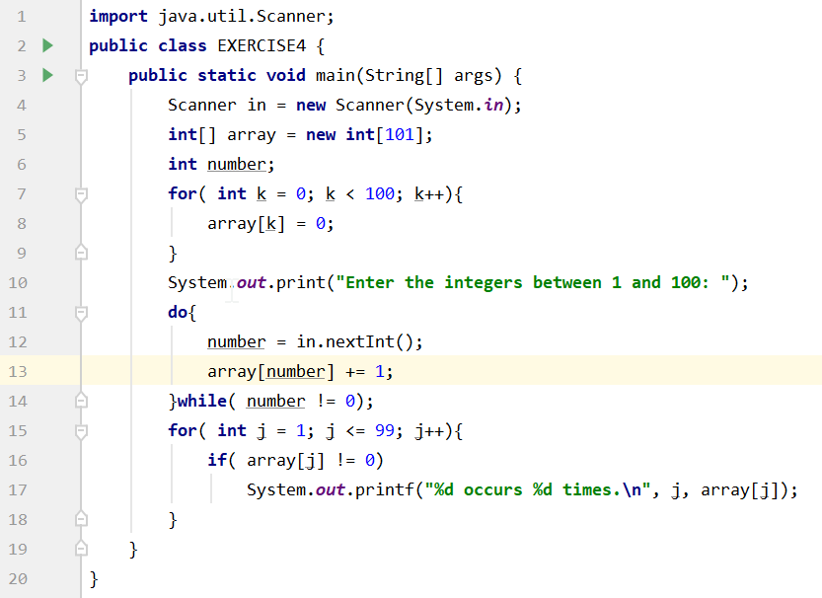

* **Result**

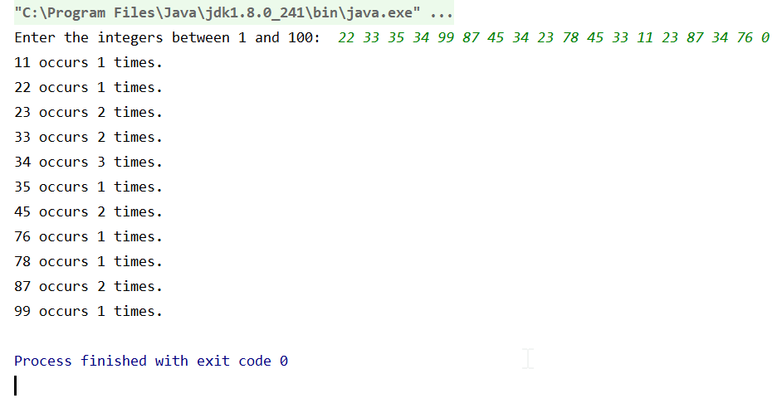

**E5 Exercise**

* **Code**

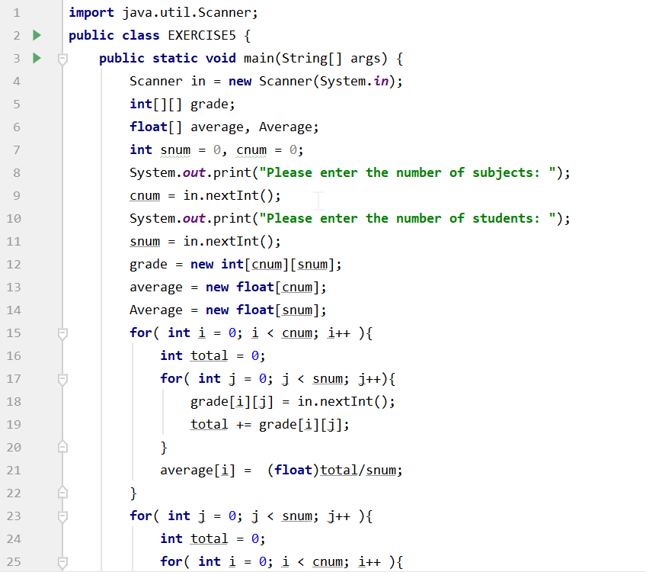

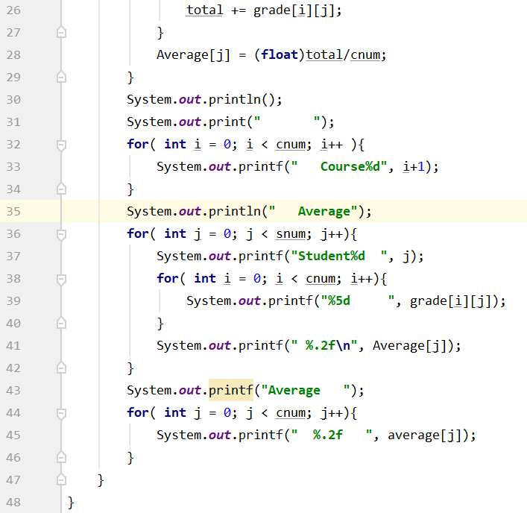

* **Result**

