Lab1 Exercise Template

**Name:** 陈梓涵(Chen Zihan)

**SID:** 11910507

**Eexercise1**

* **Code**

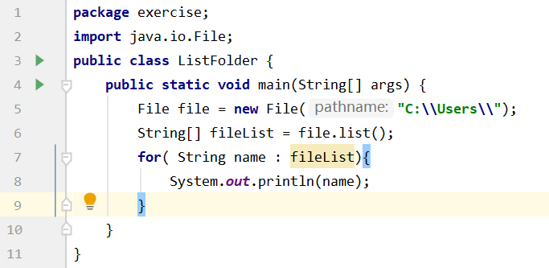

* **Result**

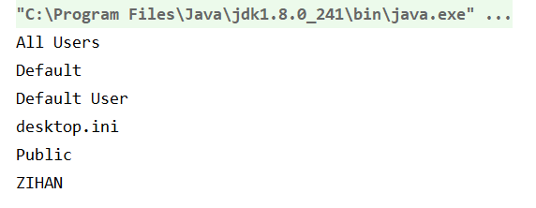

**Eexercise2**

* **Code**

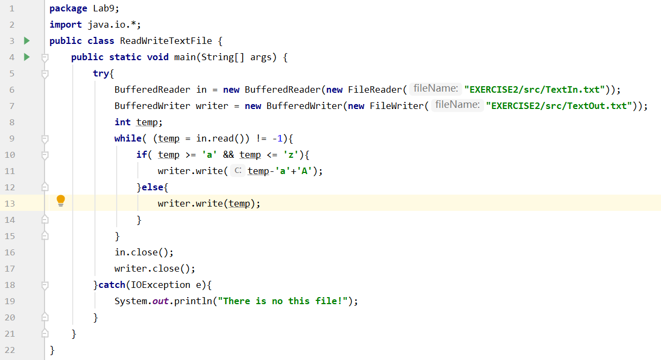

* **Result**





**Eexercise3**

* **Code**

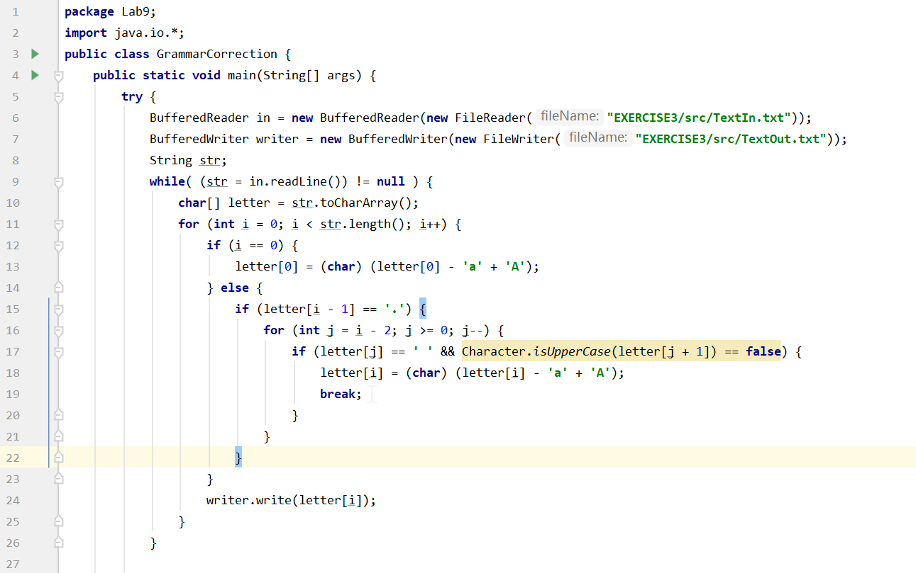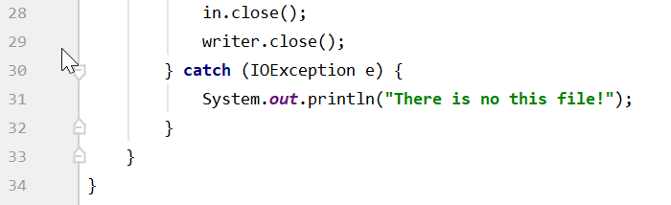

* **Result**

**Eexercise1**

**Eexercise4**

**If we run it by IDEA, when we write “src\TextIn.txt”, we should put the text in /src.**

**If we run it by command, when we write “src\TextIn.txt”, we should also put it in /src.**