Module 4 Linux Essentials   
TASK 4.3

After you have logged into the system, do the following.   
1.Invoke pwd to see your current working directory (there should be your home directory).



2.Collect output of these commands   
ls -l / - list contents of directory

-l - Lists in long format

/ - the extended system attributes are printed when filesystem supports extended system attributes.

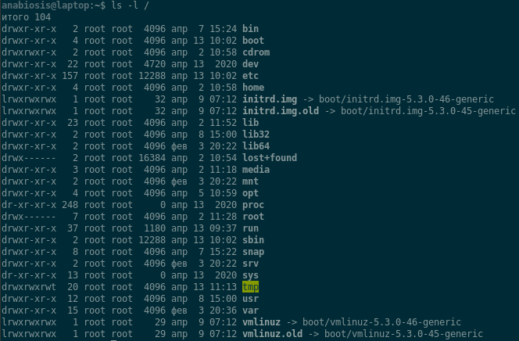

ls - list contents of directory

ls ~ list contents of home directory



ls -l - the long list

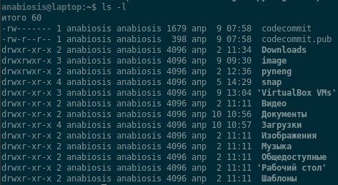

ls -a Lists all entries, including those that begin with a dot (**.**), which are normally not listed.

ls -la

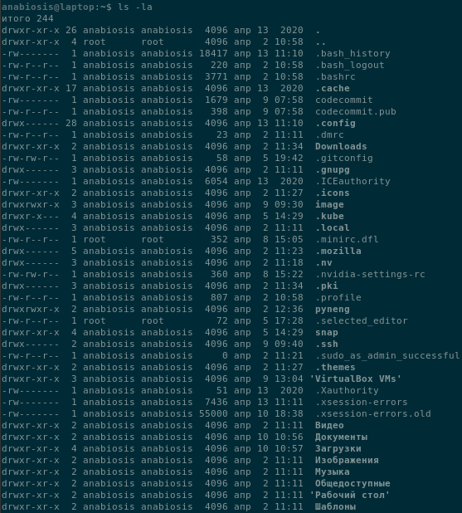

ls -lda ~

l - Lists in long format

d - If an argument is a directory, lists only its name (not its contents).

a - Lists all entries, including those that begin with a dot (**.**), which are normally not listed.



Note differences between produced outputs. Describe (in few words) purposes of these commands.

3. Execute and describe the following commands (store the output, if any):   
mkdir test   
cd test   
pwd touch test.txt   
ls -l test.txt   
mkdir test2   
mv test.txt test2   
cd test2   
ls mv test.txt test2.txt   
ls cp test2.txt ..   
cd ..   
ls rm test2.txt   
rmdir test2

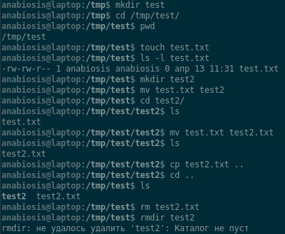

4. Execute and describe the difference   
cat /etc/fstab – safely view the file /*etc*/fstab

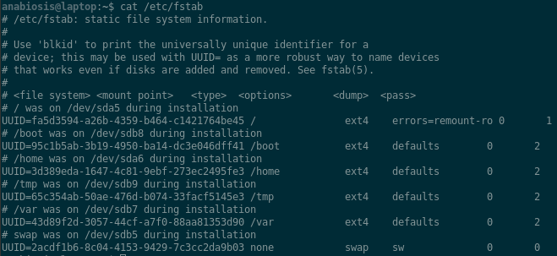

less /etc/fstab – view file by page, also move to the desired location in the file

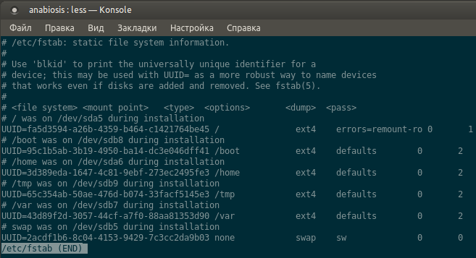

more /etc/fstab

more - is a filter for paging through text one screen at a time.

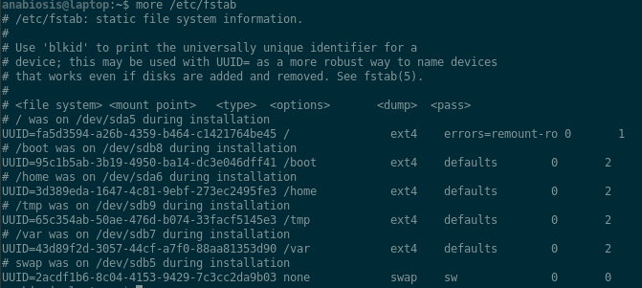

5. Add to archive all ‘test’ directories.

a. to the pure ‘tar’;

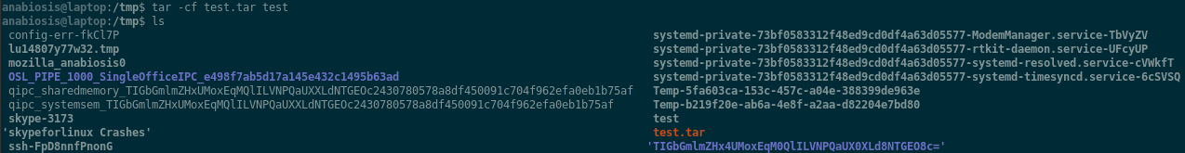 b. to the zipped ‘tar’ with only tar command;

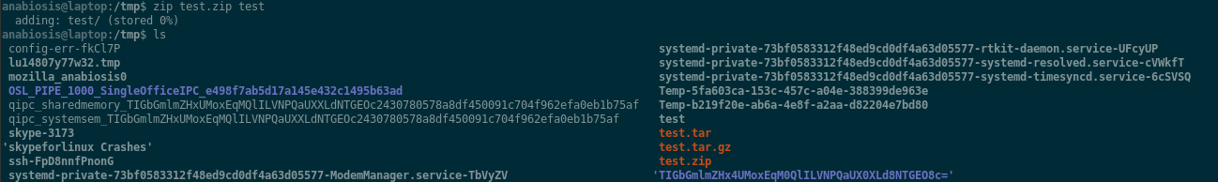

c. to the zipped ‘tar’ with gzip command;

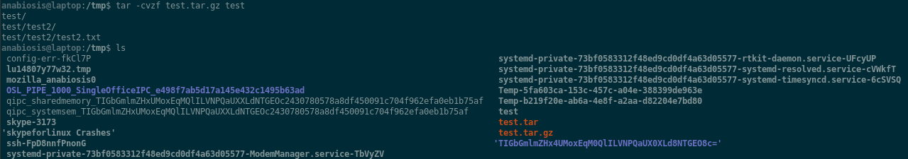

extract from archives all above.

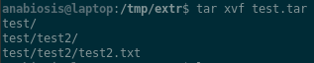





6. Look through man pages of the listed above commands.

man tar:

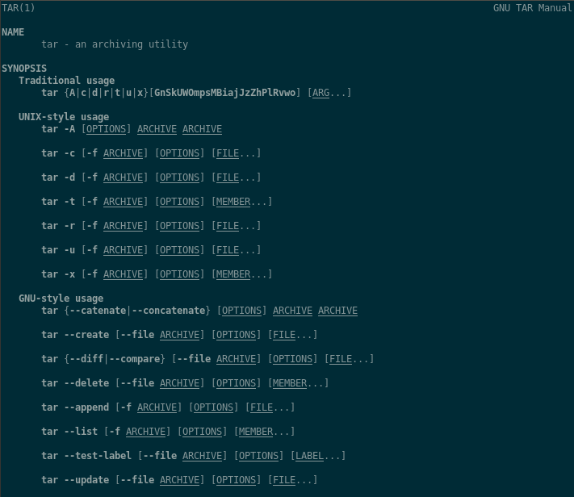

man zip:

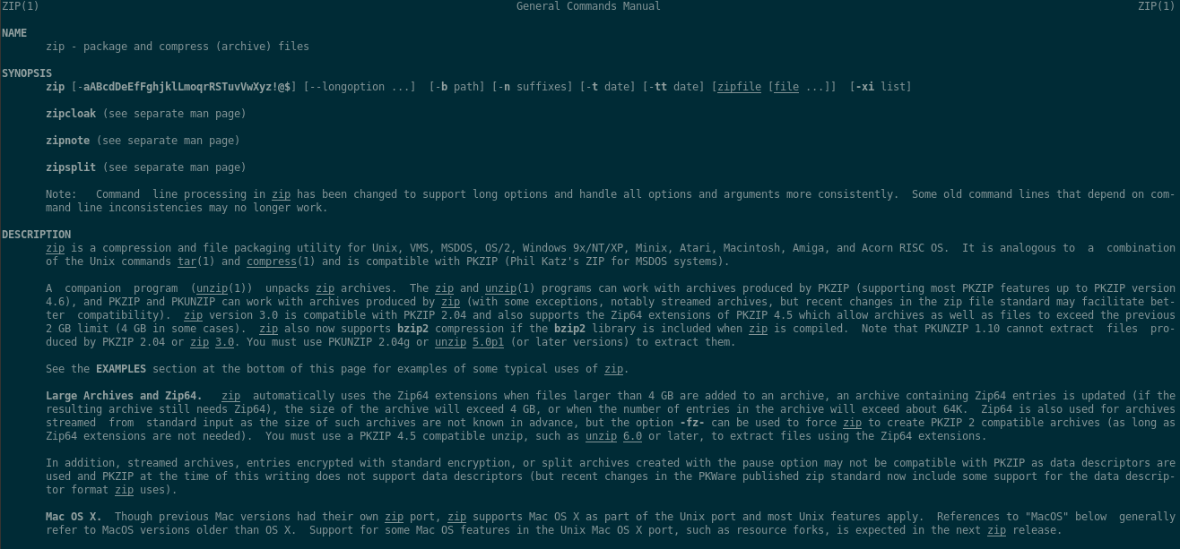

man gzip:

