# HD map

1. HD map is the base of the auto-driving software stack.
2. Construction of HD map consists of five step：

Data sourcing (collection, matching, updating);

Data processing (classification, cleaning, standardlizing);

Object detection (detect static obj);

Manual verification (identify the issues);

Publication.

1. HD map contain many imformation, such as the precise position of the traffic lights & heigh,

Apollo use crowd source to update the HD map, which can use phones, sensor recievers of cars & even other autonomous cars.

# Localization

To fuse the data which come from different type sensors, the localize the car on the HD map.

1. One GPS receiver should be able to detect at least four satellite at once, in which small input error may cause huge error when measures, and its update frequence is also too low.
2. IMU is realtime device, but the motion error increases at time; 3D Gyro is use to transform the local coordinate to globe;
3. So combine the IMU and the GPS to localize the car can solve those problems;but there is still problems to localize the car ,when the car travelling underground , in the canyon.
4. LiDAR, to detect the environment using laser and get points cloud; and we can continue matching the detected data from LiDAR sensor with the preexisting HD map to localize the car on the HD map; there are several algorithms to do this thing, such as Iterative closest point (ICP) ,Histogram Filter Algorithm(SSD), and Kalman Filter Algorithm. But the problem is that the situation is always changing ,so the HD map can never be up to date.
5. Camera, it’s easy and cheap but hard to localize precisely, always combine with other sensor data;use probility to localize the car on the map; usually be used to detect lane; lack of 3D information

Apollo use multitype sensor fusion system.

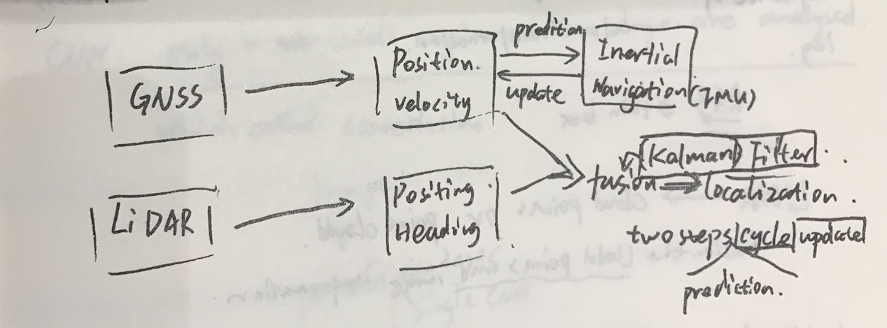

Kalman Filter Algorithm

Waiting to insert smartART;

# Perception

Computer vision (Neural network, CNN, Machine learning) to precept the world. Perception has four core tasks:

1. Detection, find out where the obj is
2. Classification, what the obj is; input a image into the system and it should output a label of the image; RGB image which alse called thin box

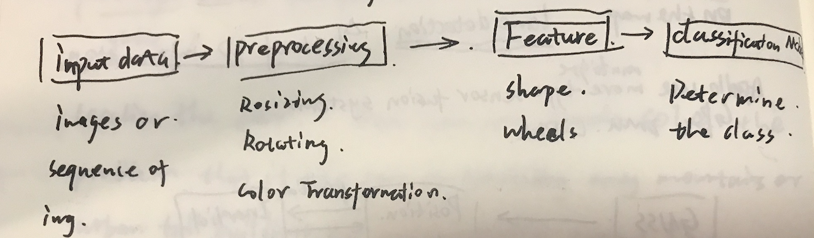

fuse the point cloud and image information.

1. Tracking, observing moving vehicles, to
2. Segmentation, matching each pic in the whole image with the segmentation catagories.

Machine Learning

1. Supervised learning, using the true label created by human to train the machine;
2. Unsupervised learning,
3. Semi-supervised learning, both of labeled and unlabeled data to train.
4. Reinforcement learning, using many learning methods to try and choose the best way

Neural network,

Still don't know what it is;

Training cycle:

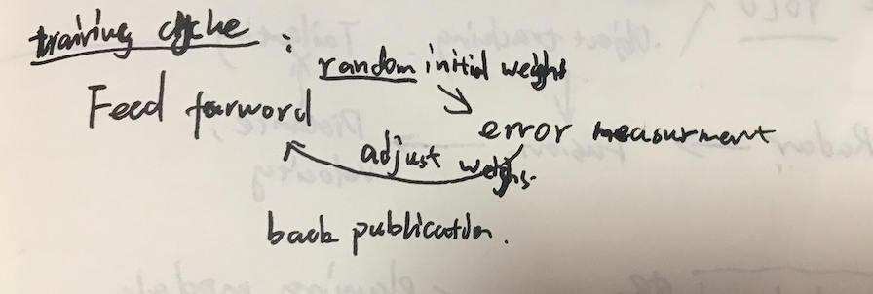

# Prediction