A library to use UART over radio

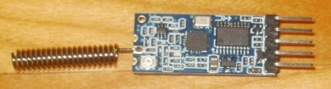
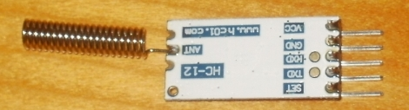

with a HC-12 module
(a serial interface using 433 Mhz radio)

for Raspberry Pi and Arduino

There is a SI4463 for RF communication on the small board and a STM8 MCU that allows to talk to it using AT-commands.
Wiring is quite simple and can be done in several ways, e.g.: using a FTDI-Adapter, using a PL2303 cable or directly connect it to an UART.

Just connect Rx of the module to Tx of e.g. your MCU and Tx of the module to Rx of the MCU.
Vcc might be 5V or 3V3. The module is 5V tolerant.
For normal operation let pin SET open or connect it to Vcc.
That‘s all.

The board has two different operation modes.
„Normal“ operation is transparent transmission mode. In this mode, data is sent and received over radio.
The second mode is „SET“ mode. In this mode you might change several parameters of the module using AT command. To enter „SET“ mode just connect the „SET“ pin to GND.

A complete user manual you may find e.g. here → https://www.elecrow.com/download/HC-12.pdf

This library can be used as an API to the HC-12 module.
All AT commands are supported as high level function calls.

Currently a shared object for Linux will be the result of the build process.
You may use it barely on every Linux OS but you have to hold in mind to use a mechanical switch to „ground“ the SET pin.
On a Raspberry Pi as a prerequisite the pigpio library is required for GPIO-handling.
You may check this by a „dpkg -L pigpio“. If pigpio is not present, please install ist. Otherwise you cannot use the API to switch the module from and to SET mode.

Note, that at this time this is a work in progress project that currently only supports Linux.
In a next step the library is ported to support Arduino platfoms as well.

To build the library change to the build directory and call make.
Please note to change the #define SET_PIN in xxxx.h to a value that meets your need.
In most cases the pin might be unchanged.

The resulting library is located in the build directory. There ist no installation call to make so yout have to copy the cccc.so youself to a matching location (e.g. usr/local/lib) as well as the header files, if needed.
Hold in mind to set LD_LIBRARY_PATH in your environment to point the location of the shared object.

TODO:
different targets in makefile for
Don‘t forget to check for updates here.
Have fun,

