smartTFT

Control TFT and TFT Touch Displays remotely

Table of Contents
I. Brief description 3
II. Proof of concept and 1st prototype 4
I. Prototype Electronic Components 5
I. Arduino Pro Mini 5
II. 1.8“ TFT Display 5
III. 4 channel logic level shifter 6
IV. Stepup/Stepdown regulator 6
V. Light Dependend Resistor (LDR) 7
VI. Piezo Buzzer 7
VII. Resistors 8
VIII. Ceramic Capacitors 8
IX. Stereo Jack 3.5 mm 9
X. DC Jack 9
XI. Pin Header 90 degree 10
XII. Prototype PCB 10
XIII. Crimp Headers 10
XIV. Some Colored Wires 11
XV. Prototype Parts List 12
II. Preparing the Prototype PCBs 13
III. Wiring the Prototype 14
I. Textual Description 14
II. Schematic 14
IV. Complete the Prototype 14
V. Software on Arduino 14
VI. Linux Testprogram 14
VII. Conclusion 14

Brief description

There is a lot of small and cheap color TFT displays around and with this project I want to give some of them the possibility to remotely control its content. Control is done by most common function calls of the Arduino GFX Library that are transferred to a µController that executes them.
µControllers that may be used are several typed of Arduino (e.g. Pro Mini) and the ESP8266 Series as well as the ESP32xx Series SoCs.
The displays that are suitable to use are the several 0.96“, 1.2“, 1.8“, 2.2“ … TFT displays and TFT displays with touch interface.
For more information about µControllers and displays see appendix A.

Proof of concept and 1st prototype

First prototype and proof of concept is done with a ST7735 based 1.8" TFT with an additional SD-card slot.
As a µController an Arduino Pro Mini is used.
Communication is done using the UART of the Arduino.
A self-made case will hold the components.
A buzzer is used to realize an alarm-function, a LDR makes ist possible to change backlight brightness of the display depending on ambient light.

Prototype Electronic Components

Arduino Pro Mini

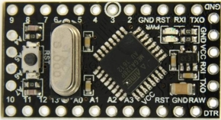
There are several different models of the Arduino Pro Mini available. There is no need for choosing a specific model but it is recommended not to use a 3V3 type.

1.8“ TFT Display

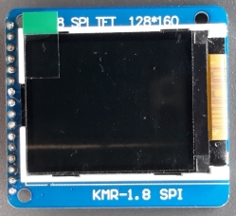 | 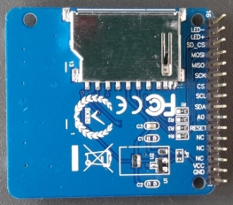

This documentation requires the use of a 16 pin 1.8“ TFT with card slot, based on a ST7735 controller. Keep in mind not to close jumper J1 to avoid damage of the display.

4 channel logic level shifter

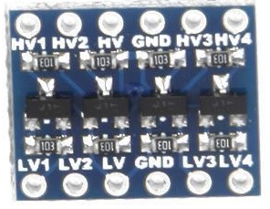

There is no special to annotate to this items. You may use a 8 channel level shifter instead of two pieces with 4 channels, but then you have to change the wiring to match this new condition.

Stepup/Stepdown regulator

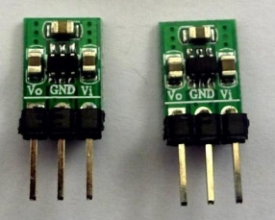

These are special items that will work with an input voltage from 1.8V up to 5V and will deliver a max. current of 100 mA @3.3V.
3.3V are necessary for the logical signals even if the display is powered by 5V.

Light Dependend Resistor (LDR)

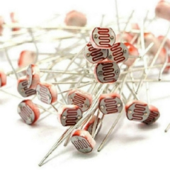

These cheap items will match our needs. You may get a bunch of them for only some cent. There is no reason to use other ones.

Piezo Buzzer
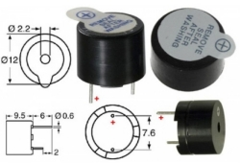

This item is a standard component, too. You may use any type of buzzer working at 5V but hold in mind that the case construction only supports one with these technical data (e.g. diameter, height, ...).

Resistors

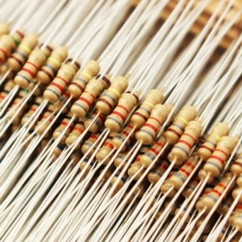

We need simple carbon resistors with ¼ W, one with 100 Ohm, two with 4.7 kOhm and one with 10 kOhm. See Prototype Parts List below.

Ceramic Capacitors
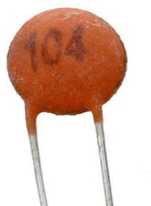

We need two pieces as decoupling capacitor, one for the TFT and one for the Arduino. For details have a look to the “Prototype Parts List”.

Stereo Jack 3.5 mm

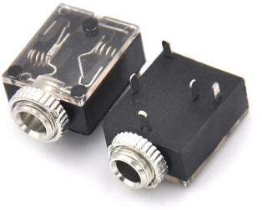

This is used to connect the UART pins. See sections “Preparing the Prototype PCBs” and “Wiring the Prototype” for more details.

DC Jack

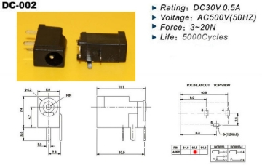

Connector for power supply (5V). See sections “Preparing the Prototype PCBs” and “Wiring the Prototype” for more details.

Pin Header 90 degree
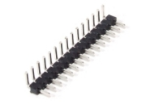

This header is used to connect the smartTFT to an I2C-Bus. Only three pins are used for SDA, SCL and GND. See sections “Preparing the Prototype PCBs” and “Wiring the Prototype” for more details.

Prototype PCB
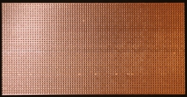

We need two small pieces of it. See section “Preparing the Prototype PCBs” for dimensions.

Crimp Headers
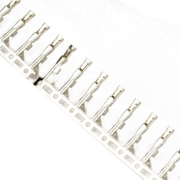

For the Prototype we’ll wire some connections with these for easily change them.

Some Colored Wires

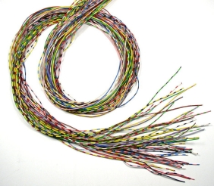

To make life easier onnections are made by colored wires.

Prototype Parts List

- 1 x Arduino Pro Mini
- 1 x 1.8" TFT with SD-slot
- 2 x Levelshifter with 4 channels
- 1 x Stepup/Stepdown Regulator 5 <-> 3V3
- 1 x LDR
- 1 x Buzzer
- 1 x Resistor 10 kOhm
- 2 x Resistor 4.7 kOhm
- 1 x Resistor 100 Ohm
- 2 x Ceramic Capacitor 100 nF
- 1 x Stereo Jack female 3.5 mm
- 1 x DC Jack female 3.5 mm x 1.1 mm
- 1 x 4x1 Pin Header 90 degree
- 1 x Proto-PCB 16 rows/32 columns (around 42 x 83 mm)
- 1 x Proto-PCB 16 rows/6 columns (around 42 x 15 mm)
- some crimp headers
- a bunch of colored wires 0.14 mm

Preparing the Prototype PCBs

Wiring the Prototype

Textual Description

Schematic

Complete the Prototype

Software on Arduino

Linux Testprogram

Conclusion

Wiring via Levelshifter
--
| Arduino | Levelshifter| Levelshifter|1.8" TFT |
|--|--|--|--|
| Pin #10 |HV*| LV** | TFT_CS |
| Pin #9 |HV| LV|TFT_RST |
| Pin #8 |HV| LV|TFT_DC |
| Pin #13 |HV| LV|TFT_SCL |
| Pin #11 |HV| LV|TFT_SDA |
| Pin #7 |HV| LV|SD_CS |
| Pin #12 |HV| LV|SD_MISO |
| Pin #11 |HV| LV|SD_MOSI|
| Pin #13 |HV| LV|SD_SCL |

*HV means High Voltage Side
**LV means Low Voltage Side

---

Because Vcc of the TFT is 5V **be aware** that **Jumper J1** on the back side of TFT is **open!** Otherwise the display is damaged.

Direct Wiring
--
|Arduino|Target 1 | Target 2| is for |
|--|--|--|--|
|Pin #5 | 100 Ohm | buzzer | limit current |
|Pin #6 | TFT LED+ | -- |dim backlight |
|Pin A0 | LDR |-- | light sense |
|Pin A0 | 10 kOhm |GND | pulldown|

Realized GFX-functions
--
- drawLine()
- drawFastHLine()
- drawFastVLine()
- drawRect()
- fillRect()
- drawCircle()
- fillCircle()
- drawTriangle()
- fillTriangle()
- drawRoundRect()
- fillRoundRect()
- setRotation()
- setTextWrap()
- fillScreen()
- setTextColor()
- fillScreen()
- invertDisplay()
- drawCircleHelper()
- fillCircleHelper()
- drawBitmap()
- drawChar()
- setCursor()
- setTextSize()
- height()
- width()
- write()
- drawPixel()
- print()
- println()

and. last but not least,
- setbrightness()

for dimming backlight of the TFT Display.

