Presentation

**Title**

**CNC MACHINE BASED ON LASER ENGRAVER USING ARDUINO**

**AIM**

Now a day’s technology is increased in rapid growth the usage and implementation of CNC system in industries and colleges but at greater cost. According to our idea on fabrication of compact and cheap cost CNC Engraver is introduced to reduce complexity, cost and man power. This paper discuss the design and implementation of two dimensional CNC router which can engrave 2D & Gray scaled images or pictures with help of high watt burning laser module on surface which can be a paper, wood, leather, plastic, foam.

Keywords: Arduino ATmega328, CNC, G-Code

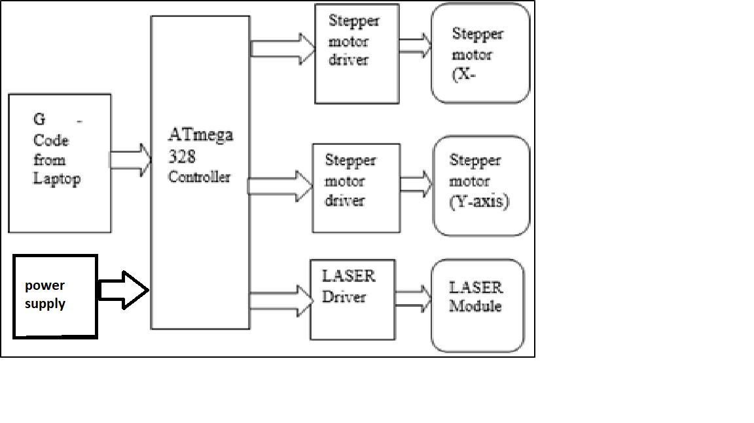

**Thank you**