Smart Bucket

Project Based Learning

Version : 0.2

Author : Shanjeevan Amalanathan

Date : 01.05.2020

DreamSpace Academy

Batticaloa, Sri Lanka

www.dreamspace.academy

# 

# Procedures and methods

Smart Bucket is a device Automatically fills water when it is empty and stops filling water when it is full. Water switching. Switching water level displays on the L.C.D Screen.  
  
Water level sensors will be added to the water container. Arduino will constaread the sensor signal and when the water reaches the bottom of the container, arduino will actuate the water pump. Then the water starts to fill in the water container. When the water container is fully filled with the water, the arduino will stop the pumping of the water pump. A syringe is used to get the water out of the container.

Arduino will constaread the sensor signal and display the water level in the L.C.D Screen.

## Requirement

<https://docs.google.com/drawings/d/1QFZIOUW16WQi_xl8eMYwkdNkD9pQ8_bBhxPWtCWxAp8/edit>

# Design

<https://docs.google.com/drawings/d/1X7IU7NF762ewbTfqA5IQbrFk8hJEcM5Zk7YGuKQQ3Sc/edit>

# Budget

|  |  |  |
| --- | --- | --- |
| Component Name | Total number | Total Price |
| Arduino Nano | 01 | US$ 10 |
| L.C.D Screen | 01 | US$ 05 |
| Water Pump | 01 | US$ 07 |
| Strinch | 01 | US$ 02 |
| ¼ “ tube | 01 | US$ 02 |
| Prototype PCB BreadBoard | 02 | US$ 01 |
| 6 VDC Relay* | 01 | US$ 04 |
| Resistor (10 kohm) | 05 | US$ 01 |
| Header Pin | 40 | US$ 04 |
| Jumper wires | 120 | US$ 07 |
| Total |  | US$ 43 |

# **Test on Breadboard without water pump**

## Connect components in the bread board according to the circuit diagram. Attach the header pin for sensing water presence in the model bucket.

## 

## Prepare the model water tank

## Testing

* <https://drive.google.com/drive/folders/1_rvHGFomH91ZQEGLoChfLC4BP9B8TEem>

# **Test on Prototype PCB BreadBoard with water pump**

## Connect components in the prototype PCB board according to the circuit diagram.

## 

## 

## Attach the header pin for sensing water presence in the upgraded bucket.

## 

## Attach the syringe to manually get the water out of the water bucket.

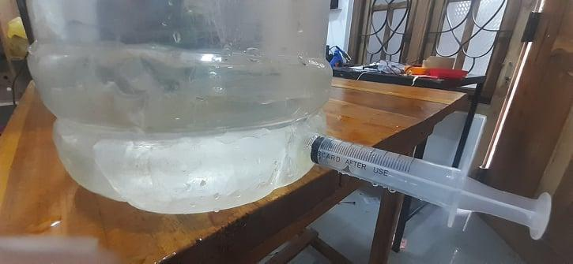

## Prepare the upgraded water tank

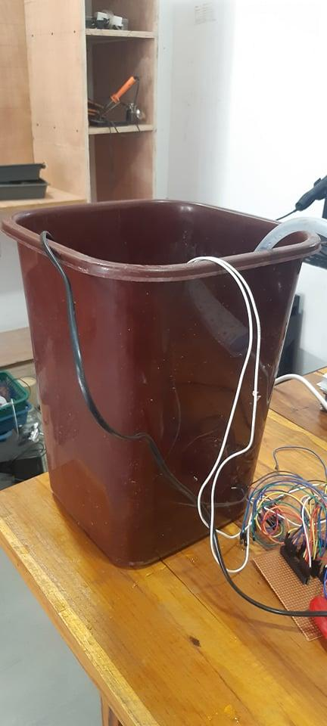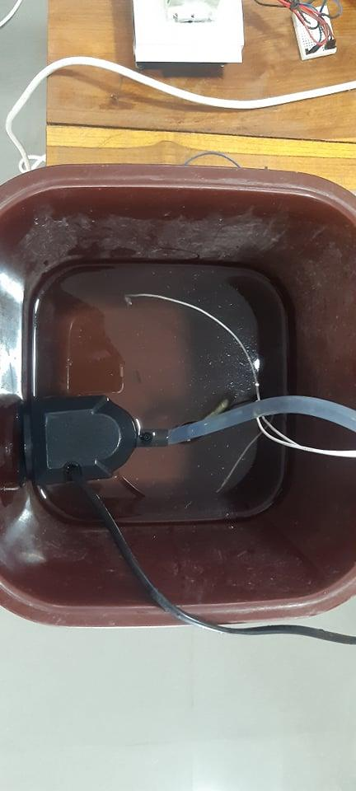

## Testing

* <https://drive.google.com/drive/folders/1_rvHGFomH91ZQEGLoChfLC4BP9B8TEem>

# **Final prototype**

# Connect components in the bread board according to the circuit diagram.

