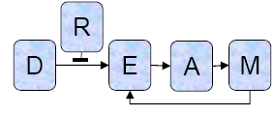

DREAM2 Challenge Scoring Methodology

Gustavo Stolovitzky

IBM T.J. Watson Research Center

Precision versus recall curve beyond the maximum recall value of a set of predictions

Suppose we have a sample space with T elements. These elements belong to one of two classes: the class of positive examples, with P elements, and the class of negative examples, with N elements. Clearly T=P+N. The fact that we know the class to which each example belongs makes this sample space a gold-standard.

A prediction is made in the form of an ordered list of L samples taken from our sample space. This list is ordered such that the examples at the top of the list are the ones on which we have the higher confidence that they belong to the positive class. We will assume that the list contains TP_{L} true positive predictions and FP_{L} false positive predictions. Clearly L = TP_{L} + FP_{L}. We now add in random order the remaining T-L samples (on which no prediction was made) to the bottom of the original list with L examples. We want to compute the precision and recall corresponding to the prediction that the k (k>L) first samples in the resulting list are positive.

We first estimate the number of TP and FP resulting from adding k-L random examples. These examples were randomly sampled from a set of P-TP_{L} positives and N-FP_{L} negatives. Therefore the probability ρ of any of those k-L examples to be a positive example is 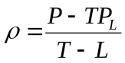 and therefore the probability of having gained ΔTP true positives in the added samples (between samples L and k) follows a binomial distribution with parameters k-L and probability ρ, whose average is 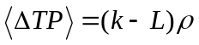. The precision p(k) and recall r(k) at depth k in the list of predictions, therefore, are functions of the random variable ΔTP:

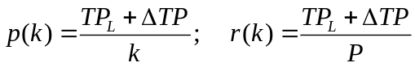. (1)

It follows that the average precision and recall at depth k are:

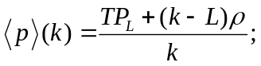 (2)

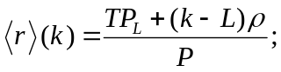 (3)

By allowing k to span the range between L and T the previous two equations give us the shape of the precision and recall curve, parameterized by k.

We can also write down an explicit function of precision versus recall curve. Solving for k in Eq. (3) and replacing in Eq. (2) we obtain

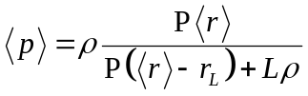 (4)

where r_{L} = TP_{L}/P is the recall at depth L.

Note that if L=0 and r_{L}=0, then 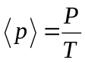, that is, it’s a constant. In other words the average precision for a random prediction list is a constant. And the integral of the area under the precision versus recall curve (or AUPRC for short, to be notated A) is A = 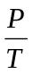.

In the general case, Eq. 4 shows that the precision versus recall curve after the addition of T-L random predictions at the end of the original L predictions, has a hyperbolic shape, and goes through the points (r_{L}, p_{L}) (where p_{L}=TP_{L}/k is the precision at depth L), and (1,P/T).
The slope of the curve for recall greater than r_{L} is

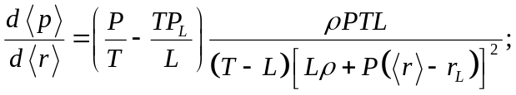

which clearly is negative (decreasing curve) if the precision at recall r_{L} is larger than random (P/T), or positive (increasing curve)if it is smaller than random. The added area under the curve, that is, the area beyond the precision recall curve above recall r_{L} is

A =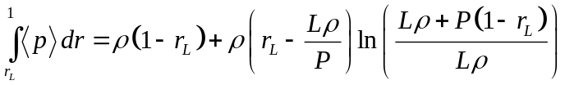.

How to integrate the precision versus recall curve to find the AUC¹
[1] J. Davis and M. Goadrich, The Relationship Between Precision-Recall and ROC Curves, in Proceedings of the 23rd International Conference on Machine Learning, Pittsburgh, PA, 2006.

A practical issue to address is how to interpolate between points in the precision versus recall curve when we try to compute the AUPRC. Each time we go down the list of predictions from item k to item k+1, two things can happen:

- We gain a FP: FP_{k+1}=FP_{k}+1.
In this case, the number of TP’s didn’t change (TP_{k+1}=TP_{k}), and PR curve moved from point k at 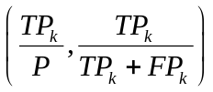 to point k+1 at 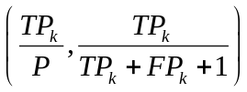. The area under the curve therefore didn’t change: A_{k+1}= A_{k}.

- We gain a TP: TP_{k+1}=TP_{k}+1.
In this case, the number of FP’s didn’t change (FP_{k+1}=FP_{k}), and PR curve moved from point k at to point k+1 at 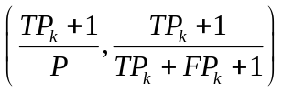. Assume that there is a continuous change in the number of TP’s from TP_{k} to TP_{k}+1. Call such continuous variable x. We have that between point k and point k+1 we traverse the curve 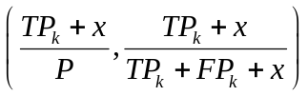 for x between 0 and 1. Calling TP+x = r P (r as in recall), we have that the PR curve can be parameterized by r as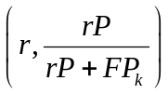 for r between TP_{k}/P and (TP_{k}+1)/P. Integrating this curve we obtain that the area under the curve changed as:

A_{k+1}= A_{k}+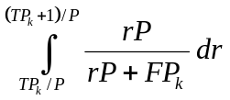= A_{k}+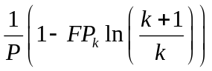

Note that if the interpolation were to be done linearly instead of hyperbolically, the resulting areas LA_{k} would be

LA_{k+1}= LA_{k}+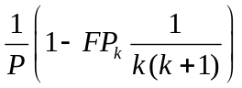.

It is then clear that a linear interpolation when we integrate would result in a more optimistic AUPRC that the hyperbolic and more accurate functional form.

Measurement of the prediction accuracy for DREAM2

Given the considerations of the previous sections, the pseudo-code to determine the precision versus recall, as well as the ROC curves of a set of incomplete predictions (i.e., L<T) is as sown in Figure 1.

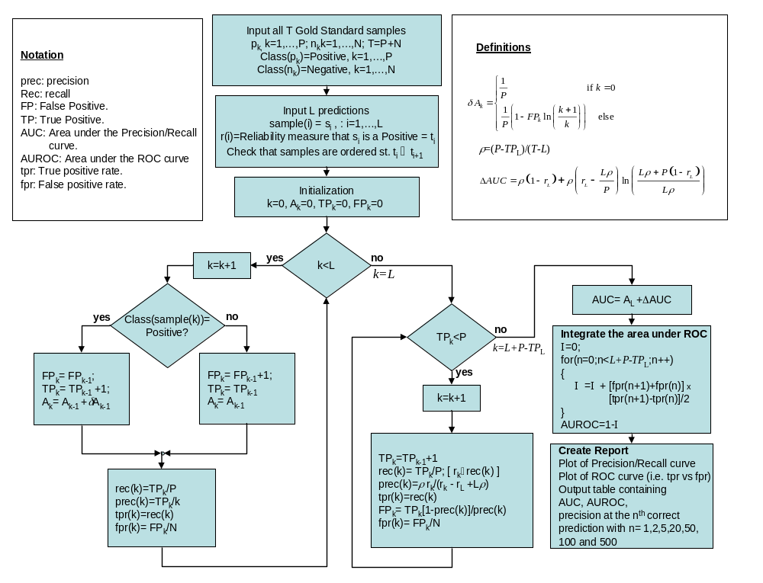

Figure 1. Pseudocode of the process to evaluate the predictions for the DREAM2 challenges.

