SELF-DRIVING CAR SIMULATION
MVP SYSTEM DESIGN, HUMAN-DRIVEN TRAINING, DQN vs SARSA & 7-DAY EXECUTION PLAN
HighwayEnv + Gymnasium • Python + PyTorch + Streamlit • Two learning vehicles: R and S
Important correction: human driving inside the simulator is the primary training-data source. Vehicle R uses DQN. Vehicle S uses SARSA. The project compares the two methods on the same driving task.

1. Project in simple words
We are building a small self-driving car simulation instead of a real car. A person first drives inside the simulated highway and the program records what the person did in different traffic situations. That human-generated driving data is then used to train two different learning agents.
R and S are simply two learning vehicles in the same traffic world. R learns with a Deep Q-Network (DQN). S learns with SARSA. We then let both drive by themselves and compare how they behave.
The core story is:
Human drives → record experience → train R with DQN and S with SARSA → let both drive autonomously → compare results

2. What the two cars are
Vehicle | Algorithm | Purpose
R | DQN | Neural-network based value learning
S | SARSA | Tabular on-policy value learning
Other traffic | HighwayEnv behaviour | Creates the traffic situation
R and S use the same road, the same action set and the same main reward objective. This is important because we want the algorithm to be the main difference being studied.
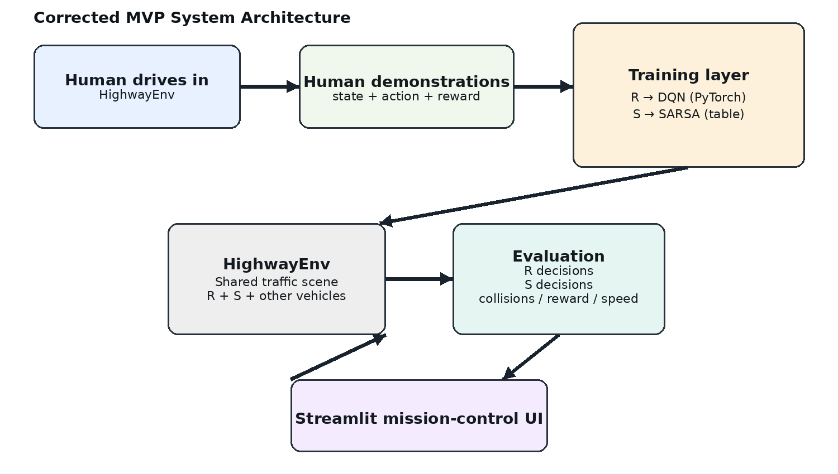
Figure 1. Corrected system architecture.

3. What human training means
Human training does not mean the model watches a recorded video. It means a person actually controls a vehicle inside HighwayEnv. At every simulation step we save the situation and the human decision.
Example:
State: middle lane, high speed, vehicle close ahead → Human action: SLOWER → Reward: positive if the action improves safety → Next state: safer distance
Those state/action/reward transitions become the training material. Human demonstrations remain stored separately so we can show exactly what came from the human and what came from the AI.

4. What DQN does for R
DQN stands for Deep Q-Network. Instead of keeping a giant table of every possible state, R uses a small neural network. The network receives the compact driving state and outputs one Q-value for each available action.
R therefore follows this simple idea:
current state → neural network → Q-values for 5 actions → choose best action
Because DQN normally learns from replayed transitions, our human demonstrations are loaded into the replay buffer first. R can then continue learning from new simulator experience.

5. What SARSA does for S
SARSA stands for State-Action-Reward-State-Action. S uses a simpler tabular Q representation. It updates the value of the action it actually takes and the next action it is going to take.
Its basic update is:
Q(s,a) = Q(s,a) + α × [r + γQ(s′,a′) − Q(s,a)]
Human demonstrations can warm-start S by increasing the value of demonstrated actions or by replaying the recorded sequence through a SARSA-compatible training routine. The documentation must state exactly which implementation is used.
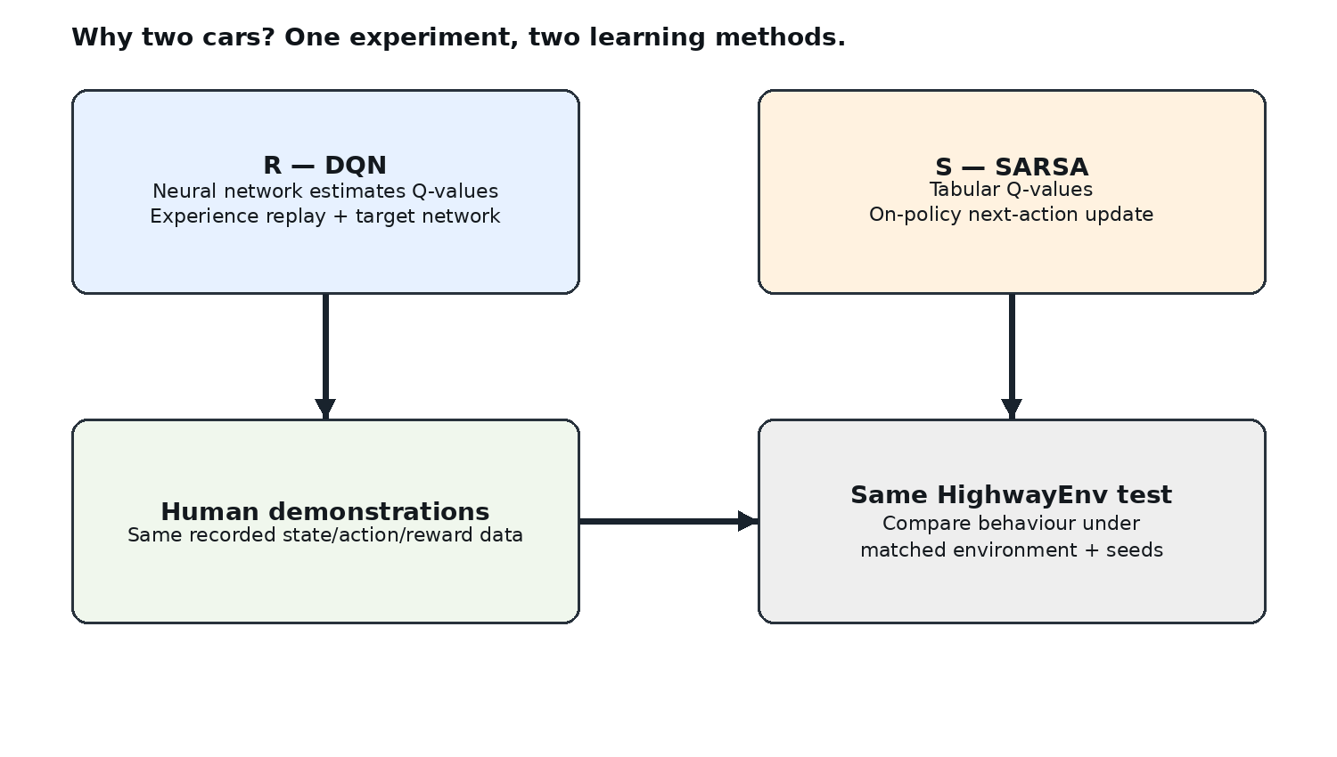
Figure 2. Why R and S are different.

6. State, action and reward
State = what the car knows about the current situation. We keep this small and understandable: lane, speed level, front distance, front relative speed, rear distance, left-lane occupancy, right-lane occupancy and risk level.
Action = what the car does. For the first MVP use five high-level actions: LANE_LEFT, IDLE, LANE_RIGHT, FASTER and SLOWER.
Reward = feedback. Safe progress gets positive reward. Collision, dangerous behaviour or poor driving gets negative reward. The exact reward weights stay in a configuration file so experiments are reproducible.

7. End-to-end training flow
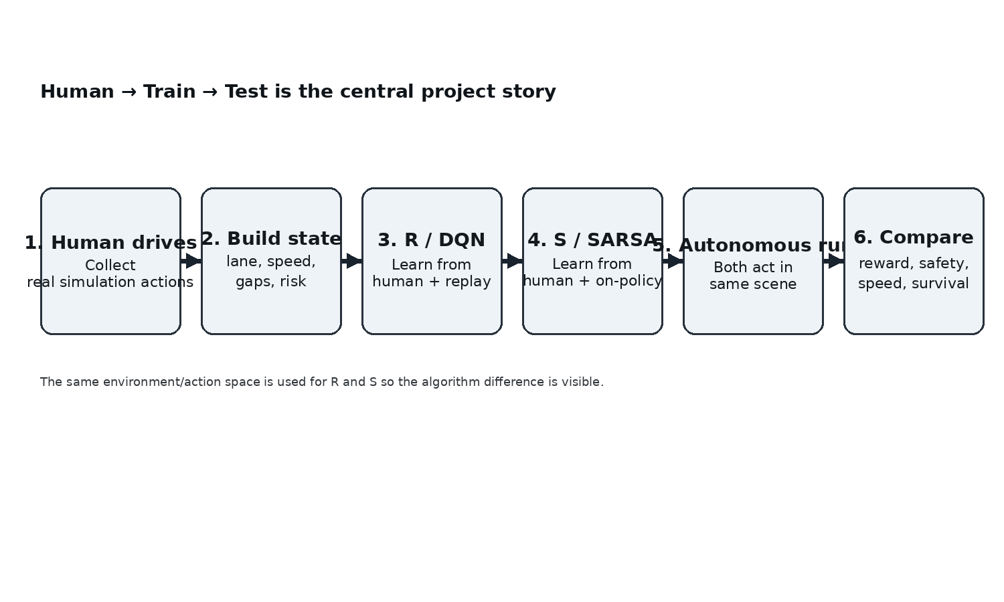
Figure 3. Human-to-model training flow.

Step 1 — Human drives
A person drives R or S in the simulated highway. The system records every decision.

Step 2 — Build states
Raw environment observations are converted into a compact state that both algorithms can understand.

Step 3 — Train R
DQN R starts from human demonstrations, then continues learning from its own simulator experience.

Step 4 — Train S
SARSA S starts from the same human demonstrations, then continues learning from on-policy simulator experience.

Step 5 — Autonomous driving
The human lets go. R and S drive themselves in the same traffic environment.

Step 6 — Compare
We compare reward, collision rate, survival time, speed and lane changes. We do not claim a winner before measuring it.

8. Human training data format
Each recorded step should contain:
- episode_id
- step_id
- agent_id
- state
- human_action
- reward
- next_state
- terminated
- truncated
Suggested storage: JSON Lines or CSV for human demonstrations, plus a small metadata file containing the environment configuration and collection date.

9. System design

9.1 Environment layer
HighwayEnv creates the road, lanes and traffic. We do not rebuild the traffic simulator. The application keeps R and S as the two learning vehicles while the other vehicles are handled by the environment.

9.2 Learning layer
R uses PyTorch for DQN. S uses a simple Python/NumPy table for SARSA. They share the state/action definitions and are trained against the same environment objective.

9.3 Data layer
Human demonstrations, autonomous training logs, checkpoints and evaluation results are stored as separate artifacts. This prevents human data from being mixed with evaluation data.

9.4 Frontend layer
Streamlit is only the interface. Core environment and learning code stays in Python modules so the training process can run without the UI.

10. Proposed project structure
self_driving_car_mvp/
├── app.py
├── pages/
│ ├── simulation.py
│ ├── human_training.py
│ ├── train_compare.py
│ ├── analytics.py
│ └── experiments.py
├── src/
│ ├── envs/
│ │ ├── highway_env_factory.py
│ │ └── state_builder.py
│ ├── agents/
│ │ ├── dqn_agent.py
│ │ └── sarsa_agent.py
│ ├── human/
│ │ └── recorder.py
│ ├── simulation/
│ │ └── controller.py
│ ├── data/
│ │ ├── schemas.py
│ │ └── logger.py
│ └── utils/
│ ├── config.py
│ └── metrics.py
├── components/
│ └── keyboard/
├── configs/
│ ├── mvp.yaml
│ └── reward.yaml
├── data/
│ └── human_demonstrations/
├── artifacts/
│ ├── checkpoints/
│ ├── experiments/
│ └── figures/
├── tests/
├── scripts/
├── docs/
├── requirements.txt
├── README.md
└── .gitignore

11. Frontend idea
The interface should look like a small simulation laboratory, not a marketing dashboard. The road simulation should occupy most of the screen. Controls stay compact. R and S are clearly labelled with their algorithms.
Simulation | R — DQN | S — SARSA
Large road view | Action + speed + reward | Action + speed + reward
Run / Pause / Reset | Decision trace | Decision trace

12. Tech stack
Technology | Use
Python | Main language
HighwayEnv | Traffic simulation
Gymnasium | Environment interface
PyTorch | DQN for R
NumPy / Python dicts | Tabular SARSA for S
Streamlit | Web frontend
JSON/CSV | Human demonstrations and logs
Git/GitHub | Version control and delivery

13. 7-day build and training plan
Day | Main work | Output
Day 1 | Simulator + human driving prototype | Working highway, R/S visible, one human episode recorded.
Day 2 | Human dataset | 5–10 human episodes, state/action/reward records, replay works.
Day 3 | DQN for R | Human demonstrations load into replay buffer; R checkpoint saved.
Day 4 | SARSA for S | Human demonstrations warm-start S; S checkpoint saved.
Day 5 | Joint autonomous run | R+DQN and S+SARSA act together; comparison logs produced.
Day 6 | Streamlit | Simulation, Human Training, Train & Compare, Analytics and Experiments pages.
Day 7 | Evaluation + GitHub | Fixed-seed evaluation, charts, documentation, cleanup and release.

14. Fair comparison rules
- Keep HighwayEnv configuration the same for R and S during a fair comparison.
- Keep the action set the same.
- Use the same main reward objective.
- Use fixed evaluation seeds.
- Report human metrics separately from AI evaluation.
- Do not declare DQN or SARSA better from a single episode.
- Keep hyperparameters and experiment configuration saved with the result.

15. What we will measure
Metric | Why it matters | Source
Mean episode reward | Overall task score | Environment + reward logger
Collision rate | Safety | Environment collision flag
Survival time | How long the vehicle remains safe | Episode log
Average speed | Progress / driving style | Vehicle state
Lane changes | Behaviour and decision frequency | Action log
DQN loss | Whether the neural learner is training | PyTorch training loop
SARSA Q-value changes | Whether the table is learning | SARSA learner logs

16. Limitations
- This is a simulation project, not a road-ready autonomous-driving system.
- Human demonstrations are limited by the driving quality and number of collected episodes.
- DQN and SARSA are being compared in a simplified action/state space.
- The simulator does not replace real cameras, LiDAR, vehicle dynamics or safety certification.
- Results depend on environment configuration, reward design, random seeds and training duration.

17. Antigravity build strategy
Do not ask the coding agent to build the whole project in one prompt. Build and test one layer at a time: environment → state → human recorder → DQN → SARSA → joint controller → training → Streamlit → analytics → testing → GitHub handoff.
The companion file `Antigravity_Codegen_Prompts.md` contains the revised prompts. The companion `7-Day_Training_Instructions.md` contains the daily execution checklist.

18. Final definition of done
- A person can drive inside the simulator and save demonstrations.
- R is trained with DQN from human demonstrations and simulator experience.
- S is trained with SARSA from the same human demonstrations and simulator experience.
- R and S can drive together in the same traffic scene.
- Streamlit shows the simulation and explains which algorithm controls each car.
- Analytics compare human reference, DQN and SARSA using real logs.
- The repository runs from a clean setup and includes documentation.

19. References to consult during implementation
- HighwayEnv documentation: https://highway-env.farama.org/
- Gymnasium API documentation: https://gymnasium.farama.org/
- PyTorch documentation: https://pytorch.org/docs/
- Streamlit documentation: https://docs.streamlit.io/
- Streamlit component template: https://github.com/streamlit/component-template

