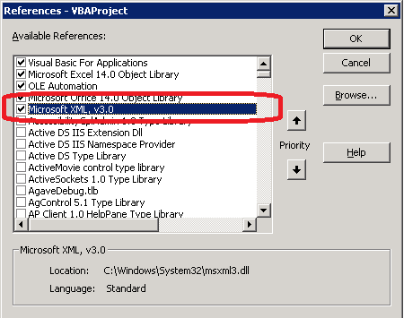

Example Function

|  |
| --- |
| Sub Examples()    Dim ws As New SPSoap  Call ws.init("http://schoen.pri:84")  ' Resultset  Dim x As MSXML2.IXMLDOMNodeList    Set x = ws.wsm_GetListItems("MasterProcess", "", Nothing, Nothing, "", Nothing, "")    Dim root As IXMLDOMElement  Set root = x.item(0)    Dim elements As Variant  Set elements = root.getElementsByTagName("rs:data")    Dim strQuery: strQuery = ".//z:row"    Set Items = root.SelectNodes(strQuery)  Debug.Print "No of Items: " & Items.Length  Dim item As Variant  For Each item In Items  Debug.Print "Title: " & item.getAttribute("ows_Title")  Next    End Sub |