Machine Learning: Assignment – 2

- Gitlab repository link: https://github.com/dreamywarrior/end-to-end-ml-classification
- Streamlit App link: https://end-to-end-ml-classification.streamlit.app/
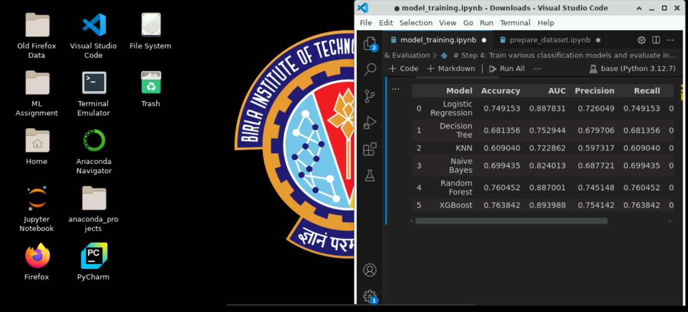
- Lab Execution Screenshot:

- Github README content:

🎓 Predict Students' Dropout and Academic Success

Problem Statement
This project implements and compares six different machine learning classification models to predict students' academic outcomes — Dropout, Enrolled, or Graduate. The goal is to build an end-to-end ML pipeline that includes model training, evaluation, and deployment through an interactive Streamlit web application.
The assignment requires:
- Implementation of 6 classification models
- Comprehensive evaluation using multiple metrics
- Interactive web application for model comparison and prediction
- Deployment on Streamlit Community Cloud

Dataset Description
Dataset: Predict Students' Dropout and Academic Success from UCI Machine Learning Repository
Source: UCI ML Repository - Predict Students' Dropout and Academic Success
Description: The dataset was created using data from a higher education institution, collected from multiple disjoint databases. It focuses on students enrolled in various undergraduate programs, including Agronomy, Design, Education, Nursing, Journalism, Management, Social Service, and Technologies. The dataset contains information available at the time of enrollment, along with academic performance at the end of the first and second semesters.
Features (36 input features): The dataset includes demographic, socioeconomic, and academic performance features such as:
- Marital status, Course, Daytime/evening attendance
- Previous qualification, Nationality, Mother's/Father's qualification and occupation
- Admission grade, Age at enrollment, Curricular units credits
- Grade point averages for 1st and 2nd semester
- And many more academic and personal attributes
Target Variable:
- Target - Student status: Dropout, Enrolled, Graduate (3 classes)
Dataset Statistics:
- Total Instances: 4,424
- Features: 36
- Classes: 3 (Dropout, Enrolled, Graduate)
- Missing Values: None

Models Used
The following six classification models were implemented and evaluated using the same dataset:
- Logistic Regression
- Decision Tree Classifier
- K-Nearest Neighbors (KNN)
- Naive Bayes (Gaussian)
- Random Forest (Ensemble Model)
- XGBoost (Ensemble Model)

Evaluation Metrics
All models are evaluated using the following metrics:
- Accuracy: Overall correctness of predictions
- AUC Score: Area Under the ROC Curve (one-vs-rest for multi-class)
- Precision: True Positives / (True Positives + False Positives)
- Recall: True Positives / (True Positives + False Negatives)
- F1 Score: Harmonic mean of Precision and Recall
- MCC: Matthews Correlation Coefficient (balanced measure for binary/multi-class)

Comparison Table with Evaluation Metrics
ML Model Name | Accuracy | AUC | Precision | Recall | F1 Score | MCC
Logistic Regression | 0.7480 | 0.8887 | 0.7290 | 0.7480 | 0.7321 | 0.5858
Decision Tree | 0.6814 | 0.7529 | 0.6797 | 0.6814 | 0.6800 | 0.4844
KNN | 0.6090 | 0.7229 | 0.5973 | 0.6090 | 0.5977 | 0.3537
Naive Bayes | 0.6994 | 0.8240 | 0.6877 | 0.6994 | 0.6868 | 0.5056
Random Forest | 0.7605 | 0.8870 | 0.7451 | 0.7605 | 0.7446 | 0.6071
XGBoost | 0.7638 | 0.8940 | 0.7541 | 0.7638 | 0.7553 | 0.6139

Observations about Model Performance
ML Model Name | Observation about Model Performance
Logistic Regression | Logistic Regression achieves strong performance with an accuracy of 0.7480 and a high AUC of 0.8887, indicating good class separability. The balanced precision (0.7290) and recall (0.7480) lead to a solid F1 score (0.7321), showing consistent predictions across classes. This performance suggests that many academic and demographic features have approximately linear relationships with student outcomes, making Logistic Regression a reliable baseline model.
Decision Tree | Decision Tree attains moderate performance with accuracy of 0.6814 and AUC of 0.7529. While its precision (0.6797) and recall (0.6814) are comparable, the lower F1 score (0.6800) and MCC (0.4844) indicate weaker generalization. This is mainly due to overfitting, as a single tree struggles with high-dimensional feature space and class imbalance present in the dataset.
KNN | KNN shows the lowest overall performance, with accuracy of 0.6090, AUC of 0.7229, and MCC of 0.3537. The relatively low precision (0.5973) and F1 score (0.5977) indicate inconsistent neighborhood-based predictions. This behavior is expected due to the curse of dimensionality (36 features) and sensitivity to feature scaling, which reduces the effectiveness of distance-based learning in this dataset.
Naive Bayes | Naive Bayes achieves reasonable performance with accuracy of 0.6994 and a comparatively high AUC of 0.8240, indicating good probabilistic ranking. However, the modest precision (0.6877) and F1 score (0.6868) suggest some misclassification at the decision boundary. This occurs because the model’s feature independence assumption does not fully hold for correlated academic and socioeconomic variables.
Random Forest | Random Forest delivers strong and stable performance, achieving accuracy of 0.7605 and AUC of 0.8870. The high precision (0.7451) and recall (0.7605) result in a strong F1 score (0.7446) and MCC (0.6071). The ensemble of trees effectively reduces overfitting and captures complex, non-linear relationships among features, making it well-suited for this dataset.
XGBoost | XGBoost achieves the best overall performance with the highest accuracy (0.7638), AUC (0.8940), F1 score (0.7553), and MCC (0.6139). Its strong precision (0.7541) and recall (0.7638) indicate an excellent balance between false positives and false negatives. The gradient boosting approach allows the model to iteratively correct errors and handle class imbalance effectively, resulting in superior predictive performance.

Project Structure
end-to-end-ml-classification/
├── app.py # Main Streamlit application
├── model_training.ipynb # Jupyter notebook for model training
├── requirements.txt # Python dependencies
├── README.md # This file
├── data/ # Directory for datasets
│ ├── train_data.csv # Training dataset for the models
│ └── test_data.csv # Test dataset for evaluation
├── model/ # Directory for saved models
│ ├── *.pkl # Trained model files
│ └── target_class_encoding.csv # Class encoding mapping
└── resources/ # Directory for image resources for app
└── model_evaluator.jpg # Model evaluation workflow iamge

Installation and Setup

Prerequisites
- Python 3.8 or higher
- pip package manager

Steps
- Clone the repository
- git clone <repository-url>
cd end-to-end-ml-classification
- Prepare the train and test dataset
jupyter notebook prepare_dataset.ipynb
- Train the models based on training data
jupyter notebook model_training.ipynb
- Run the Streamlit app locally
streamlit run app.py

Streamlit Application Features
- Model Evaluation Page
  - Upload test CSV data
  - Select one or multiple models for comparison
  - View detailed metrics for each model
  - Compare confusion matrices across models
  - Interactive dashboard with performance visualizations
- Model Comparison Dashboard
  - Side-by-side comparison of all selected models
  - Customizable metric selection
  - Bar charts for visual comparison
  - Formatted results table with color coding

Deployment

Streamlit Community Cloud
Quick Deployment Steps:
- Push your code to GitHub (already done ✅)
- git add .
- git commit -m "Initial commit"
git push origin main
- Go to Streamlit Cloud
  - Visit: https://streamlit.io/cloud
  - Sign in with your GitHub account
- Create New App
  - Click "New App" button
  - Select your repository
  - Set main file path to: app.py
  - Click "Deploy"
- Wait for Deployment
  - Deployment takes 2-5 minutes
  - Your app will be live at: https://<your-app-name>.streamlit.app

Automatic Updates
- Streamlit Cloud automatically redeploys when you push to the main branch
- Just push your changes: git push origin main
- Wait 2-5 minutes for automatic redeployment

