DATA SUPPLEMENT

Title, Matching the Main Manuscript File, and Centered

Author list, as in main manuscript (incl. affilitations), but centered

¹Department of Pharmaceutical Outcomes and Policy, College of Pharmacy, University of Florida, Gainesville, FL, USA; ²Affiliation 2; ³Affiliation 3; …

Corresponding Author: Dr. Steven M. Smith, PO Box 100496, Gainesville, FL 32610-0496; tel 352-273-5134; email ssmith@cop.ufl.edu

Table S1. Title.

<<Table S1>>

Table SX. Measurement criteria for baseline characteristics. Variable names are characterized as “TABLE.VARIABLE_NAME” according to the PCORnet Common Data Model (version 6.0 at the time of this study).

Variable | Definition
Age | Age calculated on the index date based on date of birth in DEMOGRAPHIC.BIRTH_DATE.
Sex | As per DEMOGRAPHIC.SEX
Race-ethnicity | As per DEMOGRAPHIC.RACE and DEMOGRAPHIC.HISPANIC
Current Smoking | Any of the following within one year prior to the index date (including the index date):  - Most recent VITAL.SMOKING in 01, 02, 07, or 08  - ICD-9 codes:  - ≥1 hospitalization with a discharge diagnosis code (any position) of tobacco use of 305.1, 649.0x, 989.84, or V15.82 in any discharge position  - ≥1 physician evaluation and management visit with a discharge diagnosis code (any position) of tobacco use of 305.1, 649.0x, 989.84, or V15.82 in any discharge position  - ICD-10 codes:  - ≥1 hospitalization with a discharge diagnosis code (any position) of tobacco use of F17.200, F17.201, F17.210, F17.211, F17.220, F17.221, F17.290, F17.291, or Z87.891 in any discharge position  - ≥1 outpatient visit with a discharge diagnosis code (any position) of tobacco of F17.200, F17.201, F17.210, F17.211, F17.220, F17.221, F17.290, F17.291, or Z87.891 in any discharge position  - ≥1 visit with an evaluation and management code and evidence of tobacco use, identified via CPT code (any position) of 99406, 99407, G0436, G0437, G9016, S9453, S4995, G9276, G9458, 1034F, 4004F, or 4001F  - ≥1 pharmacy prescription or fill for nicotine or varenicline in the 365 days before the index date (including the index date).
Insurance type | As per ENCOUNTER.PAYER_TYPE_PRIMARY on index encounter (if specified). Categorized as Medicare, Medicaid, Other Government, Commercial Insurance and Managed Care, Self-pay or charity care, Other, or Unknown.
Diabetes | Any of the following using all available claims prior to the index date (including the index date):  - ICD-9 codes:  - ≥1 inpatient claim with a discharge diagnosis code (any position) of 250.xx, 357.2, 362.0x, or 366.41.  - At least 2 outpatient claims with diagnosis code (any position) of 250.xx, 357.2, 362.0x, or 366.41, with the 2 claims occurring ≥7 days apart.  - ICD-10 codes:  - ≥1 inpatient claim with a discharge diagnosis code (any position) of E0836, E08.42, E09.36, E09.42, E10.10, E10.11, E10.29, E10.311, E10.319, E10.36, E10.39, E10.40, E10.42, E10.51, E10.618, E10.620, E10.621, E10.622, E10.628, E10.630, E10.638, E10.641, E10.649, E10.65, E10.69, E10.8, E10.9, E11.00, E11.01, E11.29, E11.311, E11.319, E11.329, E11.339, E11.349, E11.359, E11.36, E11.39, E11.40, E11.42, E11.51, E11.618, E11.620, E11.621, E11.622, E11.628, E11.630, E11.638, E11.641, E11.649, E11.65, E11.69, E11.8, E11.9, E13.10, E13.36, or E13.42.  - ≥2 outpatient claims with diagnosis code (any position) of E0836, E08.42, E09.36, E09.42, E10.10, E10.11, E10.29, E10.311, E10.319, E10.36, E10.39, E10.40, E10.42, E10.51, E10.618, E10.620, E10.621, E10.622, E10.628, E10.630, E10.638, E10.641, E10.649, E10.65, E10.69, E10.8, E10.9, E11.00, E11.01, E11.29, E11.311, E11.319, E11.329, E11.339, E11.349, E11.359, E11.36, E11.39, E11.40, E11.42, E11.51, E11.618, E11.620, E11.621, E11.622, E11.628, E11.630, E11.638, E11.641, E11.649, E11.65, E11.69, E11.8, E11.9, E13.10, E13.36, or E13.42, with the 2 claims occurring ≥7 days apart.  - ≥1 prescription or fill for an oral or injectable antidiabetic drug in the one-year pre-index period.  - Positive indication of T2DM via the PCORnet-validated T2DM phenotype
Chronic kidney disease | Any of the following using all available diagnoses prior to the index date (including the index date):  - ICD-9 codes:  - ≥1 inpatient claim with a discharge diagnosis code (any position) of 585.5, 585.1, 582.9, 582.81, 582.2, 585.9, 581, 404.9, 403.9, 403.1, 249.41, 637.32, 637.31, 580, 442.1, 404.1, 250.43, 249.4, 581.3, 404.12, 404, 403, 250.42, 582.89, 582.4, 582, 581.1, 404.02, 403.11, 250.4, 639.3, 585.2, 585, 580.81, 586, 581.9, 581.81, 403.91, 585.6, 585.3, 582.1, 580.8, 403.01, 582.8, 580.89, 404.93, 250.41, 637.3, 404.92, 585.4, 581.89, 581.8, 580.9, 404.13, 581.2, 404.91, 404.11, 404.03, or 404.01.  - At least 2 outpatient claims with diagnosis code (any position) of 585.5, 585.1, 582.9, 582.81, 582.2, 585.9, 581, 404.9, 403.9, 403.1, 249.41, 637.32, 637.31, 580, 442.1, 404.1, 250.43, 249.4, 581.3, 404.12, 404, 403, 250.42, 582.89, 582.4, 582, 581.1, 404.02, 403.11, 250.4, 639.3, 585.2, 585, 580.81, 586, 581.9, 581.81, 403.91, 585.6, 585.3, 582.1, 580.8, 403.01, 582.8, 580.89, 404.93, 250.41, 637.3, 404.92, 585.4, 581.89, 581.8, 580.9, 404.13, 581.2, 404.91, 404.11, 404.03, or 404.01, with the 2 claims occurring ≥7 days apart.  - ICD-10 codes:  - ≥1 inpatient claim with a discharge diagnosis code (any position) of E11.29, N26.2, E10.29, I13.11, E11.22, E11.21, O10.311, O10.213, O10.33, O10.312, E09.29, O10.211, M32.14, E13.22, E09.22, O10.32, O10.313, E13.29, E10.21, E09.21, E08.22, Q87.81, O10.212, N18.6, E10.22, I13.10, E13.21, O10.319, O10.23, O10.22, O10.219, E08.21, P96.0, N99.0, N19, N18.9, N18.5, N18.4, N18.3, N18.2, N18.1, N07.7, N07.5, N07.4, N07.3, N07.2, N05.9, N05.8, N05.7, N05.6, N05.5, N05.4, N05.3, N05.2, N05.1, N05.0, N04.9, N04.8, N04.7, N04.6, N04.5, N04.4, N04.3, N04.2, N04.1, N04.0, N03.9, N03.8, N03.7, N03.6, N03.5, N03.4, N03.3, N03.2, N03.1, N03.0, N02.7, N02.6, N02.4, N00.7, I72.2, I13.2, I13.0, I12.9, I12.0, O10.31, O10.3, O10.21, O10.2, N18, N05, N04, N03, I13.1, I13, I12, E13.2, E11.2, E10.2, or E09.2.  - ≥1 outpatient claim with a diagnosis code (any position) of E11.29, N26.2, E10.29, I13.11, E11.22, E11.21, O10.311, O10.213, O10.33, O10.312, E09.29, O10.211, M32.14, E13.22, E09.22, O10.32, O10.313, E13.29, E10.21, E09.21, E08.22, Q87.81, O10.212, N18.6, E10.22, I13.10, E13.21, O10.319, O10.23, O10.22, O10.219, E08.21, P96.0, N99.0, N19, N18.9, N18.5, N18.4, N18.3, N18.2, N18.1, N07.7, N07.5, N07.4, N07.3, N07.2, N05.9, N05.8, N05.7, N05.6, N05.5, N05.4, N05.3, N05.2, N05.1, N05.0, N04.9, N04.8, N04.7, N04.6, N04.5, N04.4, N04.3, N04.2, N04.1, N04.0, N03.9, N03.8, N03.7, N03.6, N03.5, N03.4, N03.3, N03.2, N03.1, N03.0, N02.7, N02.6, N02.4, N00.7, I72.2, I13.2, I13.0, I12.9, I12.0, O10.31, O10.3, O10.21, O10.2, N18, N05, N04, N03, I13.1, I13, I12, E13.2, E11.2, E10.2, or E09.2, with the 2 claims occurring ≥7 days apart.  - Estimated glomerular filtration rate of <60 mL/min/1.73 m².The eGFR value used is as defined above for eGFR.  - Positive indication of CKD via the eMERGE-validated phenotype
Heart failure with reduced ejection fraction | Any one of the following using all available claims before the index date:  - ICD-9 codes:  - ≥1 inpatient claim with discharge diagnosis code (any position) of 428.0x, 428.1x, 428.2x, or 428.4x.  - ≥2 outpatient claims on separate calendar days with diagnosis code (any position) of 428.0x, 428.1x, 428.2x, or 428.4x.  - ICD-10 codes:  - ≥1 inpatient claim with discharge diagnosis code (any position) of I50.1, I50.2x, I50.4x, or I50.9.  - ≥2 outpatient claims on separate calendar days with diagnosis code (any position) of I50.1, I50.2x, I50.4x, or I50.9.  - At least one prescription for sacubitril/valsartan in the 104 days prior to the index date.
History of CHD | Any of the following using all available claims prior to the index date (including the index date):  - ICD-9 codes:  - ≥1 encounter with a discharge diagnosis code (any position) of 410.xx-414.xx, V45.81, or V45.82.  - ≥2 outpatient encounter with diagnosis code (any position) of 410.xx-414.xx, V45.81, or V45.82.  - ICD-10 codes:  - ≥1 inpatient encounter with a discharge diagnosis code (any position) of I20.0, I21.xx, I22.xx, I24.0, I24.8, I24.9, I25.10, I25.110, I25.700, I25.710, I25.720, I25.730, I25.750, I25.760, I25.790, I25.810, I25.811, I25.812, I25.3, I25.41, I25.42, Z95.1, or Z98.61.  - ≥2 outpatient encounters with diagnosis codes of codes I20.0, I21.xx, I22.xx, I24.0, I24.8, I24.9, I25.10, I25.110, I25.700, I25.710, I25.720, I25.730, I25.750, I25.760, I25.790, I25.810, I25.811, I25.812, I25.3, I25.41, I25.42, Z95.1, or Z98.61.  Patients who met the definition of a prior coronary revascularization, as defined below, are also considered to have a history of CHD.
Prior coronary revascularization | Defined by ≥1 inpatient or outpatient procedure with a CPT code for coronary revascularization (33510-33519, 33521-33523, 33530, 33533-33536, 92920, 92921, 92924, 92925, 92928, 92929, 92933, 92934, 92937, 92938, 92941, 92943, 92944, 92980, 92981, 92982, 92984, or 92996), an ICD-9 procedure code (any position) of 00.66, 36.0, 36.01-36.19, or 36.2, or an ICD-10 procedure code starting with any of the following: 0210, 0211, 0212, 0213, 0270, 0271, 0272, 0273, 02C0, 02C1, 02C2, 02C3, or 3E07 using all available claims prior to the index date (including the index date). In addition to having 1 inpatient or outpatient procedure, patients are required to meet ≥1 of the following criteria:  - Have no inpatient claims with a discharge diagnosis code for acute myocardial infarction (ICD-9 codes 410.x0 or 410.x1 or ICD-10 codes I21.xx or I22.xx) within 60 days prior to the procedure.  - Have primary discharge diagnosis code for non-elective CHD-related hospitalization prior to the index date (including the index date):  - Arrhythmia: ICD-9 diagnosis code of 427.xx [except 427.5] or ICD-10 diagnosis code of I47.1, I47.2, I47.9, I48.91, I48.92, I49.01, I49.02, I49.1, I49.3, I49.40, I49.49, I49.5, I49.8, I49.9, R00.1.  - Cardiac arrest: ICD-9 diagnosis code of 427.5, or ICD-10 diagnosis code of I46.9.  - Heart failure: ICD-9 diagnosis code of 402.01, 402.11, 402.91, 404.01, 404.03, 404.11, 404.13, 404.91, 404.93, or 428.x, or ICD-10 diagnosis code of I11.0, I13.0, I13.2, I50.1, I50.20, I50.21, I50.22, I50.23, I50.30, I50.31, I50.32, I50.33, I50.40, I50.41, I50.42, I50.43, or I50.9.  - Unstable angina: ICD-9 diagnosis code of 411.xx or ICD-10 diagnosis code of I20.0, I24.0, I24.1, I24.8.
History of Stroke | Any of the following using all available claims prior to the index date (including the index date):  - ICD-9 codes:  - ≥1 inpatient claim with a discharge diagnosis code in the primary or secondary position of 433.x1 or 434.x1.  - ≥1 outpatient claim with a diagnosis code (any position) of 433.x1 or 434.x1.  - ICD-10 codes:  - ≥1 inpatient discharge diagnosis code in the primary or secondary position of I63.xx.  - ≥1 outpatient claim with diagnosis code (any position) of I63.xx.  - ≥1 inpatient ICD-10 procedure code of 03CH0ZZ, 03CH4ZZ, 03CJ0ZZ, 03CJ4ZZ, 03CK0ZZ, 03CK4ZZ, 03CL0ZZ, 03CL4ZZ, 03CM0ZZ, 03CM4ZZ, 03CN0ZZ, 03CN4ZZ, 03RH07Z, 03RH0JZ, 03RH0KZ, 03RH47Z, 03RH4JZ, 03RH4KZ, 03RJ07Z, 03RJ0JZ, 03RJ0KZ, 03RJ47Z, 03RJ4JZ, 03RJ4KZ,03RK07Z, 03RK0JZ, 03RK0KZ, 03RK47Z, 03RK4JZ, 03RK4KZ, 03RL07Z, 03RL0JZ, 03RL0KZ, 03RL47Z, 03RL4JZ, 03RL4KZ, 03RM07Z, 03RM0JZ, 03RM0KZ, 03RM47Z, 03RM4JZ, 03RM4KZ, 03RN07Z, 03RN0JZ, 03RN0KZ, 03RN47Z, 03RN4JZ, or 03RN4KZ.  - CPT codes: ≥1 inpatient or outpatient claim with a CPT code for carotid revascularization of 35301, 35390, 37215, 37216, 0005T, 0075T, or 0076.
History of PAD | Any of the following using all available claims prior to the index date (including the index date):  - ICD-9 codes:  - ≥1 inpatient claim with a discharge diagnosis code (any position) of 440.20-440.24, 440.31, 444.2, 443.9, or 444.81.  - ≥2 physician evaluation and management or outpatient claims with diagnosis code (any position) of 440.20-440.24, 440.31, 444.2, 443.9, or 444.81 on separate days.  - ICD-10 codes:  - ≥1 inpatient claim with a discharge diagnosis code (any position) of I70.209, I70.219, I70.229, I70.25, I70.269, I70.499, I73.9.  - ≥2 physician evaluation and management or outpatient claims with a diagnosis code (any position) of I70.209, I70.219, I70.229, I70.25, I70.269, I70.499, I73.9 on separate days.  - CPT codes: ≥1 inpatient or outpatient claim with a CPT code of 37205 or 75962.
History of ASCVD | Defined by a history of CHD, cerebrovascular disease, or peripheral artery disease, as defined above.
End-stage renal disease | Any of the following using all available claims prior to the index date (including the index date):  - ICD-9 codes:  - ≥1 inpatient claim with a discharge diagnosis code (any position) of 585.5.  - ≥2 physician evaluation and management or outpatient claims with a diagnosis code (any position) of 585.5.  - ICD-10 codes:  - ≥1 inpatient claim with a discharge diagnosis code (any position) of N18.6.  - ≥2 physician evaluation and management or outpatient claims with a diagnosis code (any position) of N18.6.
History of kidney transplant | Any of the following using all available claims prior to the index date (including the index date):  - ICD-9 codes:  - ≥1 inpatient claim with a discharge diagnosis code (any position) of V42.0.  - ≥2 physician evaluation and management or outpatient claims with a diagnosis code (any position) of V42.0.  - ICD-10 codes:  - ≥1 inpatient claim with a discharge diagnosis code (any position) of Z94.0.  - ≥2 physician evaluation and management or outpatient claims with a diagnosis code (any position) of Z94.0.
Atrial fibrillation | Any of the following using all available claims prior to the index date (including the index date):  - ICD-9 codes:  - ≥1 inpatient claim with a discharge diagnosis code (any position) of 427.31.  - ≥2 physician evaluation and management or outpatient claims with a diagnosis code (any position) of 427.31.  - ICD-10 codes:  - ≥1 inpatient claim with a discharge diagnosis code (any position) of I48.0, I48.2, I48.91.  - ≥2 physician evaluation and management or outpatient claims with a diagnosis code (any position) of I48.0, I48.2, I48.91.
Chronic obstructive pulmonary disease | Any of the following using all available claims prior to the index date (including the index date):  - ICD-9 codes:  - ≥1 inpatient claim with a discharge diagnosis code (any position) of 491.x or 492.x or 496.x.  - ≥2 physician evaluation and management or outpatient claims with a diagnosis code (any position) of 491.x or 492.x or 496.x.  - ICD-10 codes:  - ≥1 inpatient claim with a discharge diagnosis code (any position) of J41.x, J42.x, J43.x, or J44.x.  - ≥2 physician evaluation and management or outpatient claims with a diagnosis code (any position) of J41.x, J42.x, J43.x, or J44.x.
Asthma | Any of the following using all available claims prior to the index date (including the index date):  - ICD-9 codes:  - ≥1 inpatient claim with a discharge diagnosis code (any position) of 493.x.  - ≥2 physician evaluation and management or outpatient claims with a diagnosis code (any position) of 493.x.  - ICD-10 codes:  - ≥1 inpatient claim with a discharge diagnosis code (any position) of J45.x.  - ≥2 physician evaluation and management or outpatient claims with a diagnosis code (any position) of J45.x.
History of depression | Any of the following using all available claims prior to the index date (including the index date):  - ICD-9 codes:  - ≥1 inpatient claim with a discharge diagnosis code (any position) of 296.2, 296.3, 296.5, 300.4, 309.x, or 311.  - ≥2 physician evaluation and management or outpatient claims with a diagnosis code (any position) of 296.2, 296.3, 296.5, 300.4, 309.x, or 311.  - ICD-10 codes:  - ≥1 inpatient claim with a discharge diagnosis code (any position) of F20.4, F31.3-F31.5, F32.x, F33.x, F34.1, F41.2, or F43.2.  - ≥2 physician evaluation and management or outpatient claims with a diagnosis code (any position) of F20.4, F31.3-F31.5, F32.x, F33.x, F34.1, F41.2, or F43.2.
Charlson Comorbidity Score | Continuous variable to represent chronic disease burden. Calculated according to Elixhauser method using publicly available MINI-SENTINEL software.
Aspirin Use | At least 1 dispensing record with a DISPENSING.NDC value representing a product containing aspirin (including combination products). The list of NDC values reflecting aspirin-containing products is derived from the National Library of Medicine’s RxNorm medical terminology (https://www.nlm.nih.gov/research/umls/rxnorm/index.html) and can be viewed here: https://github.com/ssmithm/rxnorm-drug-lists
Statin Use | At least 1 dispensing record with a DISPENSING.NDC value representing a product containing any statin (including combination products). The list of NDC values reflecting statin-containing products is derived from the National Library of Medicine’s RxNorm medical terminology (https://www.nlm.nih.gov/research/umls/rxnorm/index.html) and can be viewed here: https://github.com/ssmithm/rxnorm-drug-lists

Figure S1. Study design schematic. Additional details.

<<study design figure – an example is below >>
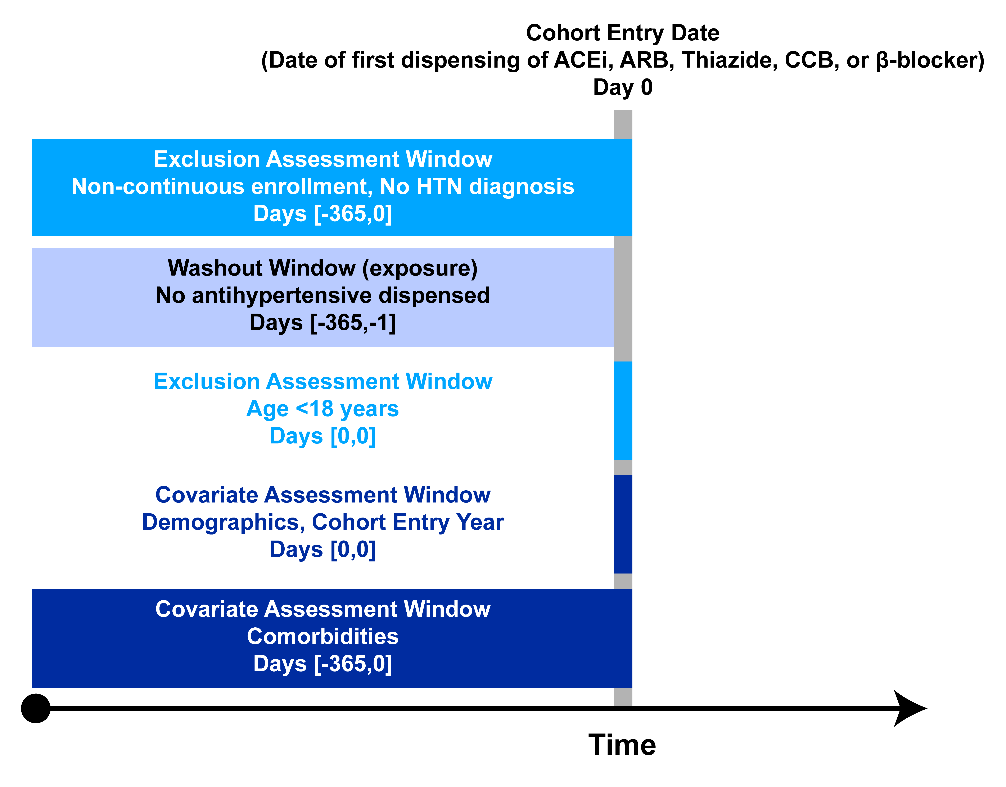
Figure S2. Flow diagram for cohort development. (an example is below)

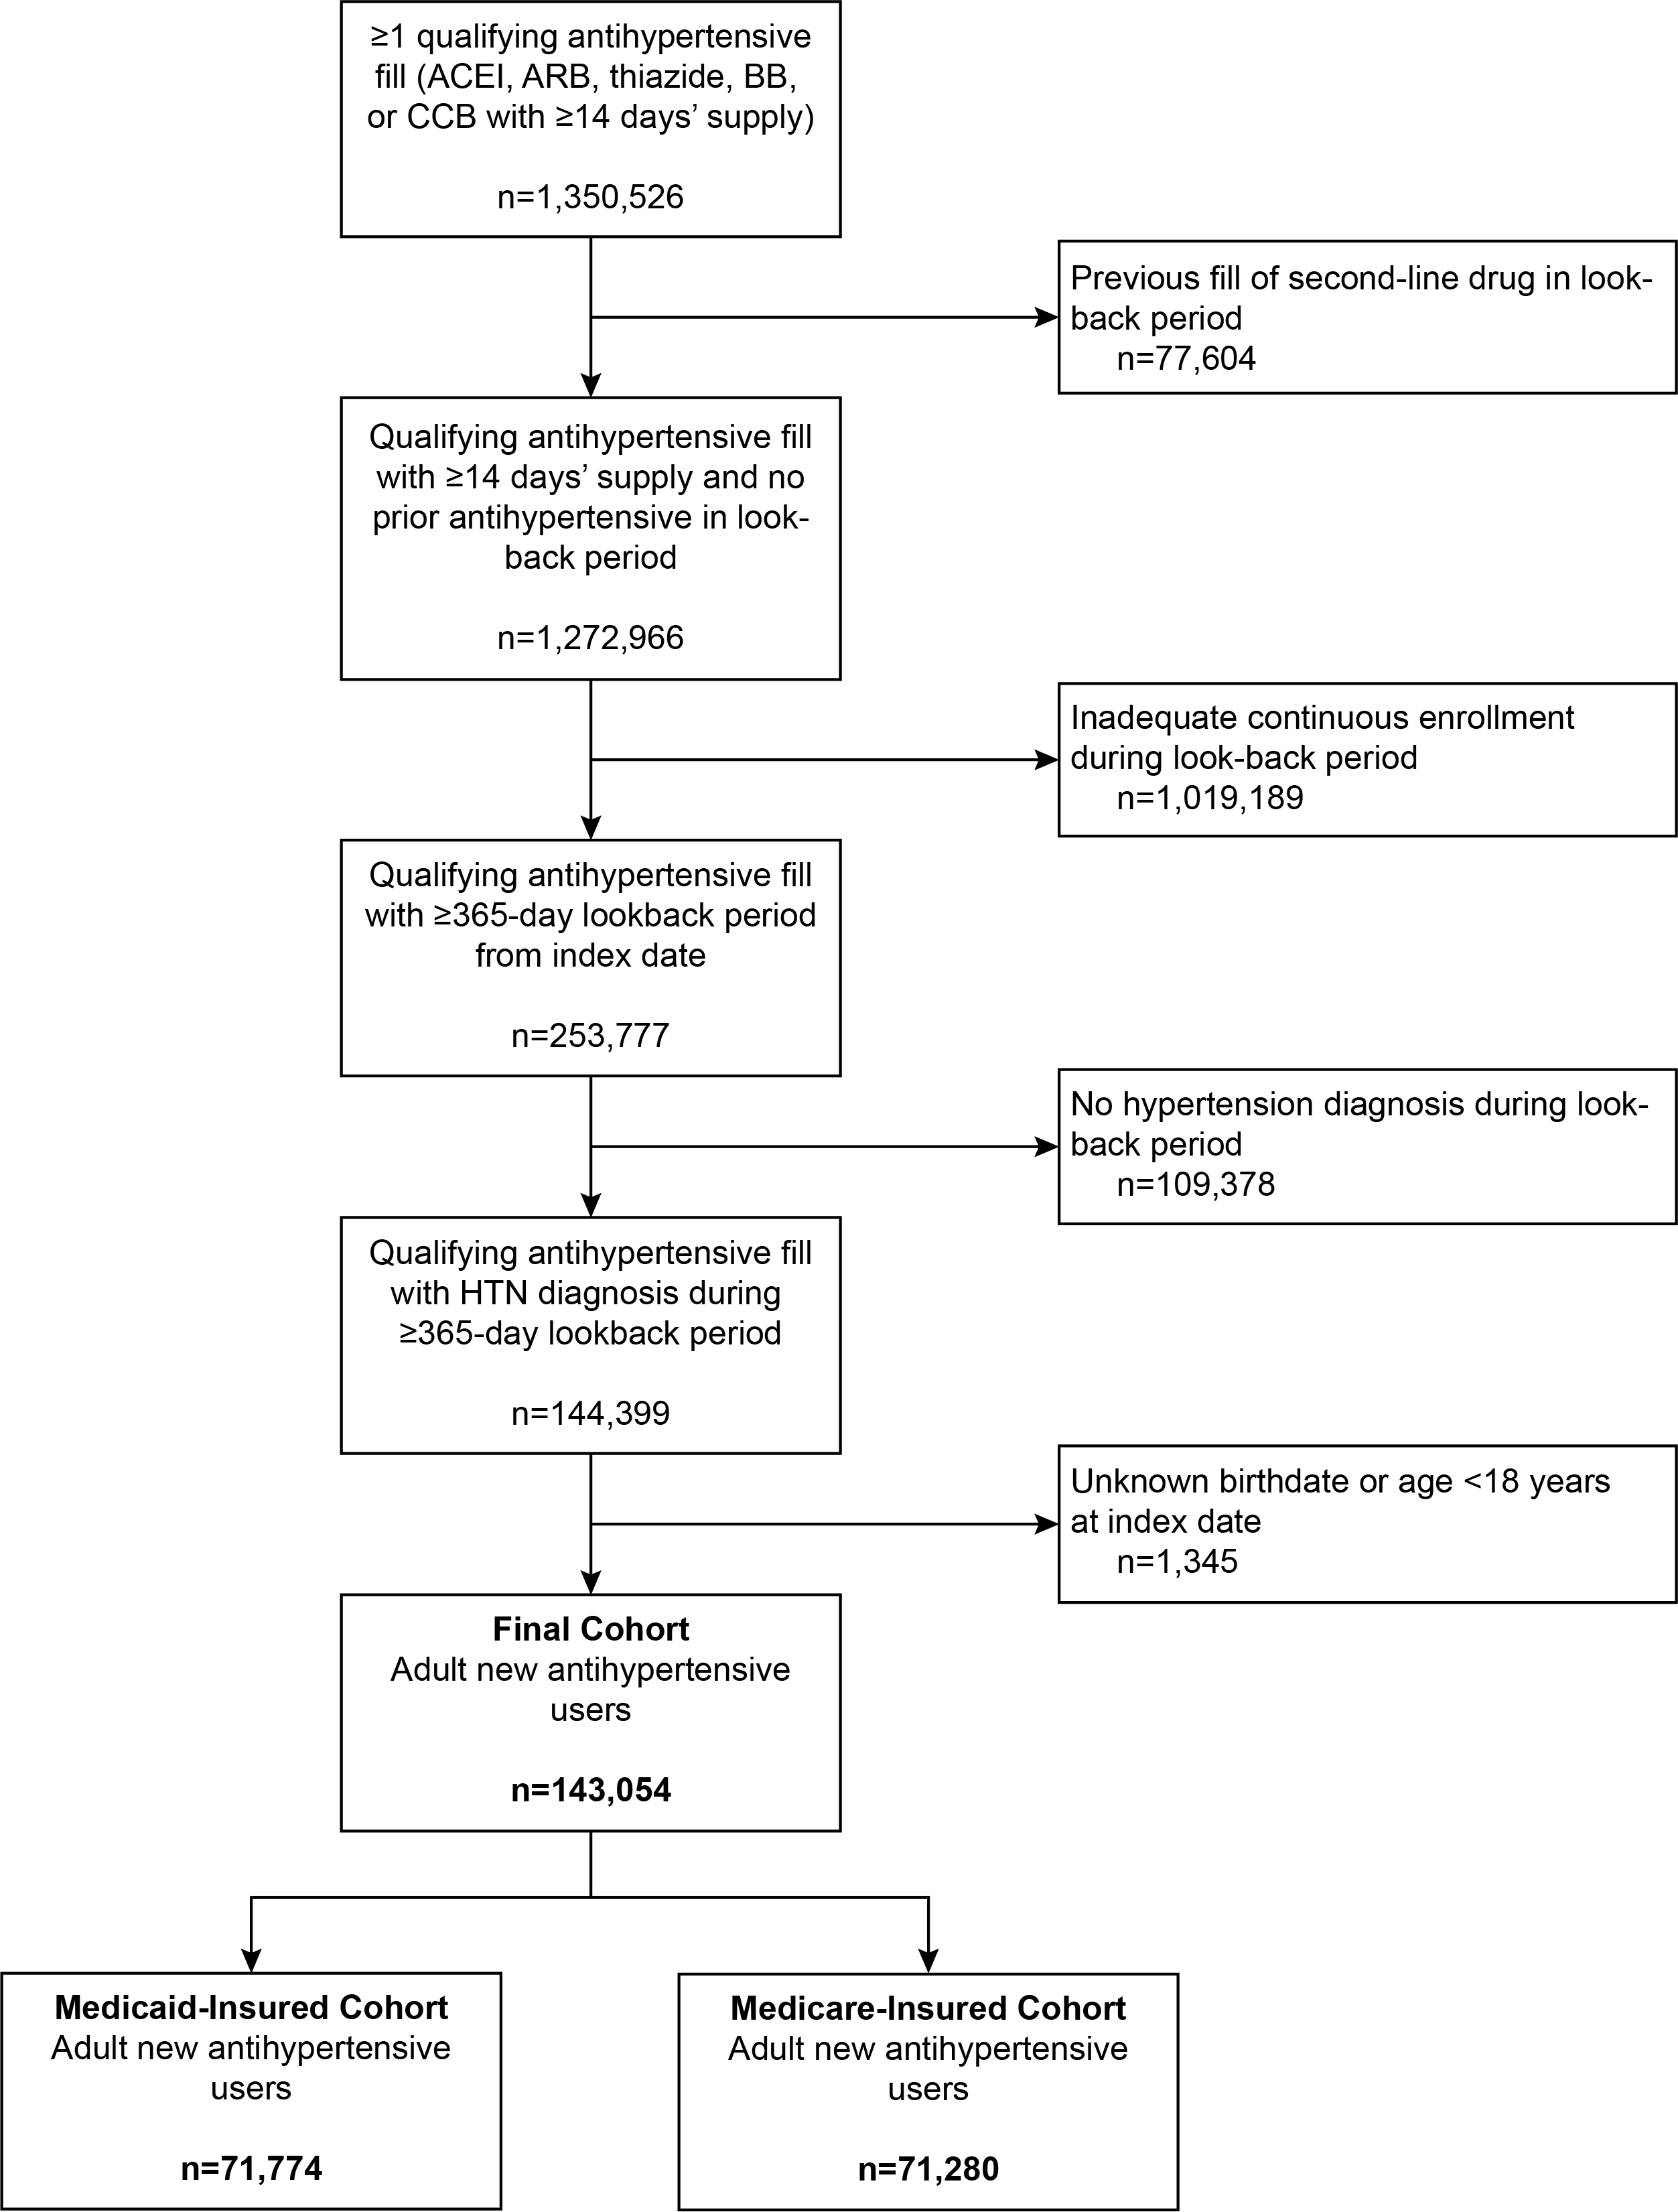

Figure S3. Title. Additional detail. ACRONYM1, meaning1; ACRONYM2, meaning 2; and so on.

<<Supplemental figure>>

