Curtis Koster & Daniel Recker

DECEMber 6, 2014

App Dev 2 (Free Late)

***Time Spent***: We each spent approximately 7hrs on this project

***Who Did What/Features***: See Git log below for who did what. For features we did everything for steps 1-4 of Option 1 along with #3 of Option 2 for the extra credit. We also added the drop down to get the optional +3 for entering song leader name via a dropbox. We also added a bonus feature which lets the user either “quickconnect” to either of our databases or they can enter info to connect to a database of their choice.

Our GitHub repository can be found at: <https://github.com/dreck410/AppDev2>

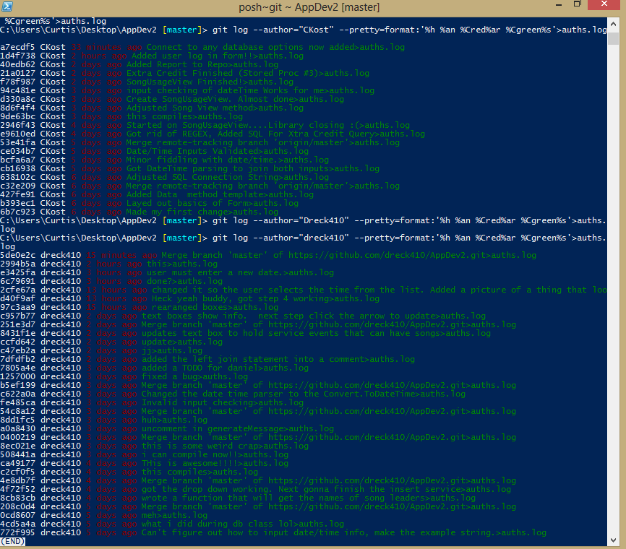

***Known Bugs:*** We aren’t aware of any bugs. That said, for the extra credit, we went with the +8 option for option #3 and left out the “Theme” field in the view.

***Instructions:***

***Please see the following hyperlink for a step-by-step picture guide on how to use this program.***

[*HowTo.mht*](HowTo.mht)

***Our SQL Statements***

