Fig.1

Longitudinal (mm)

Fig.2

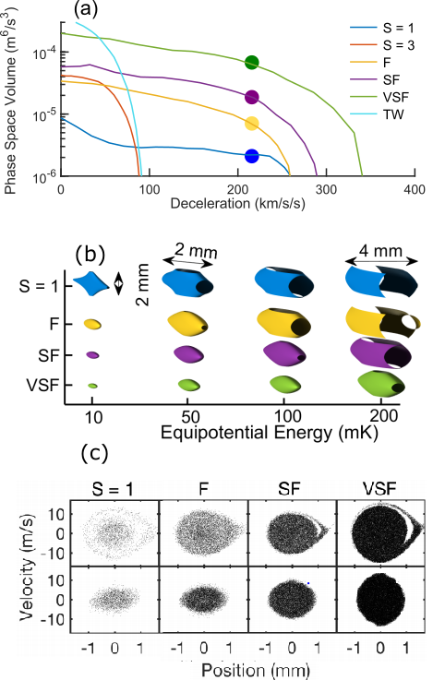

Caption: The dots in panel(a) corresponding to the conditions of the panel (b) and (c)

Fig.3

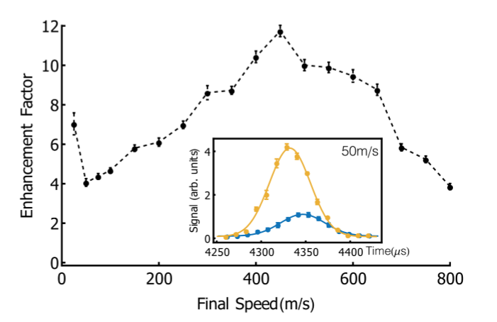

Fig. 4

Caption: 50m/s slowing