
ReactOS Build Environment
Version 2.3.0 for Windows NT based operating systems

Introduction
The ReactOS Build Environment (“RosBE”) is a complete environment for building ReactOS. It also optionally includes SVN to make it possible to load and update the Source Code. The current version is based on GCC 13.2.0/Mingw-w64.

Installation
While installing the ReactOS Build Environment you are asked to provide the directory where your ReactOS sources are located or should be checked out to later (defaults to USERPROFILE\reactos\). If you did not checkout a Source tree yet, start RosBE and type “ssvn create” (for this feature you need to have installed the Subversion Tools during installation).

Basic Usage
The ReactOS Build Environment prompt is shown here:

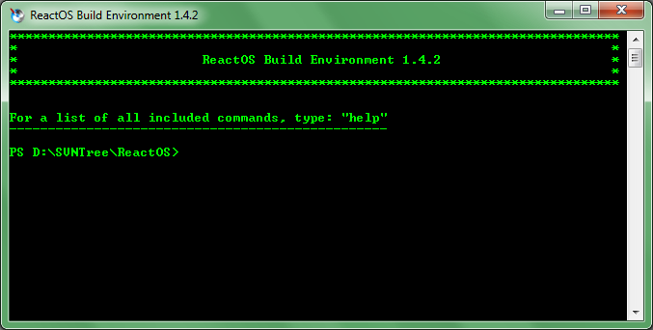
This prompt provides a complete environment for building ReactOS as well as many helpful commands. You can get a full list of available commands and their descriptions by typing 'help' at the prompt. For additional help for a specific Command, type 'help COMMAND'.

Version Information
The ReactOS Build Environment v2.3.0 contains the following packages:

- 7-Zip v25.01
- Binutils v2.42
- Bison v3.8.2-5
- ccache, Compiler Cache v4.12.2
- CMake v3.31.10
- DiffUtils v3.12-1
- Flex v2.6.4-4
- GCC, The GNU Compiler Collection v13.2.0
- GDB, The GNU Project Debugger v13.1
- GNU Make v4.4.1
- M4 v1.4.19-2
- Ninja v1.13.2
- Patch v2.7.6-3
- wget v1.21.4

Tested Operating Systems
The ReactOS Build Environment is designed to work on all Windows NT based operating systems, known working systems are as follows:
- Windows Vista SP2 (32 Bit / 64 Bit)
- Windows 7 SP1 (32 Bit / 64 Bit)
- Windows 8.1 (32 Bit / 64 Bit)
- Windows 10 (32 Bit / 64 Bit)

FAQ
- Q: I have many errors and problems like:
gcc.exe: CreateProcess: No such file or directory
'getdate.exe' is not recognized as an internal or external command
- A: Go to your System Settings and create a new System Variable called _ROSBE_COMPAT_MODE and with a value of “1”. This will fix it.

Websites
7-Zip
https://www.7-zip.org/
MinGW-w64
https://mingw-w64.sourceforge.net/
GNU Binutils
https://www.gnu.org/software/binutils/
GCC
https://www.gcc.org/
GDB
https://www.gnu.org/software/gdb/
GNU Make
https://www.gnu.org/software/make/
Ninja
https://github.com/ninja-build/ninja/releases/
CCache
https://ccache.dev/download.html
WGet
https://eternallybored.org/misc/wget/

Credits
Amine Khaldi (amine.khaldi@reactos.org) (active)
Colin Finck (colin@reactos.org) (active)
Pierre Schweitzer (heis_spiter@hotmail.com) (active)
Daniel Reimer (daniel.reimer@reactos.org) (semi active)
Peter Ward (dralnix@gmail.com) (inactive)

Thanks to ROSFan, who created the nice ReactOS Build Environment Logo.
Thanks also goes out to all those who provide so much help by testing the new versions. Without them RosBE would not be what it is today.
Credits to Gregor Anich who created the original ReactOS Build Environment.
This product includes software developed by the University of California, Berkeley and its contributors. (Flex)

