Chapter VI

Simulation Experiments

6.1. Description of the Knowledge Base
This chapter reports the results of several simulation experiments performed with Ambr. The long-term memory of the model is the same for all experiments, with variation of some links as described below.
The LTM consists of 569 permanent agents. 273 of them are concept-agents and encode semantic knowledge about the micro-domain introduced in section 4.1. For example, it is represented that tea, milk, and water are subclasses of drinkable-liquid, which in turn is subordinate to liquid. The system ‘knows’ that temperature-of is a physprop-relation and that its first argument must be an object while the second one a temperature-qualifier such as high-temp or low-temp. The semantic memory also contains 49 instance-agents. Most of them are general propositions such as heat-source-is-hot and bottle-made-of-glass.
The remaining agents in the long-term memory represented twelve simple situations. These situations are outlined below. Appendix A contains a full description of one of them as taken directly from the source file fed to the program. Appendix B contains simplified representations in predicate calculus of all situations.
Base situation WTP (Water in a Teapot on a Plate): There is some water in a teapot. The teapot is made of metal and its color is black. There is also a hot plate. The teapot is on the plate. The temperature of the plate is high.
The goal is that the temperature of the water is high.
The outcome is that the temperature of the teapot is high because it is on the hot plate. In turn, this causes the temperature of the water to be high, as it is in the teapot.
Base situation BF (Bowl on a Fire burns out): There is some water in a bowl. The bowl is made of wood. There is also a fire. The bowl is on the fire. The temperature of the fire is high.
The goal is that the temperature of the water is high.
The outcome is that the bowl burns out because it is made of wood and is on the fire. In turn, this causes the water to dissipate, as it is in the bowl.
Base situation GP (Glass on a hot Plate breaks): There is some water in a glass. The glass is made of [material] glass. There is also a hot plate. The glass is on the plate. The temperature of the plate is high.
The goal is that the temperature of the water is high.
The outcome is that the glass breaks because it is made of [material] glass and is on the hot plate. In turn, this causes the water to dissipate, as it is in the glass.
Base situation IHC (Immersion Heater in a Cup): There is some water in a cup. There is an immersion heater in the water. The immersion heater is hot. The cup is on a saucer. The cup is made of china.
The goal is that the temperature of the water is high.
The outcome is that the temperature of the water is high due to the hot immersion heater in it.
Base situation FDO (Food on a Dish in an Oven): There is a baking dish and some food on it. The shape of the dish is rectangular. There is also an oven. The dish is in the oven. The temperature of the oven is high.
The goal is that the temperature of the food is high.
Since the food is on the dish which in turn is in the oven, the food is in the oven too. This causes the temperature of the food to be high, as the temperature of the oven is high.
Base situation MTF (Milk in a Teapot in a Fridge): There is some milk in a teapot. The color of the teapot is green. There is also a fridge. The teapot is in the fridge. The temperature of the fridge is low.
The goal is that the temperature of the milk is low.
Since the milk is in the teapot which in turn is in the fridge, the milk is in the fridge too. This causes the temperature of the milk to be low, as the temperature of the fridge is low.
Base situation ICF (Ice Cube in a Fridge): There is an ice cube on a glass. The glass is made of [material] glass. There is also a fridge. The glass is in the fridge. The temperature of the fridge is low.
The goal is that the temperature of the ice cube is low.
Since the ice cube is on the glass which in turn is in the fridge, the ice cube is in the fridge too. This causes the temperature of the ice cube to be low, as the temperature of the fridge is low.
Base situation BPF (Butter on a Plate in a Fridge): There is some butter on a plate. The plate is made of china and its shape is circular. There is also a fridge. The plate is in the fridge. The temperature of the fridge is low.
The goal is that the temperature of the butter is low.
Since the butter is on the plate which in turn is in the fridge, the butter is in the fridge too. This causes the temperature of the butter to be low, as the temperature of the fridge is low.
Base situation STC (Sugar in Tea in a Cup): There is some tea in a cup. There is some sugar in the tea. The taste of the sugar is sweet. The cup is on a saucer.
The goal is that the taste of the tea is sweet.
The outcome is that the taste of the tea is sweet due to sugar in it.
Base situation SFF (Salt in Food in a Fridge): There is some food on a plate. There is some salt in the food. The taste of the salt is salty. There is also a fridge. The temperature of the fridge is low.
The goal is that the temperature of the food is low.
The outcome is that the food is both cold and salty. Since the food is on the plate and the plate is in the fridge, the food is in the fridge too. This causes the temperature of the food to be low. In the same time, the salt that is in the food causes its taste to be salty.
Base situation ERW (Egg in Red Water): There is some water in a teapot. The color of the water is red. The teapot is made of metal. There is also an egg which is in the water.
The goal is that the color of the egg is red.
The outcome is that the color of the egg is red because it is in the red water.
Base situation GWB (Glass in a Wooden Box): There is a glass. It is made of [material] glass. The glass is in a box. The box is made of wood.
The goal is that the box protects the glass.
The outcome is that the box protects the glass.
The verbosity of these (simplified) descriptions reveal how much knowledge is involved even in the seemingly trivial task of heating water. As simple and monotonous as they are, the twelve situations are designed to highlight various subprocesses of analogy-making. The descriptions involve objects and relations in different combinations and at various levels of similarity. Many episodes involve identical objects but are not isomorphic. Others go the other way around. Some episodes fail to achieve their goal and/or have side effects besides the main goal.

6.2. Statistics Over 1000 Runs

6.2.1. Experimental Setting
This section tests the behavior of the model on ten target problems. The goal is to check whether the model can reliably access episodes from long-term memory and map them to the target.
Each target problem is run 100 times, yielding a total of 1000 runs for the ten problems. All parameters of the model are kept constant across all runs (and across all experiments reported in this Thesis in general).
The architecture Dual is completely deterministic. The behavior of a Dual-based model such as Ambr depends on five factors (i) the target problem, (ii) the contents of the long-term memory, (iii) the order of presentation of target elements (order effect), (iv) the residual activation in the long-term memory (priming effect), and (v) the external environment (context effect). The experiments reported in this section vary the first factor as independent variable and use the second one as source of replications. The remaining factors are kept constant. (They are explored in separate experiments. Kokinov (1994a) has demonstrated priming and context effects in an earlier version of Ambr. Order effects are explored in section 6.4. below.)
The knowledge base is replicated 100 times for the purpose of the experiments. Each variant contains the same 569 permanent agents outlined in section 6.1. Most of the links among them are the same too. There are, however, some links that vary randomly across the 100 variants. They are ‘top-down’ links from concepts to instances (i.e. links labeled instance). The sampling procedure for picking up links for each KB variant is designed to approximate the (unimplemented) mechanism for dynamic ‘privileged instances’ suggested in section 4.3. A small number of associative links (a-link) also differ randomly across KB variants. Thus it could be said that each variant represents a ‘snapshot’ of the long-term memory of the system. The core KB contains approximately 3000 links. Each variant adds about 100 new links (which amounts to less than 4% of the total network connectivity).
Each target problem is run on each KB variant for 200 time units. This period is enough for the model to promote a winner situation in all but one of the 1000 runs. (In this exceptional run the model failed to access any episode from LTM to a sufficient degree.) The dependent variable is the number of times that each source situation is accessed and mapped to the particular target problem.
The activation level of all permanent agents is set to zero at the beginning of each run (i.e. there is no priming). Each target situation is represented by temporary agents. Some of them are attached to the goal and input nodes of the system. All attachments are done simultaneously at the beginning. The input node does not activate any agents apart from the target elements (i.e. the external context is ignored).

6.2.2. Heating Milk
The first pair of problems that are presented to the system involve heating milk (in the micro-domain). There are complementary to each other in the sense that the first has an explicit representation of the goal but the initial conditions are incomplete. In contrast, the second problem specify the initial arrangement in full and asks about the expected outcome of this arrangement. Appendix B contains simplified representations in predicate calculus of all target situations.
Target situation HM1 (Heating Milk, variant 1): There is a teapot and some milk in it. The teapot is made of metal.
The goal is that the temperature of the milk is high.
Target situation HM2 (Heating Milk, variant 2): There is a teapot and some milk in it. The teapot is made of metal. There is also a hot plate. The teapot is on the plate. The temperature of the plate is high.
The goal, if any, is not represented explicitly.
What is the outcome of this state of affairs?

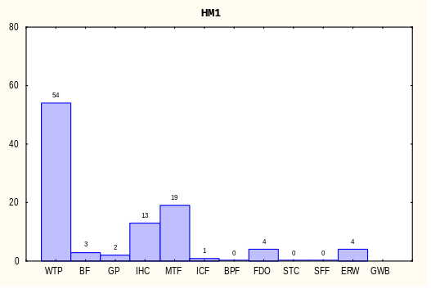
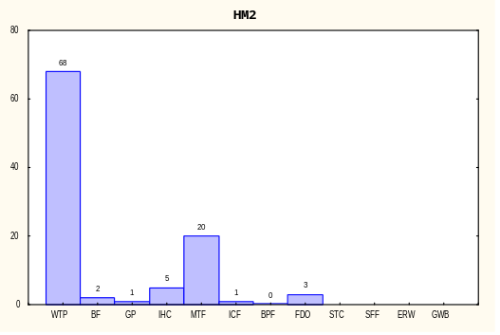

Figure 6.2.2 Bar plots showing the frequencies of mapping each long-term memory episode to target problems HM1 and HM2, respectively.
The bar plots in Figure 6.2.2 demonstrate that in the majority of cases (54% of the runs) the model maps the target HM1 to the prototypical source episode about heating liquids — situation WTP. In these cases Ambr notices the analogy in which milk-HM1 maps to water-WTP.
Two other sources stand out against the rest. Situation MTF is another good match. Its liquid is the same, but it requires the reversal high-temperature<-->low-temperature. The fact that it is three times less frequent than WTP demonstrates that Ambr is sensitive to pragmatic pressures. The same pressures explain the frequency of situation IHC too — it represents an alternative way to heat liquids (by an immersion heater).
The second variant of the target problem (HM2) generates a similar pattern. The main difference is that situation WTP becomes even stronger (68%) at the expense of IHC. After all, the target problem contains a hot plate, not an immersion heater.
The bar plots reveal also that the model is not confined to the most obvious solutions to a problem. It reaches them most of the time (as it should) but occasionally it chooses more remote analogs. These are the cases with frequencies below 5% in the graphs. Most of them are episodes having some superficial similarity to the target: a teapot, goal related to high temperature, etc. These low-frequency answers are an important attestation of Ambr’s flexibility.

6.2.3. Cooling Milk
The second pair of problems is similar to the first except that it deals with low temperatures. It tests whether Ambr is able to respond to a small (yet crucial) change in the target description.
Target situation CM1 (Cooling Milk, variant 1): There is a teapot and some milk in it. The teapot is made of metal.
The goal is that the temperature of the milk is low.
Target situation CM2 (Cooling Milk, variant 2): There is a teapot and some milk in it. The color of the teapot is black. There is also a fridge. The teapot is in the fridge. The temperature of the fridge is low.
What is the probable goal for this arrangement?
The outcome of this state of affairs is not known.

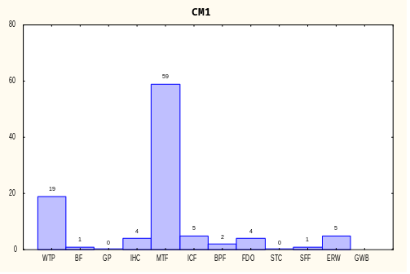
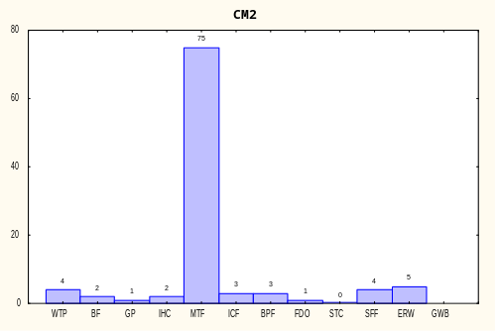

Figure 6.2.3 Bar plots showing the frequencies of mapping each long-term memory episode to target problems CM1 and CM2, respectively.
A brief comparison between the left plots in Figures 6.2.2 and 6.2.3 reveals that change in the filler of a single slot in a single target agent can turn the behavior of Ambr to 180 degrees. Specifically, the inst-of slot of low-T-CM1 (the second argument of temperature-of-CM1) is filled with a reference to the concept agent low-temperature while the respective slot in high-T-HM1 points to high-temperature. (The names of the agents themselves are of course irrelevant.) This change is small but it is in a very important place — the respective agent is attached the goal node and the activation it provides to its parent concept is a major determinant of the overall content of the working memory. As a consequence, CM1 maps to MTF in 59% of the runs versus 19% for WTP. In contrast, the respective percentages for the target problem HM1 are 54% vs. 19%. (Recall that the experiment uses within subject design as the two targets run over the same set of knowledge bases.) Clearly, the pragmatic constraint plays an important role in Ambr.
Let us now turn to the other problem in the pair: CM2. It is literally similar to the base situation MTF (Gentner, 1983, 1989). The only difference in the two descriptions, apart from the incompleteness of the target, is the color of the teapots. As seen in Figure 6.2.3, MTF wins in full 75% of the cases. This is the maximal frequency among all 1000 runs. All rival episodes occur with marginally low probabilities. This suggests that Ambr models accurately the empirical finding that analog access is dominated by literal similarities (Gentner & Landers, 1985; Holyoak & Koh, 1987; Ross, 1987).

6.2.4. When the Container is Fragile
The next pair is inspired by the target problem from experimental studies on priming effects (Kokinov, 1990, 1994a). The subjects in these studies were asked how one could heat water in a wooden bowl in a forest. Kokinov (1994a) performed related simulation experiments in the micro-domain.
Target situation WB1 (Water in a Bowl): There is a bowl and some milk in it. The bowl is made of wood.
The goal is that the temperature of the water is high.
Target situation WG1 (Water in a Glass): There is a glass and some water in it. The glass is made of [material] glass.
The goal is that the temperature of the water is high.
As evident from Figure 6.2.4, the model is split between two responses to the first problem. WTP is the prototypical case for heating liquids. It could not generate a good solution to the problem, however, as it suggests to put the bowl on the fire where it would burn. Still, it provides a sound match to the target. The other strong episode is BF which is an unsuccessful past attempt to solve this problem.
Note that the source analog that provides the ‘immersion heater’ solution (IHC) works in only 6% of the cases. Incidentally, the subjects of (Kokinov, 1990) had similar difficulties in the absence of priming.

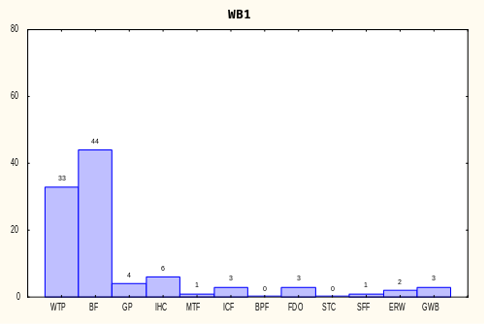
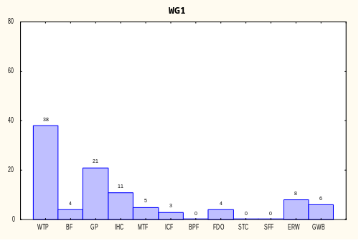

Figure 6.2.4 Bar plots showing the frequencies of mapping each long-term memory episode to target problems WB1 and WG1, respectively.
In an attempt to increase the probability of using the immersion heater, target problem WG1 replaces the wooden bowl with a glass. (Situation IHC involves a cup.) The attempt is moderately successful — the frequency of IHC increases to 11%. As a side effect, situation GP takes the place of BF. A look at the descriptions of these two episodes (see section 6.1) shows that this is to be expected.

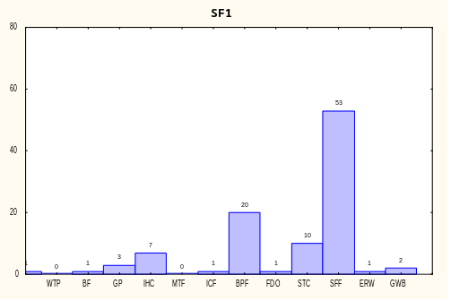
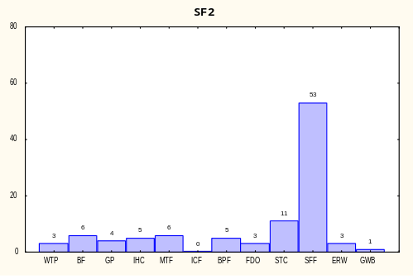

Figure 6.2.5 Bar plots showing the frequencies of mapping each long-term memory episode to target problems SF1 and SF2, respectively.

6.2.5. Scaling Up: Problems Involving Taste
The problems in this subsection go away from the temperature-related focus of the current knowledge base. They deal with tastes and are intended to check whether the model is able to switch to this different thematic line. The base episodes are added to the long-term memory for similar reason.
Target situation SF1 (Salty Food, variant 1): There is a plate and some food on it. The plate is made of china.
The goal is that the taste of the food is salty.
Target situation SF2 (Salty Food, variant 2): There is a plate and some food on it. There is some salt in the food.
The goal, if any, is not represented explicitly.
What is the outcome of this state of affairs?
The bar plots in Figure 6.2.5. show that indeed the two episodes related to taste are accessed by these targets. Note also that situations STC, SFF, and BPF almost never show up for other target problems. This gives reasons for some optimism about the ability of Ambr to scale up to larger memory sizes. It suggests that adding more and more episodes and different ‘thematic lines’ will not lead to diffusion of the answers. Of course, this topic should be explored more rigorously with future (and bigger) versions of the knowledge base. We fully agree that memory of 12 episodes is very insufficient to support any serious claims about the scalability of the model.

6.2.6. Two Final Problems
Target situation EHW (Egg in Hot Water): There is a teapot and some water in it. There is an egg in the water. The teapot is made of metal. The color of the egg is white. The temperature of the water is high.
The goal, if any, is not represented explicitly.
What is the outcome of this state of affairs?
Target situation ICC (Ice Cube in Coke): There is a glass and some coke in it. The glass is made of [material] glass. There is an ice cube in the coke. The temperature of the ice cube is low. There is also a table. The glass is on the table.
The goal, if any, is not represented explicitly.
What is the outcome of this state of affairs?

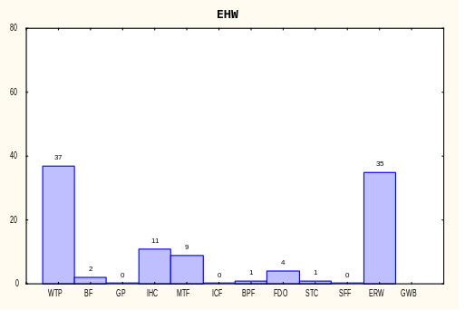
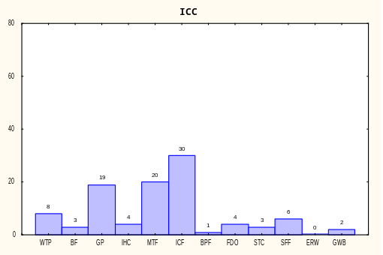

Figure 6.2.6 Bar plots showing the frequencies of mapping each long-term memory episode to target problems EHW and ICC, respectively.

The target problem EHW and its long-term memory counterpart ERW are added for similar scaling-up considerations. Problem ICC is used for the experiment discussed in section 6.3. The respective bar plots are shown in Figure 6.2.6.

6.2.7. Variability and Determinism
A few final remarks are in order before closing this section. Table 6.2.7. presents the joint distribution produced by all 1000 runs. The few empty cells in the table (the first column notwithstanding) indicate that the model populates all regions of its ‘problem space’. That is, there is some small probability to map any source analog to almost any target. No possibilities are ruled out a priory. On the other hand, Ambr focuses on the episodes that best fit any given problem. It is efficient without being rigid. This is a consequence of the dynamic emergent style of computation that is characteristic of Dual (Kokinov, Nikolov, & Petrov, 1996).
Note also that although Ambr is completely deterministic, it is still able to demonstrate the variability of behavior evident from the table. As described in subsection 6.2.1., the random factor in the experiment amounts to less than 4% of the initial links in the long-term memory. Nevertheless, each target problem generates a whole range of answers. This is again a consequence of the dynamic emergent style of computation. The macroscopic behavior of the system depends on a multitude of interrelated microscopic factors. A small change in the initial conditions can drift the global outcome far away in the problem space. Therefore, the macroscopic behavior of Ambr must be analyzed in probabilistic terms even though all microscopic mechanisms are deterministic.
 |  |  | ?? |  | WTP | BF |  | GP |  | I  HC |  |  | MTF | I  CF |  | BPF |  | FDO |  | STC |  |  | SFF | ERW |  | GWB |  |  | To-tal
 | HM1 |  |  |  | 54 | 3 |  | 2 |  | 13 |  |  | 19 | 1 |  |  |  | 4 |  |  |  |  |  | 4 |  |  |  |  | 100
 | HM2 |  |  |  | 68 | 2 |  | 1 |  | 5 |  |  | 20 | 1 |  |  |  | 3 |  |  |  |  |  |  |  |  |  |  | 100
 | CM1 |  |  |  | 19 | 1 |  |  |  | 4 |  |  | 59 | 5 |  | 2 |  | 4 |  |  |  |  | 1 | 5 |  |  |  |  | 100
 | CM2 |  |  |  | 4 | 2 |  | 1 |  | 2 |  |  | 75 | 3 |  | 3 |  | 1 |  |  |  |  | 4 | 5 |  |  |  |  | 100
 | WB1 |  |  |  | 33 | 44 |  | 4 |  | 6 |  |  | 1 | 3 |  |  |  | 3 |  |  |  |  | 1 | 2 |  | 3 |  |  | 100
 | WG1 |  |  |  | 38 | 4 |  | 21 |  | 11 |  |  | 5 | 3 |  |  |  | 4 |  |  |  |  |  | 8 |  | 6 |  |  | 100
 | SF1 |  | 1 |  |  | 1 |  | 3 |  | 7 |  |  |  | 1 |  | 20 |  | 1 |  | 10 |  |  | 53 | 1 |  | 2 |  |  | 100
 | SF2 |  |  |  | 3 | 6 |  | 4 |  | 5 |  |  | 6 |  |  | 5 |  | 3 |  | 11 |  |  | 53 | 3 |  | 1 |  |  | 100
 | EHW |  |  |  | 37 | 2 |  |  |  | 11 |  |  | 9 |  |  | 1 |  | 4 |  | 1 |  |  |  | 35 |  |  |  |  | 100
 | ICC |  |  |  | 8 | 3 |  | 19 |  | 4 |  |  | 20 | 30 |  | 1 |  | 4 |  | 3 |  |  | 6 |  |  | 2 |  |  | 100
Total |  | 1 |  | 264 |  |  | 68 |  | 55 |  | 68 | 214 |  |  | 47 |  | 32 |  | 31 |  | 25 | 118 |  |  | 63 |  | 14 | 1000
Table 6.2.7. Joint distribution for all 1000 runs. Each cell gives the frequency of accessing and mapping a target problem (row) to a source episode (column).

6.3. Influence of Mapping on Analog Access

6.3.1. Simulation Experiment Method
This section presents a case study exploring the integration of analog access and mapping in Ambr. It contrasts two strategies for combining access and mapping — parallel vs. serial.

6.3.1.1 Design
The experiment consists of two conditions. Both conditions involved running the model on a target problem. In the ‘parallel condition’, Ambr operates in its normal manner with the mechanisms for access and mapping working in parallel. In the ‘serial condition’, the program is artificially forced to work serially — first to access and only then to map. The target problem and the content of the long-term memory are identical in all runs. The topics of interest fall into two categories — the final mapping constructed by the program and the dynamics of the underlying computation. The latter is monitored by recording a set of variables describing the internal state of the system at regular time intervals throughout each run.

6.3.1.2. Materials
The experiment uses the knowledge base described in section 6.1. Situation ICC (Ice Cube in Coke) is the target problem. Its verbal description is given in subsection 6.2.6. Two of the twelve episodes are most important for the present discussion: situations IHC (Immersion Heater in a Cup with water) and ICF (Ice Cube in a Fridge).
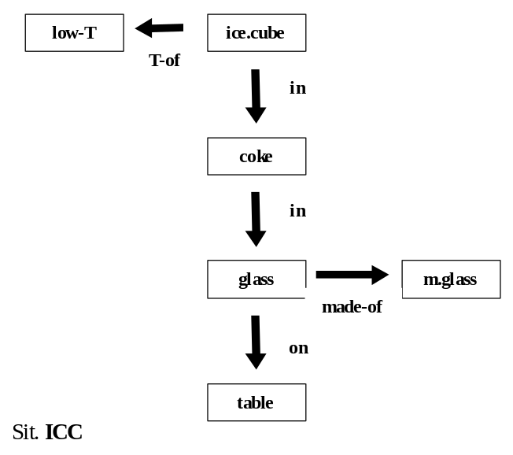
Figure 6.3.1.1. Schematized representation of target situation ICC. Objects are shown as boxes and relations as arrows. The actual Ambr representation is more complex and consists of 15 agents.

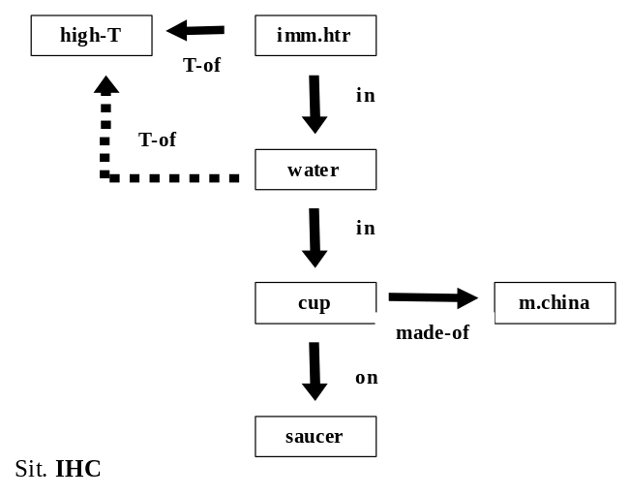
Figure 6.3.1.2. Schematized representation of situation IHC. Dashed arrows stand for relations in the ‘outcome’. The actual Ambr representation is more complex — it consists of 19 agents and explicates the causal structure (not shown in the figure).
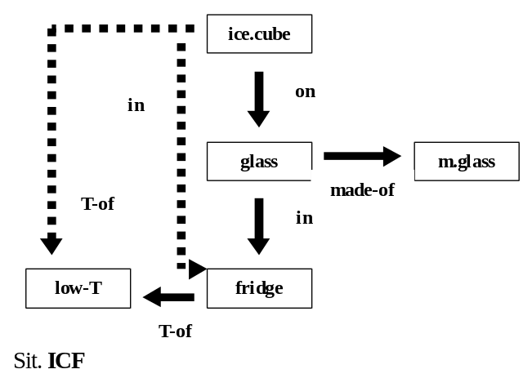
Figure 6.3.1.3. Schematized representation of situation ICF. The actual Ambr representation is more complex — it consists of 21 agents and explicates the causal structure (not shown in the figure).
As evident from Figures 6.3.1.1, 2, and 3, both situations IHC and ICF may be considered similar to the target problem. There are some differences, however. Situation ICF involves the same objects and relations as the target but the structure of the two are different. In contrast, situation IHC involves different objects but its system of relations is completely isomorphic to that of the target. According to Gentner (1989), the pair IHC–ICC may be classified as analogy while ICF-ICC as mere appearance. Thus it is expected that situation ICF would be easier to retrieve from the total pool of episodes stored in LTM. On the other hand, IHC would be more problematic to retrieve but once accessed it would support better mapping.

6.3.1.3. Procedure
The model is run two times on the target problem. The two runs carry out the ‘parallel’ and the ‘serial’ conditions of the experiment, respectively. The contents of the long-term memory and the parameters of the model are identical in the two conditions.
Recall that situations have decentralized representations in Ambr. The target problem is represented by a coalition of 15 agents standing for the ice-cube, the glass, two instances of the relation in and so on (See Appendix B). 12 of these agents are attached to the special nodes that serve as activation sources in the model. The attachment is the same in the two experimental conditions.
In the parallel condition, the model is allowed to run according to its specification. That is, all Ambr mechanisms run in parallel, interacting with each other. The program iterates until the system reaches a resting state. A number of variables are recorded at regular intervals throughout the run. Out of these many variables, the retrieval index is of special interest. It is computed as the average activation level of the agents involved in each situation.
In short, the data accumulated at the end of the run are the final mapping constructed by the program and a log file of the retrieval indices of all twelve situations from the LTM.
In the serial condition, the target problem is attached to the activation source in the same way and the same data were collected. However, the operation of the program is forcefully modified to separate the processes of access and mapping. To that end, the run is divided in two steps.
During step one, all mapping mechanisms in Ambr are manually switched off. Thus, spreading activation is the only mechanism that remains operational. It is allowed to work until the pattern of activation reaches asymptote. The situation with the highest retrieval index is then identified. If we hypothesize a ‘retrieval module’, this is the situation that it would access from LTM.
After the source analog is picked up in this way, the experiment proceeds with step two. The mapping mechanism is switched back on again but it is allowed to work only on the source situation retrieved at step one. This situation is mapped to the target. Thus, the data at the end of the second run are the final mapping constructed at step two and two logs of the retrieval indices.

6.3.2. Results and Discussion
In both experimental conditions the model settles in less than 150 time units and produces consistent mappings. By ‘consistent’ we mean that each element of the target problem is unambiguously mapped to an element from LTM and that all these corresponding elements belong to one and the same base situation. Stated differently, the mappings are one-to-one and there are no blends between situations.
In the parallel condition, the target problem maps to situation IHC, yielding the correspondences in–in, water–coke, imm.heater–ice.cube, T.of–T.of, high.T–low.T, made.of–made.of, etc. Four elements from the source situation remain unmapped and in particular the agent representing that the water is hot. This proposition is a good candidate for inference by analogy. Mutatis mutandis, it could bring the conclusion that the coke is cold.
In the serial condition, situation ICF wins the retrieval stage. This is explained by the high semantic similarity between its elements and those of the target — both deal with ice cubes in glasses, cold temperatures, etc. The asymptotic level of the retrieval index for ICF is about four times greater than that of any other situation. In particular, situation IHC ends up with only 5 out of 19 agents passing the working memory threshold.
According to the experimental procedure, situation ICF is then mapped to the target during the second stage of the run. The correspondences that emerge during the latter stage are shown in Table 6.3.2. The semantic similarity constraint dominates this run. This is not surprising given the high degree of superficial similarity between the two situations. There is, however, a serious flaw in the set of correspondences. The proposition T-of(ice-cube-ICC, low-T-ICC), which belongs to the initial state of the target, is mapped to the proposition T-of(ice-cube-ICF, low-T-ICF), which is a consequence in the source. Therefore, the whole analogy between the target problem and situation ICF could hardly generate any useful inference.
Base situation ICF | Target situation ICC
ice-cube | ice-cube
fridge | coke
glass | glass
in (ice-cube, fridge) | in (ice-cube, coke)
in (glass, fridge) | in (coke, glass)
on (ice-cube, glass) | on (glass, saucer)
T-of (fridge, low-T) | <unmapped>
T-of (ice-cube, low-T) | T-of (ice.cube, low-T)
low-T | low-T
made-of (glass, m.glass) | made-of (glass, m.glass)
m.glass | m.glass
initstate1 | initstate
initstate2 | <unmapped>
interstate | table
endstate | endstate
goalstate | <unmapped>
follows (initstate1, endst) | follows (initstate, endst)
to-reach (initstate1, goalst) | <unmapped>
cause(initstate2,in(ic,fr)) | <unmapped>
cause(interstate,T-of(ic,lT)) | <unmapped>
Table 6.3.2. Correspondences constructed by the model in the serial condition.
To summarize, when the mechanisms for access and mapping work together, the model constructs an analogy that can potentially solve the problem. On the other hand, when the two mechanisms are separated, the retrieval stage favors a superficially similar but inappropriate base.
The presentation so far concentrated on the final set of correspondences produced by the model. We now turn to the dynamics of the computation as revealed by the retrieval indices. Figure 6.3.2.1 plots the retrieval indices for the two critical LTM episodes during the first run of the program (i.e. when access and mapping work in parallel). Figure 6.3.2.2 concentrates on the early stage of the first run and compares it with the second run (i.e. when only the access mechanism is allowed to work). Note that the two plots are in different scales.
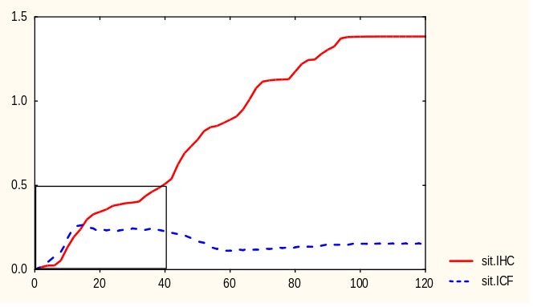
Figure 6.3.2.1. Plot of retrieval indices versus time for the parallel condition. The 'south-west' corner of the plot is reproduced in Figure 6.3.2.2. with threefold magnification.
These plots tell the following story: At the beginning of the parallel run, several situations are probed tentatively by bringing a few elements from each into the working memory. Of this lot, ICF (with the ice cube) looks more promising than any of its rivals as it has so many objects and relations in common with the target. Therefore, about half of the agents belonging to situation ICF enter the working memory and begin trying to establish correspondences between themselves and the target agents. The active members of the rival situations are doing the same thing, although with lower intensity — their symbolic processor are slower.
At about 15 time units since the beginning of the simulation, however, situation IHC (with the immersion heater) rapidly gains strength and eventually overtakes the original leader. At time 40, it takes the lead and gradually transforms its small advantage into an uncompromising triumph.
The final victory of situation IHC, despite its lower semantic similarity compared to situation ICF, is due to the interaction between the mechanisms of access and mapping in Ambr. More precisely, in this particular case it is the mapping that radically changes the course of access. To illustrate the importance of this influence, Figure 6.3.2.2 contrasts the retrieval indices with and without mapping.
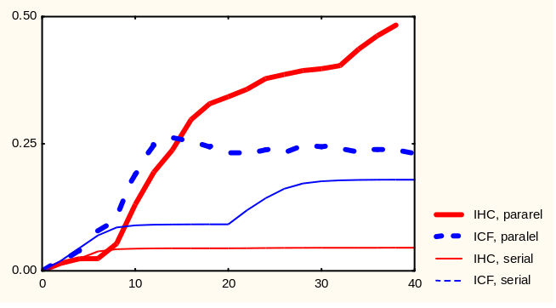
Figure 6.3.2.2. Retrieval indices for situations IHC and ICF with and without mapping influence on access. The thick lines correspond to the parallel condition and replicate (with threefold magnification) the lines from the 'south-west' corner of Figure 6.3.2.1. The thin lines show ‘pure’ retrieval indices.
The thin lines in the figure show the retrieval indices for the two situations when mapping mechanisms are suppressed. Thus, they indicate the ‘pure’ retrieval index of each situation — the value that is due to the access mechanism alone. The index for situation ICF is much higher than that of IHC and, therefore, ICF is used as source when the mapping is allowed to run only after the access has finished.
The step-like increases of the plots indicate moments in which an agent (or usually a tight sub-coalition of two or three agents) passes the working memory threshold (cf. Transcript 5.8.1). This happens, for instance, with situation ICF between time 20 and 30 of the serial condition (the thin dashed line in Figure 6.3.2.2). Thus, accessing a source episode in Ambr is not an all-or-nothing affair. Instead, situations enter the working memory agent by agent and this process extends far after the beginning of the mapping. In this way, not only can the access influence the mapping but also the other way around.
In the interactive condition the mapping mechanism boosts the retrieval index via what we call a bootstrap cascade. This cascade operates in Ambr in the following way. First, the access mechanism brings two or three agents of a given situation into the working memory. If the mapping mechanism then detects that these few agents can be plausibly mapped to some target elements, it constructs new correspondence nodes and links in the Ambr network. This creates new paths for the highly active target elements to activate their mates. The latter in turn can then activate their ‘coalition partners’, thus bringing a few more agents into the working memory and so on.
The bootstrap cascade is possible in Ambr due to two important characteristics of this model. First, situations have decentralized representations which may be accessed piece by piece. Second, Ambr is based on a parallel cognitive architecture which provides for concurrent operation of numerous interacting processes. Taken together, these two factors enable seamless integration of the subprocesses of access and mapping in analogy-making.

6.4. Order Effect on Analog Access

6.4.1. Simulation Experiment Method
This section presents an experiment testing the prediction made in subsection 5.2.4. — the order of presentation of target elements affects the frequency of accessing episodes from memory. More concretely, source analogs containing elements which are semantically similar to a given target element are accessed more frequently when this target element is attached earlier to the input node.

6.4.1.1 Design
The experiment consists of three conditions. The same target problem is presented to the system in all three conditions. In the control condition all target elements are attached simultaneously to the input and goal nodes. In the two experimental conditions the elements are attached in two different (and roughly reverse) orders. The dependent variables are frequencies of accessing and mapping the episodes in the long-term memory.

6.4.1.2. Materials
Target situation EHW presented in section 6.2.6. is used as a target problem. Its verbal description is reproduced below. The 100 variants of the knowledge base described in section 6.2.1. are used as replications.
Target situation EHW (Egg in Hot Water): There is a teapot and some water in it. There is an egg in the water. The teapot is made of metal. The color of the egg is white. The temperature of the water is high.
The goal, if any, is not represented explicitly.
What is the outcome of this state of affairs?
Note the following details of this description. On one hand, there is some water whose temperature is high. These elements are similar to the source analogs related to heating water and in particular to situations WTP (Water in a Teapot on a Plate) and IHC (Immersion Heater in a Cup). On the other hand, there is an egg whose color is white. These elements are similar to situation ERW (Egg in Red Water) described in section 6.1.

6.4.1.3. Procedure
The target problem is run three times on the set of 100 knowledge bases, yielding a total of 300 runs. In the control condition, all target elements are attached to the input node at the beginning of the run. The number of times that each of the twelve episodes in the long-term memory are accessed and mapped is recorded.
In the hot water condition the agents water-EHW, T-of-EHW, and high-T-EHW are attached to the input node at time zero. The remaining target elements are attached later according to the schedule shown in the left column of Table 6.4.1.3.
In the colored egg condition the agents egg-EHW, color-of-EHW, and white-EHW are attached to the input node at time zero. The remaining target elements are attached later according to the schedule shown in the right column of Table 6.4.1.3.
time | ‘hot-water’ condition | ‘colored-egg’ condition
0 | water  high-T  T-of(water,high-T) | egg  white  color-of(egg,white)
5 | teapot | teapot
10 | metal  made-of(teapot,metal) | metal  made-of(teapot,metal)
15 | in(water,teapot) | water
20 | egg | in(egg,water)
25 | in(egg,water) | in(water,teapot)
30 | white  color-of(egg,white) | high-T  T-of(water,high-T)
35 | endst  follows(initst,endst) | endst  follows(initst,endst)
Table 6.4.1.3. Time schedule for attaching different target elements in the two experimental conditions.

6.4.2. Results and Discussion
Figure 6.4.2.1. shows bar plots of the frequencies obtained in the two experimental conditions. The bar plot for the control condition is shown in Figure 6.2.6. is section 6.2

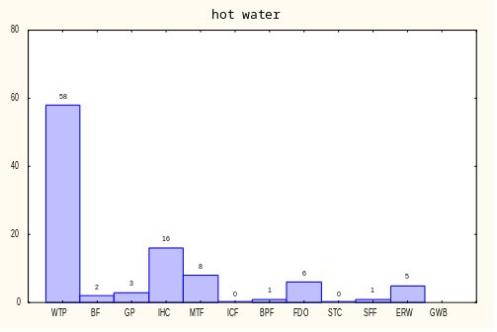
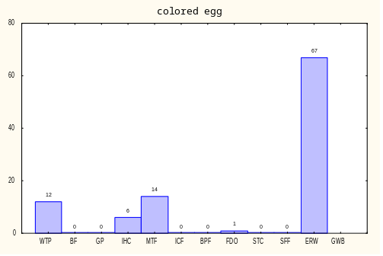

Figure 6.4.2.1. Bar plots showing the frequencies of accessing and mapping each long-term memory episode in the ‘hot water’ and ‘colored egg’ conditions, respectively.
The data show that each experimental condition differs from the control and from each other. The difference is very significant according to the chi-square test (χ²=89.5, df=7, p<0.00001). Moreover, the effect is in the predicted direction — the two base situations about heating water appear much more frequently in the ‘hot water’ condition. The reverse pattern holds for the episode about coloring an egg (ERW).
Condition | freq(WTP) | freq(IHC) | freq(ERW) | other | total
Hot water | 58 (37) | 16 (11) | 5 (35) | 21 (17) | 100
Color egg | 12 (37) | 6 (11) | 67 (35) | 15 (17) | 100
Total | 70 (74) | 22 (22) | 72 (70) | 36 (34) | 200
Table 6.4.2. Observed frequencies of accessing base episodes from memory for the two experimental conditions. The control condition (in parentheses) defines the expected frequencies for the chi-square test. χ²=89.5, df=7, p<0.00001.
Thus, order of presentation of the target problem influences the process of accessing source analogs in Ambr. As the mapping process in the model is intimately intertwined with access, it is influenced too. Moreover, the direction of influence is in accord with the well-known primacy effects demonstrated in many studies of short-term memory (e.g. Postman & Phillips, 1965). Elements that appear earlier have greater impact than later elements.
Ambr differs from other models of analog retrieval with respect to the primacy effect (Forbus, Gentner, & Law, 1994; Hummel & Holyoak, 1997). As far as we can judge from the articles, neither MAC/FAC nor LISA predict such order effect on analog access. The first stage of MAC/FAC depends on dot products over feature vectors and, therefore, all target elements necessarily enter simultaneously. Thus the model must wait until all target elements are available and only then can trigger the retrieval process.
LISA do present target (or more precisely driver) elements in a temporal order. Indeed, this is the only way of processing available to LISA due to the limitations of the phase set. As argued in section 4.5.1, however, the model uses centralized representation of situations. Therefore, episodes are retrieved as units — either all nodes are flipped from dormant to recipient mode or none of them. In the current version of LISA this decision is taken probabilistically based on the Luce retrieval index computed for each episode in LTM (Hummel, personal communication, January 1998). The important point is that the indices are computed after multiple iterations through the whole driver set. The article does not specify the moment in which the probabilistic decision about bringing an episode to the working memory is taken (Hummel & Holyoak, 1997). If we suppose that this happens after the network has settled, the order of the driver set would have negligible effect on the retrieval indices.

See Figure 6.3.1.2. for a schematic diagram.
See Figure 5.1.2. for a schematic diagram.
See Figure 6.3.1.3. for a schematic diagram.
See Figure 5.1.1. for a schematic diagram.

