Chapter VII

Evolving AMBR: AMBR4 ?
Throughout this thesis we have emphasized that analogy-making cannot be decomposed into a sequence of independent components. Ambr advocates an interactionist emergent approach and conceptualizes analogy-making in terms of overlapping subprocesses (Figure 3.2.1.2). Still, the current version of the model addresses mainly the subprocesses of access and mapping. Does this mean that Ambr assumes that these two subprocesses can be modeled separately from the rest?
The problem lies in the complexity of analogy-making. As we have argued, it is not an isolated module but emerges out of the general cognitive architecture. Therefore, any comprehensive treatment of analogy-making should cover the whole cognition. For instance, Chalmers, French, & Hofstadter (1992) have argued that analogy is inseparable from high-level perception. Without perception, the mapping between the base and the target is in effect contained in latent form in the representations of the two episodes. As Ambr starts from hand-coded descriptions, it takes the essence of the analogy from outside. This definitely is a limitation of the model. It should try to include mechanisms for high-level perception in the future. But high-level perception is obviously rooted in low-level perception. Perception at all levels involves attention, which in turn depends on motivation, which is culturally grounded, etc., etc.
It follows that any model of analogy-making is necessarily incomplete. Ambr makes no exception. We hope, however, that it is open-ended enough to be able to grow. This chapter suggests ways for extending the model in two directions: transfer and perception.

7.1. Possibilities for Transfer
In the current version of Ambr, each run of the model ends in the following way: One by one the authorized secretaries (i.e. the agents from the target, see section 5.6) pick up one of the hypotheses registered at them and send it a promotion incentive. The promoted agents enter the third phase of their life cycle and become winner hypotheses. All other hypotheses registered at the respective secretaries become losers. In this way, the model makes commitments about the correspondences between the two episodes. As there are no mechanisms that can advance the process further, the model stops. All symbolic activity comes to an end. The activation in the network reaches a resting state.
In a hypothetical future version of Ambr (Ambr4 ?), the mapping between the base and the target is to be used for generating inferences in the target (and possibly the base). We refer to this process as transfer. It involves at least three issues:
- Which members of the two descriptions remain unmapped? These are the potential candidates for transfer? As Ambr uses decentralized representations of situations, this question cannot be answered by going through some list-like structure and crossing out mapped entities.
- Which unmapped elements really merit transferring? This is a very difficult question. For example, suppose the target problem is to heat some milk in a teapot. The base contains water, a teapot, and a hot-plate (among other things). The color of the teapot in the base is green. The temperature of the plate is high. Neither proposition has any analog in the target and, therefore, both are candidates for transfer. Perhaps the milk will get hot if one paints the teapot green?
- How to carry elements from the one domain to the other? Objects and propositions in the base cannot be copied literally to the target; they must be ‘translated’.
The ordering above looks like a sequence of steps but it should not be understood in this way. According to the overall philosophy of Ambr, these ‘steps’ overlap in time. Whenever an element is identified as unmapped (point 1), the evaluation of its relevance and potential usefulness could begin (point 2). There is no need to wait for the other unmapped agents. In addition, the potential usefulness of an element depends on the quality of the inferences that this element could ‘propose’ (point 3). Hence, in our view the whole process should be modeled by a ‘wave’ similar to the one outlined in subsection 3.2.1.
How could Ambr mechanisms carry out the transfer process? Let us start with point 1. above. One possible answer is that the secretaries of the target are authorized to judge which elements are mapped while the secretaries of the source are authorized to judge which elements are unmapped.
Hummel & Holyoak (1996, 1997) propose two very useful concepts. In addition to the conventional target/base distinction, they introduce the driver/recipient distinction. The driver is the one that has the initiative and ‘makes things happen’. In Ambr terminology, it is authorized. This could be the target problem or the source episode. Hummel & Holyoak (1997) suggest the following ‘canonical flow of control’: First the target is used as driver during the access stage. Once a source is in working memory, mapping can be performed in either direction (including successive switches between the two episodes). After the mapping stage is over, the source is used to drive inferences and schema induction in the target.
We adopt the driver/recipient terminology and agree with the main idea of the previous paragraph. However, we propose a correction — switches between ‘driver mode’ and ‘recipient mode’ should not be done in a way that serializes the process of analogy-making and cut it into separate stages (marked by interventions of the human user). Among other things, this implies that it should be possible that both situations act as drivers simultaneously.
For lack of better terminology, we will denote the situation (or, more precisely, the elements thereof) that drives the mapping as driver-M. The one that drives the transfer is driver-T. Each is authorized to do different and complementary things.
The target problem in Ambr typically acts as driver-M. Its agents access (partially) episodes from the long-term memory, establish correspondences, administer rating surveys, and promote winners. When a source episode emerges as winner, it becomes driver-T and its agents become authorized to identify unmapped elements, judge their potential usefulness for transfer, propose ‘translations’ in the target, etc. The two coalitions — driver-M and driver-T — work together, each according to its authorization. In this way, the transfer subprocess overlaps in time with mapping, potentially altering the balance in the constraint satisfaction network and affecting the correspondences that remain to be promoted.
More concretely, the driver-T secretaries could identify whether they are unmapped or not by a constraint propagation mechanism (e.g. Waltz, 1975). Commitment in one place (in the form of a winner promotion) propagates to other places. Consider the example in Figure 7.1.1.
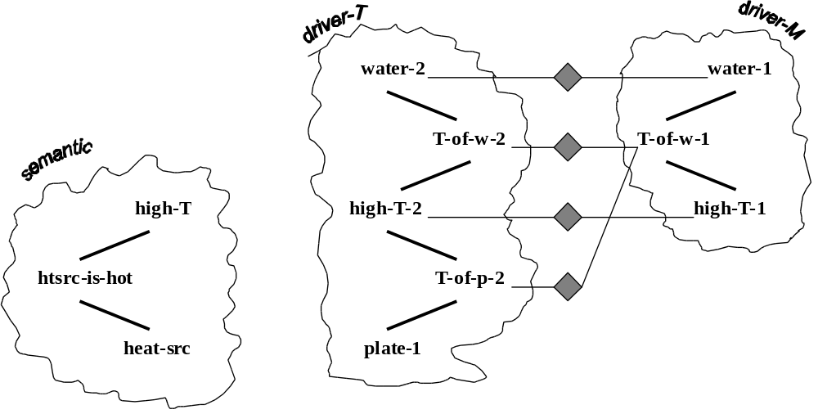
Figure 7.1.1. The driver-M coalition (to the right) has established four hypotheses (diamonds) with the driver-T coalition (in the middle). A general proposition waits in the semantic memory (to the left) and could be used for skolemization. See text for details.
Figure 7.1.1. illustrates a fragment of the network at the moment when the driver-M coalition (to the right) has established several hypotheses with the recipient coalition (in the middle). Note that two hypotheses compete for the agent T-of-w-1. The secretary of the latter is authorized to promote one of them as winner. Suppose the hypothesis T-of-w-1<-->T-of-w-2 is the winner (due to structural and semantic pressures in the CSN as both propositions involve water). When it is promoted, the rival hypothesis T-of-w-1<-->T-of-p-2 becomes a loser. It notifies the secretary of T-of-p-2 about this. The latter agent belongs to the recipient situation (in the middle). This same situation, however, is driver-T at the same time. As such, it checks whether it has at least one non-loser hypothesis on its record. When T-of-w-1<- ->T-of-p-2 becomes a loser, the secretary detects that T-of-p-2 is unmapped.
Driver-T secretaries are authorized to trigger the skolemization mechanism (just as driver-M secretaries are). Thus, the general proposition that the temperature of heat-sources is high could be used to augment the driver-M situation. This could be done in the following way: The agent T-of-p-2, having missed the chance to map to T-of-w-1, now takes the initiative and issues a marker. (Note that it acts as a driver at this moment.) As described in section 5.3., this marker goes to the ‘parent concept’ temperature-of. It intersects there with the marker issued from the general proposition htsrc-is-hot. The marker intersection leads to a construction of a new hypothesis agent: T-of-p-2<-->htsrc-is-hot. The symbolic processor of this new agent could now carry out the skolemization routines (section 5.7.) and augment the description of the ‘other’ situation. As this particular instantiation of the skolemization mechanism has been triggered by the driver-T situation, the new Skolem instances will be added to situation driver-M. (Note that the latter acts as a recipient with respect to driver-T.)
The skolemization mechanism will re-use the agent high-T-1 in the recipient. As the concept agent heat-source has received no marker from the came coalition, a new Skolem instance will be created and affiliated to the episode shown to the right in Figure 7.1.1. Suppose the name of this new agent is sk-htsrc-1. Finally, a Skolem proposition will be created. It binds sk-htsrc-1 and high-T-1 as arguments of a relation temperature-of. Let the name of this latter proposition is sk-T-of-1. Figure 7.1.2. shows the new configuration.
The new agents sk-htsrc-1 and sk-T-of-1 affiliate to the driver-M coalition. In this way, the description of the target problem is augmented with a heat source. The new agents now take the initiative and issue markers. These markers will create the hypotheses sk-htsrc-1<-->plate-2 and sk-T-of-1<-->T-of-p-2. Hence, plate-2 and T-of-p-2 are not unmapped any more. After the rating mechanism does its job, the new hypotheses will be promoted as winners. In particular, the hypothesis sk-T-of-1<-->T-of-p-2 will eliminate the general hypothesis T-of-p-2<-->htsrc-is-hot that has carried out the skolemization process.
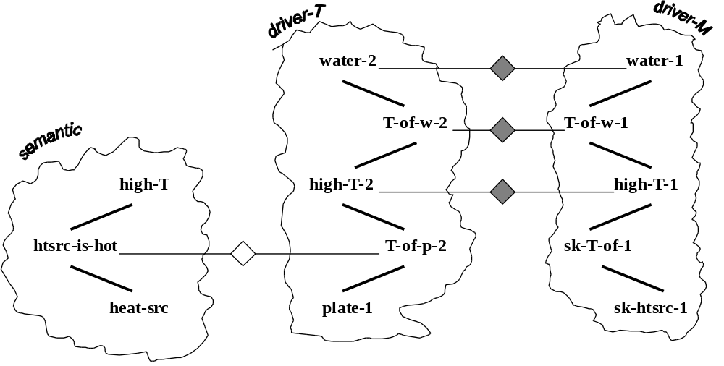
Figure 7.1.2. State of the network after the skolemization mechanism has added two new Skolem agents to the driver-M coalition introduced in Figure 7.1.1. The general-hypothesis agent that has carried out the skolemization is depicted by a white diamond. It will be eliminated when the new Skolem instances create hypotheses of their own. See text for details.
This example suggests that the existing Ambr mechanisms can be useful not only for the processes of analog access and mapping but for the transfer process too. The utility of the mechanisms of rating, marker passing, and skolemization is clear from the example. The other mechanisms are potentially useful too. The spreading activation is a key mechanism for estimating relevance, and such estimates will surely be needed for the selection of candidates for transfer. The constraint satisfaction is also useful when there is a need for selecting one option among alternatives.
Considerations of this kind make us believe that the Ambr model is open-ended enough and its functionality could be extended in the direction of analogical transfer. Moreover, we hope that this could be done without giving up the properties of the current version. Analog transfer could be done in a dynamic emergent way over decentralized representations. It could run in parallel with the subprocesses of mapping and access.

7.2. Possibilities for Perception
This section suggests how Ambr could be extended in the direction of high-level perception. As argued by Hofstadter (1984, 1995) and Chalmers, French, & Hofstadter (1992), the process of building representations is a crucial part of analogy-making. The same authors defend the methodological utility of micro-domains for research on high-level perception. Micro-domains allow the model to focus on building structured representations instead of dealing with low-level details such as filtering noise from images.
One such micro-domain that could be used in the research on Dual and Ambr is the so-called Textscreen. It is based on an imaginary text processing program. Textscreen is deliberately simplified — there is plain text over a limited matrix of screen positions. There are objects like characters, marked areas, etc. The characters can be grouped in words, lines, paragraphs, columns, etc. Most of the objects are directly visible on the screen where they tend to form regular rectangular patterns.
The objects have attributes such as long and vertical. There are also a number of relations such as left-of, part-of, aligned-with, etc. Finally, there are various actions (or commands) to navigate through the text, to insert, delete, or move objects, and mark portions of text and thus form aggregate units for subsequent manipulation.
This material is rich enough to allow various configurations on the screen (see Figure 7.2.1). A model that operates in this environment is presented with a situation which has some defect somewhere on the screen and the task of the system is to locate the defect and correct it. To that end, the model can use previous situations (with solutions) as source analogs.

Figure 7.2.1. Sample problem in Textscreen.
Visual perception has much to do with space. Even in a simplified two-dimensional micro-world like Textscreen spatial properties, relations, and configurations are all important. This characteristic feature of the environment must be reflected somehow in the cognitive architecture Dual. The main network cannot meet this requirement because it lacks spatial organization. Therefore, we plan to augment the architecture with a large-scale structure having explicit spatial organization — the visual array (VA).
As everything in Dual, the visual array consists of agents. The defining characteristic of the array is that the agents are arranged in a rectangular matrix. Each agent in the array is associated with a particular position on Textscreen and can ‘see’ whether the cell is empty or not. Thus the VA is a mediator between two different worlds — the external environment of Textscreen and the internal representations in the main network. The defining principle of Textscreen is physical location. On the other hand, the defining principle of the network is interconnectivity. In the visual array these two principles meet — the visual agents have both physical locations and links to other agents. For instance, each agent is linked to the agents in the four neighboring cells. It can interact with them, send them symbols and activation, etc.
There are other perceptual agents that are connected to a whole row or column of the agents in the VA. These agents can detect lines, lines with defects, etc. When they locate an object in their receptive field, they create a new temporary agent in the main network that represents this external object. Other specialized perceptual agents combine lines in regions, identify various spatial relations between them, etc. They build new agents in the network to represent these regions and relations. Still other agents group things together or parse a complex object into parts. Each perceptual agent works at individual speed depending on its activation level. The activation in turns reflects two kinds of influences: bottom-up (from the VA) and top-down (from the ‘parent concept’ in the network).
The visual array is a source of activation. It will replace the input node of the current version of Dual and Ambr. Instead of hand-coding the description of the scene and attaching it to the input list, the model should be able to build the representation itself. It would be built agent by agent. Each new agent enters the working memory, sends activation to its respective concept agent, and emits a marker to trigger the mechanisms for finding correspondences. As the simulation experiments on order effects have demonstrated (section 6.4), Ambr is capable to handle target problems that are presented over the course of time.

There is a notion of neighborhood in the network but it is not related to spatial proximity.

