Influence of Mapping on Analog Access:
A Simulation Experiment with AMBR

Alexander A. Petrov*
* New Bulgarian University
Department of Cognitive Science
21, Montevideo Str.
Sofia 1635, Bulgaria
apetrov@cogs.nbu.acad.bg
Boicho N. Kokinov# *
# Institute of Mathematics and Informatics
Bulgarian Academy of Science
Bl. 8 Acad. G. Bonchev Str.
Sofia 1113, Bulgaria
kokinov@cogs.nbu.acad.bg

ABSTRACT
This paper contrasts two views about the relationship between the processes of access and mapping in analogy-making. According to the modular view, analog access and mapping are two separate ‘phases’ that run sequentially and relatively independently. The interactionist view assumes that they are interdependent subprocesses that run in parallel. The paper argues in favor of the second view and presents a simulation experiment demonstrating its advantages. The experiment is performed with the computational model Ambr and illustrates one particular way in which the subprocess of mapping can influence the subprocess of access.

Keywords
Analogy-making, interactionist approach, access, mapping, simulation experiment, hybrid cognitive architecture.

INTRODUCTION
A crucial point in analogy-making is the retrieval of a base (or source) analog. Accessing an appropriate base from the vast pool of episodes stored in the long-term memory is not only a logical necessity (one cannot make analogies without a source) but apparently is the most difficult and capricious element of analogy-making. Starting with the classical experiments of Gick and Holyoak (1980) it has been repeatedly demonstrated that people have difficulties in spontaneously accessing a base analog, especially when its domain is very different from that of the target problem. In the aforementioned study only about 20% of the subjects were able to solve the so-called radiation problem even though an analogous problem (with solution) was presented shortly before the test phase. When provided by an explicit hint to use this source analog, however, 75% of the subjects achieved the solution. This great difference between the two experimental conditions was attributed to the difficulty of analog access.
On the other hand, we know a lot of stories about great scientists making discoveries by spontaneously using remote analogies. We have also personal experience in everyday usage of remote analogies. A recent study by Wharton, Holyoak, and Lange (1996) has demonstrated that about 35% of their subjects were successfully reminded about a remote analog story studied 7 days earlier when cued by the target story. (They have used a directed reminding task, not a problem solving task, however.)
Researchers of analogical access have become interested in the features of a remote analog that facilitate retrieval. Most data in the field (Holyoak and Koh, 1987, Ross 1989) suggest that analogical access is almost exclusively guided by superficial semantic similarities between base and target—similar objects and relations, similar themes, similar story lines, etc. In contrast, analogical mapping is dominated by the structural similarity between target and base, i.e. having common systems of relations (Gentner, 1983, 1989). This explains why remote analogs are much more difficult to access than to map—they lack the superficial similarities needed for access but do have the (quasi)isomorphic relational structure necessary for mapping.
This clear separation stimulated the researchers in the field to build separate models of mapping and retrieval and even to claim that they are different cognitive modules. Thus Gentner (1989) claims that ‘the analogy processor (the mapping machine) is a well-defined separate cognitive module whose results interact with other processes, analogous to the way some natural language models have postulated semi-autonomous interacting subsystems for syntax, semantics, and pragmatics.’ Although she explicitly mentions in a footnote that this should not be considered in the Fodorian sense as innate and impenetrable, the actual models built are quite impenetrable. This line of research has generated a number of quite successful models that explained the data and made some new predictions. Typically, a model of mapping is coupled with a (separate) model of retrieval. The best-known examples are SME + MAC/FAC (Falkenhainer, Forbus, and Gentner, 1986; Forbus, Gentner, and Law, 1995) and ACME + ARCS (Holyoak and Thagard, 1989; Thagard, Holyoak, Nelson, and Gochfeld, 1990).
However, the experimental work soon revealed that the pattern is not that clear and straightforward. It has been demonstrated that superficial similarities do play an important role in mapping as well. In particular cross-mapping is difficult (Ross, 1989). This led Holyoak and Thagard to include syntactic, semantic, and pragmatic constraints in their model of mapping ACME (Holyoak & Thagard, 1989) and to develop their multi-constraint theory (Holyoak & Thagard, 1995).
There are also some indications that structural similarity might play a role in access as well. Thus Ross (1989) demonstrated that in some cases (when the general story line is similar) structural similarity plays a positive role in retrieval, while in other cases (when the general story line is dissimilar) it does not play any role or can even worsen the results. The results of Wharton, Holyoak, and Lange (1996) also support indirectly the hypothesis that structural correspondences might affect the access. This was reflected in the models being proposed. Both MAC/FAC and ARCS included a submodule of partial mapping in the module of retrieval, thus considering structural similarities at an early stage.
To sum up, the initial separation between retrieval and mapping was founded on their different psychological characteristics—semantic factors govern the retrieval, structural factors govern the mapping. Subsequent more precise experiments, however, cast doubt on this clear separation. These complications were accommodated by making patches to the original models. Finally, it was acknowledged that all kinds of constraints affected all phases of analogy-making, although to different extent (Holyoak & Thagard, 1995).
The experimental data themselves became more and more complex and controversial. These controversies can be explained in terms of more and more sophisticated classifications of the types of similarities involved in access and mapping (Ross, 1989; Ross & Kilbane, 1997). We argue, however, that these problems are resolved more parsimoniously by adopting a principally different view of analogy-making.
This resembles an episode of the history of astronomy. The geocentric system of Ptolemy started as a straightforward theory that described the observable movement of both stars and planets remarkably well. As accuracy of measurement increased, however, discrepancies between theory and data crept in every now and then. It became routine for astronomers to deal with such ‘anomalies’ by adding more and more epicycles. But as time went on, it became evident that astronomy’s complexity was increasing far more rapidly than its accuracy and that a discrepancy corrected in one place was likely to show up in another (Kuhn, 1970).
Back to the domain of analogy-making, most classical models assume sequential processing: first the retrieval process finds the base for analogy and then the mapping process builds the correspondences between the target and the retrieved base (Figure 1). Thus MAC/FAC+SME and ARCS+ACME are linear models separating retrieval and mapping in time and space. This view underlies most of the experimental work in the field as well. Researchers often contrast hint versus non-hint conditions in problem solving supposing that in the first case only mapping takes place, while in the second retrieval and mapping are running one after the other. However, as Ross (1989) has noted, even when explicitly hinted to use a certain analog subjects still must access the details of its representation. Another common experimental technique uses a memory task (typically recall) for studying access with the assumption that the same processes take place during analogical problem solving.
Figure 1. Dominating sequential models of analogy-making.
Retrieval Source Mapping
time
The limitations of both the models and experimental methods can be overcome by giving up the linearity assumption. This might look strange at first glance—how can you map the source analog onto the base if you have not even accessed it?! If, however, one reconsiders one more assumption—that there are centralized representations of situations/problems in human memory—then it becomes clear that whenever we have partial retrieval of the base (having recalled a few details) we can start looking for corresponding elements in the target. This allows us to conceptualize access and mapping as parallel processes that can interact (Figure 2). In this paradigm, access and mapping refer not to phases or other behavioral steps, but rather to separate mechanisms that both play a role in selecting and activating a base and in finding the correspondences between base and target.
Figure 2. Parallel and interactive models of analogy-making.
Access
Mapping
time
The current paper explores the implications of the parallel and interactive view on access and mapping by running simulation experiments with an integrated model of human (analogical) reasoning called Ambr (Kokinov, 1994c, Petrov, 1997). These experiments provide a detailed example of how these two processes can interact and thus open space for new theoretical speculations as well as for new experimental paradigms. AmbrÕs predictions about the development of the process over time call for appropriate experimental methods capturing the dynamics of human analogy-making—RT studies, think-aloud protocols, etc. Some of the controversies around the role of superficial and structural similarities in access and mapping ‘phases’ can now be expressed in terms of the interactions between the two mechanisms.
A very important contribution of the simulation is that it demonstrates how the supposedly later ‘phase’ of mapping can influence the supposedly earlier ‘phase’ of access. A detailed example shows how the access process develops over time and how it is influenced by the concurrent mapping process. This is contrasted with the case of isolated access. Different results are obtained in the two cases. These results correspond to the data of Ross and Sofka (unpublished) which main conclusions are summarized in (Ross, 1989) as follows: ‘... other work (Ross & Sofka, 1986) suggests the possibility that the retrieval may be greatly affected by the use. In particular, we found that subjects, whose task was to recall the details of an earlier example that the current test problem reminded them of, used the test problem not only as an initial reminder but throughout the recall. For instance, the test problem was used to probe for similar objects, and relations and to prompt recall of particular numbers from the earlier example. The retrieval of the earlier example appeared to be interleaved with its use because subjects were setting up correspondences between the earlier example and the test problem during the retrieval.’ The simulation data presented in the current paper (obtained absolutely independently and based only on the theoretical assumptions of Dual and Ambr) exhibit exactly the same pattern of interaction.
We must admit that even in a highly parallel and interactive model such as Ambr the effects of interactions are not predominating. In the majority of cases the independent work of the access mechanism might well yield the same results as the interaction between mapping and access described above. That is why the classical linear models of analogy have been successful and have contributed a lot to our understanding of human analogy-making. However, exactly the few exceptional cases that do provide different results in a parallel model are the more interesting and those who make the interpretation of the experimental data look controversial if analyzed in the spirit of the sequential models.
There are a few other models that advocate a parallel, overlapping, and interactive view on analogy—Copycat (Mitchell, 1993, Hofstadter, 1995), Tabletop (French, 1995, Hofstadter, 1995), and LISA (Hummel and Holyoak, 1997). However, Copycat and Tabletop do not model retrieval at all—they model the parallel work and interaction between perception/representation building and mapping. LISA also integrates access and mapping and performs them in parallel. Thus the mapping mechanism (connectionist learning in this case) influences the access. As a result, LISA could in principle demonstrate effects similar to those reported here.

Brief Description of the Architecture Dual and the model ambr
The basis for the simulation experiment discussed in this paper is a model called Ambr (Associative Memory-Based Reasoning). It is built on the cognitive architecture Dual. Space limitations allow only an extremely sketchy description of Dual and Ambr here. The interested reader is referred to earlier publications (Kokinov, 1988, 1994a,b,c; Petrov, 1997).
Dual is a multi-agent cognitive architecture that supports dynamic emergent computation (Kokinov,Nikolov, and Petrov, 1996). All knowledge representation and information processing in the architecture is carried out by small entities called Dual agents. Each Dual-based system consists of a large number of them. There is no central executive in the architecture that controls its global operation. Instead, each individual agent is relatively simple and has access only to local information, interacting with a few neighboring agents. The overall behavior of the system emerges out of the collective activity of the whole population. This ‘society of mind’ (Minsky, 1986) provides a substrate for concurrent processing, interaction, and emergent computation.
Each Dual agent is a hybrid entity that has symbolic and connectionist aspects (Kokinov 1994a,b,c). On the symbolic side, each agent ‘stands for’ something and is able to perform certain simple manipulations on symbols. On the connectionist side, it sends/receives activation to and from its immediate neighbors. Thus, we may adopt an alternative terminology and speak of nodes and links instead of agents and interactions. The population of agents may be conceptualized as a network of nodes.
The long-term memory of a Dual-based system consists of the network of all agents in that system. The size of this network can be very large. Only a small fraction of it, however, may be active at any particular moment. The active subset of the long-term memory together with some temporary agents constitutes the working memory (WM) of the architecture. The mechanism of spreading activation plays a key role for controlling the size and the contents of the WM. There is a threshold that sets the minimal level of activation that must be obtained by an agent to enter the WM. There is also a spontaneous decay factor that pushes the activation levels back to zero. As the pattern of activation changes over time, some agents from the working memory fall back to dormancy, others are activated, etc. Only active agents may perform symbolic computation. Moreover, the speed of this computation depends on the level of activation of the respective agent. This makes the computation in Dual dynamic and context-sensitive (Kokinov et al., 1996; Kokinov, 1994a,b,c). One particular consequence of this dynamic emergent nature of the architecture is that, although all micro-level processing is strictly deterministic, the macroscopic behavior of a Dual system can be described only probabilistically.
The Ambr model takes advantage of these architectural features to account for some phenomena of human reasoning and in particular reasoning by analogy (Kokinov, 1988, 1994c). Again, due to space limitations we will consider only a small fraction of model’s mechanisms.
Analog access in Ambr is done by means of spreading activation by the connectionist aspects of the Dual agents. In particular, only few of the many episodes stored in the long-term memory are active during a run and only they are accessible for processing. The episodes or ‘situations’ have decentralized representations—it is not a single agent but a whole coalition that represents the elements of a situation and the relationships among them. Therefore, it is possible that an episode is only partially accessed because only some of the agents have entered the WM.
The process of analogical mapping is done in Ambr by a combination of three mechanisms—marker passing, constraint satisfaction, and structure correspondence (Kokinov, 1994c; Petrov, 1997). The main idea is to build a constraint satisfaction network (CSN) to determine the mapping between two situations. This network consists of hypothesis agents representing tentative correspondences between two elements. Consistent hypotheses support, and incompatible ones inhibit each other.
This is similar to other models of analogy-making and notably ACME (Holyoak and Thagard, 1989). Ambr differs from the latter model, however, in several ways: (i) the CSN is constructed dynamically, (ii) only hypotheses that have some justification are created, (iii) the CSN is incorporated into the bigger working memory network, and (iv) there is no separate relaxation phase so there is a partial mapping at each moment.
The implication of these four points is that, unlike ACME and most other analogy models, the processes of access and mapping run in parallel and influence each other in Ambr. In other words, the model departs from the classical ‘pipeline’ paradigm and aims at a more interactive account of analogy making.
The influence between the two subprocesses in Ambr goes in both directions. The present paper concentrates on the ‘backward’ direction—from mapping to access. The next section describes a simulation experiment that sheds light on this kind of influence.

Simulation experiment method
We performed a simulation experiment to contrast the two ways of combining access and mapping—parallel vs. serial. The experiment also tested whether the Ambr model was capable to access a source analog out of a pool of episodes, and to map it onto a target situation.
Design
The experiment consisted of two conditions. Both conditions involved running the model on a target problem. In the ‘parallel condition’, Ambr operated in its normal manner with the mechanisms for access and mapping working in parallel. In the ‘serial condition’, the program was artificially forced to work serially—first to access and only then to map. The target problem and the content of the long-term memory were identical in all runs. The topics of interest fell into two categories—the final mapping constructed by the program and the dynamics of the underlying computation. The latter was monitored by recording a set of variables describing the internal state of the system at regular time intervals throughout each run.
Materials
The domain used in the experiment deals with simple tasks in a kitchen. The long-term memory of the model contains semantic and episodic knowledge about this domain. It has been coded by hand according to the representation scheme used in Dual and Ambr (Kokinov, 1994c; Petrov, 1997). The total size of the knowledge base is about 500 agents (300 ‘semantic’ + 200 ‘episodic’). It states, for example, that water, milk, and tea are all liquids, that bottles are made of glass, and the relation ‘on’ is a special case of ‘in-touch-with’. The LTM also stores the representations of eight situations related to heating and cooling liquids. Two of these eight situations are most important for the experiment and are described below together with the target problem.
Situation A: There is a cup and some water in it. The cup is on a saucer and is made of china. There is an immersion heater in the water. The immersion heater is hot. The goal is that the water is hot.
The outcome is that the water is hot. This is caused by the hot immersion heater in it.
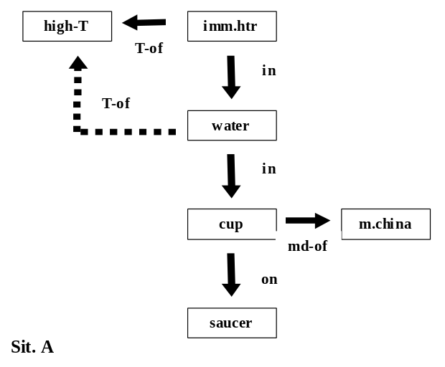
Figure 3. Schematized representation of situation A. Objects are shown as boxes and relations with arrows. Dashed arrows stand for relations in the ‘outcome’. The actual Ambr representation is more complex—it consists of 19 agents and explicates the causal structure (not shown in the figure). See text for details.
Situation B: There is a glass and an ice cube on it. The glass is made of [material] glass. The glass is in a fridge. The fridge is cold The goal is that the ice cube is cold.
The outcome is that the ice cube is cold. The fact that it is on the glass and the glass is in the fridge entails that the ice cube itself is in the fridge. In turn, this causes the ice cube to be cold, as the fridge is cold.
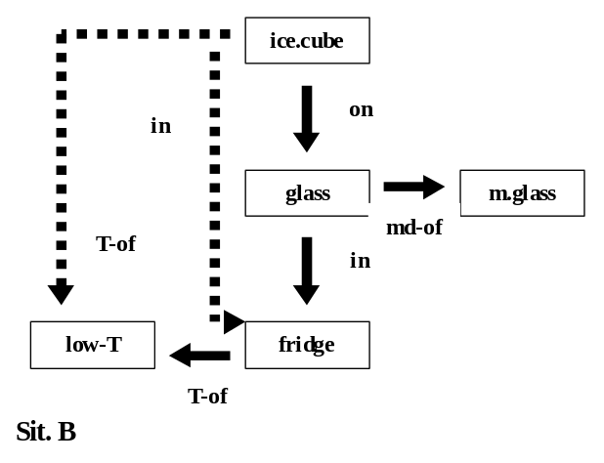
Figure 4. Schematized representation of situation B. Dashed arrows stand for relations in the ‘outcome’. The actual Ambr representation is more complex—it consists of 21 agents and explicates the causal structure (not shown in the figure). See text for details.
Target problem (situation T): There is a glass and some coke in it. The glass is on a table and is made of [material] glass. There is an ice cube in the coke. The ice cube is cold. The goal, if any, is not represented explicitly.
What is the outcome of this state of affairs?
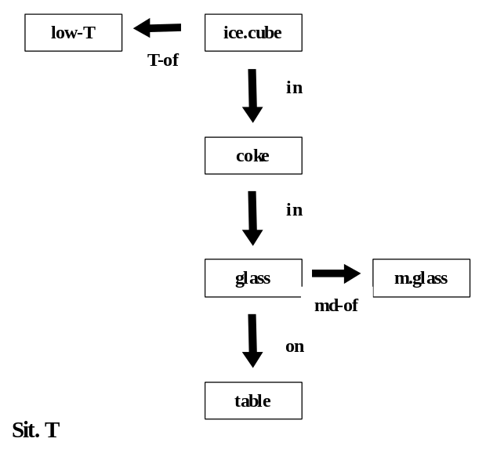
Figure 5. Schematized representation of the target situation. The actual Ambr representation is more complex and consists of 15 agents. See text for details.
As evident from Figures 3, 4, and 5, both situations A and B may be considered similar to the target problem. There are some differences, however. Situation B involves the same objects and relations as the target but the structure of the two are different. In contrast, situation A involves different objects but its system of relations is completely isomorphic to that of the target. According to Gentner (1989), the pair A-T may be classified as analogy while B-T as mere appearance. Thus it was expected that situation B would be easier to retrieve from the total pool of episodes stored in LTM. On the other hand, A would be more problematic to retrieve but once accessed it would support better mapping.
Procedure
The Common Lisp implementation of the Ambr model was run two times on the target problem. The two runs carried out the ‘parallel’ and the ‘serial’ conditions of the experiment, respectively. The contents of the long-term memory and the parameters of the model were identical in the two conditions.
Recall that situations have decentralized representations in Ambr. The target problem was represented by a coalition of 15 agents standing for the ice-cube, the glass, two instances of the relation ‘in’ and so on. 12 of these agents were attached to the special nodes that serve as activation sources in the model. The attachment was the same in the two experimental conditions.
In the parallel condition, the model was allowed to run according to its specification. That is, all Ambr mechanisms ran in parallel, interacting with one another. The program iterated until the system reached a resting state. A number of variables were recorded at regular intervals throughout the run. Out of these many variables, the so-called retrieval index is of special interest. It is computed as the average activation level of the agents involved in each situation.
In short, at the end of the run we had the final mapping constructed by the program as well as a log file of the retrieval indices of all eight situations from the LTM.
In the serial condition, the target problem was attached to the activation source in the same way and the same data were collected. However, the operation of the program was forcefully modified to separate the processes of access and mapping. To that end, the run was divided in two steps.
During step one, all mapping mechanisms in Ambr were manually switched off. Thus, spreading activation was the only mechanism that remained operational. It was allowed to work until the pattern of activation reached asymptote. The situation with the highest retrieval index was then identified. If we hypothesize a ‘retrieval module’, this is the situation that it would access from LTM.
After the source analog was picked up in this way, the experiment proceeded with step two. The mapping mechanism was switched back on again but it was allowed to work only on the source situation retrieved at step one. This situation was mapped to the target. Thus, at the end of the second run we had the final mapping constructed at step two, as well as two logs of the retrieval indices.

Results and Discussion
In both experimental conditions the model settled in less than 150 time units and produced consistent mappings. By ‘consistent’ we mean that each element of the target problem was unambiguously mapped to an element from LTM and that all these corresponding elements belonged to one and the same base situation. Stated differently, the mappings were one-to-one and there were no blends between situations.
In the parallel condition, the target problem was mapped to situation A, yielding the correspondences in–in, water–coke, imm.heater–ice.cube, T.of–T.of, high.T–low.T, made.of–made.of, etc. Four elements from the source situation remained unmapped and in particular the agent representing that the water is hot. This proposition is a good candidate for inference by analogy. Mutatis mutandis, it could bring the conclusion that the coke is cold. (In the current version of Ambr the mechanisms for analogical transfer are not implemented yet.)
In the serial condition, situation B won the retrieval stage. This is explained by the high semantic similarity between its elements and those of the target—both deal with ice cubes in glasses, cold temperatures, etc. The asymptotic level of the retrieval index for B was about four times greater than that of any other situation. In particular, situation A ended up with only 5 out of 19 agents passing the working memory threshold.
According to the experimental procedure, situation B was then mapped to the target during the second stage of the run. The correspondences that emerged during the latter stage are shown in Table 1. The semantic similarity constraint has dominated this run. This is not surprising given the high degree of superficial similarity between the two situations. There is, however, a serious flaw in the set of correspondences. The proposition ‘T.of (ice.cube, low-T)’, which belongs to the initial state of the target, is mapped to the proposition ‘T.of (ice.cube, low-T)’, which is a consequence in the source. Therefore, the whole analogy between the target problem and the situation B could hardly generate any useful inference.
Situation B | Target situation
ice.cube | ice.cube
fridge | coke
glass | glass
in (ice.cube, fridge) | in (ice.cube, coke)
in (glass, fridge) | in (coke, glass)
on (ice.cube, glass) | on (glass, saucer)
T.of (fridge, low-T) | <unmapped>
T.of (ice.cube, low-T) | T.of (ice.cube, low-T)
low-T | low-T
made.of (glass, m.glass) | made.of (glass, m.glass)
m.glass | m.glass
initstate1 | initstate
initstate2 | <unmapped>
interstate | table
endstate | endstate
goalstate | <unmapped>
follows (initstate1, endst.) | follows (initstate, endst.)
to.reach (initstate1, goalst) | <unmapped>
cause (initstate2, in(i.c,fr)) | <unmapped>
cause (interstate, T.of(i.c)) | <unmapped>
Table 1. Correspondences constructed by the model in the serial condition.
To summarize, when the mechanisms for access and mapping worked together, the model constructed an analogy that can potentially solve the problem. On the other hand, when the two mechanisms were separated, the retrieval stage favored a superficially similar but inappropriate base.
The presentation so far concentrated on the final set of correspondences produced by the model. We now turn to the dynamics of the computation as revealed by the time course of the retrieval indices. Figure 6 plots the retrieval indices for several LTM episodes during the first run of the program (i.e. when access and mapping worked in parallel). Figure 7 concentrates on the early stage of the first run and compares it with the second run (i.e. when only the access mechanism was allowed to work). Note that the two plots are in different scales.
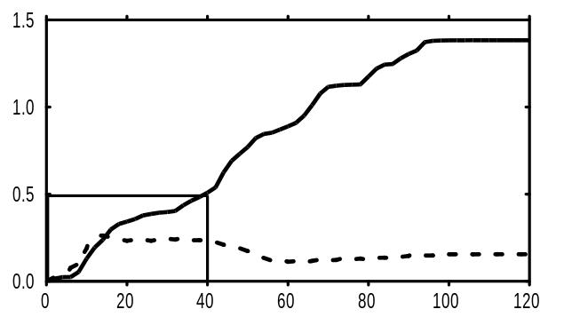Figure 6. Plot of retrieval indices versus time for the parallel condition. Situation A is in solid line, B in dashed. The 'south-west' corner of the plot is reproduced in Figure 7 with threefold magnification.
These plots tell the following story: At the beginning of the parallel run, several situations were probed tentatively by bringing a few elements from each into the working memory. Of this lot, B looked more promising than any of its rivals as it had so many objects and relations in common with the target. Therefore, about half of the agents belonging to situation B entered the working memory and began trying to establish correspondences between themselves and the target agents. The active members of the rival situations were doing the same thing, although with lower intensity. At about 15 time units since the beginning of the simulation, however, situation A (with the immersion heater) rapidly gained strength and eventually overtook the original leader. At time 40, it had already emerged as winner and gradually strengthened its dominance.
The final victory of situation A, despite its lower semantic similarity compared to situation B, is due to the interaction between the mechanisms of access and mapping in Ambr. More precisely, in this particular case it is the mapping that radically changes the course of access. To illustrate the importance of this influence, Figure 7 contrasts the retrieval indices with and without mapping.
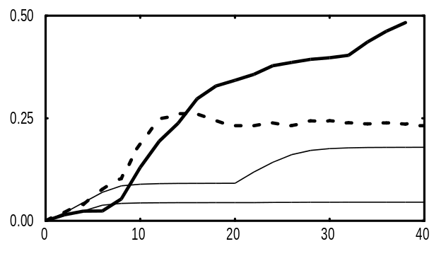Figure 7. Retrieval indices for situations A and B with and without mapping influence on access. The thick lines correspond to the parallel condition and replicate (with threefold magnification) the lines from the 'south-west' corner of Fig. 6. The thin lines show ‘pure’ retrieval indices. See text for details.
The thin lines in Figure 7 show the retrieval indices for the two situations when mapping mechanisms are suppressed. Thus, they indicate the ‘pure’ retrieval index of each situation—the value that is due to the access mechanism alone. The index for situation B is much higher than that of A and, therefore, B was used as source when the mapping was allowed to run only after the access had finished.
The step-like increases of the plots indicate moments in which an agent (or usually a tight sub-coalition of two or three agents) passes the working memory threshold. This happens, for example, with situation B between time 20 and 30 of the serial condition (the thin dashed line in Figure 7). Thus, accessing a source episode in Ambr is not an all-or-nothing affair. Instead, situations enter the working memory agent by agent and this process extends far after the beginning of the mapping. In this way, not only can the access influence the mapping but also the other way around.
In the interactive condition the mapping mechanism boosted the retrieval index via what we call a ‘bootstrap cascade’. This cascade operates in Ambr in the following way. First, the access mechanism brings two or three agents of a given situation into the working memory. If the mapping mechanism then detects that these few agents can be plausibly mapped to some target elements, it constructs new correspondence nodes and links in the Ambr network. This creates new paths for the highly active target elements to activate their mates. The latter in turn can then activate their ‘coalition partners’, thus bringing a few more agents into the working memory and so on.
The bootstrap cascade is possible in Ambr due to two important characteristics of this model. First, situations have decentralized representations which may be accessed piece by piece. Second, Ambr is based on a parallel cognitive architecture which provides for concurrent operation of numerous interacting processes. Taken together, these two factors enable seamless integration of the subprocesses of access and mapping in analogy-making.

Conclusion
The simulation experiment reported in this paper provides a clear example of mapping influence on analog access and of the advantages of the parallel interactionist view on analogy-making. Furthermore, the computational model Ambr provides a theoretical framework for explaining the controversies in the psychological data on access and reminding. It is possible to explore in which cases the interaction between access and mapping produces results different from a sequential and independent processing. It provides also a framework for generating more precise hypotheses and new experimental designs for their testing. Thus, for example, the detailed logs of the running model might be used for comparison with protocols of think-aloud experiments.
Analogy-making has certainly no clear cut boundaries. Most literature has concentrated on explicit analogies, i.e. consciously retrieving an analog and noticing the analogy. However, there are other cases which might be called implicit or partial analogies, e.g. subconsciously accessing part of a previously solved problem and mapping it to part of the target description without consciously noticing the analogy. The decentralized representations of situations in Ambr make it possible to model the process of partial access, access with distortions, blending (Turner & Fauconnier, 1995), and interference. A previously solved problem can influence the course of problem solving in an even more subtle way by priming some concepts or situations which then trigger a particular solution (Kokinov, 1990, Schunn and Dunbar, 1996). The Ambr model can be used to analyze such cases. It has already been successfully applied for predicting priming and context effects (Kokinov, 1994c).
Priming effects are an example of the influence of access on mapping which is the opposite direction of the one discussed in the current paper. Order effects are another kind of effect that goes in ‘forward’ direction. Such effects may be due to non-simultaneous perception of the elements of the target problem (Keane, Ledgeway, & Duff, 1994) and/or non-simultaneous retrieval of relevant pieces of information from LTM. Thus the mutual influence between analog access and mapping offers many opportunities for investigation.

REFERENCES
Falkenhainer, B., Forbus, K., and Gentner, D. (1986). The structure-mapping engine. Proceedings of the Fifth Annual Conference on Artificial Intelligence. Los Altos, CA: Morgan Kaufman.
Forbus K., Gentner D., and Law, K (1995). MAC/FAC: A model of similarity-based retrieval. Cognitive Science, 19, 141-205.
French, R. (1995). The subtlety of sameness: A theory and computer model of analogy-making. Cambridge, MA: MIT Press.
Gentner, D. (1983). Structure-mapping: A theoretical framework for analogy. Cognitive Science, 7, 155-170.
Gentner, D. (1989). The mechanisms of analogical learning. In S. Vosniadou and A. Ortony (Eds.), Simiarity and analogical reasoning. New York, NY: Cambridge University Press.
Gick, M.L. and Holyoak, K.J. (1980). Analogical problem solving. Cognitive Psychology 12 (80), 306-356.
Hofstadter, D. and the Fluid Analogies Research Group (1995). Fluid concepts and creative analogies: Comuter models of the fundamental mechanisms of thought. New York: Basic Books.
Holyoak K. and Koh K. (1987). Surface and structural similarity in analogical transfer. Memory and Cognition, 15 (4), 332-340.
Holyoak K. and Thagard P. (1989). Analogical mapping by constraint satisfaction. Cognitive Science, 13, 295-355.
Holyoak, K. and Thagard, P. (1995). Mental leaps: Analogy in creative thought. Cambridge, MA: MIT Press.
Hummel, J. and Holyoak, K. (1997). Distributed representation of structure: A theory of analogical access and mapping. Psychological Review, 104, 427-466.
Keane, M., Ledgeway, K., and Duff, S. (1994). Constraints on analogical mapping: A comparison of three models. Cognitive Science, 18, 387-438.
Kokinov, B. (1988). Associative memory-based reasoning: How to represent and retrieve cases. In T. O'Shea and V. Sgurev (Eds.), Artificial intelligence III: Methodology, systems, applications. Amsterdam: Elsevier.
Kokinov, B. (1990). Associative memory-based reasoning: Some experimental results. Proceedings of the Twelfth Annual Conference of the Cognitive Science Society. Hillsdale, NJ: Lawrence Erlbaum Associates.
Kokinov, B. (1994a). The context-sensitive cognitive architecture DUAL. Proceedings of the Sixteenth Annual Conference of the Cognitive Science Society. Hillsdale,NJ: Lawrence Erlbaum Associates.
Kokinov, B. (1994b). The Dual cognitive architecture: A hybrid multi-agent approach. Proceedings of the Eleventh European Conference of Artificial Intelligence. London: John Wiley & Sons, Ltd.
Kokinov, B. (1994c). A hybrid model of reasoning by Analogy. In K. Holyoak and J. Barnden (Eds.), Advances in Connectionist and Neural Computation Theory. Vol. 2: Analogical Connections. Norwood, NJ: Ablex Publishing Corp.
Kokinov,B., Nikolov,V., and Petrov,A. (1996). Dynamics of emergent computation in Dual. In A. Ramsay (Ed.), Artificial Intelligence: Methodology, Systems, Applications. Amsterdam: IOS Press.
Kuhn, T. S. (1970). The Structure of Scientific Revolutions (second ed., enlarged). Chicago: The University of Chicago Press. (First edition published 1962.)
Minsky, M. (1986). The society of mind. New York: Simon and Schuster.
Mitchell, M. (1993). Analogy-making as perception: A computer model. Cambridge, MA: MIT Press.
Petrov, A. (1997). Extensions of Dual and Ambr. M.Sc. Thesis. New Bulgarian University, Cognitive Science Department.
Ross, B. (1989). Distinguishing types of superficial similarities: Different effects on the access and use of earlier problems. Journal of Experimental Psychology: Learning, Memory, and Cognition, 15, 456-468.
Ross, B. and Kilbane, M. (1997). Effects of principle explanation and superficial similarity on analogical mapping in problem solving. Journal of Experimental Psychology: Learning, Memory, and Cognition, 23 (2), 427-440.
Ross, B. and Sofka, M. (1986). [Remindings: Noticing, remembering, and using specific knowledge of earlier problems]. Unpublished manuscript.
Schunn, C. and Dunbar, K. (1996). Priming, analogy, and awareness in complex reasoning. Memory and Cognition, 24, 271-284.
Thagard, P., Holyoak, K., Nelson, G., and Gochfeld, D. (1990). Analog retrieval by constraint satisfaction. Artificial Intelligence, 46, 259-310.
Turner, M. and Fauconnier, G. (1995). Conceptual integration and formal expression. Metaphor and Symbolic Activity, 10 (3), 183-204.
Wharton, C., Holyoak, K., and Lange, T. (1996). Remote analogical reminding. Memory and Cognition, 24 (5), 629-643.

It is still used today as an engineering approximation.

