Deepanshu Rekhi

14BCE0030

Sound Recognition and Its Applications

**Class Diagram**

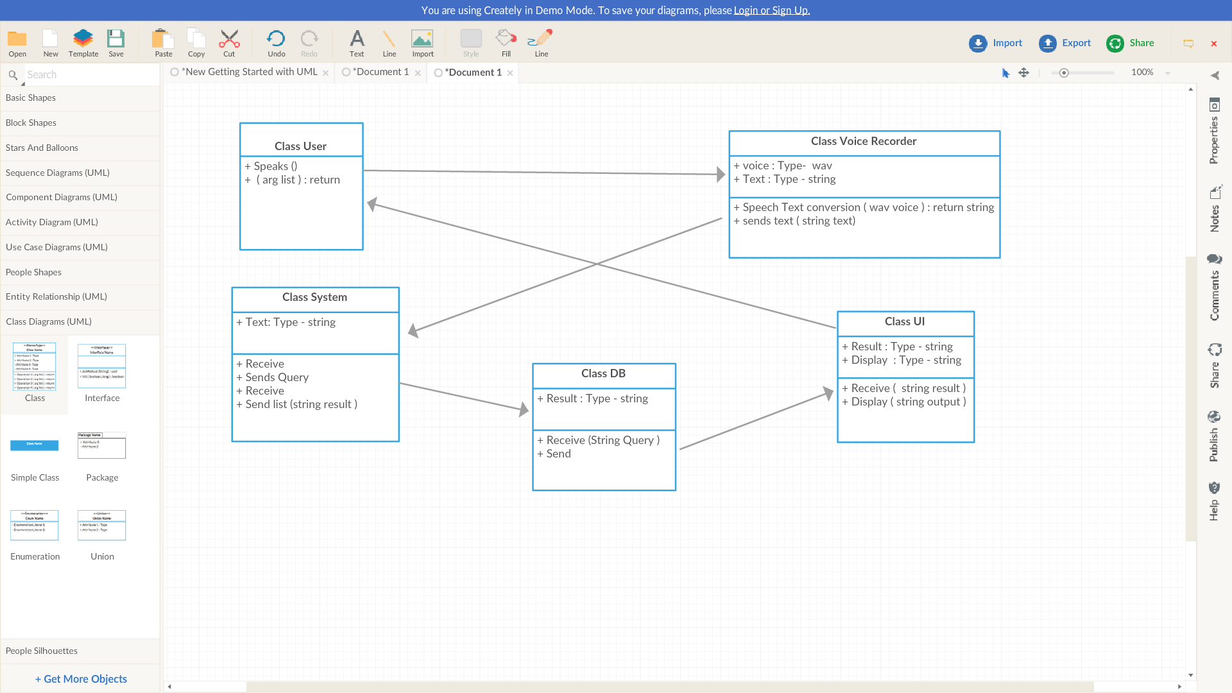

**Activity Diagram**

