Media in Transition: Beyond Border and Across Platforms

First name Middle initial. Last name

Faculty of Journalism and Mass Communication, Thammasat University

This research is supported by a grant from... . Correspondences concerning this article should be addressed to First name Middle initial. Last name, Faculty of Journalism and Mass Communication, Thammasat University, ... Rd., Bangkok, 10200,Thailand (email: [abcdefgh@tu.ac.th](mailto:abcdefgh@tu.ac.th))

Abstract

The abstract and keywords should be written in second page. The abstract should be written without bold, italics, underlining, or quotation marks and should be centered in the page. The abstract is a brief comprehensive summary of a research report. This section should include your research questions, indicated the participants involved with the study, as well as the methods, results, data analysis, conclusion and suggestion for future work. The length is 150 to 250 words written in one paragraph with double-spaced and no indentation.

Keywords: list 6 keywords here after colon (: ) with italicized font. Separate each word by comma (,).

Type the Title of Your Paper

**Introduction (Heading Level 1)**

Begin the body of your paper on page 3. The title of a paper should be centered on top of the page, and should not be bolded, underlined or italicized. The body can be separated into multiple sections and subsections. The paragraph text begins a double-spaced line below the heading, with .5” indentation at the start of each paragraph. Do not click Enter or Return key. Let the word processing software automatically adjust word wrapping or line breaking.

Click Return to start next paragraph. Authors need to follow APA 6th edition as guideline for in-text citation. The author must avoid plagiarism. Copied text and other materials from all sources in the paper will be considered misconduct. Citing direct quotes, paraphrasing, and summarizations is an easy way to avoid plagiarism. Any types of figures and tables taken from other sources must be cited.

**Method (Heading Level 1)**

The paragraph text begins a double-spaced line below the heading, with .5” indentation at the start of each paragraph.

**Population and Sample (Heading Level 2)**

The paragraph text begins a double-spaced line below the heading, with .5” indentation at the start of each paragraph.

**Sampling technique (Heading level 3).** Only the first letter of the heading word is uppercase and the remaining words are lowercase. Paragraph text begins two spaces after the period at the end of the heading

***Cluster sampling (Heading level 4).*** Your paragraph text begins two spaces after the period at the end of the heading.

*Reliability testing (Heading level 5). The paragraph text begins two spaces after the period at the end of the heading.*

**Results (Heading Level 1)**

The paragraph text begins a double-spaced line below the heading, with .5” indentation at the start of each paragraph. Results should be reported as written text, rather than just figures and table captions. Authors determine which figures and tables should be demonstrated in the manuscript.

Figures and tables should be located next to the text where they are mentioned. The titles of figures and tables should be placed on top while the captions should be written below. Figures include graphs, charts, maps, drawings, and photographs. Figure title and caption goes below figure. Tables are for descriptive and inferential statistic. The numerical values that are reported as a descriptive statistic and inferential statistic are rounded to two decimal places; whereas the p-value (alpha level) is rounded to two or three decimal places. All statistical symbols that are not Greek letters should be italicized (*M, SD, t, r, p*); and Greek symbols are not italicized (χ, α, β). The author should include effect sizes accompanied by 95% confidence intervals, standard deviations, significant level and correlation coefficient value.

Table1. (Type without italicize. Number each table consecutively.)

*Comparison of Marketing Factors and Customers’ Incomes for Personal Loan Services (Type Table Title in Italic)*

|  |  |  |  |  |  |  |
| --- | --- | --- | --- | --- | --- | --- |
| Marketing factors | Income (Baths) | Frequency | Mean | S.D. | F | Sig. |
| Product | 15,000-25,000 | 71 | 3.80 | 0.61 | 0.734 | 0.532 |
| 25,001-50,000 | 122 | 3.86 | 0.68 |  |  |
| 50,001-100,000 | 60 | 3.75 | 0.69 |  |  |
| 100,001 | 39 | 3.70 | 0.63 |  |  |
| Price | 15,000-25,000 | 71 | 3.27 | 0.65 | 0.279 | 0.840 |
| 25,001-50,000 | 122 | 3.19 | 0.87 |  |  |
| 50,001-100,000 | 60 | 3.17 | 0.94 |  |  |
| 100,001 | 39 | 3.29 | 0.87 |  |  |
| Place | 15,000-25,000 | 71 | 3.38 | 0.73 | 0.152 | 0.928 |
| 25,001-50,000 | 122 | 3.42 | 0.70 |  |  |
| 50,001-100,000 | 60 | 3.36 | 0.83 |  |  |
| 100,001 | 39 | 3.44 | 0.81 |  |  |
| Marketing Communications | 15,000-25,000 | 71 | 3.45 | 0.66 | 2.713 | 0.045* |
| 25,001-50,000 | 122 | 3.26 | 0.73 |  |  |
| 50,001-100,000 | 60 | 3.17 | 0.85 |  |  |
| 100,001 | 39 | 3.04 | 0.89 |  |  |

*p. < 0.05

*Note.* Begin the caption with the word Note in italic and a period. The author uses caption to describe the table. Caption locates below the table and should not be too long. Double spaces the entire table. Number every table in the manuscript consecutively. If the table comes from another source, please identify the original source of the table e.g. Note. , Note. From..., Note. Adapted from..., or Note. Reprinted from....

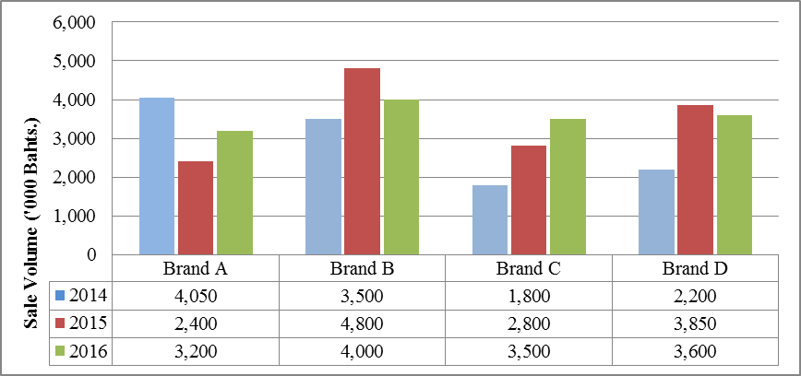

*Figure 1.* Brand Sale Volume in Year 2014-2016

*Note.* Figure title, and caption describe graphs, image, chart, photograph that the author wants to illustrate. Do not italicize figure title. Type figure number and the word Note in italic below the illustrated figure. Number every figure in the manuscript consecutively. If the figure comes from another source, please identify the original source of the figure e.g. Note. , Note. From..., Note. Adapted from..., or Note. Reprinted from.... Do not forget to write the copyright holder.

**Discussion (Heading Level 1)**

The paragraph text begins a double-spaced line below the heading with .5” indentation. The discussion should be a clear and comprehensive conclusion of your research results. The author should interpret the findings. Please elucidate whether research questions were solved. Give clear explanation on hypotheses testing. Interpret the results and discuss the significance of the findings. The discussion must relate to theory and concept referred in your literature review. Provide recommendations for future research on the same or related area of study.

When finish typing the body of your paper, click the Insert then click the Page Break to begin the new page for Reference. Word-processing software automatically adjusts word wrapping or line breaking.

**Reference (Heading Level 1)**

American Psychological Association. (2010). *Publication manual of the American Psychological Association*. Washington, DC: American Psychological Association.

Carlson, L. (2015). The Journal of Advertising: Historical, Structural, and Brand Equity Considerations. Journal of Advertising, 44(1), 80-84. doi:10.1080/00913367.2014.993487

Doyle, G. (2010). From Television to Multi-Platform: Less From More or More For Less. *Convergence: The International Journal of Research h into New Media Technologies, 16*(4), 1-19. doi:10.1177/1354856510375145

Nguyen, A., & Western, M. (2006). The Complementary Relationship between the Internet and Traditional Mass Media: The Case of Online News and Information. *Information Research, 11*(3). Retrieved 2014