Dennis Rendon

Project #4

05/31/17

CIS 305.01

Spring 2017

# Table of Contents

Table of Contents 1

Statement of Academic Honesty 3

Deliverable 1. Improved Database ERD 4

Deliverable 2. Price Change Data 5

3-A List all of the products provided by each supplier in alphabetical order with the least expensive products shown first for each supplier. Hint: Be sure to include the Product ID, Product Description, Supplier ID, Supplier Name, Vendor Part #, and Cost. 17

3-B Which sales representative has the highest dollar amount in total sales? Hint: Provide the name and the total sales amount for that rep only. Do not include the information for other people, and do not list details about orders. 18

3-C List all of the sales reps and their total commission amounts in order of highest sales commission dollar amount first. Hint: Provide all of sales reps’ names and their total commission dollar amounts – imagine that you were going to write one check to each sales rep to pay their total commission amount, so be sure to produce that dollar amount. Extra Hint: Not all of the sales reps have sold any orders. 19

3-D Which sales representative has sold the most products? Hint: Name of the sales rep and a number representing the total number of distinct products sold by that rep. This is the number of different products they have sold, not the quantity of any products. 21

3-E Which sales representative has generated the most profit for the company? Hint: Provide the name of the sales rep and the total profit amount only. This one SQL statement will have subqueries. You must determine the profitability of a product by subtracting its cost from its selling price and multiplying the difference by the quantity sold. Regarding the cost, many products are supplied by more than one supplier, and each supplier may provide a different cost, so when this occurs, use the least expensive cost in measuring your profitability. 22

3-F Provide a listing of all of the details for each order. The report must be organized by sales rep, then alphabetically by each customer for that sales rep, and then by each Order ID for that customer. The listing must include the Sales Rep’s name, Customer Name, Order ID, Order Date, Due Date, Product ID, Product Description, Quantity Purchased, and Unit Price. 24

3-G List the suppliers that provide hack saws, and sort the list with the lowest prices first. Hint: Your SQL statement must look for a “Hack Saw”, and not some ProductID or PartID. Include the Supplier IDs, Supplier Names, Vendor Part #s, and cost. 26

3-H Show the components and cost of materials for fabricating a hack saw. Hint: Your SQL statement must look for a “Hack Saw”, and not some ProductID or PartID. Include the ProductID (really PartID), Product Description, and Quantity Used for each component of a hack saw. 27

3-I Which customer purchased the overall largest dollar amount? Hint: One name and the total dollar amount only – the result should be one record only. 28

3-J Provide an inventory report based on ’17-MAY-2017’ that lists the most costly items first. Hint: The most costly item is the one in which the product (i.e., multiplication) of cost and quantity yields the largest value, in other words, the item that we have spent the most money on. Include Product ID, Product Description, Unit Price, Cost, Quantity Purchased, Amount Spent (the product of Quantity Purchased and Cost), Supplier ID, and Supplier Name. 29

3-K Provide an inventory report based on ’17-MAY-2017’ that lists the most profitable items first. Hint: The most profitable item is the one in which the difference between the sales price and the purchase cost yields the largest value, in other words, the item that we can potentially make the most money on. Include Product ID, Product Description, Unit Price, Cost, Profit Margin (difference between price and cost), Supplier ID, and Supplier Name. 31

3-L List all the employees in alphabetical order and each course they have completed in order of date completed. Hint: Include all employee names even if they didn’t complete any courses, course ID, course name, and date of completion. Also, think about the way to sort individuals by alphabetical order. 33

3-M List the ProductIDs, product descriptions, and unit prices that are valid on July 14, 2016 for all products sorted by ProductID. Hint: Search for prices valid on ’14-JUL-2016’ 34

3-N Who are the employees that report directly to Sam Drucker’s manager? Provide the information by their names in alphabetical order, and include their Employee IDs and Job Titles. Hint: Your SQL statement must look for “Sam” and “Drucker”, and not some EmployeeID that was not given to you in the problem statement. 35

3-O What is the information relevant to order ID 1527? I want to know the Customer Name, Customer City, State, Sales Rep’s Name, Order Date, Due Date, Ship Date, Customer PO Number, ProductID, Product Description, Order Quantity, and Unit Price. Hint: Be sure that every item on the order is included and be sure that the price is valid for that order date. 36

# Statement of Academic Honesty

I, Dennis Rendon, certify that I have completed my assignment alone, without discussing this project with anyone, other than the professor for this course, and I did not obtain any Internet-based solutions for this project.

# Deliverable 1. Improved Database ERD

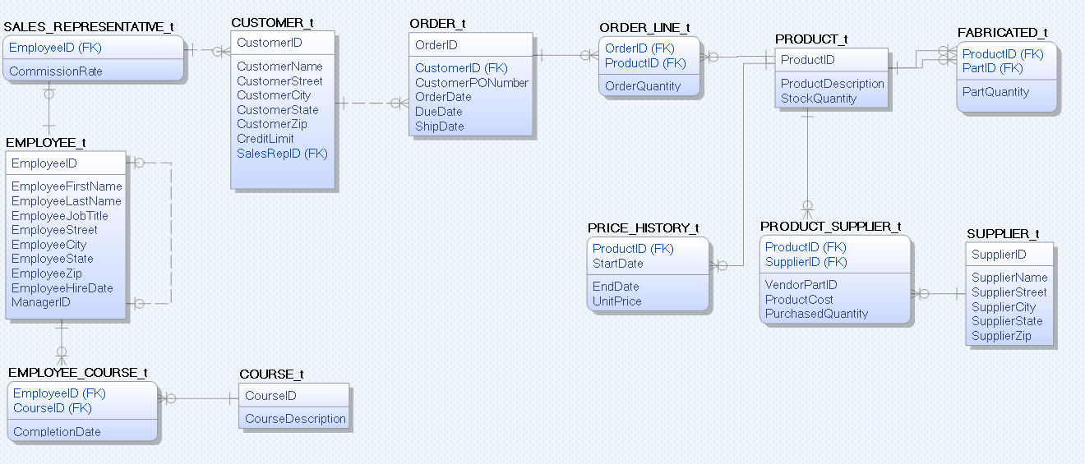

# Deliverable 2. Price Change Data

COURSE_t

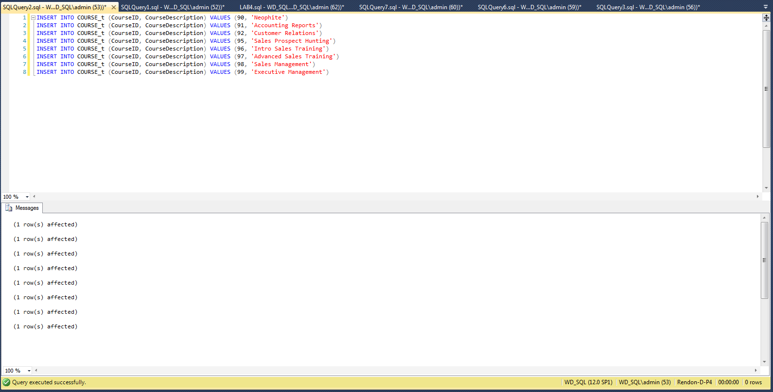

EMPLOYEE_t

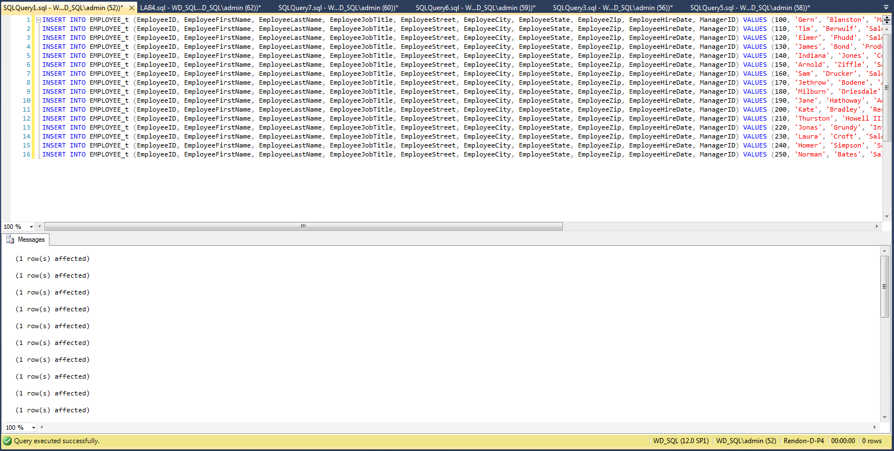

SUPPLIER_t

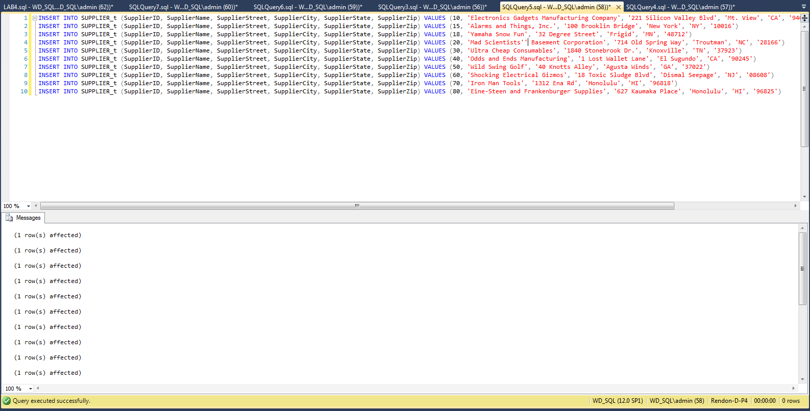

SALES_REPRESENTATIVE_t

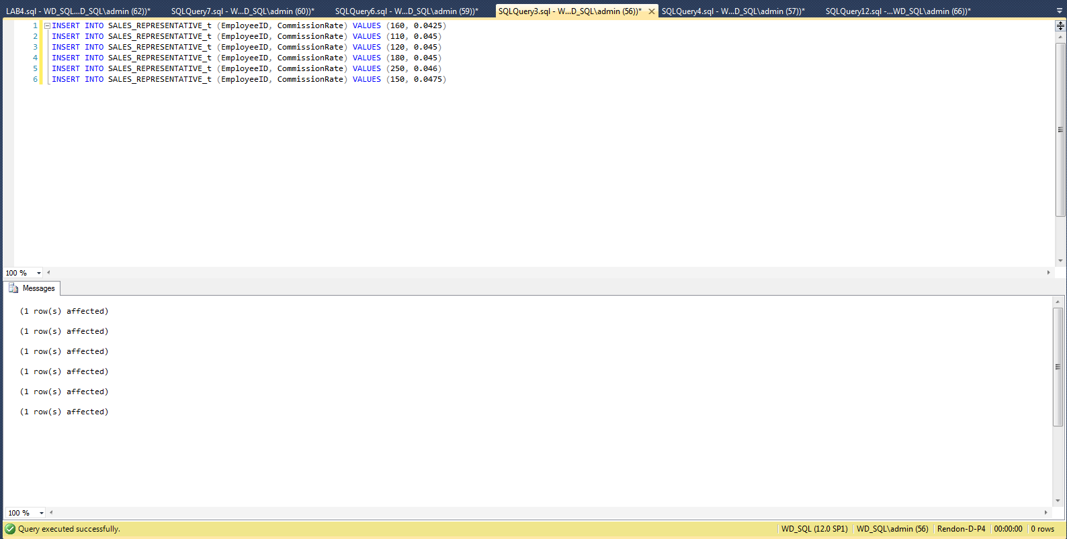

PRODUCT_t

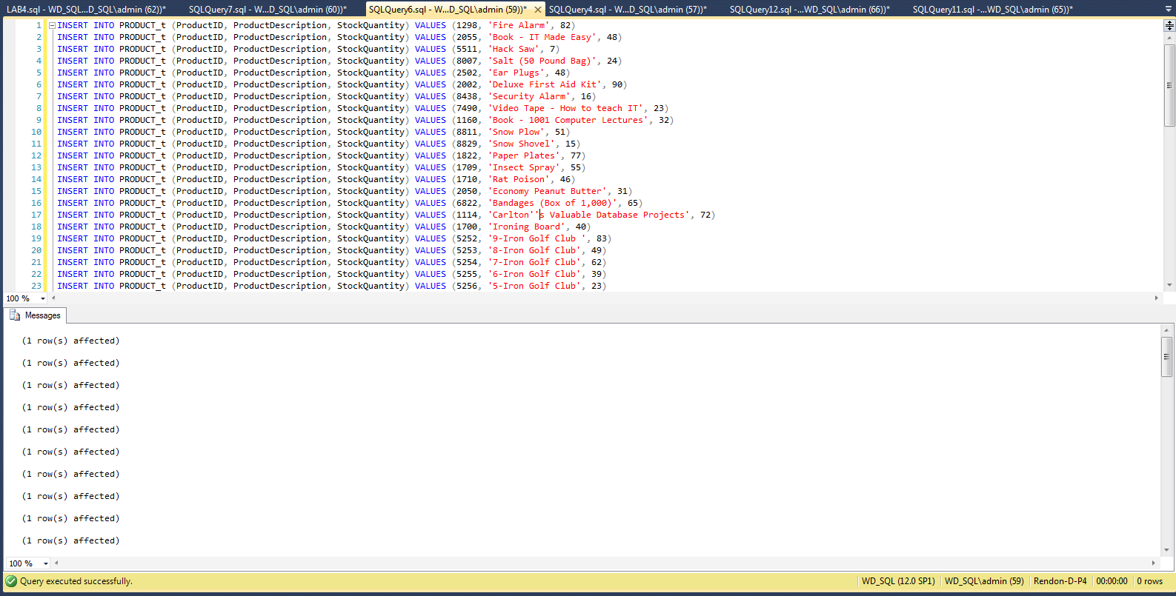

FABRICATED_t

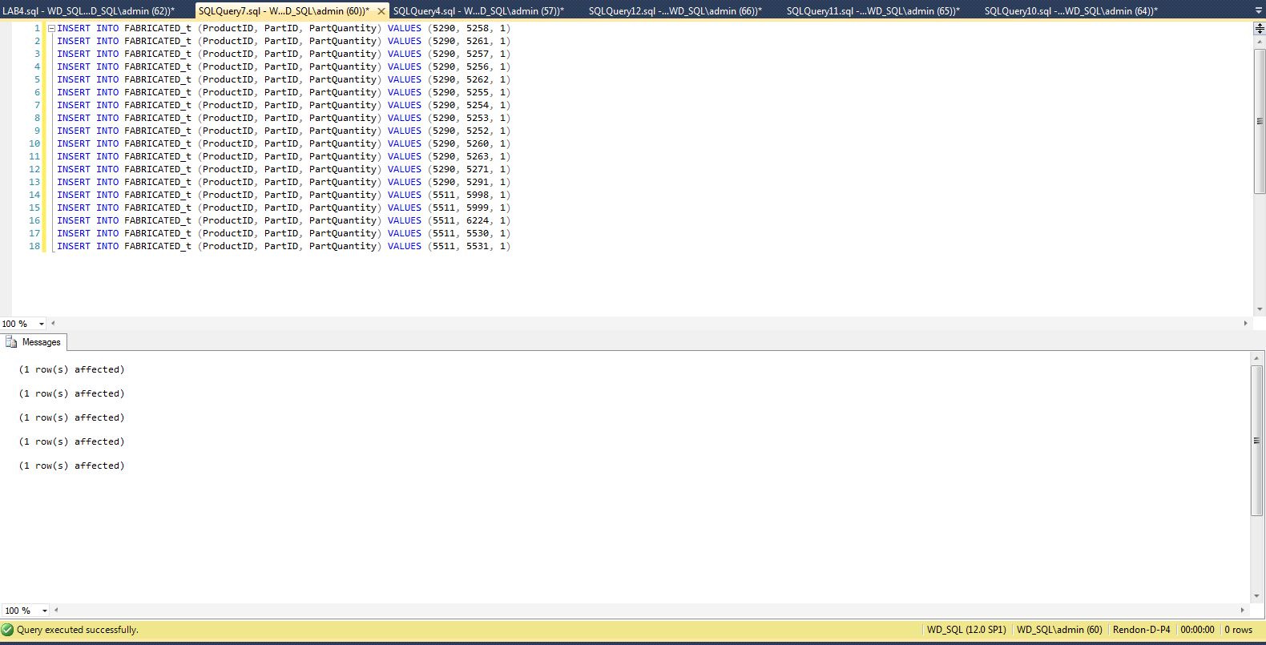

EMPLOYEE_COURSE_t

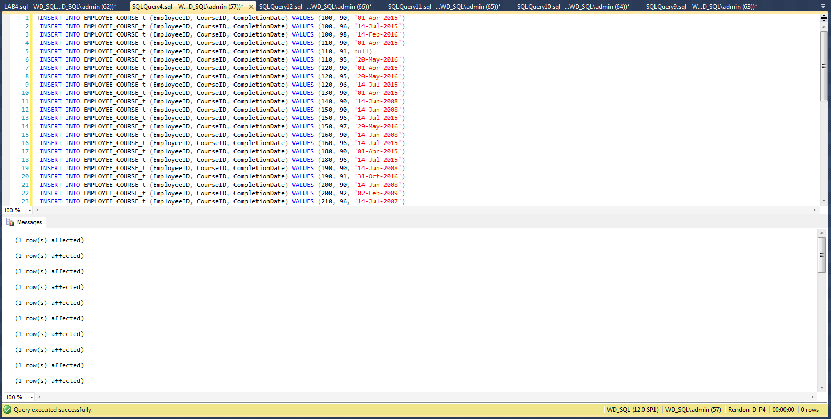

ORDER_LINE_t

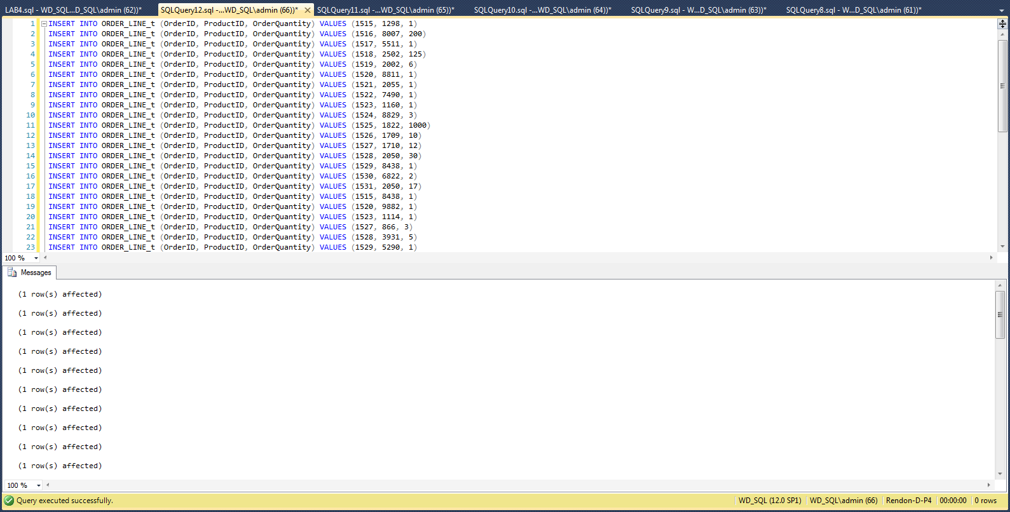

ORDER_t

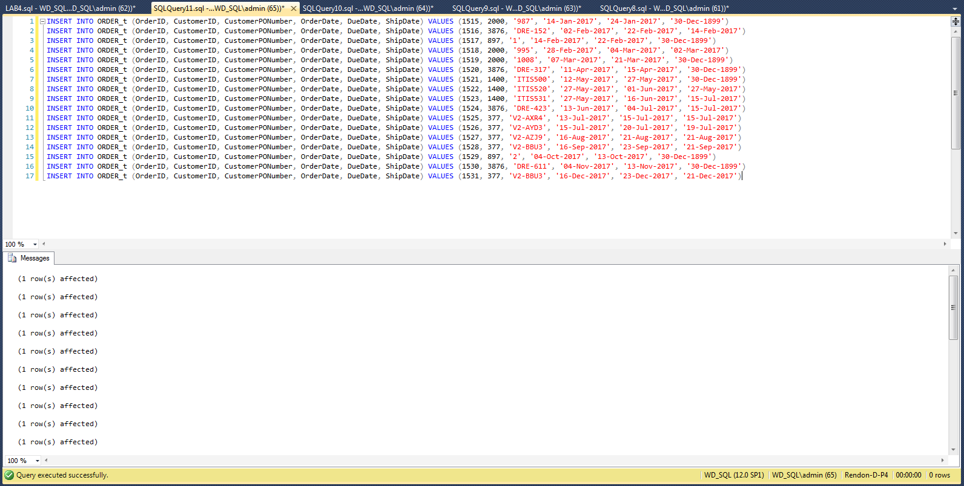

CUSTOMER_t

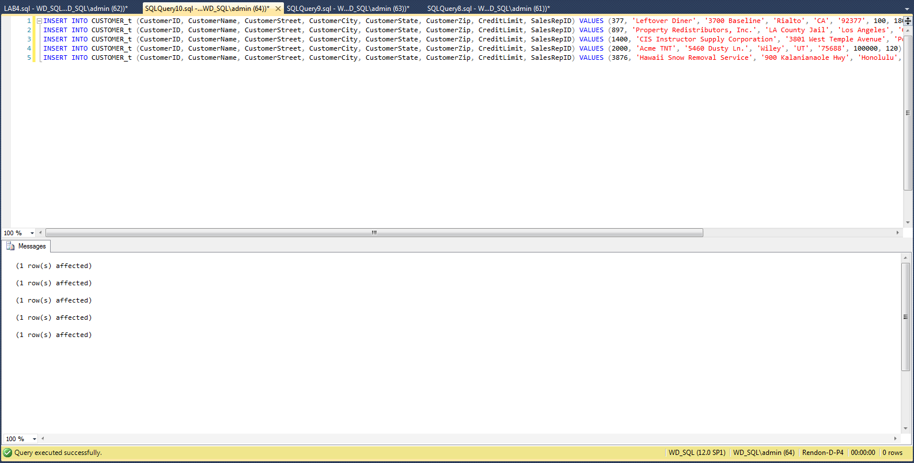

PRICE_HISTORY_t

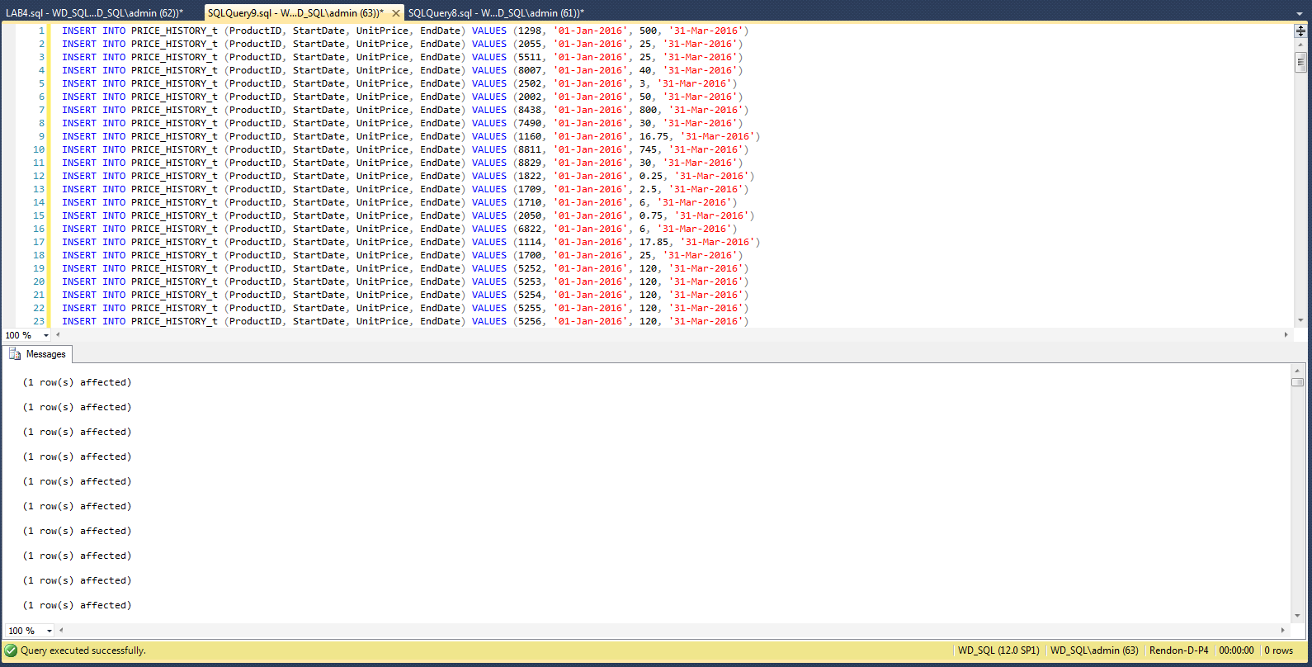

PRODUCT_SUPPLIER_t

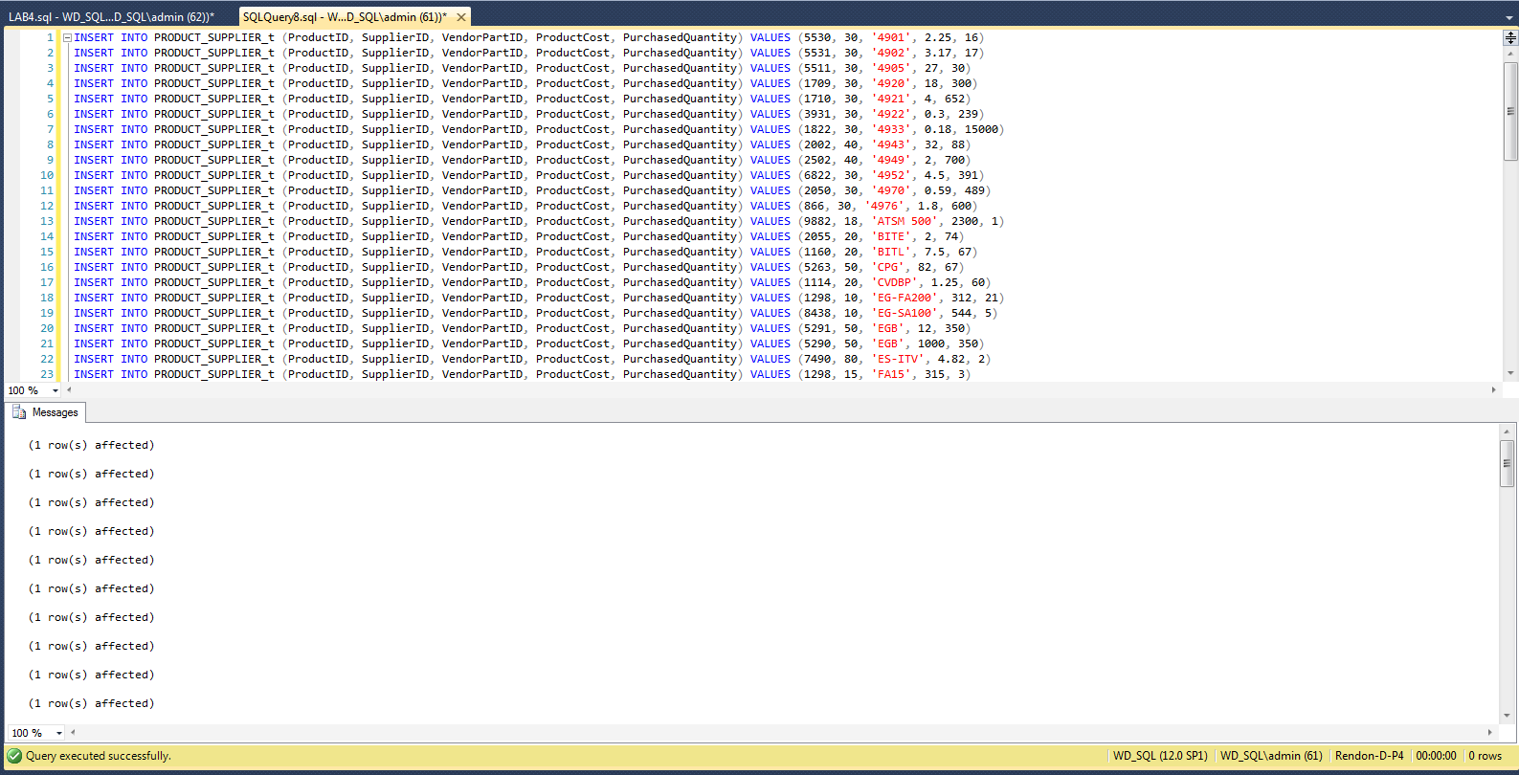

# 3-A List all of the products provided by each supplier in alphabetical order with the least expensive products shown first for each supplier. Hint: Be sure to include the Product ID, Product Description, Supplier ID, Supplier Name, Vendor Part #, and Cost.

SELECT P.ProductID, P.ProductDescription, S.SupplierID,

S.SupplierName, PS.VendorPartID, PS.ProductCost

FROM PRODUCT_t AS P, PRODUCT_SUPPLIER_t AS PS, SUPPLIER_t AS S

WHERE P.ProductID = PS.ProductID

AND PS.SupplierID = S.SupplierID

ORDER BY S.SupplierName, PS.ProductCost

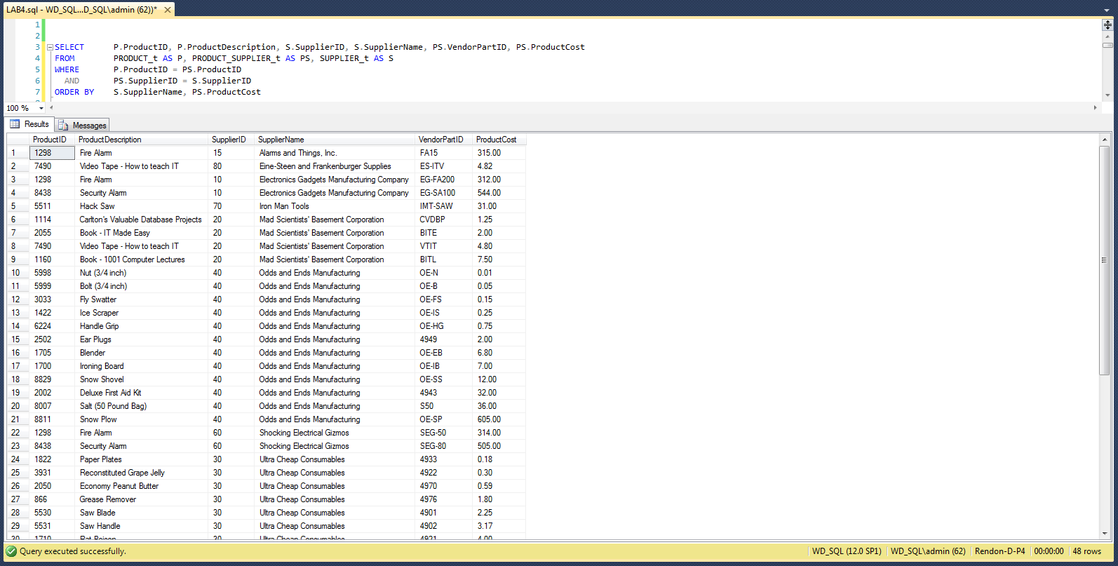

# 3-B Which sales representative has the highest dollar amount in total sales? Hint: Provide the name and the total sales amount for that rep only. Do not include the information for other people, and do not list details about orders.

SELECT TOP 1 E.EmployeeFirstName + ' ' + E.EmployeeLastName AS SalesRep,

SUM(PH.UnitPrice * OL.OrderQuantity) AS TotalSales

FROM EMPLOYEE_t AS E, CUSTOMER_t AS C, ORDER_t AS O,

ORDER_LINE_t AS OL, PRICE_HISTORY_t AS PH

WHERE E.EmployeeID = C.SalesRepID

AND C.CustomerID = O.CustomerID

AND O.OrderID = OL.OrderID

AND OL.ProductID = PH.ProductID

AND O.OrderDate >= PH.StartDate

AND O.OrderDate <= PH.EndDate

GROUP BY E.EmployeeFirstName + ' ' + E.EmployeeLastName

ORDER BY TotalSales DESC

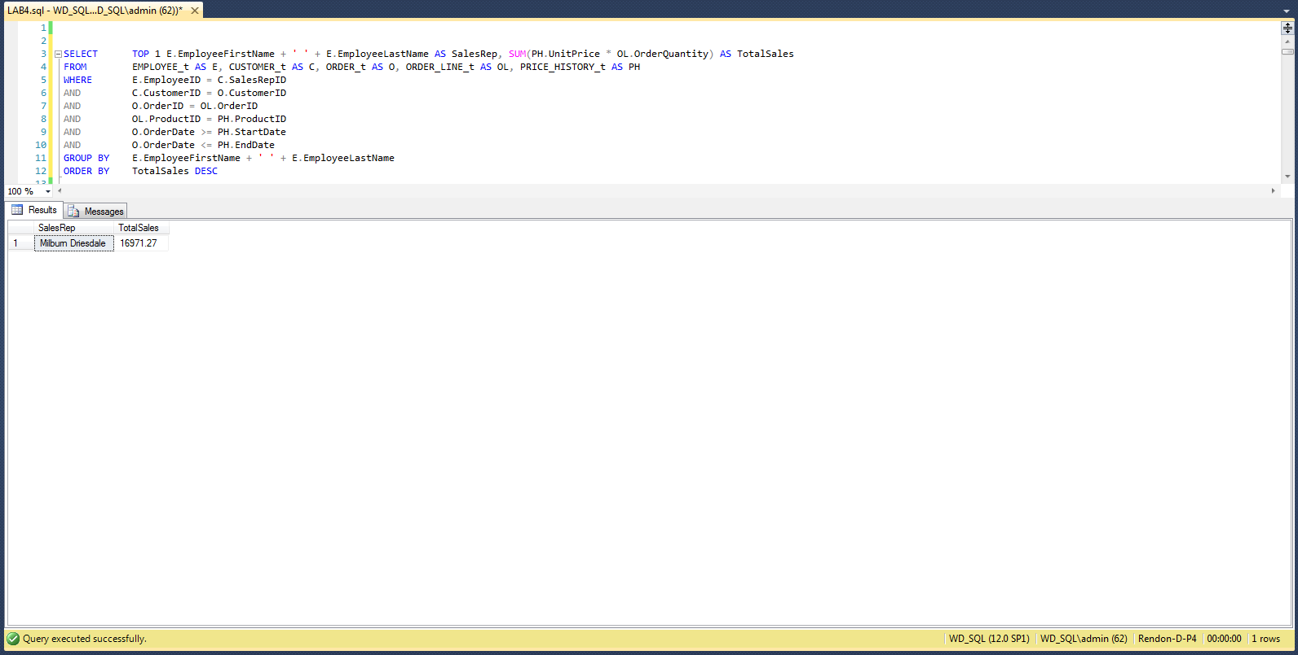

# 3-C List all of the sales reps and their total commission amounts in order of highest sales commission dollar amount first. Hint: Provide all of sales reps’ names and their total commission dollar amounts – imagine that you were going to write one check to each sales rep to pay their total commission amount, so be sure to produce that dollar amount. Extra Hint: Not all of the sales reps have sold any orders.

SELECT E.EmployeeFirstName + ' ' + E.EmployeeLastName AS SalesRep,

SUM(CustomerSales.TotalSale * S.CommissionRate) AS

TotalCommission

FROM SALES_REPRESENTATIVE_t AS S, EMPLOYEE_t AS E LEFT OUTER JOIN

(

SELECT C.SalesRepID,

SUM(PH.UnitPrice * OL.OrderQuantity) AS TotalSale

FROM CUSTOMER_t AS C, ORDER_t AS O, ORDER_LINE_t AS OL,

PRICE_HISTORY_t AS PH

WHERE C.CustomerID = O.CustomerID

AND O.OrderID = OL.OrderID

AND OL.ProductID = PH.ProductID

AND O.OrderDate >= PH.StartDate

AND O.OrderDate <= PH.EndDate

GROUP BY C.SalesRepID

) AS CustomerSales

ON E.EmployeeID = CustomerSales.SalesRepID

WHERE S.EmployeeID = E.EmployeeID

GROUP BY E.EmployeeFirstName + ' ' + E.EmployeeLastName

ORDER BY TotalCommission DESC

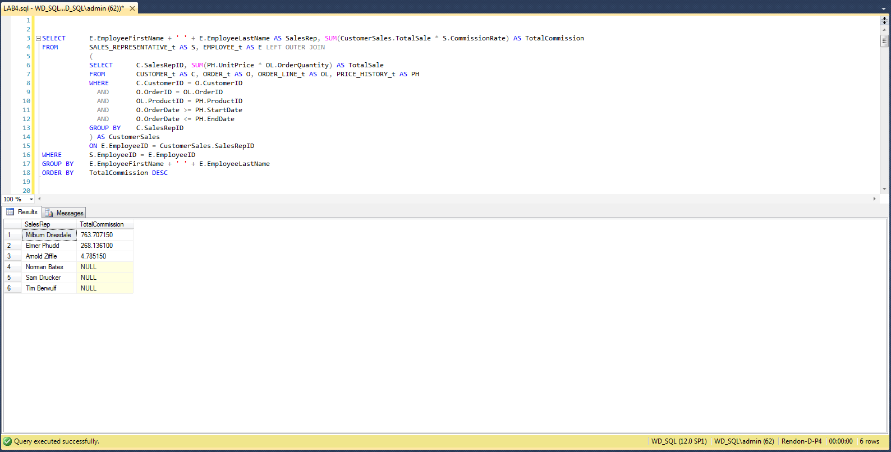

# 3-D Which sales representative has sold the most products? Hint: Name of the sales rep and a number representing the total number of distinct products sold by that rep. This is the number of different products they have sold, not the quantity of any products.

SELECT E.EmployeeFirstName + ' ' + E.EmployeeLastName AS SalesRep,

COUNT(O.ProductID) AS CountOfProducts

FROM EMPLOYEE_t AS E,

(

SELECT DISTINCT C.SalesRepID, OL.ProductID

FROM CUSTOMER_t AS C, ORDER_t AS O, ORDER_LINE_t AS OL

WHERE C.CustomerID = O.CustomerID

AND O.OrderID = OL.OrderID

) AS O

WHERE E.EmployeeID = O.SalesRepID

GROUP BY E.EmployeeFirstName + ' ' + E.EmployeeLastName

ORDER BY CountOfProducts DESC

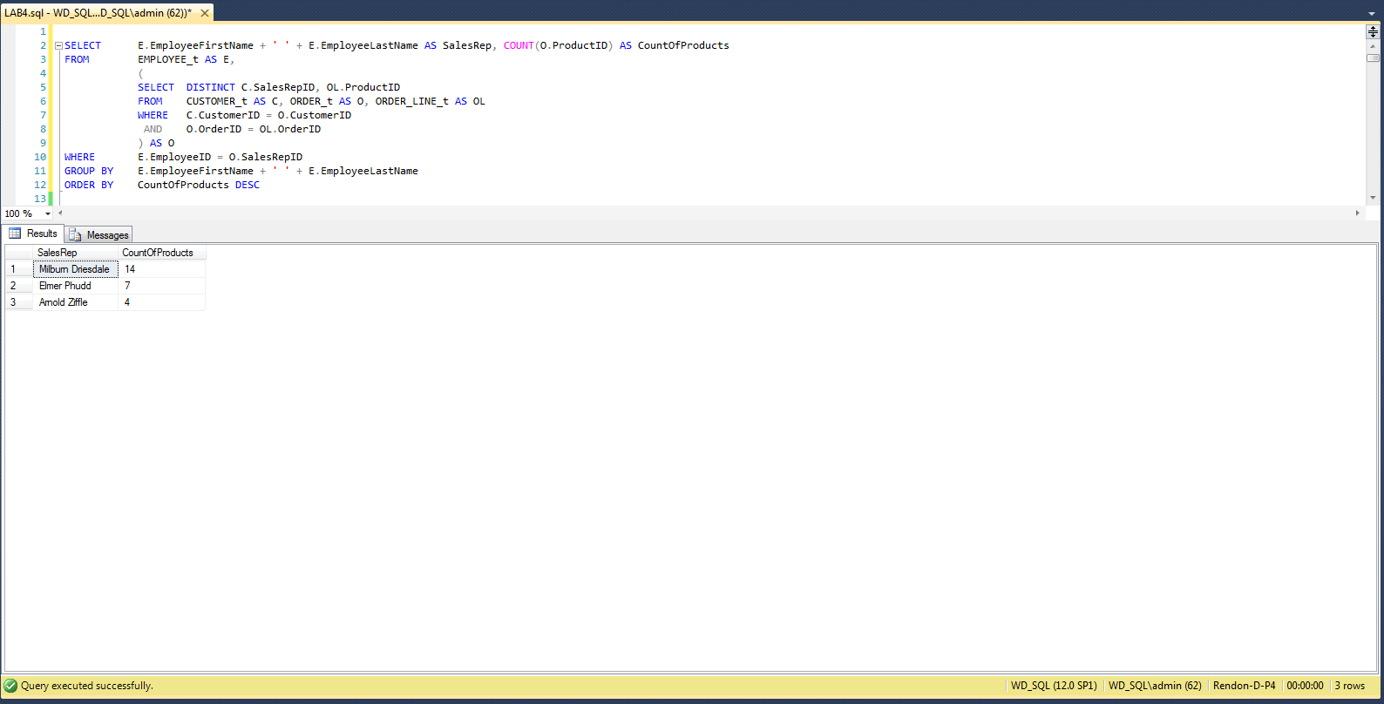

# 3-E Which sales representative has generated the most profit for the company? Hint: Provide the name of the sales rep and the total profit amount only. This one SQL statement will have subqueries. You must determine the profitability of a product by subtracting its cost from its selling price and multiplying the difference by the quantity sold. Regarding the cost, many products are supplied by more than one supplier, and each supplier may provide a different cost, so when this occurs, use the least expensive cost in measuring your profitability.

SELECT TOP 1 E.EmployeeFirstName + ' ' + E.EmployeeLastName AS SalesRep,

PP.ProductProfit * OL.OrderQuantity AS TotalProfit

FROM EMPLOYEE_t AS E, CUSTOMER_t AS C, ORDER_t AS O,

ORDER_LINE_t AS OL,

(

SELECT PH.UnitPrice - MIN(PS.ProductCost) AS ProductProfit,

PS.ProductID, PH.StartDate, PH.EndDate

FROM PRODUCT_SUPPLIER_t AS PS, PRICE_HISTORY_t AS PH

WHERE PS.ProductID = PH.ProductID

GROUP BY PS.ProductID, PH.StartDate, PH.EndDate, PH.UnitPrice

) AS PP

WHERE E.EmployeeID = C.SalesRepID

AND C.CustomerID = O.CustomerID

AND O.OrderID = OL.OrderID

AND OL.ProductID = PP.ProductID

AND O.OrderDate >= PP.StartDate

AND O.OrderDate <= PP.EndDate

ORDER BY TotalProfit DESC

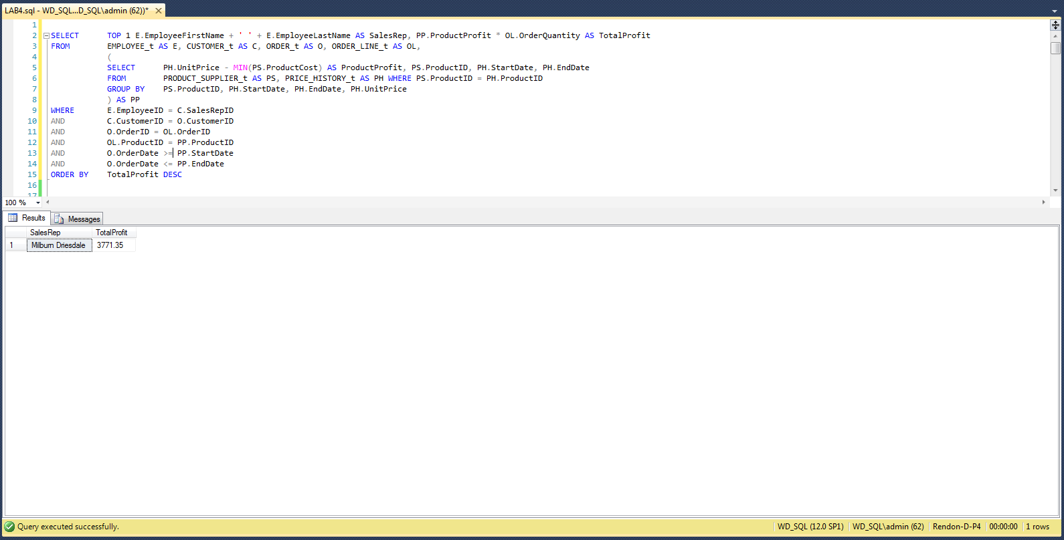

# 3-F Provide a listing of all of the details for each order. The report must be organized by sales rep, then alphabetically by each customer for that sales rep, and then by each Order ID for that customer. The listing must include the Sales Rep’s name, Customer Name, Order ID, Order Date, Due Date, Product ID, Product Description, Quantity Purchased, and Unit Price.

SELECT E.EmployeeFirstName + ' ' + E.EmployeeLastName AS SalesRep,

C.CustomerName, O.OrderID, O.OrderDate, O.DueDate, OL.ProductID,

P.ProductDescription, PS.PurchasedQuantity, PH.UnitPrice

FROM EMPLOYEE_t AS E, CUSTOMER_t AS C, ORDER_t AS O,

ORDER_LINE_t AS OL, PRODUCT_t AS P, PRODUCT_SUPPLIER_t AS PS,

PRICE_HISTORY_t AS PH

WHERE E.EmployeeID = C.SalesRepID

AND C.CustomerID = O.CustomerID

AND O.OrderID = OL.OrderID

AND OL.ProductID = P.ProductID

AND P.ProductID = PS.ProductID

AND P.ProductID = PH.ProductID

AND O.OrderDate >= PH.StartDate

AND O.OrderDate <= PH.EndDate

ORDER BY E.EmployeeLastName, E.EmployeeFirstName,

C.CustomerName, O.OrderID

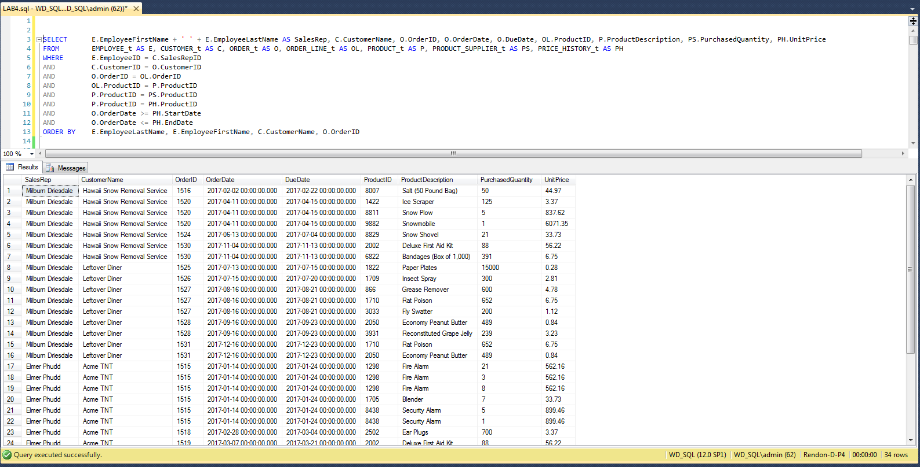

# 3-G List the suppliers that provide hack saws, and sort the list with the lowest prices first. Hint: Your SQL statement must look for a “Hack Saw”, and not some ProductID or PartID. Include the Supplier IDs, Supplier Names, Vendor Part #s, and cost.

SELECT PS.SupplierID, S.SupplierName, PS.VendorPartID, PS.ProductCost

FROM PRODUCT_t AS P, PRODUCT_SUPPLIER_t AS PS, SUPPLIER_t AS S

WHERE P.ProductDescription = 'HACK SAW'

AND P.ProductID = PS.ProductID

AND PS.SupplierID = S.SupplierID

ORDER BY PS.ProductCost

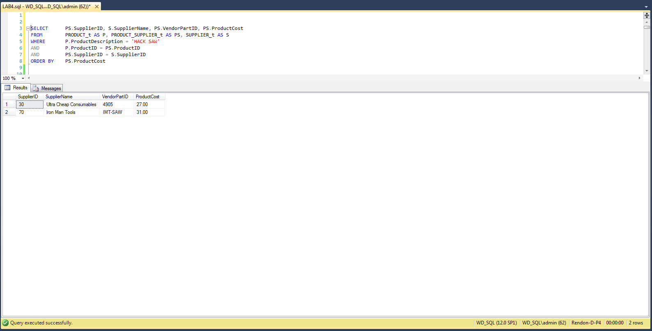

# 3-H Show the components and cost of materials for fabricating a hack saw. Hint: Your SQL statement must look for a “Hack Saw”, and not some ProductID or PartID. Include the ProductID (really PartID), Product Description, and Quantity Used for each component of a hack saw.

SELECT Parts.ProductID, Parts.ProductDescription, F.PartQuantity

FROM FABRICATED_t AS F, PRODUCT_t AS P, PRODUCT_t AS Parts

WHERE P.ProductDescription = 'HACK SAW'

AND F.ProductID = P.ProductID

AND F.PartID = Parts.ProductID

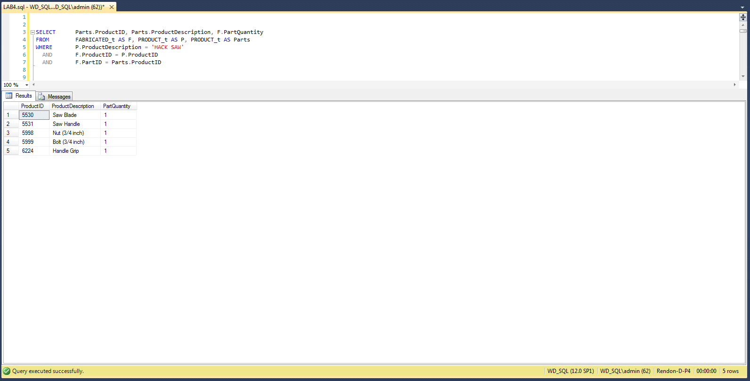

# 3-I Which customer purchased the overall largest dollar amount? Hint: One name and the total dollar amount only – the result should be one record only.

SELECT TOP 1 C.CustomerName, TS.TotalSales

FROM CUSTOMER_t AS C,

(

SELECT O.CustomerID, SUM(PH.UnitPrice) AS TotalSales

FROM ORDER_t AS O, ORDER_LINE_t AS OL,

PRICE_HISTORY_t AS PH

WHERE O.OrderID = OL.OrderID

AND OL.ProductID = PH.ProductID

AND O.OrderDate >= PH.StartDate

AND O.OrderDate <= PH.EndDate

GROUP BY O.CustomerID

) AS TS

WHERE C.CustomerID = TS.CustomerID

ORDER BY TS.TotalSales DESC

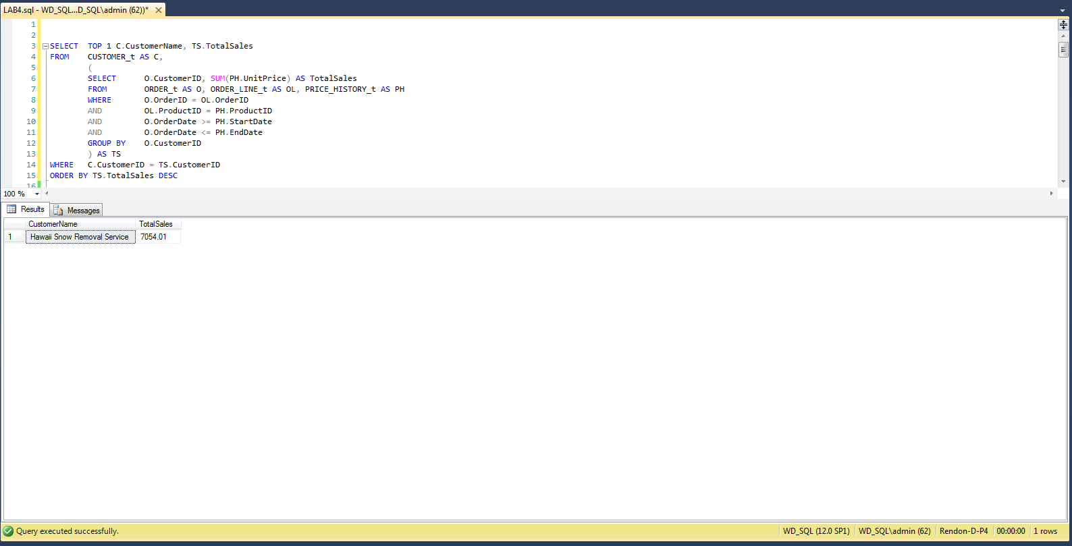

# 3-J Provide an inventory report based on ’17-MAY-2017’ that lists the most costly items first. Hint: The most costly item is the one in which the product (i.e., multiplication) of cost and quantity yields the largest value, in other words, the item that we have spent the most money on. Include Product ID, Product Description, Unit Price, Cost, Quantity Purchased, Amount Spent (the product of Quantity Purchased and Cost), Supplier ID, and Supplier Name.

SELECT P.ProductID, P.ProductDescription, PH.UnitPrice, PS.ProductCost,

PS.PurchasedQuantity,

(PS.ProductCost * PS.PurchasedQuantity) AS AmountSpent,

PS.SupplierID, S.SupplierName

FROM PRODUCT_t AS P, PRODUCT_SUPPLIER_t AS PS, SUPPLIER_t AS S,

PRICE_HISTORY_t AS PH

WHERE P.ProductID = PS.ProductID

AND PS.SupplierID = S.SupplierID

AND PH.ProductID = P.ProductID

AND '17-MAY-2017' BETWEEN StartDate AND EndDate

ORDER BY AmountSpent DESC

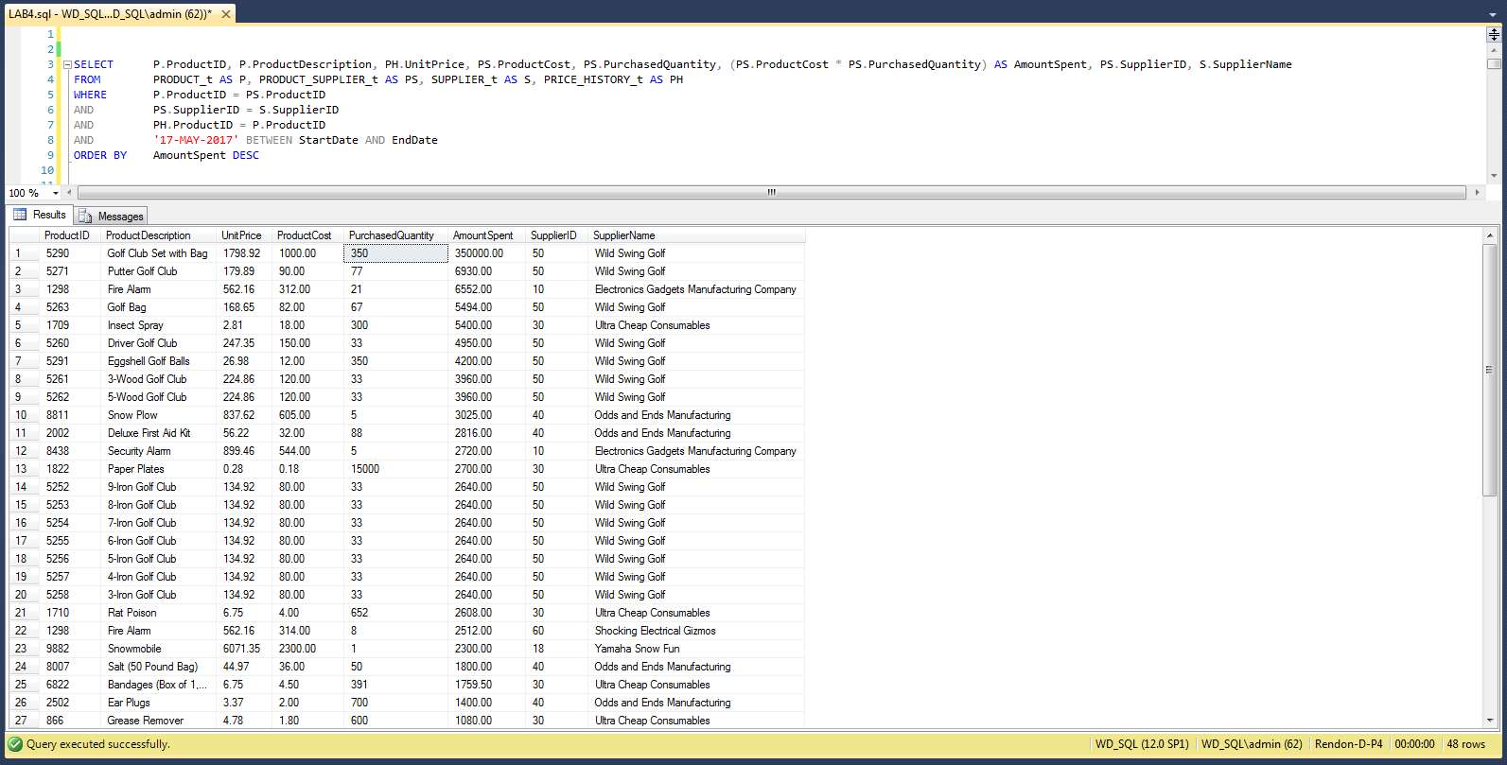

# 3-K Provide an inventory report based on ’17-MAY-2017’ that lists the most profitable items first. Hint: The most profitable item is the one in which the difference between the sales price and the purchase cost yields the largest value, in other words, the item that we can potentially make the most money on. Include Product ID, Product Description, Unit Price, Cost, Profit Margin (difference between price and cost), Supplier ID, and Supplier Name.

SELECT P.ProductID, P.ProductDescription, PH.UnitPrice, PS.ProductCost,

(PH.UnitPrice - PS.ProductCost) AS ProfitMargin, PS.SupplierID,

S.SupplierName

FROM PRODUCT_t AS P, PRODUCT_SUPPLIER_t AS PS, SUPPLIER_t AS S,

PRICE_HISTORY_t AS PH

WHERE P.ProductID = PS.ProductID

AND PS.SupplierID = S.SupplierID

AND PH.ProductID = P.ProductID

AND '17-MAY-2017' BETWEEN StartDate AND EndDate

ORDER BY ProfitMargin DESC

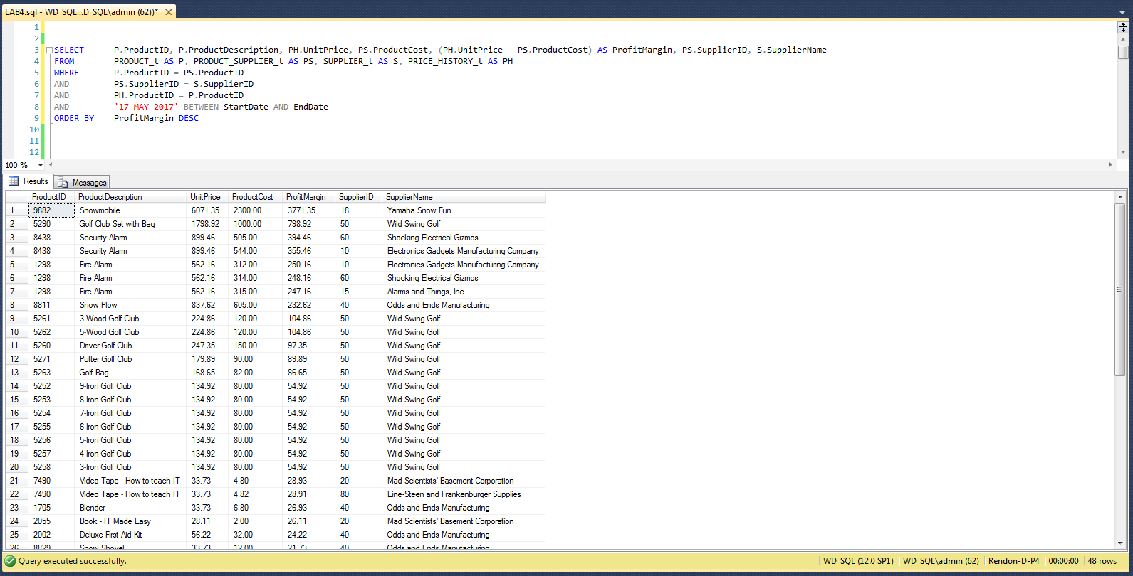

# 3-L List all the employees in alphabetical order and each course they have completed in order of date completed. Hint: Include all employee names even if they didn’t complete any courses, course ID, course name, and date of completion. Also, think about the way to sort individuals by alphabetical order.

SELECT E.EmployeeFirstName + ' ' + E.EmployeeLastName AS EmployeeName,

CC.CourseID, CC.CourseDescription AS CourseName,

CC.CompletionDate

FROM EMPLOYEE_t AS E LEFT OUTER JOIN

(

SELECT EC.EmployeeID, EC.CompletionDate, EC.CourseID,

C.CourseDescription

FROM EMPLOYEE_COURSE_t AS EC, COURSE_t AS C

WHERE EC.CourseID = C.CourseID

) AS CC

ON E.EmployeeID = CC.EmployeeID

ORDER BY E.EmployeeLastName, E.EmployeeFirstName, CC.CompletionDate

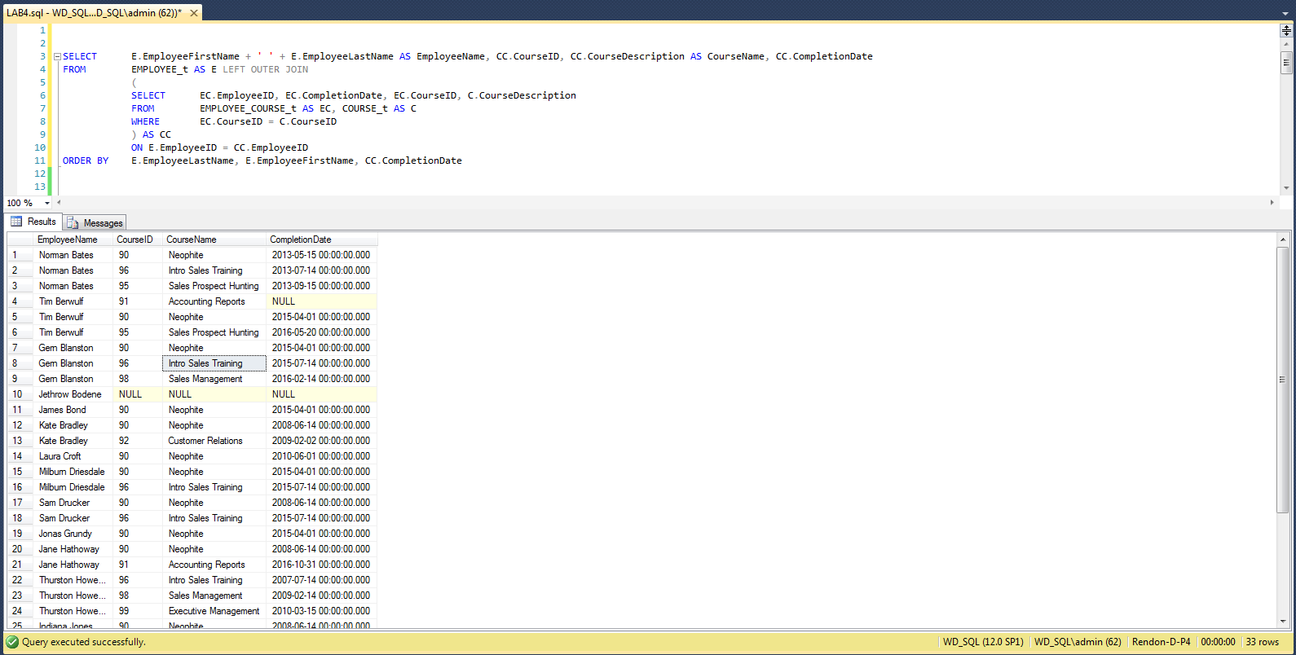

# 3-M List the ProductIDs, product descriptions, and unit prices that are valid on July 14, 2016 for all products sorted by ProductID. Hint: Search for prices valid on ’14-JUL-2016’

SELECT P.ProductID, P.ProductDescription, PH.UnitPrice

FROM PRODUCT_t AS P, PRICE_HISTORY_t AS PH

WHERE P.ProductID = PH.ProductID

AND '14-JUL-2016' BETWEEN StartDate AND EndDate

ORDER BY P.ProductID

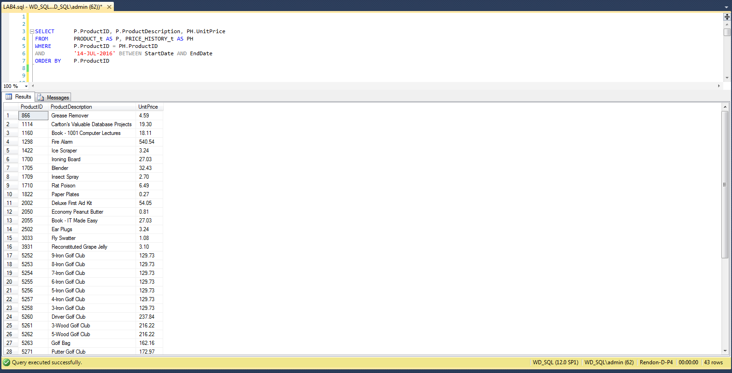

# 3-N Who are the employees that report directly to Sam Drucker’s manager? Provide the information by their names in alphabetical order, and include their Employee IDs and Job Titles. Hint: Your SQL statement must look for “Sam” and “Drucker”, and not some EmployeeID that was not given to you in the problem statement.

SELECT EmployeeFirstName + ' ' + EmployeeLastName AS EmployeeName,

EmployeeID, EmployeeJobTitle

FROM EMPLOYEE_t

WHERE ManagerID IN

(

SELECT ManagerID

FROM EMPLOYEE_t

WHERE EmployeeFirstName = 'Sam'

AND EmployeeLastName = 'Drucker'

)

ORDER BY EmployeeLastName, EmployeeFirstName

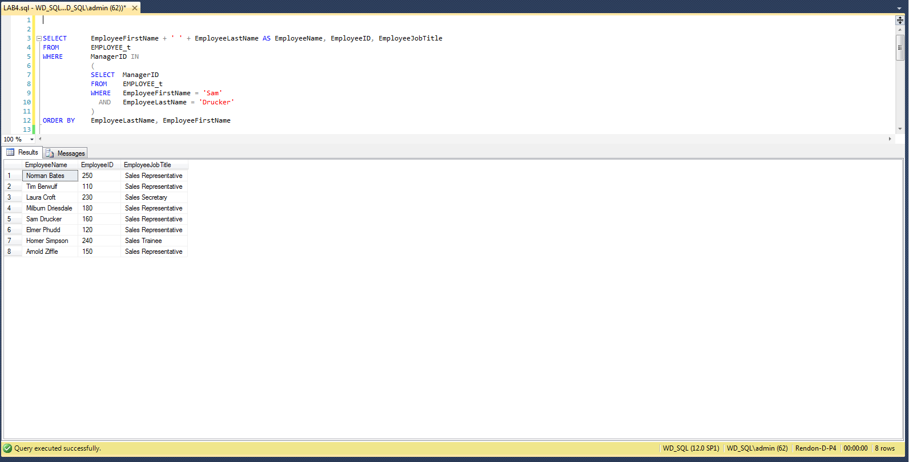

# 3-O What is the information relevant to order ID 1527? I want to know the Customer Name, Customer City, State, Sales Rep’s Name, Order Date, Due Date, Ship Date, Customer PO Number, ProductID, Product Description, Order Quantity, and Unit Price. Hint: Be sure that every item on the order is included and be sure that the price is valid for that order date.

SELECT C.CustomerName, C.CustomerCity, C.CustomerState,

E.EmployeeFirstName + ' ' + E.EmployeeLastName AS SalesRep,

O.OrderDate, O.DueDate, O.ShipDate, O.CustomerPONumber,

OL.ProductID, P.ProductDescription, OL.OrderQuantity,

PH.UnitPrice

FROM EMPLOYEE_t AS E, CUSTOMER_t AS C, ORDER_t AS O,

ORDER_LINE_t AS OL, PRODUCT_t AS P, PRICE_HISTORY_t AS PH

WHERE E.EmployeeID = C.SalesRepID

AND C.CustomerID = O.CustomerID

AND O.OrderID = OL.OrderID

AND OL.ProductID = P.ProductID

AND P.ProductID = PH.ProductID

AND O.OrderDate >= PH.StartDate

AND O.OrderDate <= PH.EndDate

AND O.OrderID = 1527

