# Objectives and motivation of the project

In the aeronautical industry, it is of vital importance the study of the fluid’s behaviour in different conditions as the air behaves as a fluid and in order to design an aircraft (airfoil, sustaining surfaces, etc ) it is necessary these study with the aim of being able to perform their functions at all times.

In fluid dynamics, the study of the fluid behaviour has a great complexity; several manipulations of complex equations are required and some simplifications are needed to simplify them and attempt achieving an analytical solution.

However, apart from these simplifications, nowadays we have help of computers and computational fluids dynamics to facilitate even more the process of obtaining the solutions of these problems related with the behaviour study of fluids, giving more visual results and using numerical resolution techniques instead of complex analytical solutions.

This project is orientated to the simulation of one of the process that occurs inside the supersonic air flux, in concrete, the study of an expansive wave, also known as Prandtl-Meyer expansion.

# Description of the physic problem and its relevance

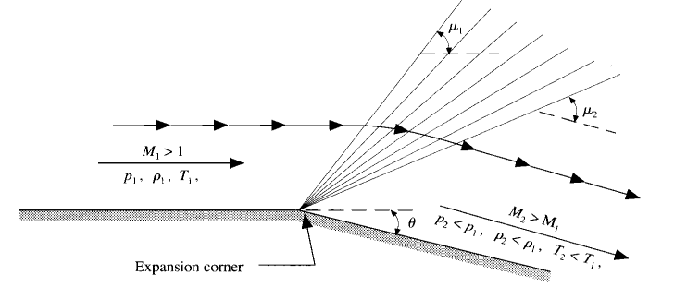

Figure 1. Prandtl-Meyer expansive wave [1]

The Prandtl-Meyer expansion or expansive wave is the process that occurs inside a supersonic flux when it expands over a convex corner (that forms an angle θ with the horizontal), creating infinity of Mach waves.

This expansion is caused by the drastic change in the direction of the geometry of flux, as it is a convex corner. This phenomenon affects the fluid properties in a gradual and continuous way, making the temperature, pressure and density decrease at the same time that velocity increases.

It has to be empathized that the increase in Mach number and velocity is soft and, as the variations of temperature, pressure and density are also infinitesimal, we can consider the flux as isentropic.

This flux has a leading edge with which creates an angle and a trailing edge with which the final flux forms an angle . These angles are the Mach angles and, as their name already indicates, they are related with the Mach numbers at the beginning () and final () with the following expressions:

This problem is of great interest to us in the aeronautical industry for the design of wing profiles, since practically all aircraft move within supersonic flows (due to the high speeds they reach) where the wing of an aircraft in question acts in a similar to the convex corner of the Prandtl-Meyer model. The air flow will maintain its direction parallel to the wing surface at the leading edge and it will be when, upon reaching the trailing edge, the flow direction will change producing an expansion wave and accelerating the air behind the wing (at the same time temperature, pressure and density decrease).

# Description of the math’s involved

The objective of this project is to simulate and obtain a numerical solution of a flow over a Prandtl-Meyer expansion corner.

In this simulation, we are going to suppose that the flow that moves on the surface is two-dimensional, supersonic and invisible and we are going to establish a series of initial conditions in order to simplify the problem and obtain the 5 properties of the flow that interests us to study its behavior: velocity (both vertical and horizontal), Mach number, density, temperature and pressure. For that purpose, we will solve the problem numerically using the MacCormack’s predictor-corrector explicit finite-difference method solution technique.

## Physical equations

The governing Euler equation for a fluid with the mentioned properties can be expressed as:

Where F and G are the flux variables, two columns of vectors that contain different values ​​of the properties that we want to study to describe the behavior of the fluid, defined as follows in equation.

Moreover, assuming a calorically perfect gas, we can use the next relation between the energy and the temperature of the gas in favor of the pressure and density of the fluid:

, where is the specific heat at constant volume, a constant that measures the amount of heat that a gas can release or absorb during a change on temperature keeping constant the volume. Introducing this condition we obtain the following equations for F and G.

Where are the density, horizontal speed, pressure, vertical speed and module of the speed, respectively.

As had be seen in equation 3.1.1., vectors F and G are related to each other thanks to the Euler equation for a stationary and two-dimensional flow as follows:

So we can assume that if we know the flow variables at a point as a function of y (initial data line), the y derivative of G is known along this entire line and therefore the x derivative of F is known (from where we can extract F). Therefore, the problem can be solved by making Δx jumps along the x-direction of the flow and calculating the next line above at each step.

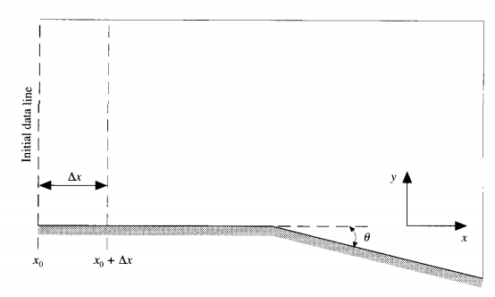

Figure 2. Model for the downstream solution

To obtain the so-called primitive variables (, u, v, p, T) we must perform a decoding task of the flow variables in the following way:

And knowing the Fs and all the primitive variables we can obtain the Gs in order to calculate the next point (at ):

To end-up with this section, note that, since the the grid where the problem develops (the physical grid) is not completely rectangular, we must transform it into a fully rectangular computational plane. That is why we introduce the variables and . In a plane, denotes horizontal step and denotes vertical step. The conversion from x,y coordinates to coordinates is as follows:

Where is the y location of the lower surface and h(x) is the local height from the lower to the upper boundary in the physical plane. So, now transforming the Euler equation into coordinates:

Writing the column vectors F and G with these partial derivatives we obtain a systems of equations, which physically are the equations of conservation of mass (continuity equation), conservation of momentum and conservation of energy.

* Continuity equation:
* X-momentum conservation equation:
* Y-momentum conservation equation:
* Energy conservation equation:

## MacCormack’s technique

As we said before, we will use the finite-difference method of the MacCormack’s technique in order to numerically solve the problem. This method is represented in the following general equation: , where we discretize A with respect to b. In our case, A will be both of the flow variables (F and G) and b will be the or components of the computational plane.

From the previous conservation equations we can set up an explicit finite-difference solution for the two-dimensional flow by the MacCormack technique from the space derivatives isolated from the conservation equations of mass, momentum and energy written in terms of forward differences:

Next, with the previous equations and following the same explicit method in space, we can obtain the predicted values ​​of the fluid properties, which can be identified with a bar above each property:

## Predictor-Corrector method

In the previous point, what we have obtained are predicted values ​​since they do not have an accuracy of second order. Therefore, to improve the accuracy of our results, we must implement a predictor-corrector method in our calculations with which we will obtain the final value of each one of the flow properties.

The Predictor-Corrector method uses the same general equation mentioned from the MacCormack’s technique with explicit finite-differences but using an average derivative that corrects the predicted values of the used method. The name "average derivative" comes from the fact that the derivative in question comes from averaging two derivatives, that of point i, j of the mesh with that of point i + 1, j of the same:

Where the derivatives on the right-hand side of the equations are known numbers; as it can be written analog to the predictor step equation:

And as we already have the values, the can be computed as had be done at the beginning with the primitives

In this equation we are considering the space derivative of the conservation equations in a point and the time derivative of the equations by using the MacCormack’s technique in the next interval of space (point). Finally, we obtain the following equations:

## Artificial viscosity

## Boundary conditions

Last but not least, a boundary condition must be applied to the system: tangent flow to the wall. Following the Abbett’s boundary condition treatment, we first calculate the u and v values at the wall and compute the direction of the resulting velocity (Ф) as tan-1(v/u) and the Mach number.

With the formulas previously seen, Pcal, Tcal, ρcal can be obtained. Once we have the calculated values Pcal, Tcal, ρcal we must compute the actual values. They can be computed as:

However the Mact is not defined yet and it must be obtained by trial and error. As Mcal is known it can be computed the fcal with the formula:

And as fact=fcal + Ф it can be solved the value of fcal. With this value it is proposed a trial and error resolution yet we are using a numerical method (secant).

With the secant method two initial random but realistic values of Mach must be defined and the tangent line is computed. Then, it is evaluated the value when the tangent line is 0 and this new point, and the last of the previous Mach points defined, is used to compute the next tangent line to find the new value of 0. This is done iteratively until a value is found, defining some tolerances.

With this method a good approach of Mach is obtained and all the remaining actual parameters can be obtained.

# Bibliography

[1] J.D. Anderson, Chapter 8: “Numerical solution of a two-dimensional supersonic flow: Prandtl-Meyer Expansion Wave” from Computational Fluid Mechanics, 1995. [Book].