Project PLan

Andre Davis, Andres Giraldo, Paul Hendrick, David Machado, Rhea Prohaska, Malachi Woodlee

University of Maryland Global College

CMSC 495

**Table of Contents**

1. **Purpose**…………………………………………………………………………………………..2
   1. Document Overview…………………………………………………………..2
   2. Project Description…………………………………………………………….2
2. **Scope Management Plan**……………………………………………………………….2
   1. Requirements Definition……………………………………………………2
      1. Project Requirements……………………………………………….2
      2. System Requirements……………………………………………….3
   2. Scope Verification………………………………………………………………4
   3. Scope Control……………………………………………………………………4
3. **Communication Management Plan………………………………………………4** 
   1. Introduction………………………………………………………………………4
   2. Emails…………………………………………………………………………………4
   3. GitHub.com…………………………………………………………………………4
   4. Group Collaboration – Group – 5………………………………………4
4. **Staffing Management Plan……………………………………………………………5**
5. **Schedule Management Plan…………………………………………………………6**
   1. Schedule……………………………………………………………………………6
   2. Tools to Manage Schedule………………………………………………….6
   3. Schedule Responsibility………………………………………………………7

**Revision History**

|  |  |  |  |
| --- | --- | --- | --- |
| **Date** | **Version** | **Description** | **Author** |
| **10/24/19** | **1.00** | **Initial start of project planning** | **Andre Davis** |

**1 Purpose**

**1.1 Document Overview**

This Project Plan will outline the developing process of group 5 program design. This document will cover all the planning, execution, monitoring, control, and the closing of the project on completion. This project plan will go into details of the approach to manage the project while ensuring that the project performance will be optimize. The project plan will include the following plans

* **Scope Management Plan**
* **Communication Management Plan**
* **Staffing Management Plan**
* **Schedule Management Plan**
  1. **Project Description**

The main goal of our program is to create an email parser that would go through several emails and separate all the “junk” mail out of them. The program can be broken up into three different parts. First, having an API for the communication with the mail sever. Second, having a handler that would take the emails from the API, parse it, and then output a CSV file. Lastly, having an API for sending the CSV file to the Random Forest Classifier.

1. **Scope Management Plan**
   1. **Requirements Definition**

The requirements are broken into two different parts for the program. One being Project Requirements and the other being System requirements.

* + 1. **Project Requirements**

The main requirement of the project is to be able to tell junk mail from other email. This chart will show the flow of how the process receiving the email, the email going through our program, and then going to someone email or being quarantine.

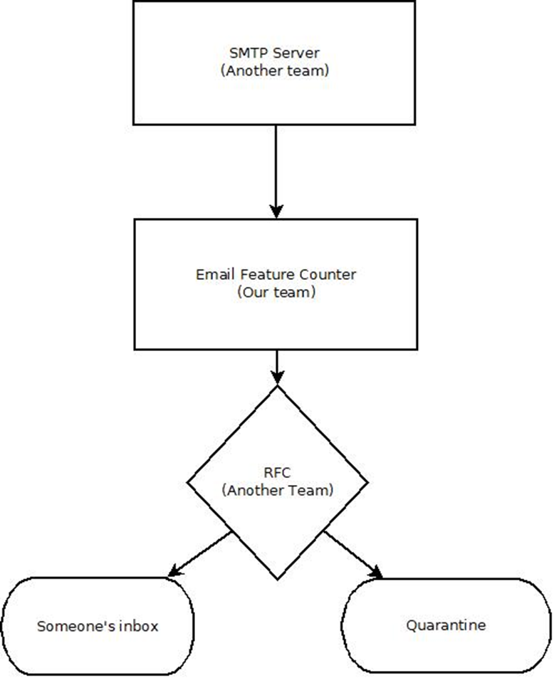

* + 1. **System Requirements**

The recommended hardware system requirements will go as follow

* JDK/JRE 1.7 or higher
* Microsoft Windows 7 Professional or higher
  + Processor: Intel Core i5 or equivalent
* Ubuntu 15.04 or higher
  + Processor: Intel Core i5 or equivalent
* OS X 10.10 Intel or higher
  + Processor: Dual-Core Intel or equivalent
  1. **Scope Verification**

The deliverables will be formally accepted through the electronic communications that are define in the Communication Management Plan. The process of a full team review on all deliverables will ensure their quality will meet the requirements of the overall project. The team review will also include testing the application as well as appropriate sing offs on all deliverables.

* 1. **Scope Control**

The team as a while will monitor the scope of the project through regular reviews to make sure the program is advancing to the same goal as stated in the project plan. Any and all changes to the project scope must be approved by all team members and the project plan must be revised to include the changes.

1. **Communication Management Plan**
   1. **Introduction**

The Communication Management Plan describes the planned methods of communication within the team itself. This will help ensure timely intercommunication which will help with ensuring the program quality.

* 1. **Emails**

The team will use emails as the primary use for communication. This is where the team will ask any questions for anything about the project. This is also where team will discuss any changes to the project and vote on matters as well.

* 1. **GitHub.com**

The project will be using GitHub.com for software control management. The features that we will be using is

* Source code management
* Version control
  1. **UMGC Group Collaboration – Group – 5**

This will be using in addition to the emails as a way of communication within the team. In addition, any rough drafts of any documentation will be posted here for the whole team to view over and provide any changes.

1. **Staffing Management Plan**

The staff on this team has been assign these roles and tasks as follows:

|  |  |  |  |
| --- | --- | --- | --- |
| **Roles** | **SDLC Lead** | **Responsibilities** | **Team Member** |
| Project Manager | Functional Design | * Project Plan * Organize all project documentation * Schedule meetings | Andre Davis |
| UX/HCI | Requirements | * Assisting Project Design to make program more user-friendly | *Andres Giraldo |
| Technical Writer | Requirements | * User’s Guide | Paul Hendrick |
| Software Engineer | Development | * Project Design | David Engineer |
| Integration Engineer | Development | * Project Design | Rhea Prohaska |
| Test Engineer | Test | * Test Plan | Malachi Woodlee |

1. **Schedule Management Plan** 
   1. Schedule

This is the schedule that the program will need to follow:

|  |  |  |  |  |
| --- | --- | --- | --- | --- |
| **Task** | **Duration in Days** | **Start Date** | **End Date** | **Roles assigned to task** |
| Project Plan and GitHub account setup | 7 | 10/27/2019 | 11/03/2019 | Project Lead |
| User Guide and Test Plan | 7 | 11/03/2019 | 11/10/2019 | Technical Writer  UX/HCL  Test Engineer |
| Project Design | 7 | 11/10/2019 | 11/17/2019 | Software Engineer  Integration Engineer |
| Phase 1 Source | 7 | 11/17/2019 | 11/24/2019 | Project Lead  Software Engineer  Integration Engineer  Test Engineer |
| Phase 2 Source | 7 | 11/27/2019 | 12/01/2019 | Project Lead  Software Engineer  Integration Engineer  Test Engineer |
| Phase 3 Source | 7 | 12/01/2019 | 12/08/2019 | Project Lead  Software Engineer  Integration Engineer  Test Engineer |
| Final Report | 7 | 12/08/2019 | 12/15/2019 | Project Lead  UX/HCL  Technical Writer  Software Engineer  Integration Engineer  Test Engineer |

* 1. Tools to Manage Schedule

The tools the team will be using to ensure we are on schedule is having regularly schedule meetings as well as communications that were defined by the Communications Management Plan. If any risk that the project tis to fall behind schedule, all members will help with the task.

* 1. Schedule Responsibility

The project lead will be accountable for maintaining and reporting the schedule. The project lead will also be responsible organizing any help, if needed, to ensure the project remains on schedule