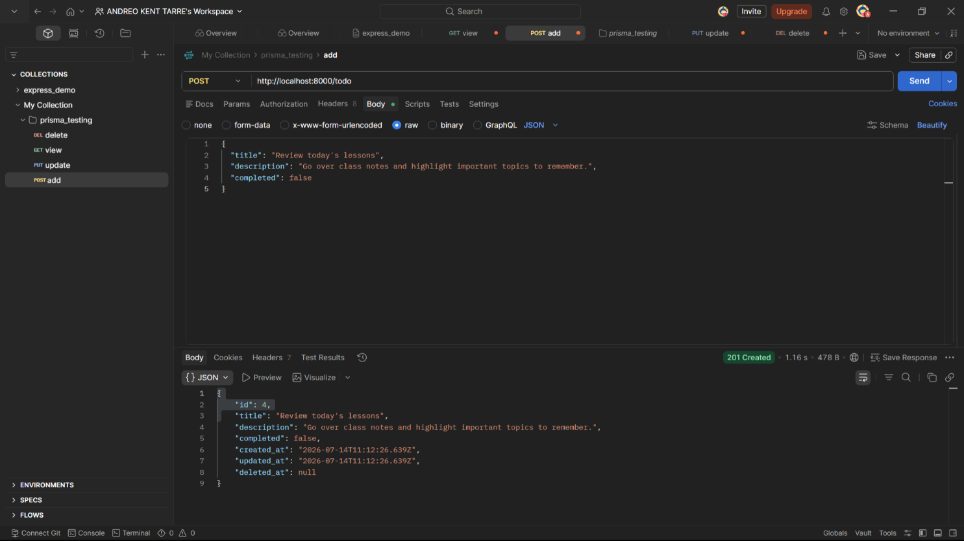
- POST – Adding New Record
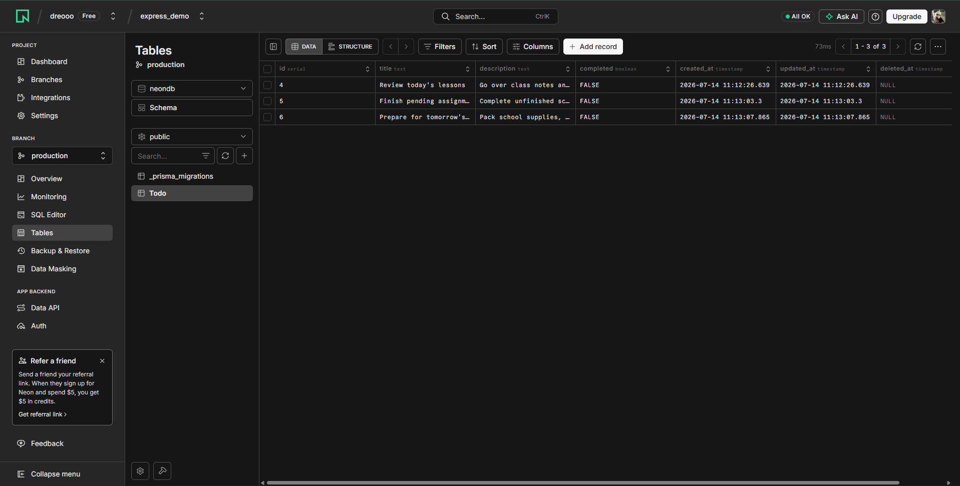

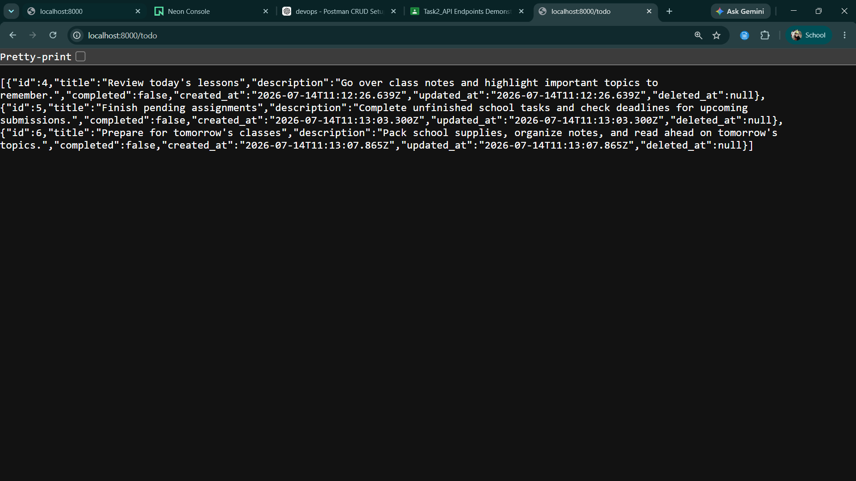
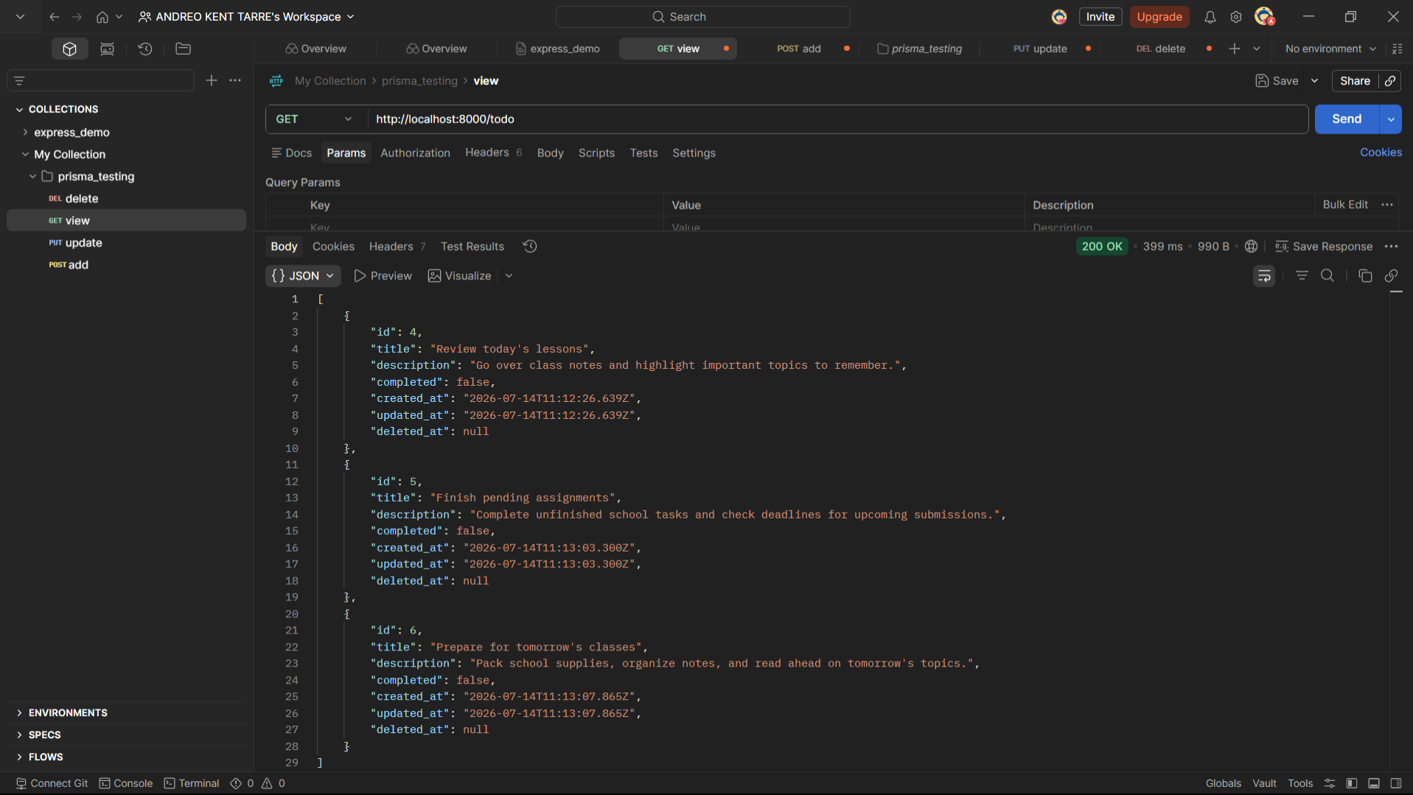
- GET – Viewing Records


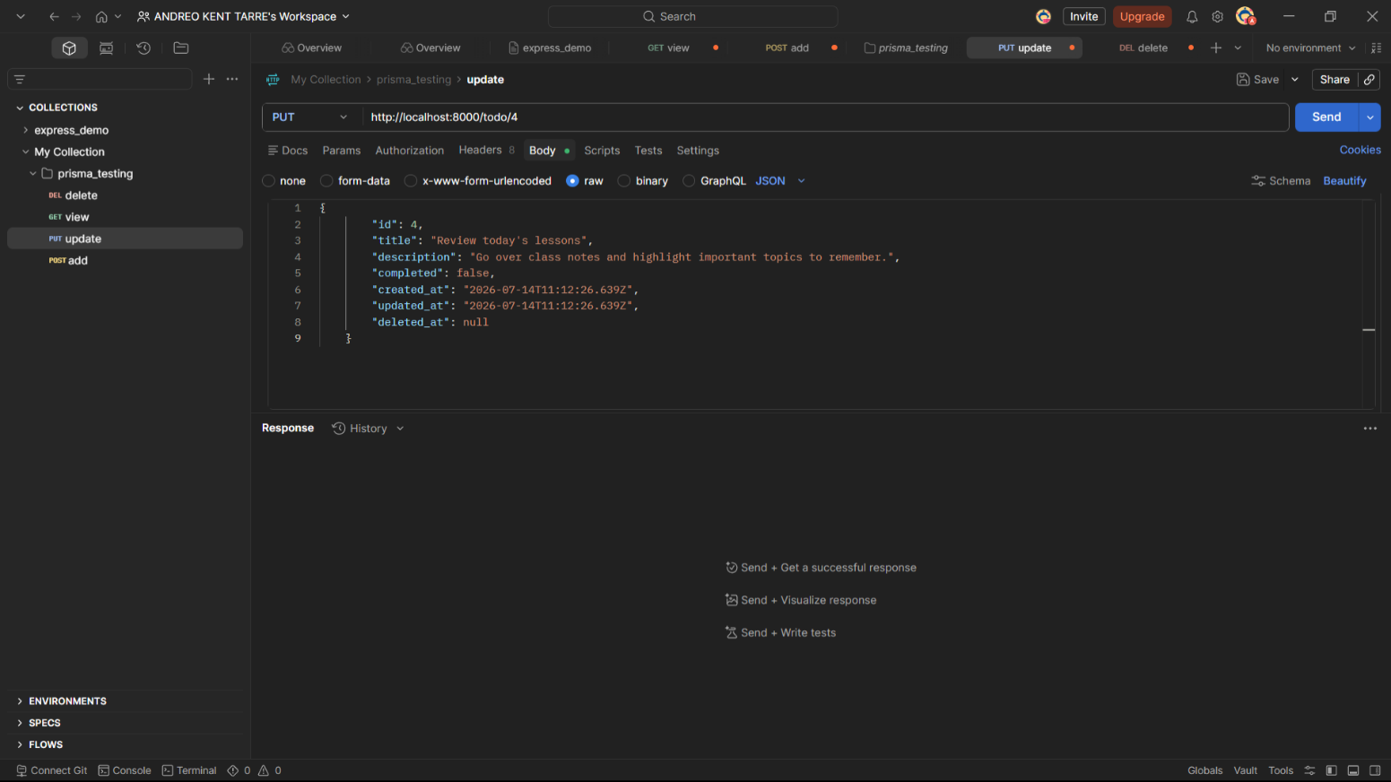
- PATCH – Updating Existing Record
Note: Before the update.

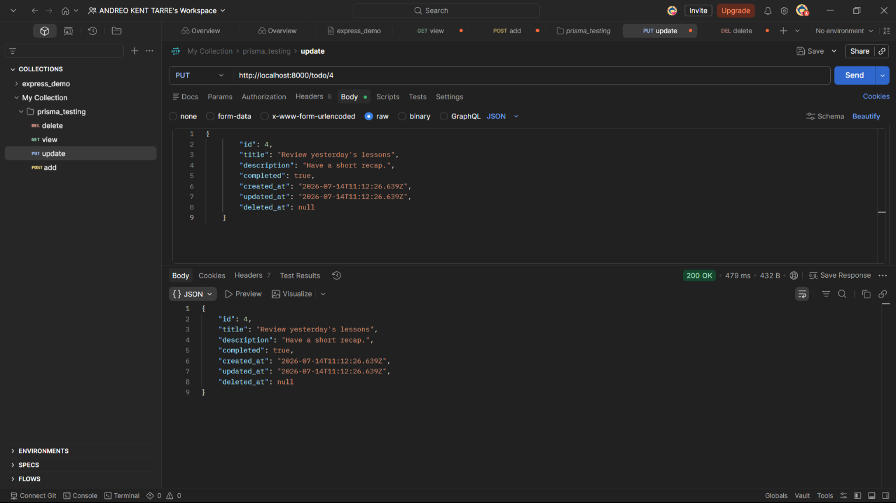
Note: Data after being updated using Postman.
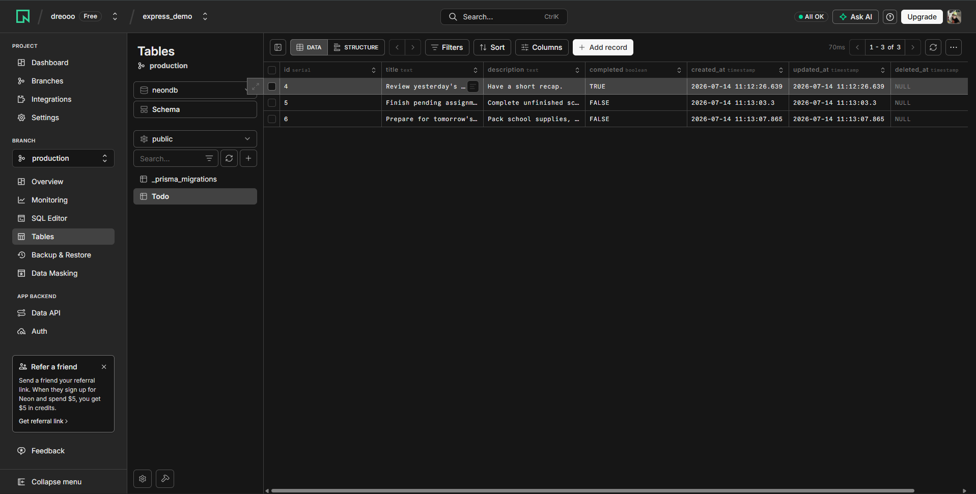
Note: The table has been updated in the Neon database.
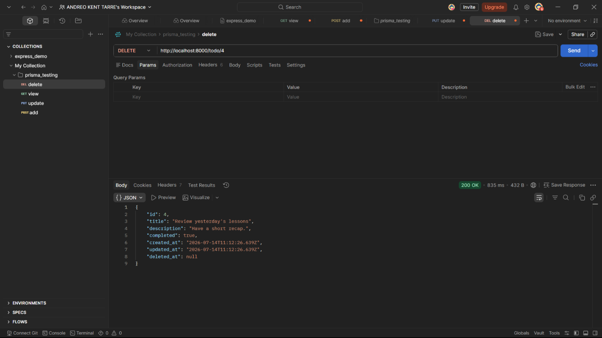
- DELETE – Deleting Record
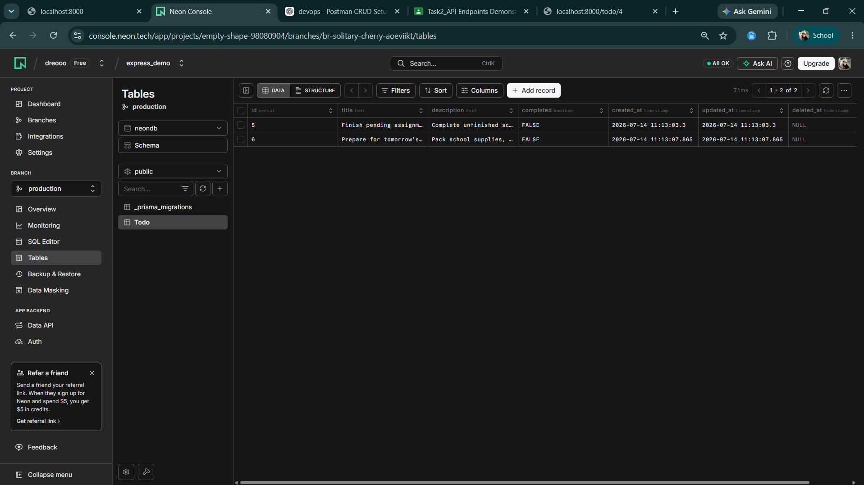
Note: Delete the row with id = 4 using Postman.
Note: The row with ID 4 was deleted from the Neon database.

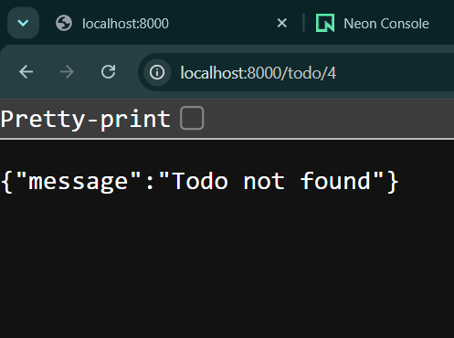

Note: The record with ID 4 was not found because it has already been deleted from the database.

