AEGIS–KG
Knowledge-Graph Threat Intelligence Platform
Software Technical Design & Architecture Document
System architecture, component design, data model, and non-functional specification

Document ID | AEGIS-KG-TDD-001
Version | 1.0 (Draft for Architecture Review)
Status | For Review
Classification | Internal – Confidential
Audience | Architecture review board, engineering, security

Contents

1 Executive summary
This document specifies the technical design and architecture of Aegis–KG, a knowledge-graph threat intelligence platform for institutional digital-asset security. The platform ingests heterogeneous intelligence — structured ledgers, semi-structured attribution feeds, unstructured incident reports, documents, and web sources — uses a large language model to construct a typed ontology and populate a knowledge graph from that material, and exposes the result through an interactive explorer, a reasoning API, and standards-based sharing.
The platform's centre of gravity is not detection latency and not address scoring; those markets are already served. Its differentiating operation is exposure reasoning: given a threat actor, campaign, or compromised entity, the platform answers what that specifically means for the institution and what should be done about it. That question can only be answered by intersecting two models that no competing tool holds together — a normalised model of blockchain adversary activity and a model of the institution's own operational topology — inside a single reasoning graph.
Architectural thesis. The moat is the ontology and the graph it instantiates, not the user interface or the feeds. Every other layer of the system exists to populate, validate, reason over, or surface that graph. The design therefore optimises for ontology quality, provenance integrity, and traversal expressiveness above all else.
The design is organised as eight layers grouped into an engine (collection, normalisation, ontology, attribution, exposure reasoning) and a surface (AI reasoning, analyst and executive UI, sharing). The construction pipeline that populates the graph is an LLM-assisted, provenance-grounded, validated process in which the language model proposes structure and deterministic code disposes of anything that violates the ontology or lacks evidence. This document covers the system context, requirements, the layered architecture, the construction pipeline, the ontology and graph data model, the component design, the non-functional and security architecture, the deployment topology, key architecture decisions, risks, and a phased delivery plan.

2 Context and scope

2.1 Problem context
Institutions holding or servicing digital assets face an adversary environment that is both fast and semantically alien to traditional security tooling. The defensive market is bifurcated. Real-time detection vendors identify malicious transactions in seconds but cannot explain what an attack means for a given institution. Address-risk and AML vendors provide attribution but are not threat-intelligence platforms. Traditional cyber threat-intelligence platforms speak STIX and reason about adversaries but have no native model for on-chain entities such as bridges, mixers, oracles, or drainer services. No existing platform unifies normalised blockchain adversary intelligence with a model of an institution's own exposure.

2.2 System context
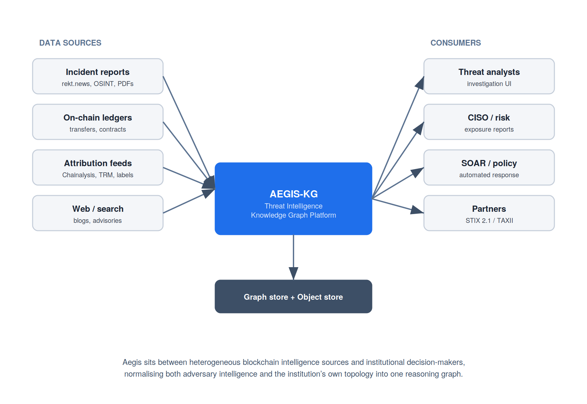
Figure 1. System context. Aegis–KG mediates between heterogeneous blockchain-intelligence sources and institutional decision-makers.
The platform consumes from four broad source classes and serves four broad consumer classes. Sources comprise incident and OSINT reporting, on-chain ledger and contract data, third-party attribution feeds, and general web and search material. Consumers comprise threat analysts working investigations, CISO and risk functions consuming exposure assessments, automated policy and SOAR systems acting on findings, and external partners receiving standards-based intelligence exports.

2.3 In scope
- Multi-source ingestion (CSV/TSV, JSON, PDF, text, web URLs) with provenance capture, plus keyword-driven web-search enrichment.
- LLM-assisted ontology proposal and typed entity/relationship extraction, with a deterministic validation gate and entity resolution.
- A persisted, typed knowledge graph with the Aegis-TIS three-layer schema, and exposure-reasoning queries over it.
- An interactive graph explorer, a reasoning/query API, grounded LLM question-answering, and STIX 2.1 / TAXII export.

2.4 Out of scope
- Sub-second real-time transaction interdiction (this platform interprets and reasons; it is not a mempool firewall).
- Primary on-chain indexing infrastructure; the platform consumes from indexers and warehouses rather than operating full archive nodes.
- Custody key management and signing; the platform models policy and exposure but does not hold keys or execute transactions.

3 Stakeholders and requirements

3.1 Primary stakeholders
Stakeholder | Primary concern | Key interaction
Threat analyst | Investigate incidents, pivot across entities, trace funds | Graph explorer, reasoning API, AI Q&A
CISO / risk | Understand institutional exposure to a given threat | Exposure dashboards and reports
Security engineer | Integrate findings into policy / SOAR | Reasoning API, STIX export
Data engineer | Onboard new sources reliably | Ingestion config, connectors
Partner / ISAC | Exchange normalised intelligence | TAXII server, STIX bundles

3.2 Functional requirements
ID | Requirement | Layer
FR-1 | Ingest CSV, JSON, PDF, text, and web sources into a normalised document model with provenance | Collection
FR-2 | Enrich a corpus with web-search findings for analyst-supplied keywords | Collection
FR-3 | Propose a typed ontology over a corpus and allow human review / seeding | Normalisation
FR-4 | Extract typed entities and relationships conforming to the ontology, each with an evidence span | Normalisation
FR-5 | Reject any extracted fact that violates the ontology or lacks provenance | Normalisation
FR-6 | Resolve and merge entities across sources; record corroboration | Attribution
FR-7 | Persist a typed graph and support neighbourhood, path, and reachability queries | Ontology / Reasoning
FR-8 | Compute institutional exposure by intersecting threat and institution sub-graphs | Exposure
FR-9 | Provide an interactive explorer where selecting a node reveals all its relationships and connected nodes | Surface
FR-10 | Answer natural-language questions grounded strictly in the graph | AI reasoning
FR-11 | Export findings as STIX 2.1 bundles and serve them over TAXII | Sharing

3.3 Non-functional requirements
ID | Attribute | Target
NFR-1 | Provenance integrity | 100% of graph facts trace to a source span; no orphan assertions
NFR-2 | Extraction precision | Validation gate rejects 100% of ontology-violating triples; measured per release
NFR-3 | Query latency | Neighbourhood (≤ 2 hops) < 300 ms p95; bounded reachability < 2 s p95
NFR-4 | Ingestion throughput | ≥ 1,000 documents/hour/worker, horizontally scalable
NFR-5 | Scale | 10⁷ nodes, 10⁸ edges per tenant without query-shape change
NFR-6 | Reproducibility | Deterministic re-runs given cached LLM responses; idempotent merges
NFR-7 | Tenant isolation | Institution topology never co-mingled across tenants
NFR-8 | Auditability | Every automated decision (extraction, merge, rejection) is logged and replayable

4 Architecture overview
The platform is decomposed into eight layers. The lower five constitute the engine that builds and reasons over the graph; the upper three are the surface through which the engine delivers value. Layering is strict in one direction: each layer depends only on those beneath it, and data flows upward from raw sources to institutional decisions. The defining property of the design is that the ontology layer (layer 3) is the centre around which everything else is organised.
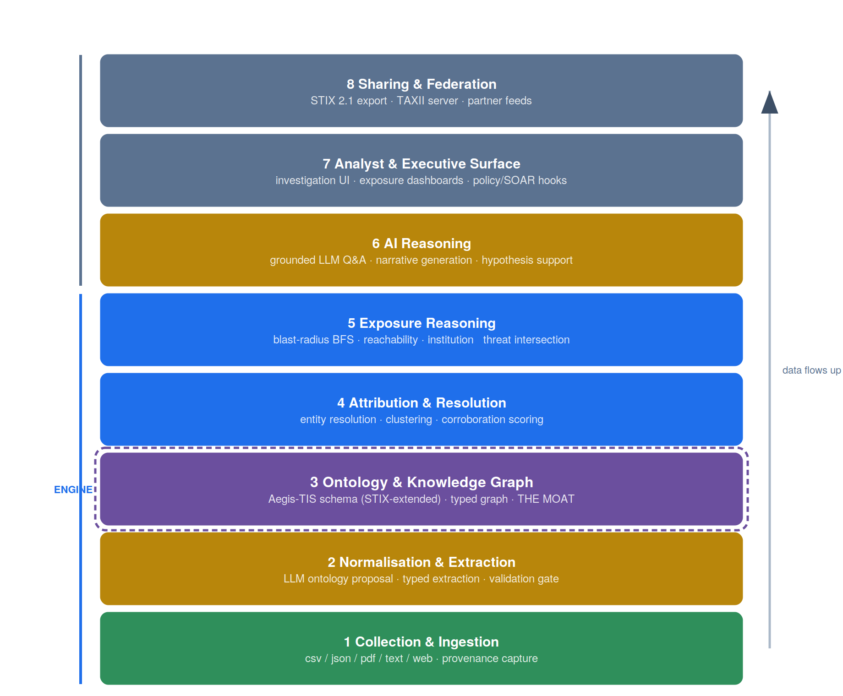
Figure 2. The eight-layer architecture. The dashed boundary marks the ontology and knowledge-graph layer — the platform's moat.

4.1 The engine
Collection (layer 1) normalises every input into a common document model carrying its provenance, and emits structured facts directly when a source is clean and mapped. Normalisation and extraction (layer 2) is the LLM-assisted construction pipeline: ontology proposal, typed extraction, and the validation gate. The ontology and knowledge graph (layer 3) holds the Aegis-TIS schema and the typed graph it instantiates — the moat. Attribution and resolution (layer 4) collapses entities that denote the same real-world thing and scores corroboration. Exposure reasoning (layer 5) performs blast-radius and reachability traversal and intersects the institution sub-graph with the adversary sub-graph.

4.2 The surface
AI reasoning (layer 6) answers natural-language questions strictly grounded in graph facts and generates analyst narratives. The analyst and executive surface (layer 7) provides the interactive explorer, exposure dashboards, and the policy / SOAR hooks through which findings drive action. Sharing and federation (layer 8) exports STIX 2.1 and serves TAXII so that intelligence becomes a reusable asset beyond a single institution.
Why layered separation matters here. The collection layer changes constantly as new feeds appear; the ontology changes slowly and deliberately; the surface changes with product needs. Strict layering lets each evolve at its own rate. Critically, the normalisation layer translates everything into the ontology before it touches the graph, so the graph never accumulates source-specific schema debt.

5 Graph construction pipeline
The pipeline that turns sources into graph facts is the heart of the engine. It is a seven-stage flow in which a language model proposes structure and deterministic code validates it. The design principle throughout is that the model is a proposer whose every output is checked; nothing the model produces enters the graph without passing an ontology and provenance gate.
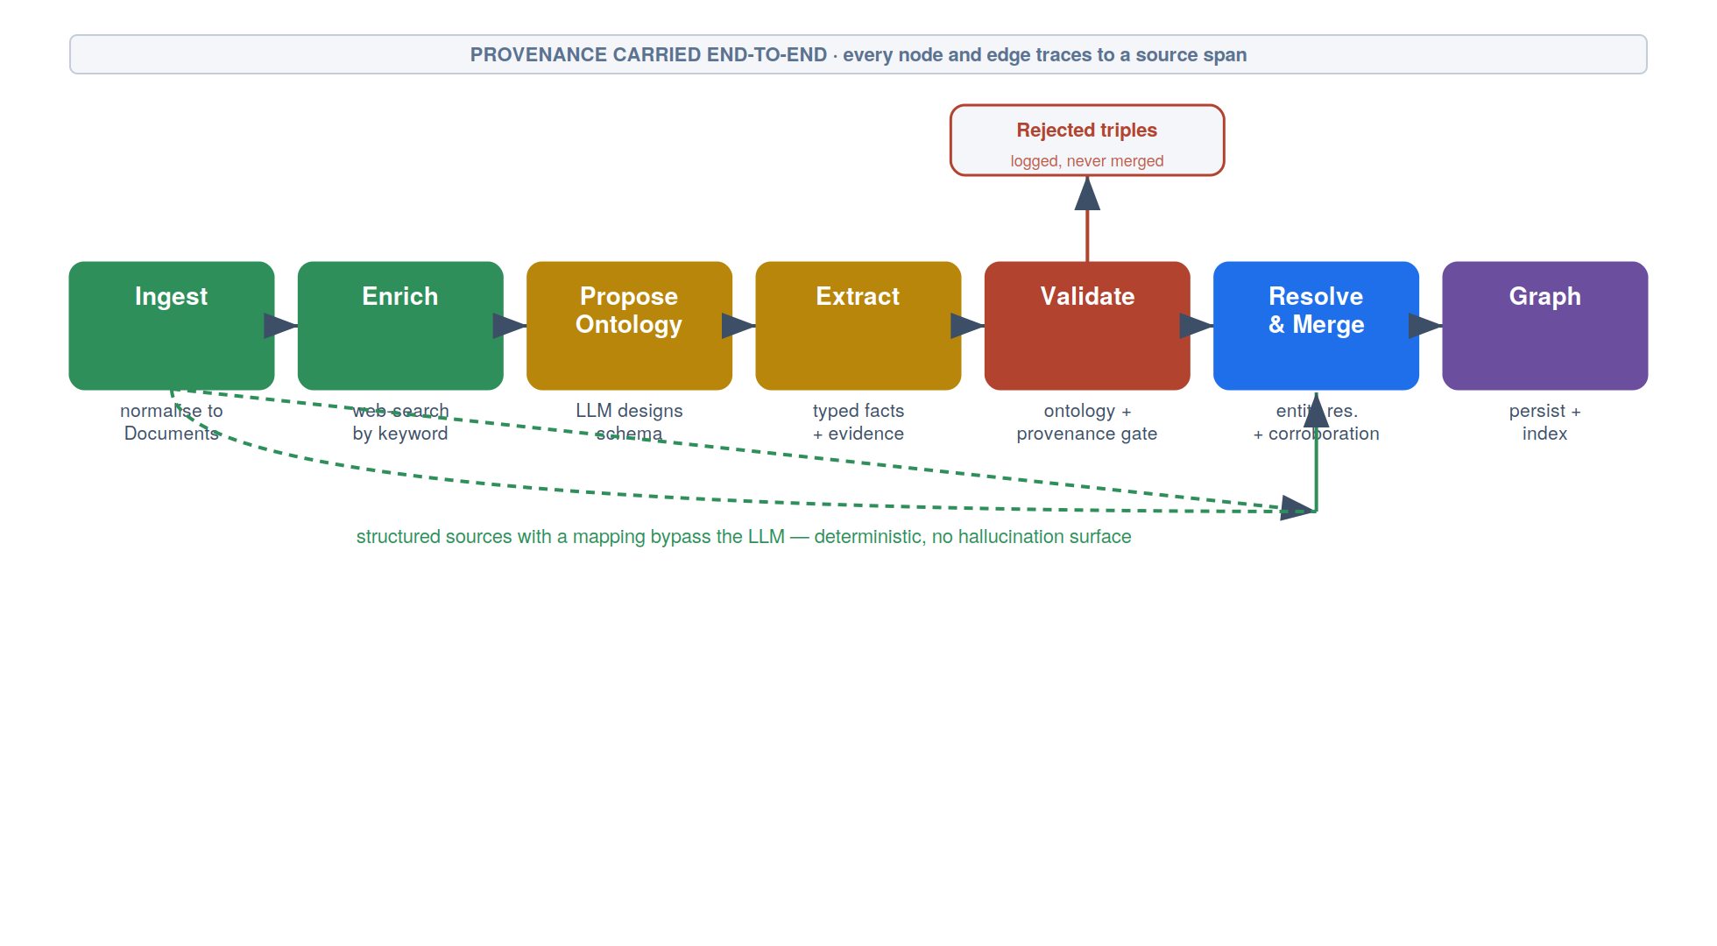
Figure 3. The construction pipeline. Structured sources with a mapping bypass the LLM entirely; prose is extracted and validated; provenance is carried end-to-end.

5.1 Stage responsibilities
Stage | Responsibility and key design choice
Ingest | Normalise each input to Documents carrying source type and URI. Clean structured inputs with a declarative mapping additionally yield typed facts with no LLM call.
Enrich | Run web search for analyst keywords and fold findings in as additional Documents, broadening coverage beyond supplied files.
Propose ontology | The LLM proposes a unified property-graph ontology over a representative corpus sample. A seed ontology can pin or extend an existing schema; humans review once.
Extract | Per text chunk, the LLM extracts typed entities and relationships conforming to the ontology, each carrying a verbatim evidence span.
Validate | Deterministic gate. Rejects any triple whose (source-type, relation, target-type) the ontology does not license, and anything lacking provenance. Rejections are logged, never merged.
Resolve & merge | Collapse entities sharing a canonical identity onto one node; deduplicate identical facts and record corroboration count as a confidence signal.
Graph | Persist the typed graph and indexes; emit JSON, GraphML, and Cypher for downstream stores and visualisation.

5.2 Where the LLM is, and is not, used
A central design decision is to use the language model only where it adds value. Clean structured data with a known mapping becomes graph facts deterministically, with no model call and therefore no hallucination surface. Only unstructured prose passes through ontology proposal and extraction. This bounds both cost and risk: the probabilistic component of the system is confined to the part of the corpus that genuinely requires natural-language understanding, and even there its output is gated.

5.3 The validation gate
The gate is the component that separates a demonstrator from a system. It enforces three invariants: every entity has a type drawn from the ontology; every relationship's domain and range are licensed by the ontology; and every fact carries an evidence span present in the source text. The slogan is the LLM proposes; the validator disposes. Because the gate is deterministic code, its behaviour is testable and auditable in a way the model's is not, and the rejection rate is a measured release metric (NFR-2).

6 Ontology and graph data model
The ontology is the schema of meaning: the node types that may exist, the relationship types permitted between them, and the domain and range constraints that make a relationship semantically valid. Aegis-TIS structures this in three layers, extending STIX 2.1 rather than replacing it, so that the platform interoperates with the wider cyber-threat-intelligence ecosystem while expressing concepts that ecosystem lacks.
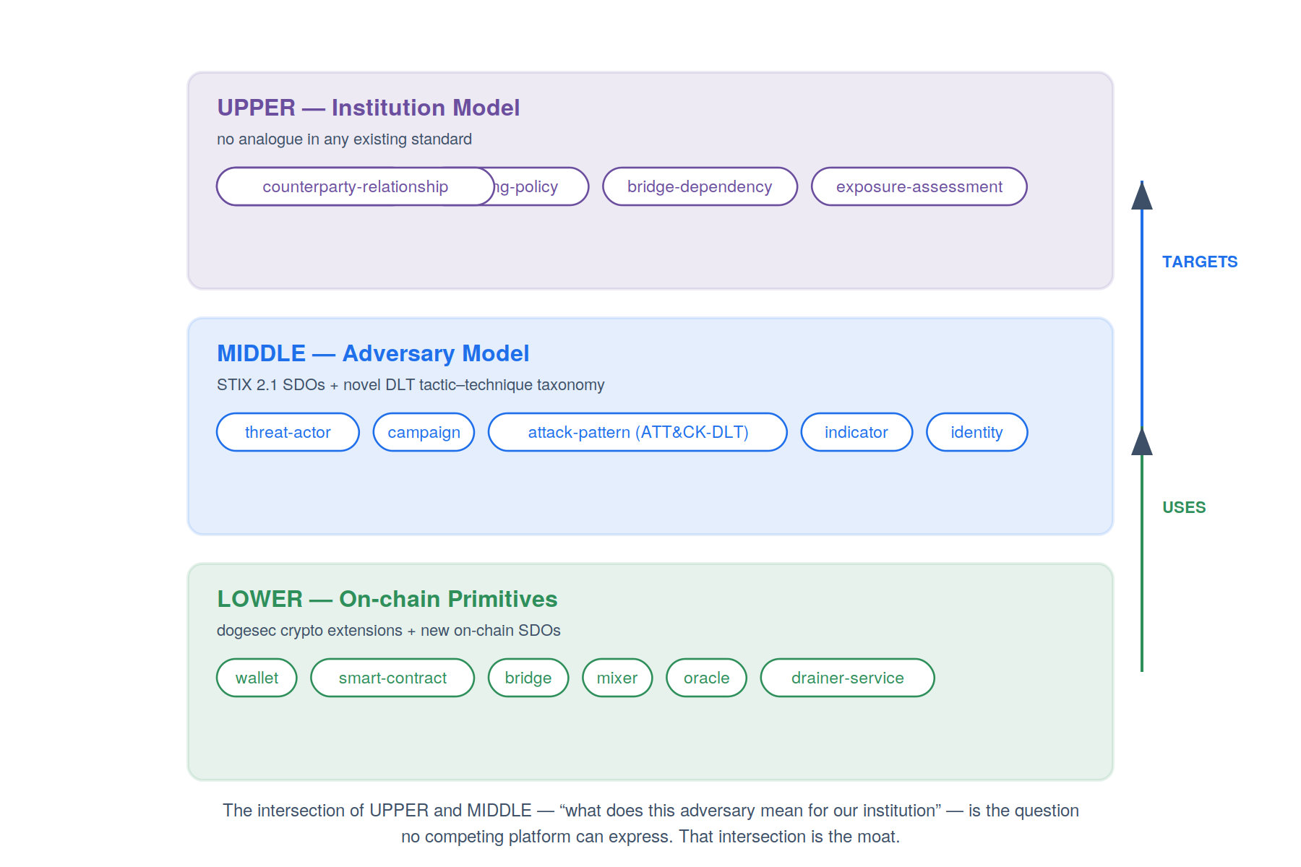
Figure 4. The Aegis-TIS three-layer ontology. The intersection of the upper and middle layers is the question no other platform can express.

6.1 The three layers
Lower layer — on-chain primitives. Adopts established cryptocurrency STIX extensions verbatim and adds on-chain domain objects with no analogue in base STIX: bridge, oracle, mixer, governance entity, MEV bot, drainer service, and smart contract. This layer makes the platform fluent in blockchain-native entities.
Middle layer — adversary model. Adopts STIX 2.1 domain objects — threat actor, campaign, attack pattern, indicator, identity — and overlays a novel ATT&CK-style tactic–technique taxonomy specialised for distributed-ledger attacks. This is what lets the platform reason about adversaries the way a traditional CTI platform does.
Upper layer — institution model. Has no analogue in any existing standard. It models the institution's own topology: institution asset, signing policy, signing quorum, protocol approval, bridge dependency, oracle dependency, counterparty relationship, business function, and exposure assessment. This layer is what makes institutional exposure reasoning possible at all.
The intersection is the moat. Real-time vendors model the lower layer; CTI platforms model the middle layer; nobody models the upper layer, and so nobody can compute the intersection — “this adversary uses this technique against this kind of bridge, and we depend on that bridge for this business function.” That intersection is the product.

6.2 Property-graph representation
Internally the ontology is realised as a labelled property graph: nodes and edges both carry key-value properties, and edges are typed and directed. This model is chosen over a pure RDF triple store for developer ergonomics and traversal performance, while the STIX alignment preserves a clean mapping to RDF/OWL for federation and to SHACL for constraint validation where formal semantics are required. The ontology constrains types and directions strictly while leaving properties open, so that a node may carry attributes the schema did not anticipate without weakening the type guarantees the gate relies on.

6.3 Why a graph and not a relational store
The platform's defining queries — “what is this address connected to,” “how do funds reach this exchange,” “what is reachable from this compromised entity” — are variable-depth traversals over heterogeneous relationship types. These are the native operation of a graph and the worst case of a relational engine, where each becomes a hand-written recursive query with a guessed depth bound and a multi-table join per relationship type. The relational cost grows with the size of the database and the number of relationship types; the graph cost grows with the size of the answer. The platform therefore uses a native graph store for analysis while retaining a relational/columnar store for bulk ledger storage and aggregation, synchronised by the ingestion pipeline.
Concern | Graph store | Relational store
Variable-depth traversal | Native primitive | Recursive CTE per query
New relationship type | New edge label | New table + join rewrite
Heterogeneous entities | One structure | Many tables + join paths
Bulk aggregation | Adequate | Optimal
Transactional ledger | Not the right tool | Optimal

7 Component design
Each layer is realised by one or more services with a narrow contract. The contracts are deliberately small and pass a common set of typed objects — Document, Entity, Relationship, Ontology — so that components can evolve or be replaced independently. The reference implementation packages these as a modular library (kgforge) whose modules map one-to-one onto the engine stages, with the surface services layered above.

7.1 Core domain objects
Object | Purpose and salient fields
Document | A unit of text plus provenance (source type, URI, metadata, stable id). The common currency of ingestion.
Ontology | node_types and edge_types with domain/range; exposes the licensed-triple set and node-type set used by the gate; supports merge for incremental proposal.
Entity | A typed node instance with label, properties, evidence span, and source tag; exposes a canonical key for resolution.
Relationship | A typed, directed edge instance with properties, evidence, and source tag.

7.2 Engine services
Service | Contract
Ingestors | (path | url, optional mapping) → (Documents, Entities, Relationships). One ingestor per source family; a chunker splits long text on paragraph boundaries for the extractor.
LLM client | json_call(prompt) → parsed JSON; web_search(query) → findings; transparent on-disk cache keyed by prompt hash for deterministic, offline re-runs.
Ontology proposer | (LLM, Documents, optional seed) → Ontology, sampling the corpus and merging per-source proposals.
Extractor | (LLM, Ontology, Documents) → (Entities, Relationships), namespaced per chunk before resolution.
Validator | (Ontology, Entities, Relationships) → (valid, rejected). Pure function; the auditable trust boundary.
Resolver / merger | (valid Entities, Relationships) → (nodes, edges) with corroboration counts; the seam where multi-source integration happens.
Graph builder / store | (nodes, edges) → persisted graph + JSON/GraphML/Cypher exports.

7.3 Surface services
Service | Contract
Reasoning / query API | Neighbourhood, path, reachability, and exposure queries over the graph; the integration point for SOAR and dashboards.
Explorer | Interactive force-directed graph; selecting a node lists every incoming and outgoing relationship grouped by type, each connected node clickable, with provenance and corroboration shown.
AI Q&A | Natural-language questions answered strictly from retrieved graph facts, with citations back to evidence spans.
STIX / TAXII | Serialises findings as STIX 2.1 bundles with the ATT&CK-DLT custom kill chain and serves them over TAXII.

7.3.1 The explorer node-selection interaction
The explorer's headline interaction is the one most directly tied to the analyst's mental model: select any node and immediately see everything it relates to. On selection, the side panel enumerates every edge incident to the node, grouped into outgoing and incoming and sub-grouped by relationship type; each entry shows the relationship, the connected node, and that node's type, and is itself clickable so the analyst walks the graph by following relationships. Facts corroborated by multiple sources carry a count badge, and LLM-extracted nodes display the verbatim evidence span they were drawn from. A hop-depth control lights up the N-hop neighbourhood across all relationship types, and type filters isolate layers of the graph.

8 Non-functional architecture

8.1 Performance and scale
Read performance rests on the native graph store's index-free adjacency: following an edge is a pointer dereference, so neighbourhood and bounded reachability queries cost in proportion to the answer rather than the database. Write throughput is scaled horizontally at the extraction tier, which is stateless and parallel per document; the validator and resolver are likewise stateless. The graph store is the stateful tier and is scaled by tenant sharding, since institution topologies are isolated and queries rarely cross tenant boundaries.

8.2 Reliability and reproducibility
The pipeline is designed to be idempotent: re-ingesting the same source produces the same nodes and edges because entity identity is content-derived and merges are last-write-wins on stable keys. The LLM client's response cache makes construction reproducible — given the same inputs and cache, a re-run yields an identical graph and costs nothing, which is essential for testing, audit, and incident replay. Failed extractions are isolated to their document and do not poison the batch.

8.3 Observability
- Structured logs for every automated decision: each extraction, each rejection with its reason, each merge with the keys involved.
- Metrics: ingestion throughput, extraction latency and token cost, rejection rate, resolution merge rate, query latency percentiles.
- Traces spanning ingest → extract → validate → merge for a document, so a questionable fact can be walked back to its origin.

9 Security and trust architecture
The platform processes adversarial content by definition — incident reports describe attacks, and some sources are untrusted. The security model treats all ingested content as data, never as instruction, and confines the probabilistic component behind a deterministic gate.

9.1 Trust boundaries
Boundary | Control
Ingested content → LLM | Source text is data. Extraction prompts instruct the model to extract, not to act on, any imperative content found in sources; prompt-injection in a report cannot trigger platform actions.
LLM output → graph | The validation gate is the trust boundary. No model output reaches the graph without passing ontology and provenance checks.
Tenant → tenant | Institution topology is partitioned per tenant in storage and query scope; cross-tenant joins are structurally prevented.
Platform → external | STIX/TAXII export is filtered by sharing policy; institution-model nodes are never exported by default.

9.2 Secrets and credentials
API keys for the LLM provider and source feeds are held in a secrets manager / KMS and never embedded in artifacts, prompts, or the graph. The LLM client receives credentials at runtime; the cache stores responses, never keys. Outbound enrichment requests are egress-controlled to an allowlist.

9.3 Data classification
- Public / OSINT intelligence: freely ingestible, shareable subject to source licence.
- Institution topology (upper-layer nodes): the most sensitive class; tenant-isolated, never default-exported, access-controlled.
- Evidence spans: may quote third-party sources; retained for audit, surfaced only to authorised analysts.

10 Deployment architecture
The runtime is organised into four planes: an ingestion plane that pulls and receives sources, a processing plane that extracts and validates, a serving plane that answers queries and renders the surface, and a shared data and platform plane. The planes scale independently; the processing plane is elastic and stateless, while the data plane is the stateful core.
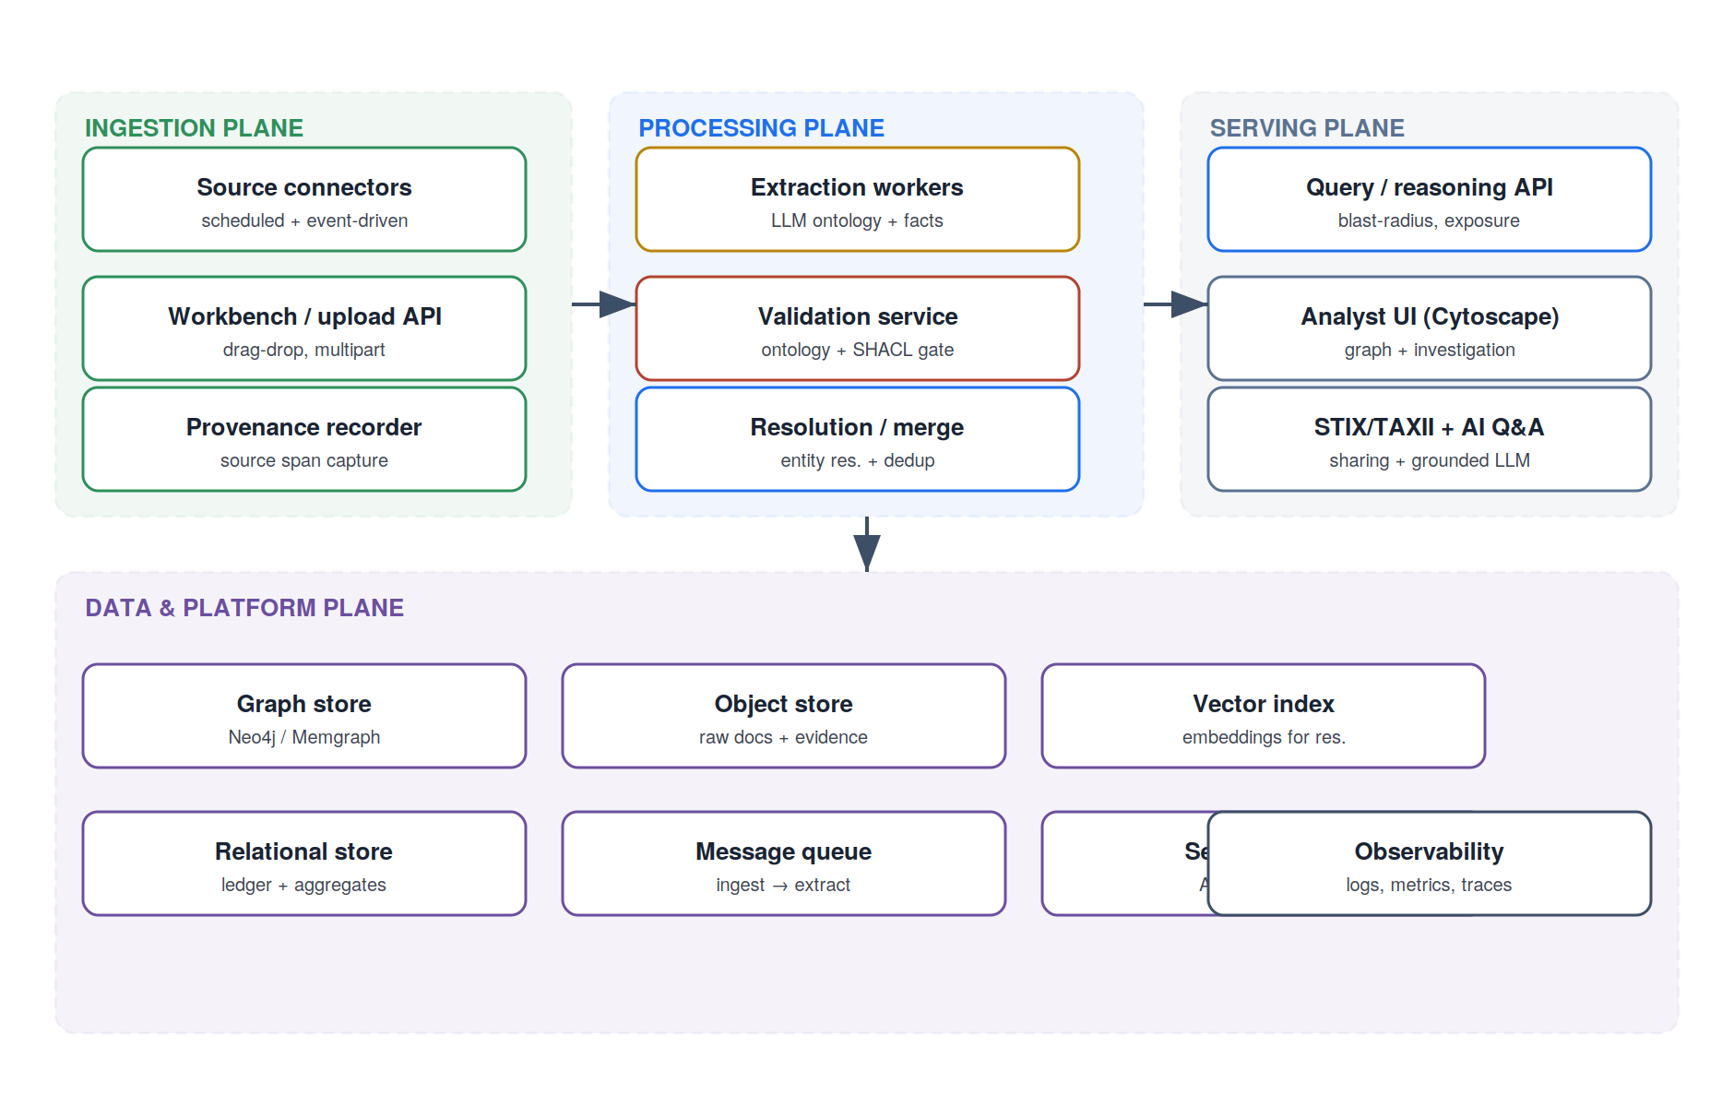
Figure 5. Runtime deployment across ingestion, processing, serving, and data planes.

10.1 Data plane components
Store | Role and technology guidance
Graph store | The analytical core. Neo4j or Memgraph for index-free adjacency, Cypher, and persistence. The reference pipeline emits Cypher directly for load.
Relational / columnar | Bulk ledger storage and aggregation; the source of record for transactional data the graph references.
Object store | Raw ingested documents and evidence spans, addressed by document id for audit and replay.
Vector index | Embeddings for fuzzy entity resolution and retrieval for grounded Q&A.
Message queue | Decouples ingestion from extraction; absorbs bursts and enables back-pressure.
Secrets / KMS | Provider and feed credentials, encryption keys.

10.2 Environments and rollout
The platform runs in three environments — development, staging, and production — with the LLM response cache promoted from staging to provide a deterministic baseline corpus in lower environments. Schema (ontology) changes are versioned and rolled out behind a review gate, because an ontology change alters what the validation gate admits and therefore what the graph can contain; ontology migrations are first-class, not ad hoc.

11 Key architecture decisions
The following decisions are the load-bearing ones; each is recorded with its context, the decision, and its principal consequence.

ADR-1 Knowledge graph as the analytical core, RDBMS as ledger of record
Context. The platform's defining queries are variable-depth, heterogeneous-relationship traversals, which are native to graphs and pathological for relational engines; but bulk ledger data and aggregation favour relational/columnar stores.
Decision. Run both. A native graph store holds the analytical graph; a relational/columnar store holds the ledger and aggregates; the ingestion pipeline synchronises them.
Consequence. Two stores to operate and keep consistent, accepted in exchange for using each engine where it is strongest and avoiding recursive-CTE complexity in the hot path.

ADR-2 LLM proposes, deterministic code disposes
Context. LLMs are excellent at proposing structure from prose but will, unguided, hallucinate facts and invent inconsistent relationship names.
Decision. Confine the model to proposal (ontology and typed extraction) and place a deterministic validation gate between model output and the graph, rejecting anything unlicensed by the ontology or lacking a provenance span.
Consequence. The probabilistic surface is bounded and auditable; rejection rate becomes a measurable quality metric; trust in the graph rests on testable code, not on model behaviour.

ADR-3 Extend STIX 2.1 rather than invent a schema
Context. A bespoke schema would maximise expressiveness but forfeit interoperability with the established CTI ecosystem; pure STIX cannot express on-chain or institution-topology concepts.
Decision. Adopt STIX 2.1 and cryptocurrency extensions for the lower and middle layers and add a novel upper layer for the institution model.
Consequence. Federation and partner sharing come largely for free, while the differentiating upper layer remains proprietary; ontology governance must track upstream STIX evolution.

ADR-4 Property graph internally, RDF/OWL mapping for federation
Context. RDF/OWL offers formal semantics and inference; property graphs offer ergonomics and traversal performance.
Decision. Use a labelled property graph as the working store and maintain a clean mapping to RDF/OWL (and SHACL for constraints) for federation and formal validation where required.
Consequence. Day-to-day development is fast and traversal-friendly; formal reasoning is available at the boundary without imposing triple-store ergonomics on the core.

ADR-5 Structured sources bypass the LLM
Context. Running every source through the model is costly and introduces hallucination risk even where the data is already clean and typed.
Decision. Allow structured sources to carry a declarative mapping that yields graph facts deterministically, reserving the LLM for genuinely unstructured prose.
Consequence. Cost and risk are confined to the prose fraction of the corpus; the deterministic fraction is exact and reproducible.

ADR-6 Provenance as a hard invariant
Context. A graph silently polluted with unattributable assertions is worse than no graph, especially for decisions touching money and compliance.
Decision. Require an evidence span on every extracted fact and reject any fact without one; carry provenance end-to-end and surface it in the explorer.
Consequence. Every fact is auditable to its source; the requirement constrains extraction prompts and adds storage for spans, accepted as the cost of trustworthiness.

12 Risks and mitigations
Risk | Impact | Mitigation
Entity resolution errors | Wrongly merged or split entities corrupt reasoning | Layered resolution: exact → alias → fuzzy → embedding; human review on low-confidence merges; corroboration scoring
Ontology drift | Model proposes inconsistent types over time, fragmenting the graph | Seed/lock the ontology; version it; gate changes through review; monitor new-type proposals
LLM hallucination | Fabricated facts enter the graph | Validation gate + mandatory provenance; rejection-rate monitoring; periodic human spot-audit
Prompt injection in sources | Adversarial report manipulates extraction or triggers action | Treat all content as data; extraction-only prompts; no action authority in the pipeline
Graph scale limits | Query latency degrades past target volumes | Tenant sharding; index tuning; pre-computed exposure materialisations for hot paths
Source feed instability | Broken or rate-limited feeds stall ingestion | Queue-decoupled ingestion; per-source isolation; back-pressure and retry
Vendor / model dependency | LLM provider change affects extraction | Abstract LLM client; cache responses; keep the gate model-agnostic

13 Delivery roadmap
Delivery is phased so that the moat — the ontology and a populated graph — is proven before surface investment scales. The minimum viable product is the engine through exposure reasoning plus a usable explorer; the surface and federation follow.
Phase | Theme | Exit criteria
0 | Foundations & ontology | Aegis-TIS schema defined; seed corpus designed; pipeline contracts fixed
1 | Graph store & loading | Structured + prose ingestion populate a persisted graph; validation gate enforced
2 | Reasoning & explorer (MVP) | Neighbourhood/path/exposure queries; explorer with node-selection; demo acceptance met
3 | Automated ingestion | Scheduled connectors; enrichment; resolution at scale; observability in place
4 | AI reasoning & policy | Grounded Q&A; exposure dashboards; SOAR / policy hooks
5 | Standards & sharing | STIX 2.1 export; TAXII server; partner federation

14 Conclusion
Aegis–KG is architected around a single conviction: that the durable value in blockchain threat intelligence is a normalised adversary-and-institution knowledge graph, not another dashboard or feed. Every design decision in this document serves that conviction — the strict layering that keeps the ontology stable while the edges of the system churn, the construction pipeline that lets a language model build the graph without being trusted to, the provenance invariant that makes every fact auditable, the three-layer ontology whose upper-middle intersection no competitor can express, and the graph-first data architecture that makes exposure reasoning a native operation rather than a recursive-query ordeal. Built this way, the platform's moat deepens with every incident it ingests, because each one enriches a graph that no one else has.
End of document — AEGIS-KG-TDD-001 v1.0

