SPEAKING SECTION – JUNE, 16

This first video is about applying for a job: <https://www.youtube.com/watch?v=-uWVa_fDeBw>

Job interview simulation: <https://www.youtube.com/watch?v=naIkpQ_cIt0>

Simulated video by the teacher: <https://www.loom.com/share/f8f4686dac3940189ddc2db1528cbd2e?sid=75b2468f-d5c8-4c13-9a3f-e78f6a84b14b>

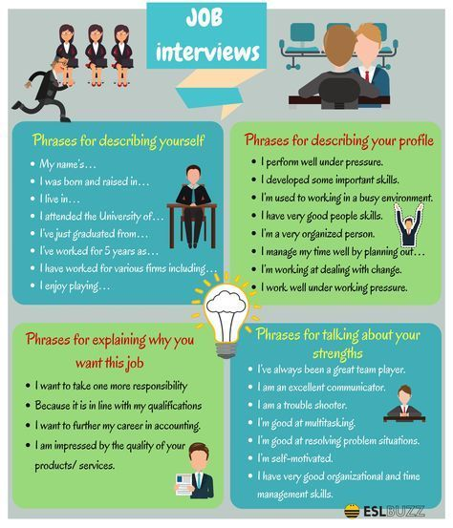

Task – Job application

Option 1: Record a voice message using <https://vocaroo.com/> and submit it in the virtual class.

Option 2: Prepare your job application and get ready to say it in class.

Hello! My name is Pedro Dresch. I am a professional in the field of web programming, software development, and cybersecurity with over five years of experience in creating complex integrated systems and working as a Security Analyst for major companies. Recently, I obtained my OSCP certification, and I'm excited to take on new challenges in my career.

I was drawn to your company because of its innovative approach and industry reputation. I have closely followed your recent projects, and I'm impressed by your ability to effectively combine creativity and technology. I believe this is an excellent opportunity for me to contribute my skills and knowledge, and I would love to be part of a dynamic team focused on excellence.

One of my key strengths is my ability to develop effective systems tailored to market needs.