SPEAKING SECTION – JUNE, 16

This first video is about applying for a job: <https://www.youtube.com/watch?v=-uWVa_fDeBw>

Job interview simulation: <https://www.youtube.com/watch?v=naIkpQ_cIt0>

Simulated video by the teacher: <https://www.loom.com/share/f8f4686dac3940189ddc2db1528cbd2e?sid=75b2468f-d5c8-4c13-9a3f-e78f6a84b14b>

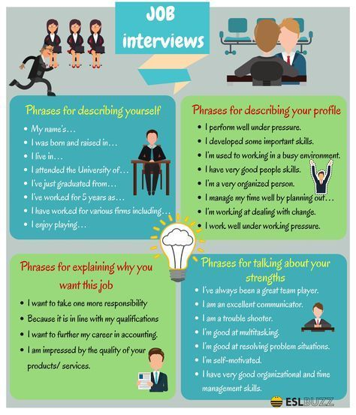

Task – Job application

Option 1: Record a voice message using <https://vocaroo.com/> and submit it in the virtual class.

Option 2: Prepare your job application and get ready to say it in class.