Letter of Application

**Software developer**

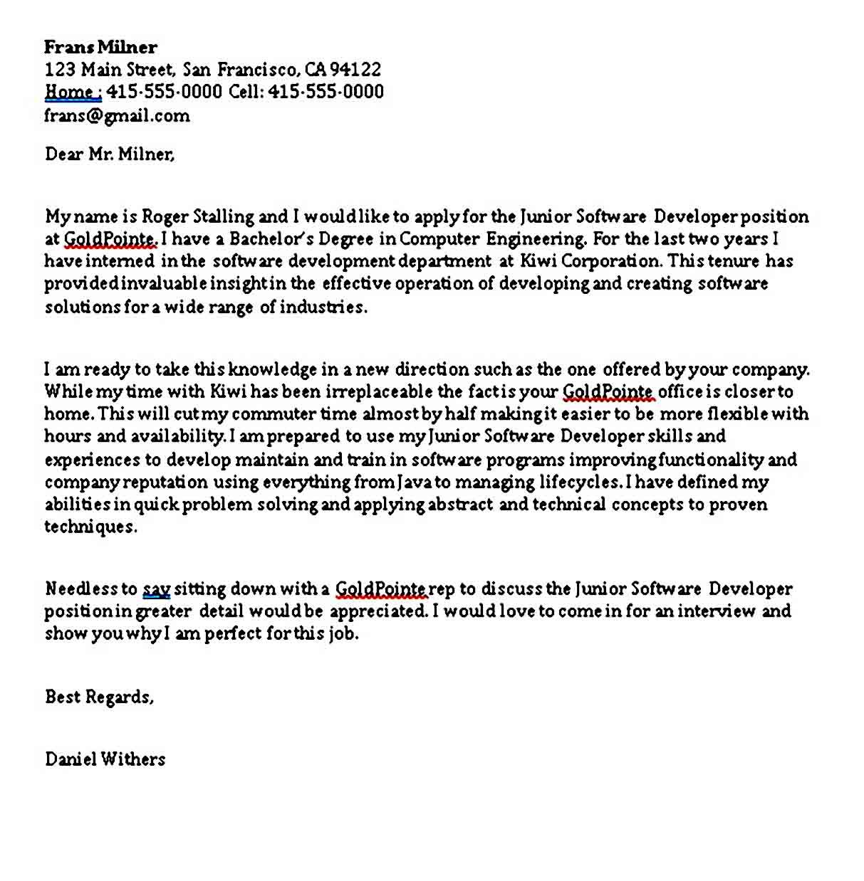

* Identify the phrases used.
* How is the letter divided?
* What skills does the writer mention?
* Write a similar letter.
* Writing a letter. Use these pieces of info.

JASON MARLON

2034 DAVON STREET – SOUTHHAMPTON – THE UK

PHONE: 0345-4965-9585

EMAIL ADDRESS: [jasonmarlonitcompany@gmail.com](mailto:jasonmarlonitcompany@gmail.com)

POSITION: IT organizer.