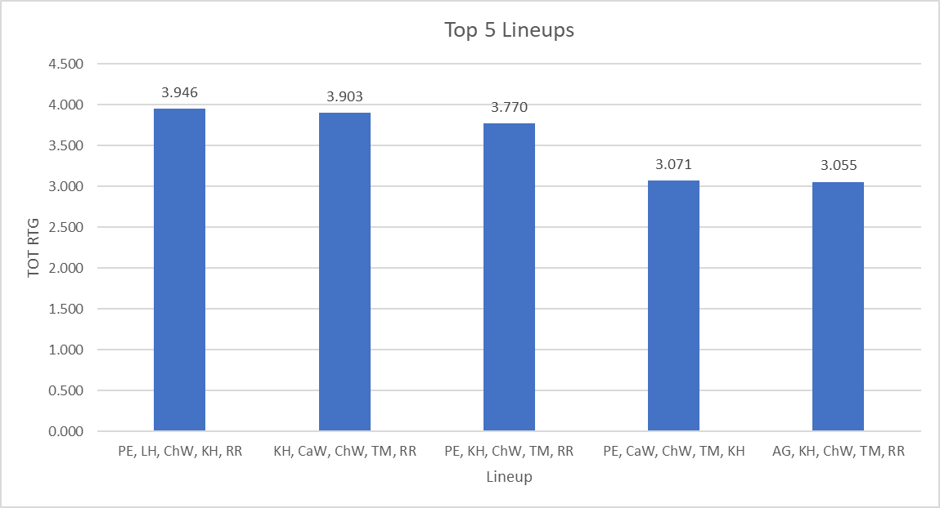

Figure 1: Season-Long Top 5 Lineups by Total Rating.  
These are the top 5 lineups by total rating for the season (offensive and defensive rating combined). To qualify, lineups must have had: 20 offensive possessions for the season, 15 offensive possessions in competitive games, and above lineup-average in both offensive and defensive rating. Total rating is on the y-axis, lineup is on the x-axis, and the number above the bar is total rating score for that lineup.  
An interesting lineup to consider testing out that did not make the cut as it has <15 possessions for the whole season – Lineup 19 PE, CaW, ChW, JC, RR. This lineup was very good offensively against Schoolcraft (15 points on 7 possessions) but hasn’t seen much action since nor been as good (4 points on 7 possessions). Defensively against Schoolcraft (2 pts on 10 poss), ROS (5 pts on 3 poss). It has played in 3 total games this year, but has not played in the past 7 games.

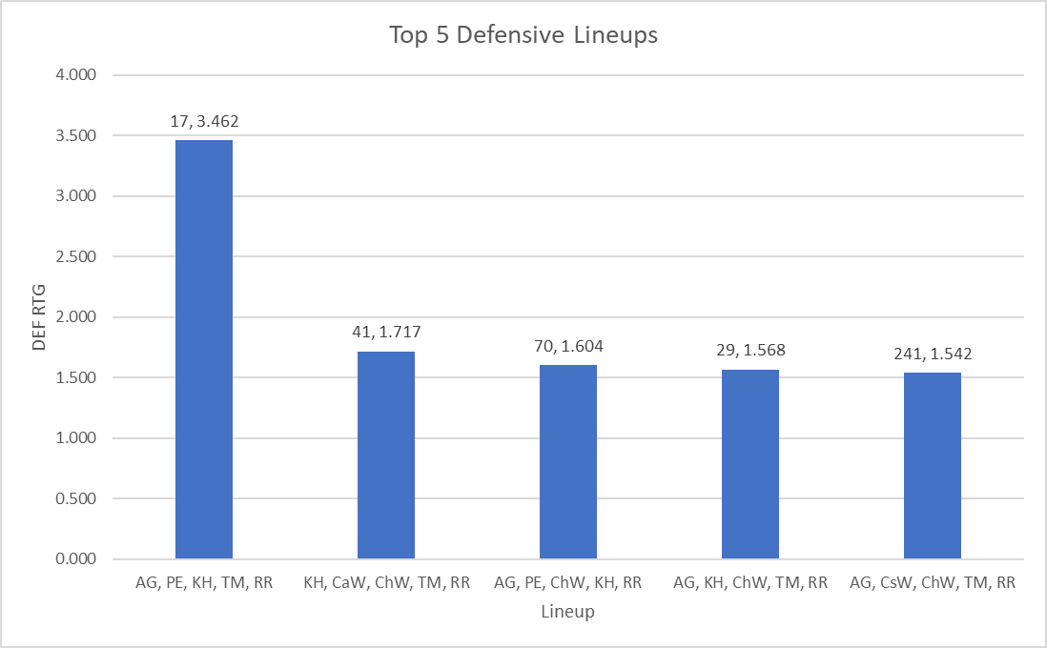

Figure 2: Season-Long Top 5 Defensive Lineups.  
The chart shows the best 5 defensive lineups (min. 15 possessions) of the entire season. These lineups also must have had at least 10 possessions played in competittive games. The first value above the bar is the number of defensive possessions played this season, the second number is the defensive rating iself.  
A note on Bar 1 – in competitive games the DEF RTG is 1.769, which is still very good.   
Additional note – two lineups that missed the cut that I think could be good are Lineup 34 (AG, CaW, PE, TM, RR) and Lineup 180 (AG, CaW, KH, TM, RR) They have exceptional competitive game scores (3.750 and 6.167, respectively) but haven’t seen much action throughout the season (each only 13 possessions played).

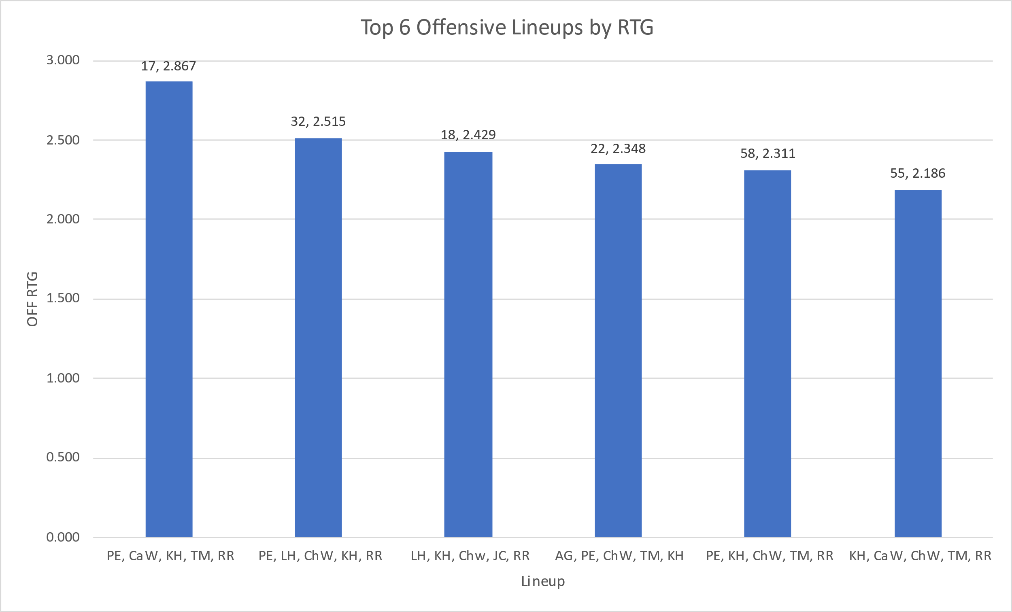

Figure 3: Season-Long Top 6 Offensive Lineups by Offensive Rating.  
The chart shows the best 6 offensive lineups (min. 15 possessions) of the entire season. These lineups also must have had at least 10 possessions played in competittive games – except for Bar 4 (AG, PE, ChW, TM, KH). I included this one anyway because the lineup composition appears to be suitable. The first value above the bar is the number of offensive possessions played this season, the second number is the offensive rating iself.

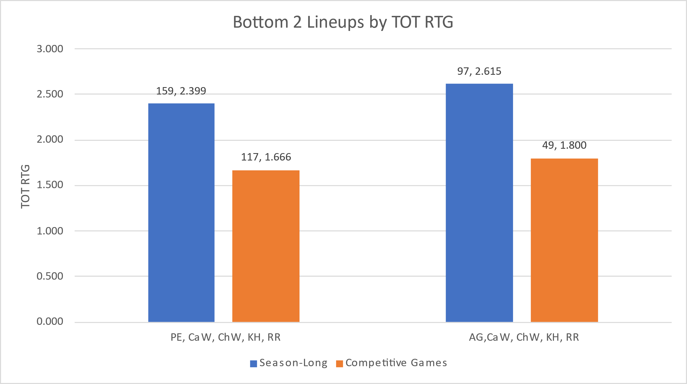

Figure 4: Season-Long Bottom 2 Lineups by Total Rating.  
These have been the 2 worst lineups as defined by the following requirements: minimum 15 offensive possessions played in competitive games, offensive rating below season-long lineup average, defensive rating below season-long lineup average. The blue column represents the season-long total rating for each lineup, and the orange bar represents the competitive games total rating. The first value above the bar is the total possessions played, the second value is the rating itself. For perspective, the starting lineup TOT RTG in competitive games alone is 2.531.

A Couple Observations I Don’t Have Graphs For

* Lineup 10: Paige, Caitlyn, Khali, Terre’ya, Rachel
  + Very good offensively (>1 PPP against Bay, and for the season)
  + Has really struggled defensively (>1 PPP against, .667 DEF RTG for the season)
  + Might be worth playing them more to try and identify why they struggle so much on the defensive end
* A screenshot of a computer

  Description automatically generatedThis is a snapshot of what your non-Rachel lineups look like in competitive games (min 5 off. possessions). The image is sorted by total rating. Lineup 39 (which also shows up in Figure 1) is your best non-Rachel lineup in my opinion, even with a lower rating than some of the ones above it. Quickly scanning the game logs, I found the ones above it to be primarily used against Alma, Oakland, and/or Muskegon.