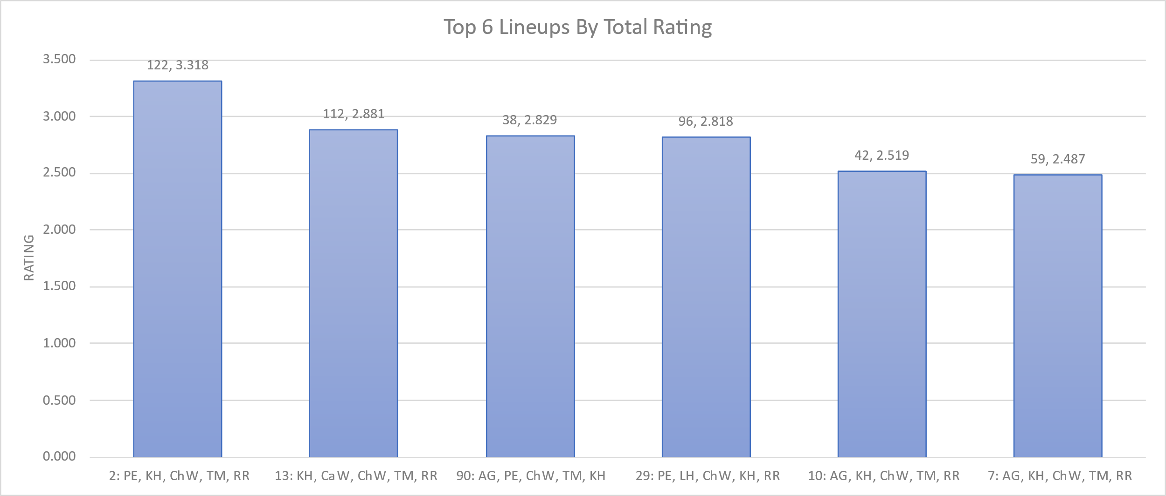

Figure 1: Season-Long Top 6 Lineups by Total Rating.  
These are the top 6 lineups by total rating for the season (offensive and defensive rating combined). To qualify, lineups must have had: 20 offensive possessions for the season, 15 offensive possessions in competitive games, and above lineup-average in both offensive and defensive rating. The only lineup that did not meet this criteria is Lineup 90 – it is well above average offensively (2.0) but weak defensively (0.8), especially in the few zone possessions they’ve played defensively.  
  
 Total rating is on the y-axis, lineup is on the x-axis, with the lineup number designation in front. The first number above the bar is the total number of possessions (off + def), the second is the rating value.

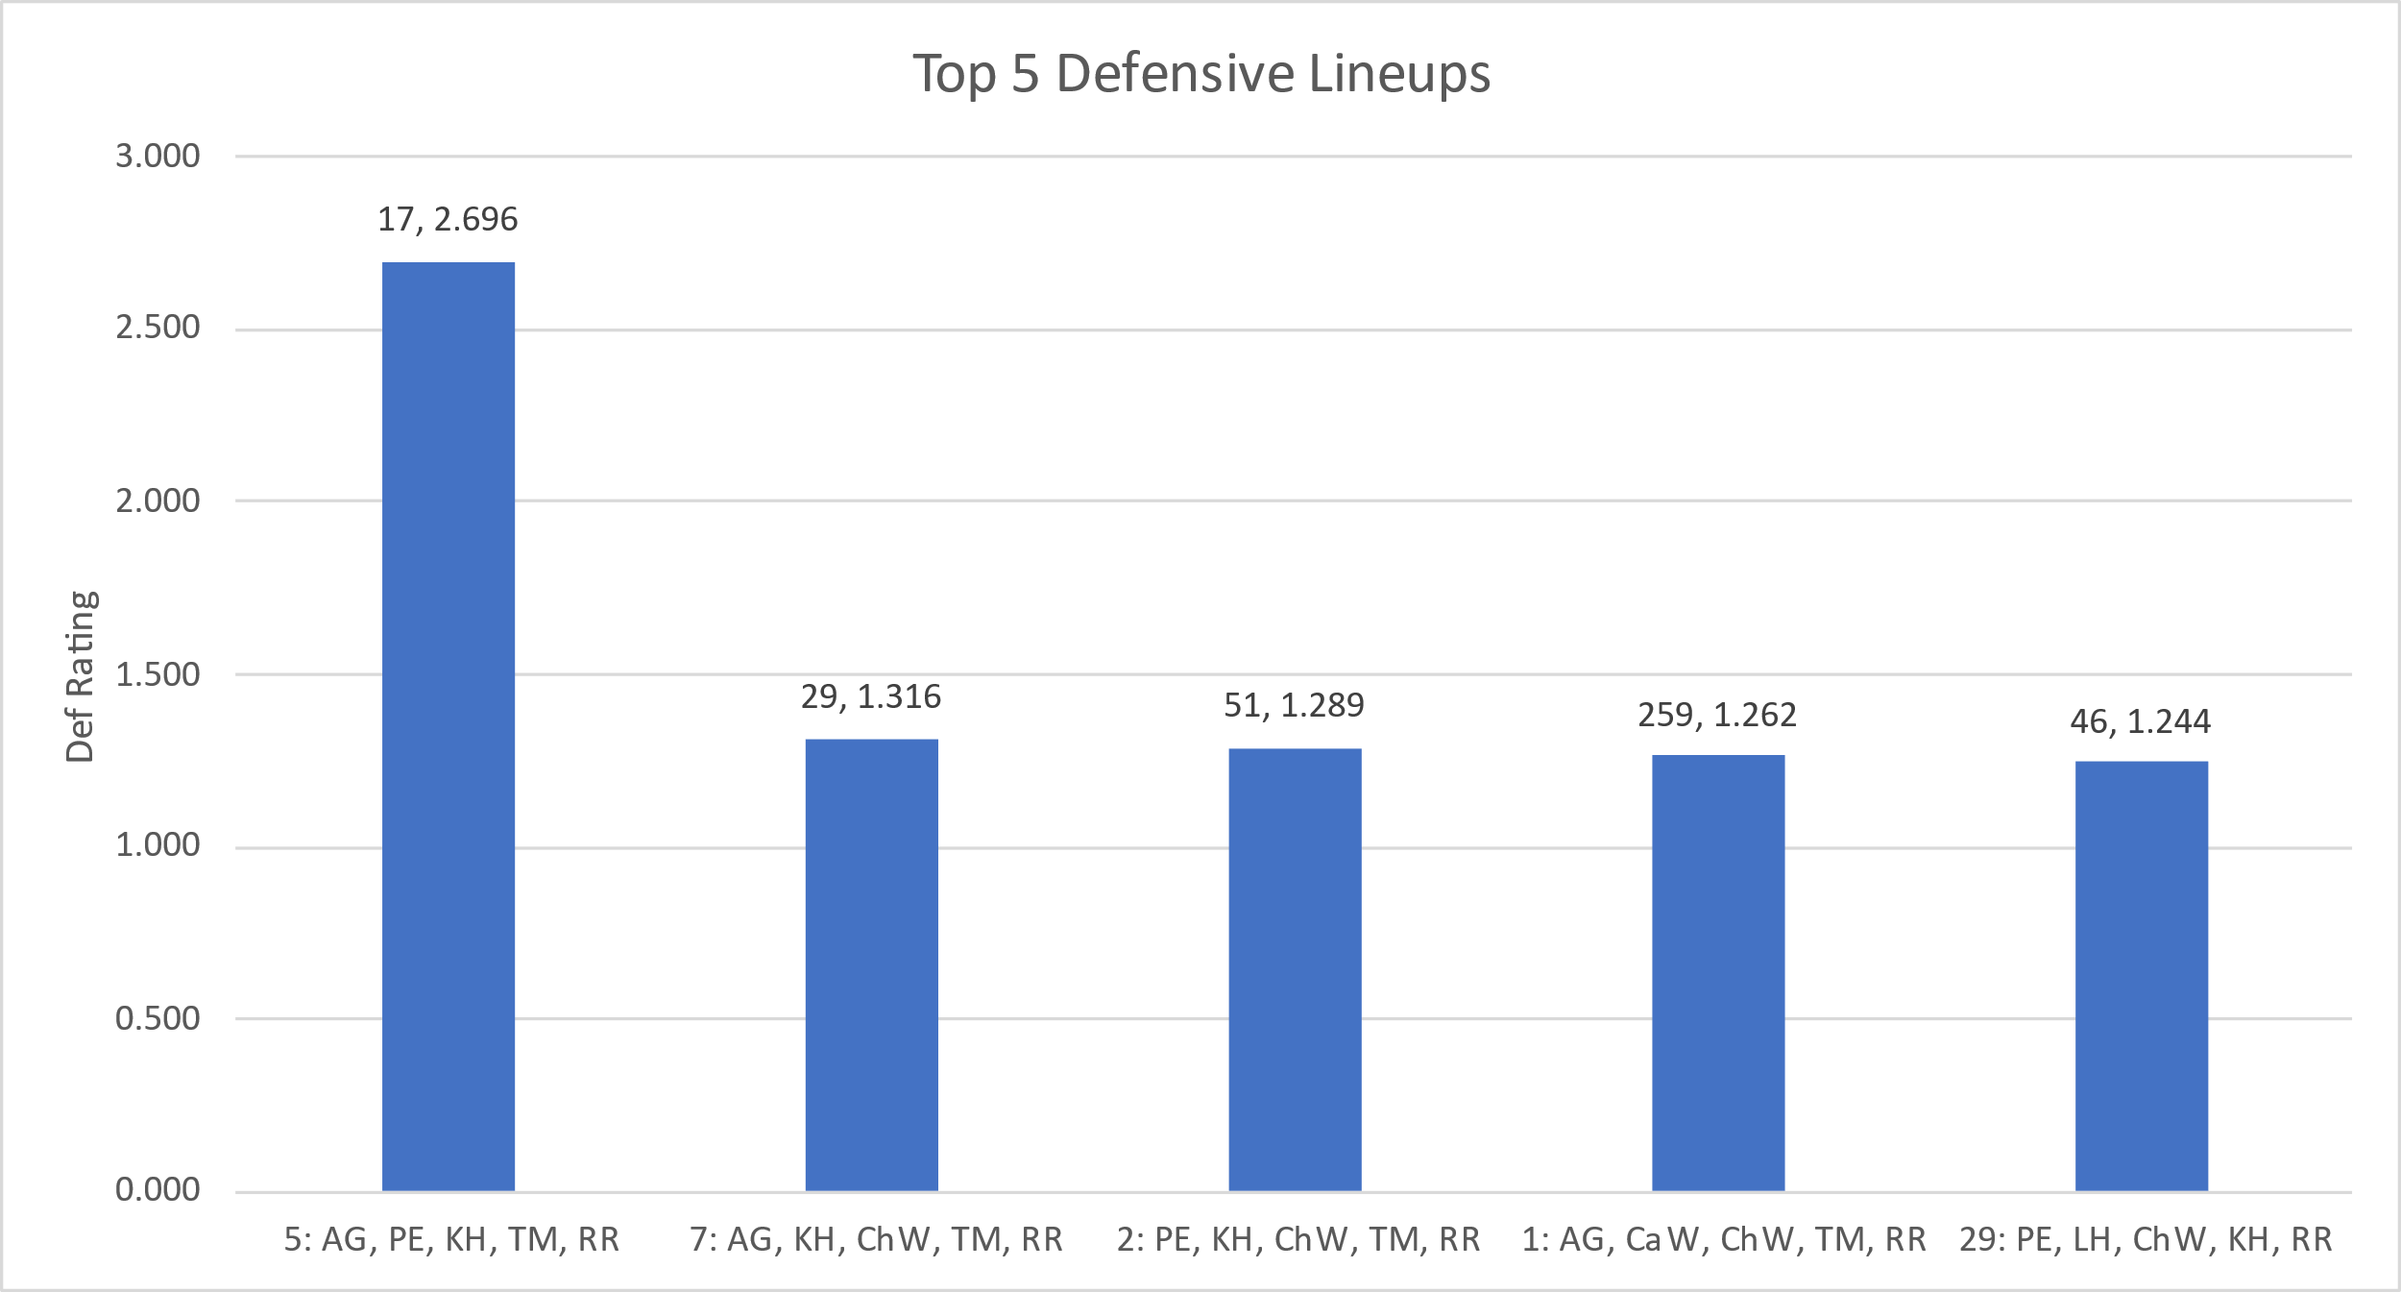

Figure 2: Season-Long Top 5 Defensive Lineups.  
The chart shows the best 5 defensive lineups (min. 15 possessions) of the entire season. These lineups also must have had at least 10 possessions played in competittive games. The first value above the bar is the number of defensive possessions played this season, the second number is the defensive rating iself.  
A note on Lineup 5 – in competitive games the DEF RTG is a full point less at 1.652, but that is still very good.

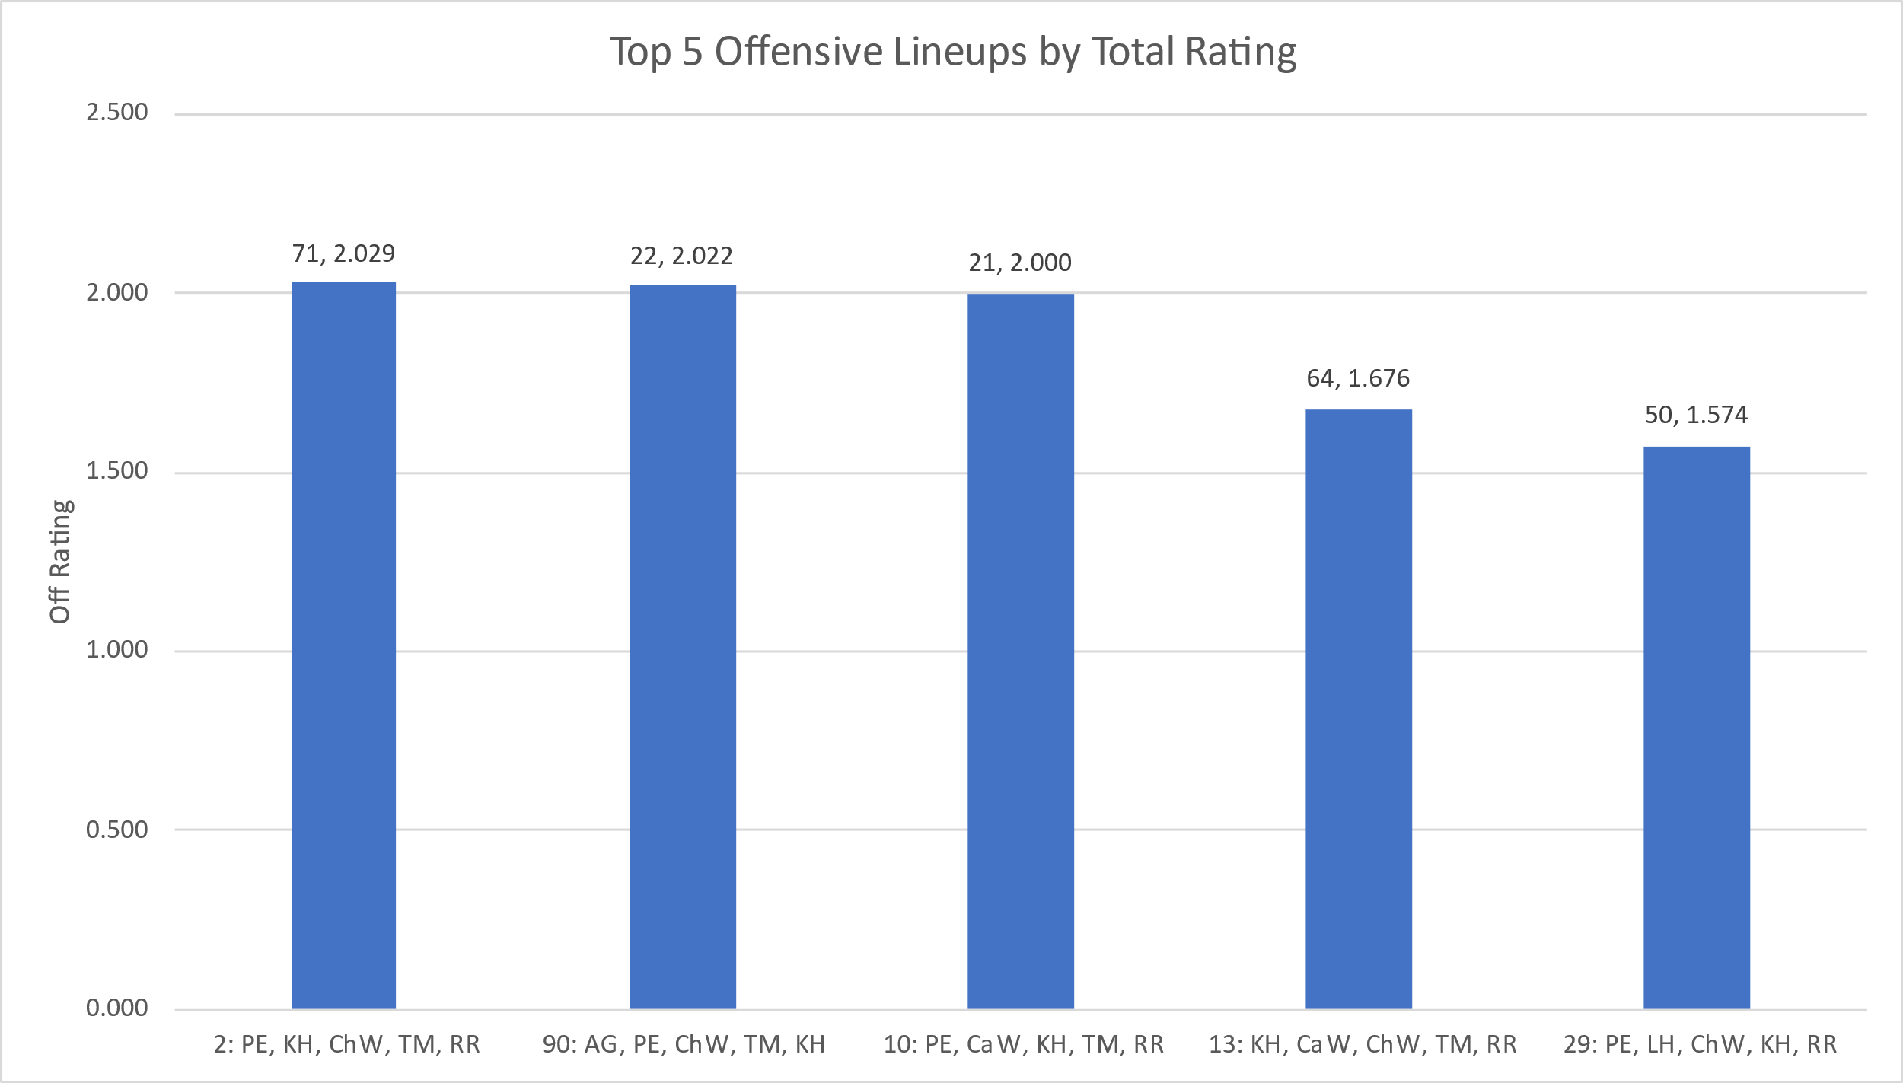

Figure 3: Season-Long Top 5 Offensive Lineups by Offensive Rating.  
The chart shows the best 5 offensive lineups (min. 15 possessions) of the entire season. These lineups also must have had at least 10 possessions played in competittive games. The first value above the bar is the number of offensive possessions played this season, the second number is the offensive rating iself. Offensive rating is on the y-axis, and the lineup (with lineup number) is on the X-axis.

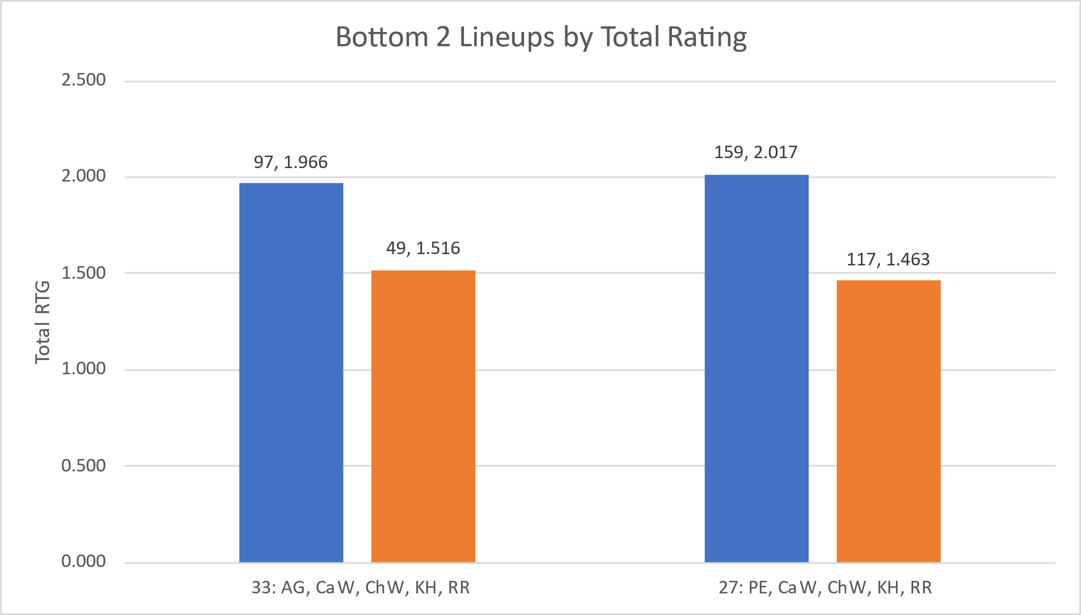

Figure 4: Season-Long Bottom 2 Lineups by Total Rating.  
These have been the 2 worst lineups as defined by the following requirements: minimum 15 offensive possessions played in competitive games, offensive rating below season-long lineup average, defensive rating below season-long lineup average. The blue column represents the season-long total rating for each lineup, and the orange bar represents the competitive games total rating. The first value above the bar is the total possessions played, the second value is the rating itself. For perspective, the starting lineup TOT RTG in competitive games alone is 2.060.

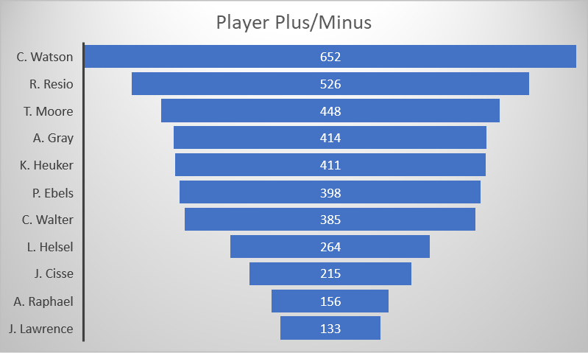

Figure 5: Player Season-Long Plus/Minus.  
The chart was generated by totaling the plus/minus of every lineup the player has appeared in this season. The values are listed in descending order, with player name on the Y-axis and the plus/minus value in the center of the bar.