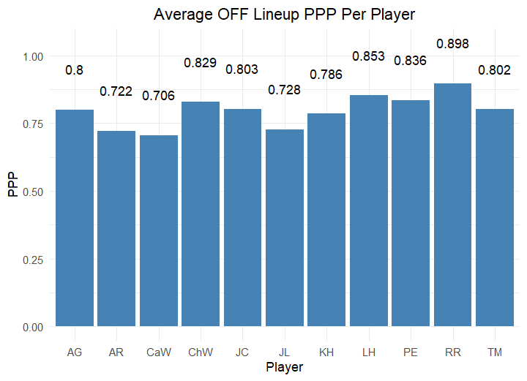

Figure 1: Average Offensive (OFF) Lineup Points Per Possession (PPP) By Player.  
The chart was generated by taking the average PPP across all lineups a player was included in. For example, the average offensive PPP for every lineup that included Addysen Gray (AG) is 0.800. Player names are organized across the X-axis in alphabetical order, by initial. PPP was generated by taking the total points and dividing by the number of possessions a lineup had. The farther away from zero the PPP is, the better.

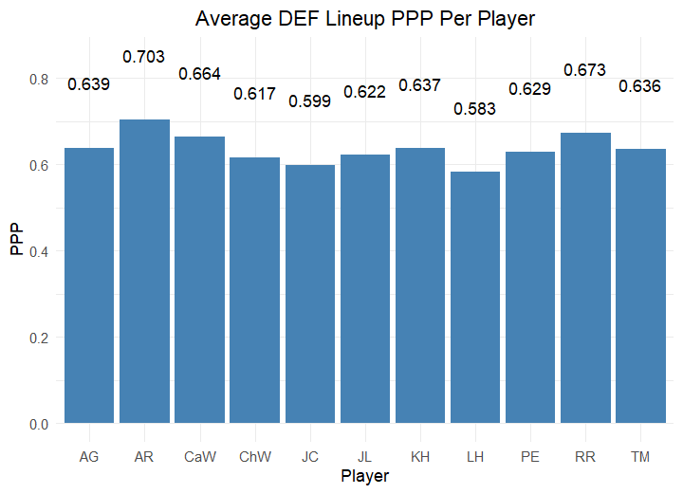

Figure 2: Average Defensive (DEF) Lineup Points Per Possession (PPP) By Player.  
The chart was generated by taking the average PPP across all lineups a player was included in. For example, the average defensive PPP for every lineup that included Addysen Gray (AG) is 0.639. Player names are organized across the X-axis in alphabetical order, by initial. PPP was generated by taking the total points and dividing by the number of possessions a lineup had. The closer the PPP is to zero, the better.

Figure 3: Average Lineup Offensive Rating Score By Player.  
Offensive rating score was generated by using the above formula. The chart was generated by taking the average offensive rating score across all lineups a player was included in. For example, the average OFF RTG SCORE for every lineup that included Addysen Gray (AG) is 1.241. Player names are organized across the X-axis in alphabetical order, by initial. The farther away from zero a score is, the better.

Figure 4: Average Lineup Defensive Rating Score By Player.  
Defensive rating score was generated by using the above formula. The chart was generated by taking the average defensive rating score across all lineups a player was included in. For example, the average DEF RTG SCORE for every lineup that included Addysen Gray (AG) is 1.321. Player names are organized across the X-axis in alphabetical order, by initial. The farther away from zero a score is, the better.

Figure 5: Median Defensive Lineup PPP Per Player.  
The chart was generated by taking the median defensive PPP across all lineups a player was included in. For example, the median defensive PPP for every lineup that included Addysen Gray (AG) is 0.556. Player names are organized across the X-axis in alphabetical order, by initial. PPP was generated by taking the total points and dividing by the number of possessions a lineup had. The closer the PPP to zero, the better.

Figure 6: Median Offensive Lineup PPP Per Player.  
The chart was generated by taking the median offensive PPP across all lineups a player was included in. For example, the median offensive PPP for every lineup that included Addysen Gray (AG) is 0.714. Player names are organized across the X-axis in alphabetical order, by initial. PPP was generated by taking the total points and dividing by the number of possessions a lineup had. The farther away from zero the PPP is, the better.

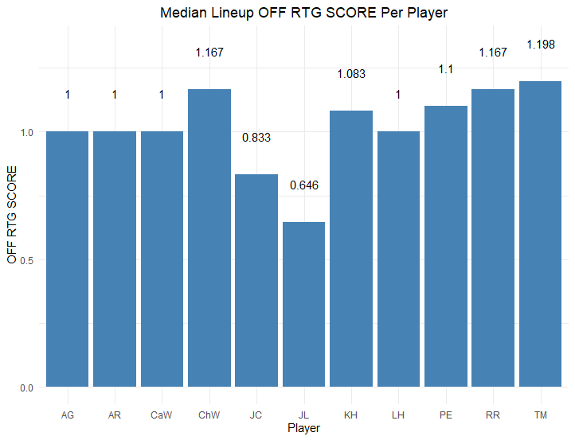

Figure 7: Median Lineup Defensive Rating Score Per Player.  
Defensive rating score was generated by using the same formula from Figure 4. The chart was generated by taking the median defensive rating score across all lineups a player was included in. For example, the average DEF RTG SCORE for every lineup that included Addysen Gray (AG) is 1.200. Player names are organized across the X-axis in alphabetical order, by initial. The farther away from zero a score is, the better.

Figure 8: Median Lineup Offensive Rating Score Per Player.  
Offensive rating score was generated by using the same formula from Figure 3. The chart was generated by taking the median offensive rating score across all lineups a player was included in. For example, the average OFF RTG SCORE for every lineup that included Addysen Gray (AG) is 1.000. Player names are organized across the X-axis in alphabetical order, by initial. The farther away from zero a score is, the better.

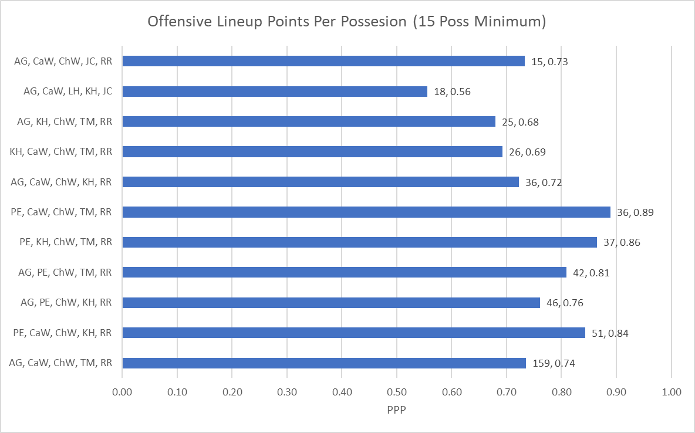

Figure 9: Offensive Lineup Points Per Possession With a Minimum of 15 Possessions Played.  
The chart shows the offensive PPP for the 11 lineups that have at least 15 possessions played. Each unique lineup is listed down the y-axis in order of increasing possessions played. The first number after the bar is how many possessions a lineup played, the second number is the PPP value itself.

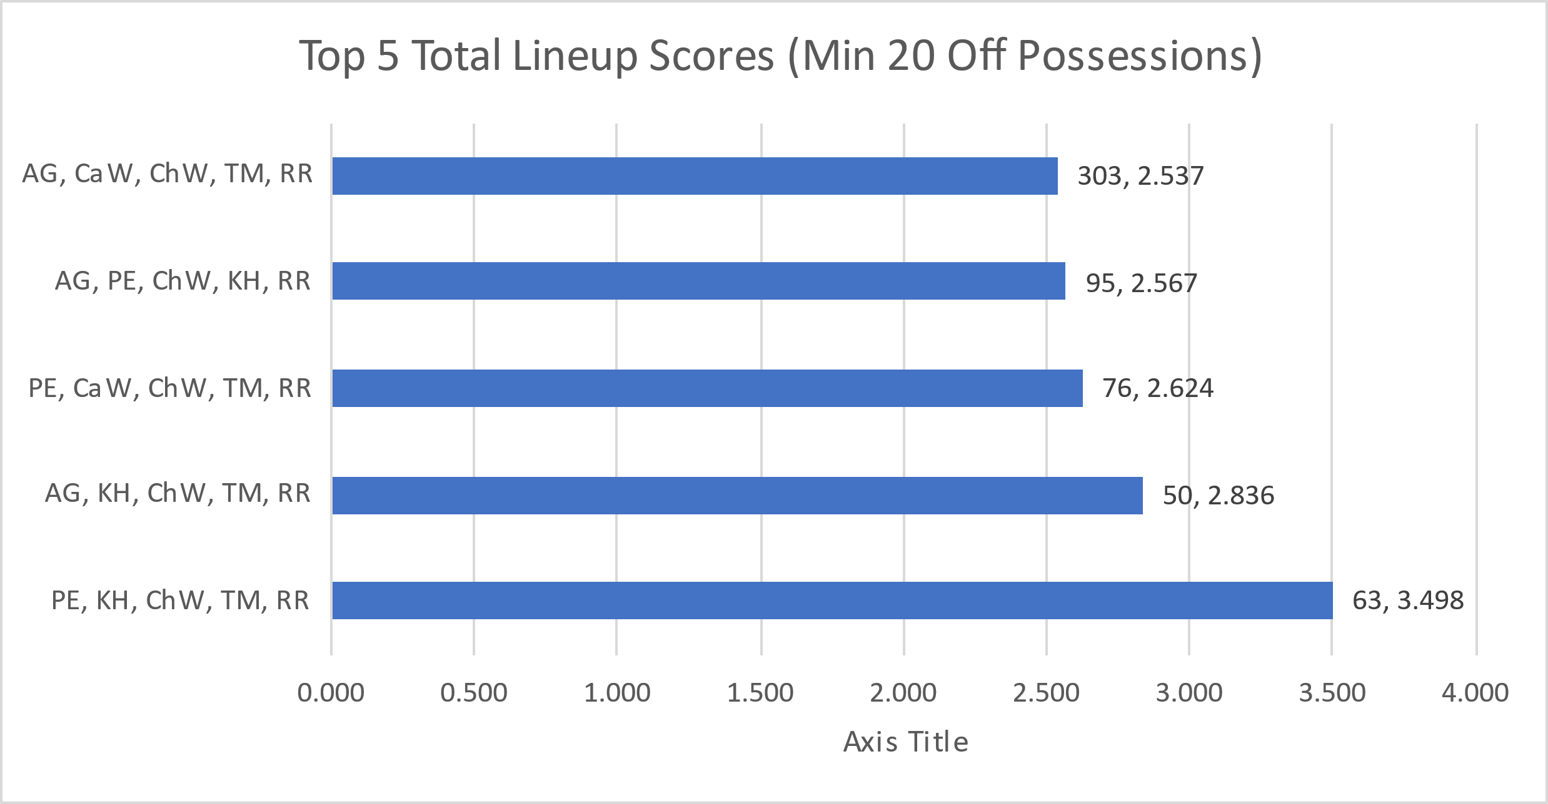

Figure 10: Total Rating Score for the Top 5 Lineups with a Minimum of 20 Offensive Possessions Played.  
The chart was generated by summing the offensive and defensive rating score for each of the top 5 lineups with at least 20 offensive possessions played, in increasing order of total score. The first value after the bar is the combined number of offensive and defensive possessions played. The second value is the total score. PPP is on the x-axis.

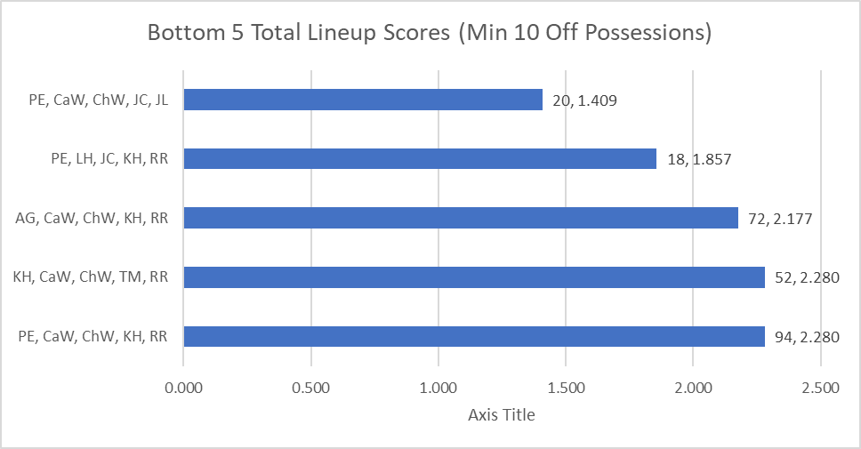

Figure 11: Total Rating Score for the Bottom 5 Lineups with a Minimum of 10 Offensive Possessions Played.  
The chart was generated by summing the offensive and defensive rating score for each of the bottom 5 lineups with at least 10 offensive possessions played, in increasing order of total score. The first value after the bar is the combined number of offensive and defensive possessions played. The second value is the total score.

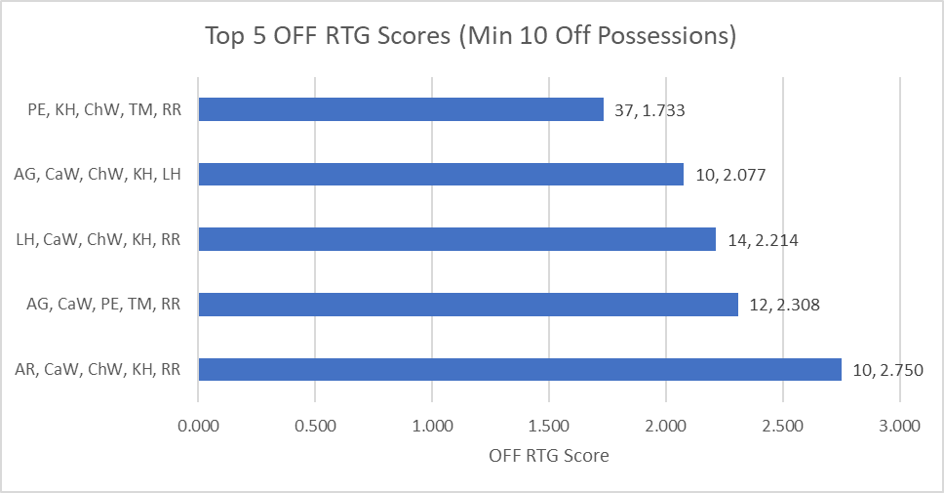

Figure 12: Top 5 Lineups by Offensive Rating Score with a Minimum 10 Offensive Possessions Played.  
The chart was generated by using the offensive rating score for each of the top 5 lineups with at least 10 offensive possessions played, in increasing order of total score. The first value after the bar is the number of offensive possessions played. The second value is the score.

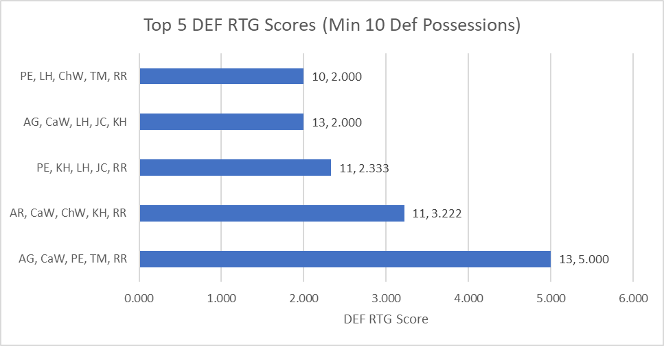

Figure 13: Top 5 Lineups by Defensive Rating Score with a Minimum 10 Defensive Possessions Played.  
The chart was generated by using the defensive rating score for each of the top 5 lineups with at least 10 defensive possessions played, in increasing order of total score. The first value after the bar is the number of defensive possessions played. The second value is the score.