In Silico Investigation of Triterpenoids as Potential Inhibitors of PDPK1 in Colorectal Cancer

In Silico Studies
Drug discovery is a complex, time-consuming, and expensive process that traditionally relies on in vitro and in vivo experiments. In recent decades, in silico studies have emerged as a vital computational approach to accelerate this process. The term "in silico" is derived from "in silicon," referring to computer chips, and denotes experiments performed using computers rather than in a laboratory.
In silico methods utilize mathematical models, algorithms, and bioinformatics tools to simulate biological systems and predict the interaction between potential drug candidates and their molecular targets. These techniques have become indispensable in the early stages of drug discovery by enabling the rapid screening of large chemical libraries, prediction of pharmacological properties, and reduction of experimental costs. In silico approaches serve as a bridge between theoretical drug design and experimental validation, thereby improving the efficiency of the drug development pipeline.
In silico techniques can be broadly classified into structure-based, ligand-based, and systems biology approaches. Structure Based Drug Design (SBDD) methods are employed when the three - dimensional structure of the target protein is available. The most widely used technique is molecular docking, which predicts the binding orientation and affinity of a ligand within the active site of a protein. To assess the stability of the protein-ligand complex, molecular dynamics simulations (MDS) are performed over a nanosecond timescale. Further, binding free energy calculations such as MM-GBSA and MM-PBSA provide more accurate estimates of binding strength.
Ligand-Based Drug Design (LBDD) is used when the target structure is unknown. Pharmacophore modelling identifies the essential 3D features required for biological activity. Quantitative Structure-Activity Relationship (QSAR) correlates the chemical structure of compounds with their biological activity to predict new molecules with improved potency. Similarity searching is also used to identify novel compounds structurally similar to known active molecules.
Virtual Screening and Database Mining enables the evaluation of millions of compounds from public databases such as ZINC, PubChem, and ChEMBL against a selected target in a short period. Additionally, drug repurposing approaches use in silico tools to identify new therapeutic applications for existing FDA-approved drugs.

ADMET and Drug-likeness Prediction is predicting pharmacokinetic and toxicity profiles is critical to reduce late-stage failures. In silico tools predict Absorption, Distribution, Metabolism, Excretion, and Toxicity (ADMET) properties. Drug-likeness is often assessed using Lipinski’s Rule of Five and Veber’s rules to evaluate oral bioavailability.
Systems Biology and Network Approaches with the advent of omics data, network pharmacology and pathway analysis have gained importance. These methods help in understanding multi-target mechanisms and identifying novel disease-related targets.
In silico studies have diverse applications in pharmaceutical research. The primary application is lead identification and optimization, where computational screening prioritizes potential hits for experimental testing. They are also extensively used for target identification by analyzing genomic and proteomic data.
During public health emergencies, drug repurposing via in silico screening has proven valuable for rapidly identifying candidate therapeutics. Furthermore, ADMET prediction helps in early elimination of compounds with poor pharmacokinetic profiles or toxicity, thereby saving resources. In silico methods are also applied in vaccine design, antibody engineering, and personalized medicine by integrating patient genomic information.
The major advantages of in silico studies include speed, cost-effectiveness, and safety. Computational screening can evaluate millions of compounds within days, a task that would take years in the laboratory. It reduces the need for expensive chemicals, animal models, and laboratory infrastructure in the early discovery phase. Moreover, in silico techniques allow researchers to test potentially toxic compounds in a virtual environment without safety risks. Access to public databases further enhances the scope and reproducibility of computational research.
Despite their advantages, in silico studies have certain limitations. The accuracy of predictions is highly dependent on the quality of structural and biological data. Current force fields and scoring functions used in docking and simulation cannot fully replicate the complexity of physiological conditions. Factors such as gut metabolism, protein binding, and tumor microenvironment are often not accounted for in computational models. Consequently, false positives and false negatives are common, necessitating experimental validation of all computational hits. Additionally, high-level simulations require significant computational resources and expertise in both biology and cheminformatics.
In silico studies have transformed the landscape of drug discovery by providing a rational, fast, and economical approach for hit identification and lead optimization. While they cannot replace in vitro and in vivo experiments, they serve as a crucial preliminary step to narrow down chemical space and prioritize candidates. With advancements in artificial intelligence, machine learning, and high-performance computing, the predictive power of in silico methods is expected to improve significantly in the coming years.

In recent years, in silico approaches have evolved beyond basic docking and screening. Machine Learning (ML) and Artificial Intelligence (AI) are now integrated into drug discovery pipelines to predict bioactivity, toxicity, and drug-target interactions with higher accuracy. Deep learning models trained on large chemical and biological datasets can identify patterns that are not easily detected by traditional QSAR methods.
Free energy calculation methods such as MM-GBSA, MM-PBSA, and FEP have improved the reliability of binding affinity predictions obtained from docking. These methods provide thermodynamic insights into protein-ligand interactions and help in ranking lead compounds more precisely.
Another important advancement is fragment-based drug design (FBDD). In this approach, small molecular fragments are docked and then linked or grown to form larger, more potent drug candidates. This reduces chemical space and increases the probability of identifying novel scaffolds.
A typical in silico drug discovery workflow begins with target identification and retrieval of 3D structures from protein databases. Ligand libraries are prepared and subjected to preprocessing steps such as energy minimization and conformer generation. Virtual screening is then performed to filter compounds based on binding affinity. Selected hits undergo ADMET profiling, toxicity prediction, and molecular dynamics simulation to assess stability. Finally, the top-ranked compounds are proposed for experimental validation.
Several public databases support in silico research. PDB provides protein structures, PubChem, ZINC, and ChEMBL provide chemical compounds, DrugBank provides drug information, and STRING and KEGG provide protein-protein and pathway data. The availability of these resources has made in silico studies more accessible and reproducible.
The future of in silico studies lies in the integration of AI, cloud computing, and big data. AI-driven models are expected to reduce false positives and improve prediction of clinical outcomes. However, major challenges remain, including the need for more accurate force fields, better modelling of protein flexibility, and inclusion of physiological factors such as membrane permeability and metabolic transformations.
Despite these limitations, in silico studies continue to play a transformative role by making drug discovery faster, cheaper, and more rational. As computational power increases and algorithms improve, the gap between computational predictions and experimental results is expected to narrow, making in silico methods even more integral to pharmaceutical research.

Colorectal Cancer
Colorectal cancer (CRC) is a malignant tumor that arises from the inner lining of the colon or rectum. It is one of the most common gastrointestinal malignancies and represents a significant cause of cancer – related morbidity and mortality worldwide. The colon and rectum are the final parts of the digestive tract responsible for absorption of water and formation of feces. CRC typically develops through a multi-step process known as the “adenoma – carcinoma sequence,’’ where normal colonic epithelium progressively transforms into benign adenomatous polyps and eventually into invasive carcinoma due to accumulation of genetic epigenetic alterations.
Molecularly, CRC is heterogenous and is driven by three major pathways: chromosomal instability (CIN), Microsatellite Instability (MSI), and cpG Island Methylator Phenotype (CIMP). These pathways dysregulate key signaling cascades including Wnt/β-catenin, PI3K/AKT/PDPK1, and MAPK, resulting in uncontrolled proliferation, survival, and metastasis. Due to its rising incidence in developing nations and its molecular complexity, CRC remains a major area of research for novel therapeutic targets.
Epidemiology and Incidence
Global Epidemiology
Colorectal cancer (CRC) represents a major global health burden. It is the third most frequently diagnosed cancer and second most leading cause of cancer-related mortality worldwide. According to the GLOBOCAN 2022 database by the International Agency for Research on Cancer (IARC), there were approximately 1.9 million new cases of CRC and 0.9 million deaths reported globally in 2022.
The distribution of CRC is not uniform and shows wide geographic variation. The highest age – standardized incidence rates (ASIR) are observed in highly developed countries. Australia and New Zealand report the highest rates at 35.3 and 32.2 per 100,000 population respectively, followed by countries in Europe and North America such as Hungary, Slovakia, Denmark, and the United States.
This high incidence in developed nations is attributed to multiple factors including aging populations, widespread adoption of Western dietary patterns high in red and processed meat, low fibre intake, physical inactivity, obesity, smoking, alcohol consumption, and the availability of screening programs like colonoscopy and fecal occult blood tests which lead to higher detection rates.
In contrast, regions in Africa and South – Central Asia report the lowest incidence rates, typically below 10 per 100,000. However, these regions are experiencing the fastest increase in CRC burden. This epidemiological transition is driven by rapid urbanization, economic development, and adoption of lifestyle risk factors previously seen only in western countries.

Projections indicate that the global burden of CRC will increase substantially by 2030. The number of new cases is expected to rise by 60% to 2.2 million, and deaths by 70% to 1.1 million annually. More than 70% of this increase is expected to occur in low – and middle – income countries, placing significant strain on already limited healthcare resources.
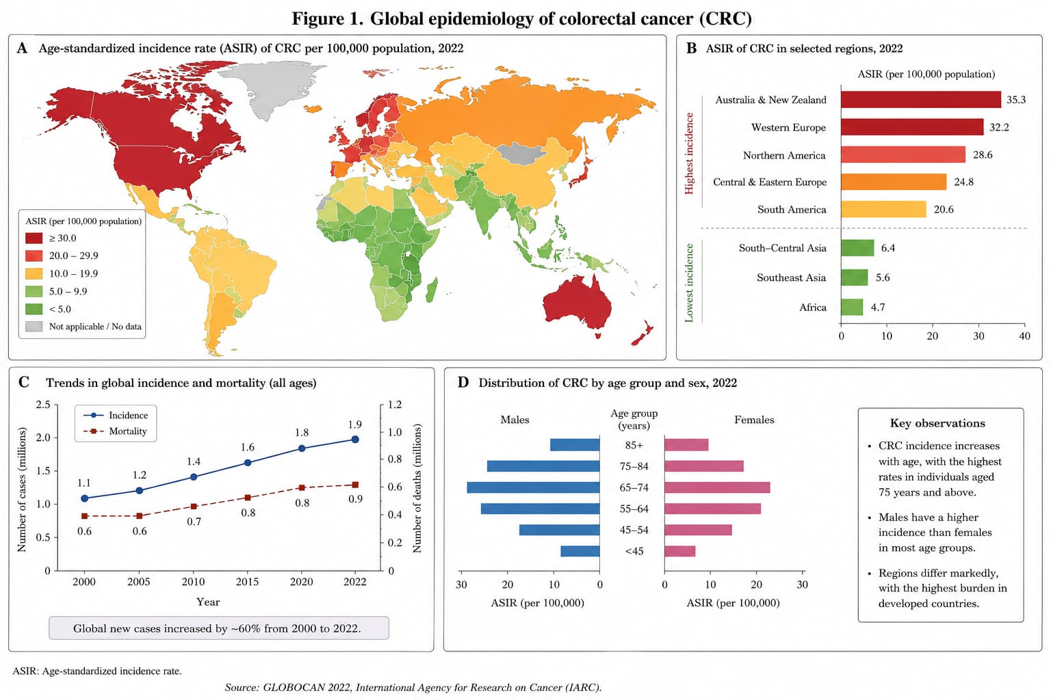
India Epidemiology
In India, CRC was traditionally considered a rare cancer. However, data from the Indian Council of medical Research – National Cancer Registry Programme (ICMR-NCRP) 2020-2021indicates that CRC has now emerged among top 10 cancers in both male and females. As per GLOBOCAN 2022, India reported approximately 72,368 new cases of CRC and 47,477 deaths. CRC accounts for 4.0% of all new cancer cases and 3.5% of all cancer deaths in India.
The ICMR – NCRP data highlights significant regional variation. The highest incidence rates observed in the North-Eastern states such as Mizoram and Nagaland, followed by metropolitan cities including Delhi, Chennai, Bangalore, and Mumbai with ASIR ranging from 8-12 per 100,000. Urban registries consistently report 2-3 times higher incidence compared to rural registries, reflecting lifestyle differences.
Parameter | Males | Females
New cases | 41,582 | 30,786
Deaths | 27,503 | 19,974
5-year prevalence | 98,214 | 71,305

The median age of diagnosis in India is 45-50 years, approximately 10 years younger than in Western countries. Nearly 35-40% of Indian CRC patients are below 50 years of age. Unlike western countries where colon cancer predominates, rectal cancer constitutes 45-55 of all CRC cases in India. This has implications for surgical management.
Due to lack of organized screening and low awareness, >60% of patients present at stage III and IV, contributing to poor survival outcomes. The rising incidence is linked to nutrition transition – shift from traditional high-fiber diet due to low-fiber, high-fat diet, along with increasing obesity, sedentary lifestyle, tobacco and alcohol use. Projections based on ICMR data suggest that the burden of CRC in India will double by 2040 due to demographic and lifestyle changes.
Figure 2.2: Comparison of site distribution of colorectal cancer in (A) India and (B) Western countries. India shows a higher proportion of rectal cancer compared to Western countries. Source: ICMR-NCRP 2020-2021; SEER 2023.
As depicted in Figure 2.2, India demonstrates a distinct pattern with nearly equal distribution of colon and rectal cancer, whereas Western countries show predominance of colon cancer at 65%.
The global and Indian burden of colorectal cancer presents a growing public health challenge. As discussed, CRC ranks as the third most common cancer worldwide and its incidence is projected to rise significantly by 2040, driven by population growth, aging, and lifestyle transitions. The epidemiological data reveal distinct patterns between developed and developing nations. While Western countries report higher overall incidence rates, India and other Asian countries are witnessing a rapid increase, particularly among individuals below 50 years of age. The disparity in stage at presentation, with majority of Indian patients diagnosed at advanced stages, contributes to poor survival outcomes and increased treatment burden.

Clinical Presentation and Diagnosis of Colorectal Cancer
Clinical Symptoms
Colorectal cancer often remains asymptomatic in early stages, which contributes to delayed diagnosis and poor prognosis. Symptoms depend on tumor location, size, and stage. Right-sided colon cancers tend to present late with vague symptoms, while left-sided and rectal cancers present earlier with obstructive and bleeding symptoms.
Persistent alteration in bowel habits lasting >6 weeks is a key warning sign. This includes diarrhea, constipation, or alternating diarrhea and constipation. Narrow caliber stools may indicate a left-sided obstructing lesion.
Bright red blood per rectum or melena is common, especially in rectal and sigmoid cancers. It is often mistaken for hemorrhoids, leads to diagnostic delay. Occult blood in stool is frequently the first sign of the right-sided colon cancer. Crampy abdominal pain, bloating, and feeling of incomplete evacuation are common. Advanced tumors may cause bowel obstruction with severe pain, vomiting, and abdominal distension.
Unintentional weight loss, anorexia, and generalized weakness are seen in advanced disease. Chronic blood loss leads to iron deficiency anaemia, presenting as fatigue and pallor. This is more common in right-sided tumors.
Other Symptoms
Tenesmus, urgency and feeling of incomplete evacuation are specific to rectal cancer. In advanced cases, symptoms of metastasis such as jaundice, hepatomegaly, or ascites may be present.
It is important to note that younger patients often present with more aggressive disease and advanced stage, as seen in Indian population data.
Diagnosis Approaches
Early diagnosis significantly improves 5-year survival from <15% in stage IV to >90% in stage I. Diagnosis involves a combination of clinical evaluation, laboratory tests, endoscopy, and imaging. Digital Rectal Examination (DRE) is essential for all patients with rectal symptoms and can detect up to 10% of rectal cancers. Abdominal examination may reveal palpable mass or hepatomegaly in metastatic disease.
Laboratory investigations play a supportive role in the diagnosis, staging, and follow-up of colorectal cancer. A complete blood count is routinely performed to detect anaemia, which is a common finding especially in right-sided colon cancers due to chronic occult blood loss. Iron deficiency anaemia often presents with fatigue, pallor, and reduced exercise tolerance and may be the first clinical clue in asymptomatic patients.

Liver function tests are essential as part of the initial workup to assess hepatic involvement, since the liver is the most common site of metastasis in CRC. Elevated liver enzymes or bilirubin may indicate advanced disease and influence treatment decisions. Renal function tests are also done to assess patient fitness for chemotherapy and contrast-based imaging.
Carcinoembryonic antigen is the most widely used tumor marker in CRC. Although it lacks sensitivity and specificity for screening, preoperative CEA levels correlate with tumor burden and prognosis. Serial monitoring of CEA after treatment is valuable for detecting recurrence and assessing response to therapy. Additional investigations such as serum electrolytes, coagulation profile, and nutritional assessment may be required depending on the patient’s clinical condition.
Overall, laboratory tests complement clinical and radiological findings and provide important baseline data for management and prognostication of colorectal cancer patients.
Colonoscopy is the gold standard for diagnosis and allows direct visualization, biopsy, and removal of polyps. Flexible sigmoidoscopy is useful for distal lesions. In India, due to cost and accessibility, colonoscopy is often done only in symptomatic patients. Biopsy from colonoscopic samples provides definite diagnosis. Histology also determines tumor grade, lymphovascular invasion, and MSI status which guide treatment.
Once the diagnosis of colorectal cancer is confirmed by histopathology, accurate staging is essential to determine the extent of disease and plan appropriate treatment. Contrast-enhanced computed tomography of the chest, abdomen, and pelvis is the standard imaging modality used for initial staging. It helps in assessing the primary tumor, regional lymph nodes, and distant metastasis, particularly to the liver and lungs.
MRI of the pelvis is the preferred modality for rectal cancer as it provides excellent soft tissue resolution and helps in evaluating the depth of tumor invasion and involvement of the mesorectal fascia, which is critical for surgical planning. Positron emission tomography combined with CT is not routinely used for initial staging but is valuable in cases of suspected recurrence or equivocal findings on conventional imaging.
Ultrasonography is often used as a first-line tool to screen for liver metastasis due to its wide availability and cost-effectiveness, especially in resource-limited settings. The information obtained from these imaging studies is used to assign the TNM stage, which directly guides decisions regarding surgery, neoadjuvant therapy, and adjuvant chemotherapy.
Individuals with a family history of CRC, inflammatory bowel disease, or hereditary cancer syndromes such Lynch syndrome are considered high-risk and require earlier initiation of screening and more frequent surveillance. Despite the availability of effective screening tools, implementation in India remains limited due to lack of awareness, infrastructure, and financial constraints, leading to a majority of patients presenting at advanced stages.

Treatment Modalities
The management of colorectal cancer is complex and multimodal, tailored according to the stage at diagnosis, tumor location, molecular characteristics, and overall health of the patient. The primary treatment modalities include surgery, chemotherapy, targeted therapy, immunotherapy, and radiotherapy. Over the past decade, advances in molecular biology have led to the development of targeted agents that act on specific signaling pathways involved in tumor growth and survival.
Surgical resection remains the mainstay of treatment for localized and potentially curable colorectal cancer. For colon cancer, segmental colectomy with adequate lymph node dissection is performed to achieve clear margins and accurate staging. In rectal cancer, total mesorectal excision is the preferred approach as it reduces local reccurence rates and improves survival. In early-stage disease, surgery alone may be curative. However, in stage II with high-risk features and all stage III patients, adjuvant therapy is recommended to eradicate micrometastatic disease. In metastatic CRC, surgery is generally reserved for palliation or in highly selected cases where complete resection of liver or lung metastasis is possible.
Chemotherapy forms the backbone of systemic treatment for both adjuvant and metastatis colorectal cancer. The most commonly used agents are fluoropyrimidines, platinum compounds, and topoisomerase inhibitors. 5-Fluorouracil is a pyrimidine analog that exerts its cytotoxic effect by inhibiting thymidylate synthase, a key enzyme required for the synthesis of thymidine, which is essential for DNA replication. By blocking this enzyme, 5-FU leads to thymineless death and disruption of both DNA and RNA synthesis in rapidly dividing tumor cells. Leucovorin is often co-administered with 5-FU because it stabilizes the binding of 5-FU to thymidylate synthase, thereby enhancing its cytotoxic activity. Capecitabine is an oral prodrug of 5-FU that undergoes enzymatic conversion to the active drug preferentially in tumor tissue, offering comparable efficacy with the convenience of oral administration.
Oxaliplatin is a platinum-based alkylating agent that forms DNA strands. These adducts interfere with DNA replication and transcription, ultimately triggering apoptosis. Oxaliplatin in combination with 5-FU and leucovorin constitutes the FOLFOX regiment, which is widely used in the adjuvant setting and for first-line treatment of metastatic disease. Irinotecan is another important chemotherapeutic agent that acts as a topoisomerase I inhibitor. During DNA replication, topoisomerase I relieves torsional strain by creating single-strand breaks. Irinotecan binds to the topoisomerase-DNA complex and prevents re-ligation of DNA strands, resulting in double-strand breaks and cell death. The FOLFIRI regimen combining 5-FU, leucovorin, and irinotecan is commonly used in metastatic CRC.

With the identification of key molecular drivers in CRC, targeted therapies have been developed to block specific pathways. The epidermal growth factor receptor pathway is frequently dysregulated in CRC and promotes cell proliferation, survival, and angiogenesis through downstream RAS-RAF-MEK and PI3K-AKT signaling. Cetuximab and panitumumab are monoclonal antibodies that bind to the extracellular domain of EGFR and prevent ligand binding and receptor activation. By blocking EGFR signaling, these agents inhibit tumor cell growth. However, their efficacy is limited to patients with wild-type KRAS and NRAS genes, as mutations in RAS lead to constitutive activation of downstream signaling independent of EGFR blockade. Therefore, RAS mutation testing is mandatory before initiating anti-EGFR therapy.
Angiogenesis is another critical process in tumor progression. Vascular endothelial growth factor plays a central role in promoting new blood vessel formation to support tumor growth and metastasis, bevacizumab deprives the tumor of oxygen and nutrients and normalizes tumor vasculature, which may also improve delivery of chemotherapy. It is approved for use in combination with chemotherapy in first-line metastatic CRC regardless of RAS status. Regorafenib is an oral multi-kinase inhibitor that targets VEGFR, PDGFR, FGFR, and RAF kinases. By simultaneously blocking angiogenesis and oncogenic signaling pathways, regorafenib provides a treatment option for patients with refractory metastatic CRC who have progressed on standard therapies.
Immunotherapy has emerged as a breakthrough for a subset of CRC patients. Tumors with high microsatellite instability or deficient mismatch repair accumulate a large number of mutations, leading to increased neoantigen load and making them more visible to the immune system. Pembrolizumab and nivolumab are immune checkpoint inhibitors that block the programmed cell death protein-1 on T-cells. Under normal conditions, interaction of PD-1with its ligand PD-L1 on tumor cells leads to T-cell exhaustion. By blocking this interaction, these antibodies restore T-cell function and enable the immune system to recognize and destroy tumor cells. These agents have shown remarkable activity in metastatic MSI-H CRC and are now approved for first-line use in this population.
Radiotherapy has a limited but important role, primarily in the management of rectal cancer. Preoperative chemoradiation using 5-FU with concurrent radiation is standard for locally advanced rectal cancer. Radiation induces DNA damage in tumor cells, leading to cell cycle arrest and apoptosis. When combined with chemotherapy, it acts as a radiosensitizer and also helps in tumor downstaging, making surgery more feasible and reducing the risk of local recurrence.
Despite these advances, current therapies are associated with significant toxicity, drug resistance, and high cost. Many patients eventually progress due to acquired resistance to chemotherapy and targeted agents. This underscores the urgent need for novel therapeutic strategies. Molecular targets involved in tumor cell survival pathways, such as PDPK1 in the

PI3K/AKT cascade, are being actively investigated. Inhibition of PDPK1 may offer a new approach to overcome resistance and improve outcomes in colorectal cancer, which forms the basis of the present study.
Apart from the standard drugs discussed above, several other agents and treatment strategies are being explored in colorectal cancer. Trifluridine-tipiracil is an oral nucleoside analog combined with a thymidine phosphorylase inhibitor. Trifluridine gets incorporated into DNA and inhibits cell proliferation, while tipiracil prevents its degradation. This drug is approved for refractory metastatic CRC and provides a survival benefit in heavily pre-treated patients.
Treatment selection in metastatic CRC is increasingly guided by molecular profiling. RAS mutation status determines eligibility for anti-EGFR therapy. BRAF V600E mutation is associated with poor prognosis and resistance to standard therapy, and combination of BRAF inhibitor with EGFR inhibitor is now used in this subset. HER2 amplification, seen in 3-5% of CRC, is another actionable target with anti-HER2 antibodies showing promising activity. NTRK fusions, though rare, are targetable with TRK inhibitors. Thus, next-generation sequencing is becoming essential for optimal therapy selection.
Drug resistance remains a major challenge. Resistance to 5-FU can occur due to increased expression of thymidylate synthase or increased DNA repair. Oxaliplatin resistance is mediated by increased DNA repair and reduced drug uptake. Anti-EGFR resistance develops through emergence of RAS mutations or activation of alternative pathways like MET and HER2. Anti-VEGF resistance involves upregulation of other pro-angiogenic factors such as FGF and PDGF. This highlights the need for combination strategies and sequential therapy.
Toxicity management is an integral part of CRC treatment. 5-FU causes mucositis, diarrhea, and myelosuppression. Oxaliplatin causes cumulative sensory neuropathy which can be dose-limiting. Irinotecan is associated with acute cholinergic syndrome and delayed diarrhea. EGFR inhibitors cause acneiform rash and hypomagnesemia. Anti-VEGF agents can cause hypertension, proteinuria, and bleeding. Immunotherapy can lead to immune-related adverse events affecting colon, liver, skin, and endocrine organs. Proper monitoring and dose modifications are required to maintain quality of life.
In the Indian context, access to targeted and immune therapy is limited due to high cost and lack of insurance coverage. Most patients receive only 5-FU based chemotherapy. Biosimilars of bevacizumab have improved access to anti-angiogenic therapy. Liquid biopsy and ctDNA monitoring are emerging tools for early detection of recurrence and resistance, but are not yet widely available. There is also growing interest in repurposed drugs and phytochemicals that can modulate key pathways like PI3K/AKT with better safety and affordability. Understanding the mechanism of action of existing drugs provides the basis for rational development of new agents.

MOLECULAR TARGETS IN COLORECTAL CANCER
Colorectal cancer arises as a result of sequential genetic and epigenetic alterations that lead to constitutive activation of oncogenic signaling pathways and inactivation of tumor suppressor pathways. The heterogeneity of colorectal cancer at the molecular level has led to identification of several druggable targets which are involved in cell proliferation, survival, angiogenesis, immune evasion, and metastasis. Understanding the function of these targets and the pathways they regulate is essential for development of targeted therapies and for identification of novel therapeutic strategies.
Among the most frequently altered targets in colorectal cancer is the epidermal growth factor receptor. EGFR is a transmembrane receptor tyrosine kinase that upon ligand binding undergoes dimerization and autophosphorylation. This activates downstream signaling cascades including the RAS-RAF-MEK-ERK pathway and the PI3K-AKT pathway. These pathways promote transcription of genes involved in cell proliferation, inhibition of apoptosis, angiogenesis, and tumor invasion. EGFR is overexpressed in 60 to 80 percent of colorectal cancers and its activation is associated with aggressive tumor behavior. Monoclonal antibodies directed against EGFR such as cetuximab and panitumumab have been approved for treatment of metastatic colorectal cancer. However, their efficacy is limited to tumors harboring wild-type RAS genes because activating mutations in KRAS or NRAS lead to constitutive activation of downstream signaling independent of EGFR blockade.
The RAS family of GTPases comprising KRAS and NRAS function as molecular switches downstream of EGFR. In their GTP-bound active state they activate RAF kinases which in turn activate MEK and ERK, leading to transcription of proliferation-associated genes. Mutations in KRAS occur in approximately 40 to 45 percent and mutations in NRAS in 3 to 5 percent of colorectal cancers. These mutations lock RAS in the active state and are associated with resistance to anti-EGFR therapy. BRAF is a serine-threonine kinase that acts downstream of RAS. The BRAF V600E mutation is present in 8 to 12 percent of colorectal cancers and is associated with microsatellite instability and poor prognosis. Targeted inhibition of BRAF in combination with EGFR inhibition has shown clinical benefit in this subset.
Angiogenesis is another hallmark of colorectal cancer and is primarily regulated by vascular endothelial growth factor. VEGF binds to VEGF receptor 2 on endothelial cells and stimulates proliferation, migration, and formation of new blood vessels that supply oxygen and nutrients to the growing tumor. Bevacizumab, a monoclonal antibody against VEGF-A, and other agents such as aflibercept, ramucirumab, and regorafenib that target VEGF signaling have been incorporated into treatment of metastatic colorectal cancer. Despite initial response, resistance develops through upregulation of alternative pro-angiogenic factors.

The phosphatidylinositol-3-kinase pathway is one of the most commonly dysregulated pathways in colorectal cancer. PI3K is a lipid kinase that phosphorylates phosphatidylinositol-4,5-bisphosphate to generate phosphatidylinositol-3,4,5-trisphosphate. PIP3 recruits AKT and 3-phosphoinositide dependent protein kinase 1 to the plasma membrane. AKT is subsequently phosphorylated and activated by PDPK1 at threonine 308 and by mTOR complex 2 at serine 473. Activated AKT phosphorylates numerous substrates that promote cell survival by inhibiting pro-apoptotic proteins, stimulate cell cycle progression, enhance protein synthesis through mTOR activation, and increase glycolysis. PTEN acts as a negative regulator of this pathway by dephosphorylating PIP3. Loss of PTEN function and activating mutations in PIK3CA are observed in 20 to 30 percent of colorectal cancers and contribute to hyperactivation of AKT signaling.
Within the PI3K-AKT axis, PDPK1 occupies a critical position as a master regulator. PDPK1 is a 556 amino acid serine-threonine kinase encoded by the PDPK1 gene located on chromosome 16p13.3. The protein consists of an N-terminal catalytic kinase domain spanning amino acids 51 to 359, a linker region, and a C-terminal pleckstrin homology domain spanning amino acids 432 to 556. The kinase domain contains the ATP binding pocket and the activation loop. Unlike many kinases, PDPK1 exhibits constitutive activity and its regulation is primarily achieved through subcellular localization. The PH domain binds with high affinity to PIP3, leading to recruitment of PDPK1 to the plasma membrane where it encounters its substrates. A unique feature of PDPK1 is the presence of a PIF pocket within the kinase domain that interacts with the hydrophobic motif of AGC family kinases. This allows PDPK1 to phosphorylate and activate not only AKT but also SGK, PKC, RSK, and S6K. Thus inhibition of PDPK1 can simultaneously block multiple pro-survival signaling branches.
In colorectal cancer, activation of the PDPK1-AKT pathway occurs through several mechanisms including upstream receptor activation, PIK3CA mutations, and loss of PTEN. Once activated, AKT promotes tumor cell survival by phosphorylating and inactivating BAD and caspase-9. It stimulates cell cycle progression by inhibiting p27 and GSK3 beta, leading to increased cyclin D1 expression. AKT also activates mTOR complex 1 which enhances protein translation and cell growth. In terms of metabolism, AKT upregulates glucose transporter 1 and glycolytic enzymes, supporting the Warburg effect in cancer cells. Furthermore, AKT stabilizes HIF1 alpha leading to increased VEGF expression and angiogenesis. PDPK1 also directly phosphorylates SGK which regulates ion channels and cell survival, and RSK which promotes proliferation and migration. Clinical studies have demonstrated that PDPK1 expression is significantly higher in colorectal tumor tissues compared to normal mucosa and that high expression correlates with advanced stage, lymph node metastasis, and reduced overall survival. Experimental knockdown of PDPK1 in colorectal cancer cell lines results in cell cycle arrest, induction of apoptosis, and decreased invasive capacity. Importantly, PDPK1 mediated signaling has been implicated in resistance to 5-fluorouracil, oxaliplatin, and EGFR inhibitors. Therefore targeting PDPK1 represents a rational strategy to overcome therapeutic resistance in colorectal cancer.

In addition to growth factor and kinase pathways, tumor suppressor pathways are frequently inactivated in colorectal cancer. TP53 is mutated in 50 to 60 percent of cases. Wild-type p53 functions as a transcription factor that induces cell cycle arrest, DNA repair, and apoptosis in response to cellular stress. Loss of p53 function allows accumulation of genetic alterations and contributes to genomic instability. The adenomatous polyposis coli gene is inactivated in approximately 80 percent of colorectal cancers. APC is a component of the beta-catenin destruction complex and its loss leads to constitutive activation of WNT signaling. Nuclear accumulation of beta-catenin drives transcription of c-MYC and cyclin D1, promoting stemness and proliferation.
The tumor microenvironment and immune regulatory pathways also play important roles. The programmed cell death protein 1 and its ligand PD-L1 constitute an immune checkpoint that inhibits T cell activity. Tumors with high microsatellite instability have high mutation burden and respond well to PD-1 blockade. For the majority of microsatellite stable colorectal cancers, the immune response is suppressed and combination strategies are being explored. Other actionable targets include HER2 amplification seen in 3 to 5 percent of RAS wild-type tumors and NTRK fusions which are rare but targetable.
Colorectal cancer is driven by complex interplay of multiple signaling pathways. While several targets such as EGFR, VEGF, and PD-1 have been successfully translated into clinical practice, the PI3K-AKT pathway remains a central mediator of tumor growth and drug resistance. PDPK1, due to its position as an upstream master kinase, its structural features that allow regulation of multiple downstream effectors, and its association with poor prognosis in colorectal cancer, emerges as a promising therapeutic target.
Given this background, there is a clear need to identify novel targets that are upstream of multiple resistance pathways and that can be inhibited with small molecules. The PI3K-AKT axis is central to many of these resistance mechanisms. However, direct AKT inhibitors have shown dose-limiting toxicities and limited efficacy due to isoform redundancy. PDPK1, being upstream of AKT and other kinases, offers a unique opportunity. Its single isoform nature reduces the problem of redundancy, and its PH domain provides a druggable pocket for small molecule inhibitors. Preclinical studies using PDPK1 inhibitors have demonstrated synergistic activity when combined with 5-FU and cetuximab in colorectal cancer cell lines. Moreover, PDPK1 expression has been found to be an independent prognostic factor in stage III and IV colorectal cancer patients. The structural and functional importance of PDPK1, combined with its role in mediating resistance to standard therapies, makes it a biologically relevant target in colorectal cancer. Detailed analysis of its mechanism of action and its specific role in colorectal cancer pathogenesis forms the basis for further investigation.

PHYTOCHEMICALS IN CANCER THERAPY
Cancer is a complex disease characterized by uncontrolled cell proliferation, evasion of apoptosis, sustained angiogenesis, metastasis, and resistance to therapy. While conventional treatments such as chemotherapy, radiotherapy, and targeted therapy remain the mainstay, their toxicity and development of resistance have led to increased interest in plant-derived compounds. Phytochemicals are bioactive non-nutrient compounds present in fruits, vegetables, herbs, and spices. Over the past decades, numerous phytochemicals have been investigated for their anticancer potential across all major cancer types including breast, colorectal, lung, prostate, liver, pancreatic, gastric, ovarian, and hematological malignancies.
The anticancer activity of phytochemicals is attributed to their ability to modulate multiple molecular targets and signaling pathways that are commonly dysregulated in cancer. Unlike conventional single-target drugs, phytochemicals often exhibit polypharmacology, meaning they can affect several pathways simultaneously. This makes them attractive for cancer prevention as well as for use as adjuvants to overcome drug resistance.
Polyphenols represent one of the largest and most studied classes of phytochemicals. Curcumin obtained from Curcuma longa has been extensively studied for its anti-inflammatory and anticancer properties. It inhibits the activation of NF-κB and STAT3 transcription factors, downregulates cyclin D1 and COX-2, and induces apoptosis through the mitochondrial pathway. Curcumin has shown activity in breast, colorectal, pancreatic, prostate, and lung cancer models. However, its clinical application is limited by poor bioavailability, which is being addressed through nanoformulations and structural analogs. Resveratrol from grapes and berries activates p53, inhibits PI3K-AKT signaling, and induces cell cycle arrest. It has been evaluated in colon, breast, and skin cancers. Epigallocatechin gallate, the major catechin in green tea, inhibits receptor tyrosine kinases, matrix metalloproteinases, and angiogenesis. It has undergone clinical trials for prostate and colorectal cancer prevention. Genistein from soy acts as a phytoestrogen and inhibits tyrosine kinases, making it relevant for hormone-dependent cancers such as breast and prostate cancer. Quercetin found in onions and apples induces apoptosis and inhibits drug efflux pumps, thereby sensitizing resistant cancer cells to chemotherapy.
Alkaloids are nitrogen-containing compounds with potent anticancer activity. Many clinically used anticancer drugs are plant alkaloids. Vincristine and vinblastine derived from Catharanthus roseus bind to tubulin and disrupt microtubule formation, leading to mitotic arrest. They are standard drugs for leukemia, lymphoma, and breast cancer. Camptothecin from Camptotheca acuminata inhibits topoisomerase I and its semi-synthetic derivatives irinotecan and topotecan are used in colorectal and lung cancer. Berberine from Berberis species has gained attention for its ability to inhibit PDPK1 and AKT phosphorylation. It induces apoptosis in colorectal, liver, and breast cancer cells and also modulates the gut microbiome, which is relevant for colorectal cancer.

Terpenoids are another major class with diverse anticancer mechanisms. Paclitaxel from Taxus brevifolia stabilizes microtubules and is approved for ovarian, breast, and lung cancer. Ursolic acid and oleanolic acid found in apple peels and rosemary induce mitochondrial apoptosis and inhibit NF-κB and STAT3. They have shown efficacy in colon, liver, and melanoma models. Artemisinin from Artemisia annua, originally an antimalarial, generates reactive oxygen species in cancer cells and has been studied in breast and leukemia cells.
Organosulfur compounds from garlic and cruciferous vegetables also exhibit anticancer properties. Sulforaphane from broccoli is a potent inhibitor of histone deacetylases and activator of Nrf2, leading to increased detoxification enzymes. It induces cell cycle arrest and apoptosis in prostate, breast, and colon cancer. Diallyl disulfide and allicin from garlic inhibit angiogenesis and metastasis. These compounds are particularly relevant for gastrointestinal cancers due to direct exposure.
Flavonoids such as luteolin, apigenin, fisetin, and kaempferol are widely distributed in fruits and vegetables. They inhibit PI3K, MAPK, and Aurora kinases. Apigenin downregulates PDPK1 expression and inhibits AKT signaling in colorectal and prostate cancer. Luteolin suppresses epithelial-mesenchymal transition and metastasis in lung and breast cancer. Fisetin induces autophagy and senescence in colon and pancreatic cancer cells.
Triterpenoids are a large class of naturally occurring C30 isoprenoid compounds widely distributed in medicinal plants, fruits, and vegetables. They are derived from the cyclization of squalene and are structurally characterized by a 30-carbon skeleton that can be arranged into pentacyclic or tetracyclic frameworks. Due to their structural diversity and multiple pharmacological activities, triterpenoids have gained significant attention in cancer research. Several triterpenoids exhibit anticancer activity across a broad spectrum of malignancies including colorectal, breast, prostate, lung, liver, pancreatic, and hematological cancers.
In colorectal cancer specifically, phytochemicals have shown significant promise due to direct contact with the colonic epithelium. Curcumin reduces the number and size of adenomas in patients with familial adenomatous polyposis. EGCG inhibits WNT-beta-catenin signaling and reduces polyp formation. Berberine directly binds to the PH domain of PDPK1 and prevents its activation of AKT, making it relevant to the focus of this thesis. Sulforaphane reactivates silenced tumor suppressor genes through HDAC inhibition. Clinical and preclinical data suggest that combining phytochemicals with conventional chemotherapy can enhance efficacy and reduce toxicity.
Fatty acids, particularly polyunsaturated fatty acids, have gained attention for their role in cancer prevention and therapy. Omega-3 fatty acids such as eicosapentaenoic acid and docosahexaenoic acid found in fish oil exhibit anti-inflammatory and pro-apoptotic effects. They inhibit NF-κB and COX-2, reduce prostaglandin synthesis, and induce lipid peroxidation in cancer cells. In colorectal cancer models, omega-3 fatty acids reduce tumor incidence and multiplicity in azoxymethane-induced carcinogenesis. They also modulate the

PI3K-AKT pathway by altering membrane lipid composition and reducing AKT recruitment to the plasma membrane. Conjugated linoleic acid induces apoptosis and cell cycle arrest in breast and colon cancer cells. Certain medium-chain fatty acids can disrupt mitochondrial function and increase reactive oxygen species in cancer cells. The ability of fatty acids to modify membrane dynamics also affects the localization and activity of signaling proteins such as PDPK1 and AKT, providing an indirect mechanism of pathway inhibition.
Glycosides are compounds in which a sugar moiety is bound to a non-sugar aglycone. Many anticancer plant glycosides exert their activity after hydrolysis to release the active aglycone. Cardiac glycosides such as digitoxin and ouabain inhibit Na+/K+ ATPase and have been repurposed for anticancer therapy. They induce calcium-mediated apoptosis and inhibit NF-κB. Saponins are triterpenoid or steroidal glycosides with potent anticancer activity. Ginsenosides from Panax ginseng induce apoptosis, cell cycle arrest, and anti-angiogenesis in lung, breast, and colon cancer. They modulate multiple pathways including PI3K-AKT, MAPK, and STAT3. Astragaloside from Astragalus enhances immune function and induces apoptosis in liver and gastric cancer. Flavonoid glycosides such as rutin and hesperidin exhibit antioxidant and anti-inflammatory activity. The sugar moiety often improves water solubility and bioavailability compared to the aglycone, which is an advantage for drug development.
Phytosterols are plant-derived sterols structurally similar to cholesterol. Beta-sitosterol, campesterol, and stigmasterol are commonly found in nuts, seeds, and vegetable oils. They have been shown to inhibit tumor growth and induce apoptosis in breast, prostate, and colon cancer cells. Beta-sitosterol reduces cholesterol absorption and also inhibits PI3K-AKT signaling. It downregulates cyclin D1 and upregulates p21, leading to G1 arrest. Phytosterols modulate membrane lipid rafts, which are important for the localization of receptor tyrosine kinases and downstream signaling molecules. By disrupting lipid rafts, they can impair EGFR and PI3K signaling. Some phytosterols also exhibit anti-inflammatory activity by inhibiting NF-κB. In colorectal cancer, dietary phytosterols have been associated with reduced risk and inhibition of tumor growth in xenograft models.
Despite their potential, several challenges limit the clinical translation of phytochemicals. The major issue is poor oral bioavailability due to low solubility, rapid metabolism, and efflux. This has led to development of nanoparticles, liposomes, and prodrugs to improve delivery. Standardization of plant extracts is difficult due to variation in composition. There is also potential for herb-drug interactions, as some phytochemicals can induce or inhibit cytochrome P450 enzymes and alter chemotherapy metabolism.
Phytochemicals represent a vast resource for anticancer drug discovery. Their ability to target multiple pathways including PI3K-AKT-PDPK1, NF-κB, and apoptosis makes them relevant for treatment of all cancer types. With advances in formulation and combination strategies, phytochemicals may serve as effective chemopreventive agents and adjuvants to conventional therapy. Further investigation of specific phytochemicals that target PDPK1 may provide novel therapeutic options for colorectal cancer.

SELECTED PHYTOCHEMICALS / MEDICINAL PLANTS
Medicinal plants are a valuable source of anticancer agents. For the present study, five Indian medicinal plants were selected based on ethnobotanical use, reported anticancer activity, and presence of triterpenoids. The selected plants are Madhuca species, Bacopa monnieri, Terminalia arjuna, Prosopis specigera, and Gymnema sylvestre. All five plants contain pentacyclic triterpenoids or triterpenoid saponins which are known to modulate PI3K-AKT-PDPK1 signaling and other pathways involved in colorectal cancer.
1. Madhuca species
Madhuca longifolia and Madhuca indica of the family Sapotaceae, commonly known as Mahua, are traditionally used for wound healing, inflammation, and tumor-like growths. Phytochemical studies report the presence of pentacyclic triterpenoids including α-amyrin, β-amyrin, lupeol, taraxerol, ursolic acid, and oleanolic acid in leaves, bark, and flowers. Ursolic acid and oleanolic acid are known inhibitors of PI3K and AKT phosphorylation. They induce apoptosis and cell cycle arrest in colon, breast, and liver cancer cells. α-amyrin and β-amyrin suppress NF-κB and COX-2, reducing inflammation associated with colorectal cancer. The seeds contain triterpenoid saponins which exhibit cytotoxicity against HCT116 and SW480 colon cancer cell lines by activating caspase-3 and inducing mitochondrial dysfunction. The antioxidant constituents of _Madhuca_ also contribute to chemoprevention by neutralizing reactive oxygen species. Due to the abundance of ursane and oleanane triterpenoids, _Madhuca_ species are relevant for targeting the PI3K-AKT-PDPK1 axis in cancer.
2. Bacopa monnieri
Bacopa monnieri of the family Plantaginaceae, known as Brahmi, is a reputed nootropic herb. Anticancer studies have identified dammarane-type triterpenoid saponins called bacosides A and B as the major active constituents. Bacoside A contains jujubogenin and pseudojujubogenin aglycones. In vitro studies show that bacosides induce apoptosis in glioma, breast, and colorectal cancer cells by downregulating PI3K-AKT-mTOR signaling. They cause G0/G1 arrest and increase BAX/Bcl-2 ratio leading to mitochondrial apoptosis. Bacopa extracts also inhibit angiogenesis by reducing VEGF and HIF-1α and suppress metastasis by downregulating MMP-2 and MMP-9. The anti-inflammatory effect is mediated through inhibition of NF-κB and STAT3. In colon cancer models, bacosides have been shown to sensitize cells to 5-fluorouracil. The triterpenoid saponin content makes _Bacopa monnieri_ a promising candidate for anticancer drug discovery, particularly for cancers driven by AKT activation.
3. Terminalia arjuna
Terminalia arjuna of the family Combretaceae is a large tree traditionally used for cardiac ailments. The bark is rich in oleanane-type triterpenoids such as arjunic acid, arjunolic acid, arjungenin, and terminic acid. Arjunic acid and arjunolic acid have demonstrated cytotoxic activity against breast, lung, and colon cancer cells. The mechanism involves induction of

intrinsic apoptosis, inhibition of NF-κB, and suppression of angiogenesis. Arjunolic acid specifically inhibits PI3K and reduces AKT phosphorylation at Ser473 and Thr308, suggesting upstream inhibition that may involve PDPK1. T. arjuna also contains polyphenols and tannins that provide antioxidant and anti-inflammatory activity. In azoxymethane-induced colon cancer models, T. arjuna bark extract reduced tumor incidence and multiplicity. The presence of bioactive oleanane triterpenoids that target survival pathways makes Terminalia arjuna significant for colorectal cancer research.
4. Prosopis specigera
Prosopis specigera belongs to the family Fabaceae. It is a hardy tree found in arid and semi-arid regions of India and is used in traditional medicine for inflammatory conditions and abnormal growths. Phytochemical screening of _P. specigera_ reveals the presence of lupane and oleanane triterpenoids including lupeol, betulin, and betulinic acid. Betulinic acid is a well-studied lupane triterpenoid that induces apoptosis independent of p53 by directly permeabilizing mitochondria. This property is important for colorectal cancer where p53 is frequently mutated. Betulinic acid also inhibits STAT3 and NF-κB and exhibits anti-angiogenic activity. Lupeol has been reported to inhibit PI3K-AKT signaling, reduce cyclin D1, and induce G1 arrest in colon and prostate cancer cells. Extracts of Prosopis specigera have shown cytotoxic effects against breast, cervical, and colon cancer cell lines. The plant also possesses anti-inflammatory activity which may be beneficial in preventing colitis-associated colorectal cancer. The presence of betulinic acid and lupeol provides scientific rationale for evaluating Prosopis specigera as a source of triterpenoid-based anticancer agents.
5. Gymnema sylvestre
Gymnema sylvestre of the family Asclepiadaceae, known as Gurmar, is traditionally used for diabetes. It contains oleanane-type triterpenoid saponins called gymnemic acids. Recent studies report anticancer activity of Gymnema in breast, lung, and colorectal cancer. Gymnemic acid induces apoptosis and G1 cell cycle arrest by downregulating cyclin D1 and upregulating p21. It inhibits PI3K-AKT-mTOR signaling and reduces NF-κB-mediated inflammation. The antioxidant constituents help in preventing DNA damage. In HCT116 colorectal cancer cells, Gymnema extract has been shown to reduce cell viability and induce caspase-dependent apoptosis. The triterpenoid saponins of Gymnema sylvestre contribute to its anticancer potential and support its inclusion in the present study.
The five selected plants Madhuca species, Bacopa monnieri, Terminalia arjuna, Prosopis specigera, and Gymnema sylvestre are rich in triterpenoids and triterpenoid saponins. These compounds exhibit anticancer activity through inhibition of PI3K-AKT-PDPK1 signaling, induction of apoptosis, anti-inflammatory, and anti-angiogenic effects. Their traditional use in India, availability, and scientific validation make them suitable for further investigation as potential sources of PDPK1 inhibitors for colorectal cancer therapy.

Objectives
To identify and evaluate the potential of selected triterpenoid compounds as ligands targeting 3-phosphoinositide-dependent protein kinase-1 (PDPK1) in colorectal cancer using an in silico approach.
To investigate the binding affinity and molecular interactions between selected triterpenoids and PDPK1 using molecular docking studies.
To assess the stability and dynamic behavior of the selected triterpenoid–PDPK1 complexes using molecular dynamics simulation.

3. METHODOLOGY
3.1 SELECTION OF THE TARGET PROTEIN
Colorectal cancer is associated with dysregulation of several intracellular signaling pathways involved in cell proliferation, survival, growth and apoptosis. Among these, the PI3K/AKT signaling pathway has an important role in colorectal cancer progression.
Based on a preliminary study of colorectal cancer-associated signaling pathways, the PI3K/AKT pathway and its major downstream signaling components were examined to identify a suitable molecular target. The pathway includes receptor tyrosine kinases, PI3K, phosphoinositide-dependent protein kinase-1 (PDK1), AKT and mTOR-associated signaling. PDK1 was selected as the target protein because it acts as an important upstream regulator of several AGC-family protein kinases, including AKT, S6K, SGK, RSK and PKC. PDK1 phosphorylates specific serine/threonine residues in the activation loops of these kinases and thereby contributes to the regulation of cellular growth, proliferation and survival.
The relevance of PDK1 to colorectal cancer provided an additional basis for its selection. Previous experimental work has reported increased PDK1 expression in colorectal cancer tissues and cell lines and showed that PDK1 knockdown reduced cellular growth and induced apoptosis, with effects associated with the AKT/cyclin D1 pathway.
Therefore, PDK1 was selected as the protein target for the present computational investigation, with the aim of evaluating the interaction of selected natural compounds with the protein.
3.2 PREPARATION OF TARGET PROTEIN
A literature and structural-database-based search was initially performed to identify experimentally determined structures of PDK1. Several PDB structures, including 2PE1, 3BQG, 3Q0C, 3QDO, 2R7B, 4AW1, 4M16 and 1Z5M, were examined according to their structural characteristics, resolution and functional information.
The structures were evaluated using the Research Collaboratory for Structural Bioinformatics Protein Data Bank (RCSB PDB) together with information from relevant scientific literature. The structural characteristics, biological function, ligand-binding properties and suitability of the available structures for molecular docking were considered during target selection.
Among the structures examined, PDB ID 1W1G was selected for the present study. The RCSB PDB records 1W1G as the crystal structure of the pleckstrin homology (PH) domain of human 3-phosphoinositide-dependent protein kinase-1 (PDK1/PDPK1) bound to the phosphoinositide ligand 4PT. The structure was determined using X-ray diffraction at a resolution of 1.45 Å, providing a high-resolution structural model suitable for structural analysis.
The PDK1 PH domain is involved in phosphoinositide recognition and contains a ligand-binding region. Structural studies have demonstrated that this domain interacts with phosphoinositides such as PtdIns(3,4,5)P₃ and PtdIns(3,4)P₂, providing an important mechanism for PDK1 localization and regulation.
The selection of 1W1G was therefore based on its high structural resolution, experimentally determined structure, presence of a defined ligand-binding region and availability of a crystallographic ligand for comparison with the docking results.
The deposited structure contains 151 modeled amino-acid residues in chain A representing the PDK1 PH domain, and the crystallographic ligand is identified as 4PT.
3.2.1 Structural examination of PDK1 and the bound ligand
Following selection of PDB ID 1W1G, the structural information of the target protein was examined to understand its molecular architecture and ligand-binding characteristics. PDK1 is a serine/threonine protein kinase consisting of an N-terminal catalytic kinase domain and a C-terminal PH domain. The catalytic domain is responsible for phosphorylation of AGC-family kinases, whereas the PH domain participates in phosphoinositide-mediated localization and regulation.
For the present study, particular attention was given to the 1W1G PH-domain structure and its bound ligand 4PT. The experimentally determined ligand-binding arrangement was examined to understand the residues surrounding the ligand and to provide a structural reference for subsequent docking analysis. The 1W1G structure contains 4PT as its deposited ligand and was therefore used as the reference protein–ligand complex.
The protein structure was downloaded from the RCSB PDB database. The downloaded structure was then prepared for subsequent molecular-docking analysis. Unnecessary components such as crystallographic water molecules and the original ligand were removed during preparation, while the protein structure was retained as the receptor for docking.
3.3 SELECTION OF LIGANDS
A set of naturally occurring compounds was selected as candidate ligands for evaluating their potential interaction with PDK1. The ligands utilised in the present study were retrieved from the Indian Medicinal Plants, Phytochemistry and Therapeutics (IMPPAT) database, comprising triterpenoid constituents derived from Madhuca species, bacopa Monnieri, Prosopis Specigera, Terminalia Arjuna, Gymnema Sylvestre. The selected compounds included Ebelin lactone, β-amyrin, betulinic acid, oleanolic acid, ursolic acid, isoarborinol, lupeol acetate, jujubogenin, friedelin, β-amyrin acetate, dammarane, bacosine, erythrodiol, maslinic acid, lupeol, methyl oleate, retinol, arjunegin, α-amyrin acetate, arjunolic acid, α-amyrin and arjunic acid.
The molecular structures of the selected compounds were obtained and prepared for docking. The ligand structures were converted into a format compatible with AutoDock-based docking calculations. Appropriate hydrogen atoms and atomic charges were assigned during ligand preparation, and the resulting ligand files were saved in PDBQT format.The preparation of the ligands was performed so that their three-dimensional structures and rotatable bonds could be considered during the docking procedure.
- Alpha-Amyrenyl acetate  (IMPHY004141)  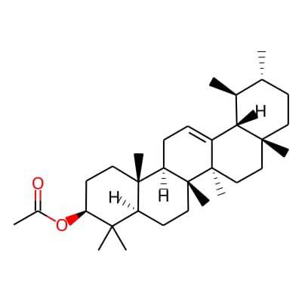 | 2) Arjunetin  (IMPHY005514)  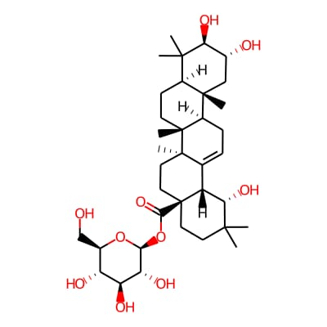 | 3) Arjungenin  (IMPHY012650)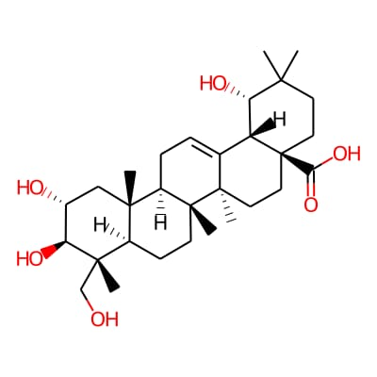
4) arjunglucoside I  (IMPHY013222)  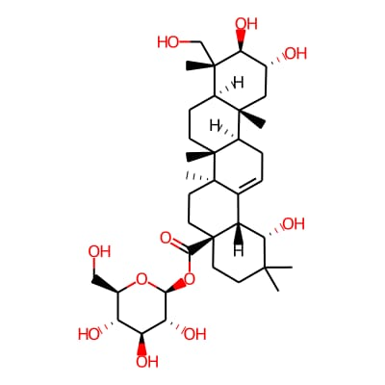 | 5) Arjunic acid  (IMPHY001431)  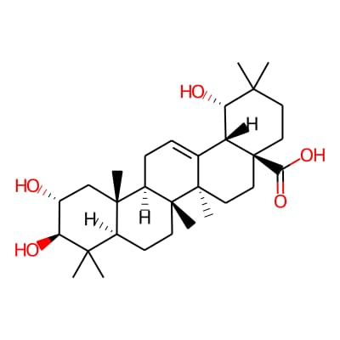 | 6) Arjunolic acid  (IMPHY011627)  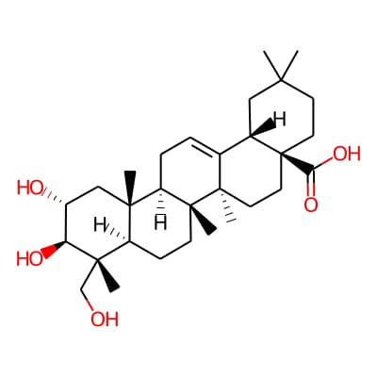
7) Bacosine  (IMPHY006699)  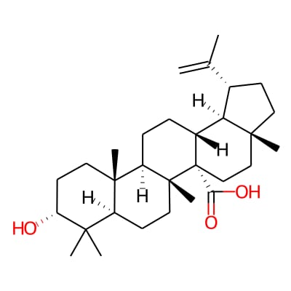 | 8) Beta-Amyrin acetate  (IMPHY004039)  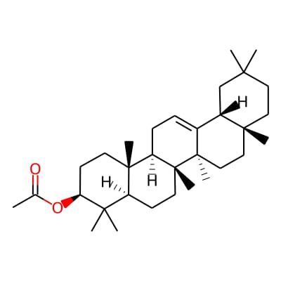 | 9) beta-Amyrin  (IMPHY012223)  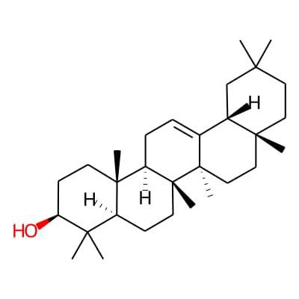
10) Betulinic acid  (IMPHY012003)  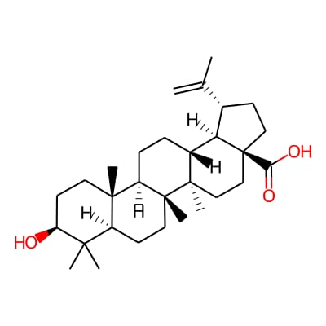 | 11) Friedelin  (IMPHY011688)  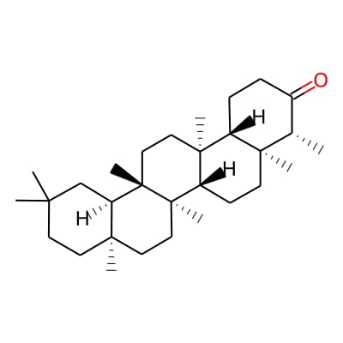 | 12) Erythrodiol  (IMPHY002190)  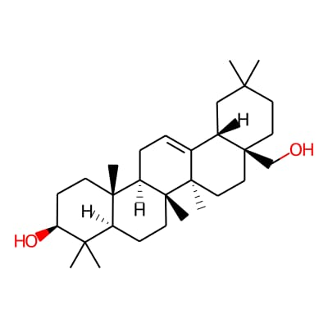

13) Gymnemagenin  (IMPHY004182)  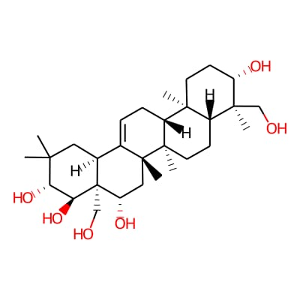 | 14) Gymnemaside II  (IMPHY008251)  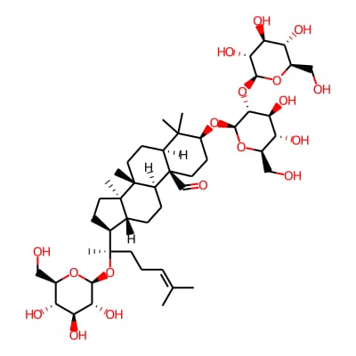 | 15) Gymnemic acid I  (IMPHY002109)  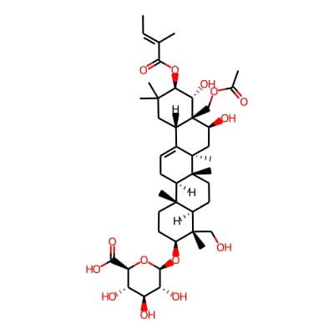
16) Gymnestrogenin  (IMPHY001589)  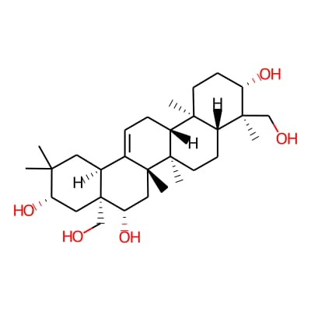 | 17) Protobassic acid  (IMPHY003866)  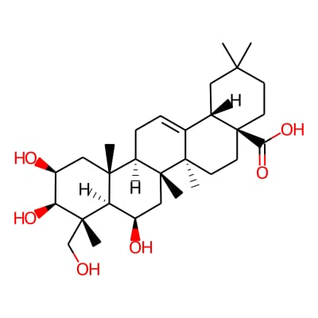 | 18) Isoarborinol  (IMPHY014764)  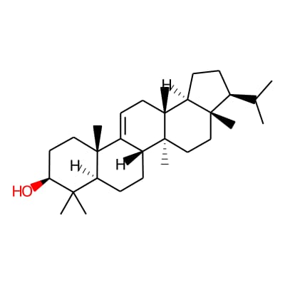
19) Maslinic acid  (IMPHY011970)  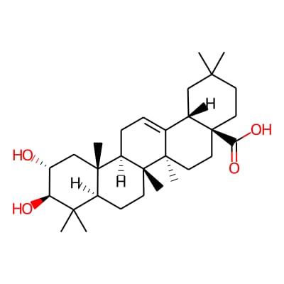 | 20) Methyl oleanolate  (IMPHY011461)  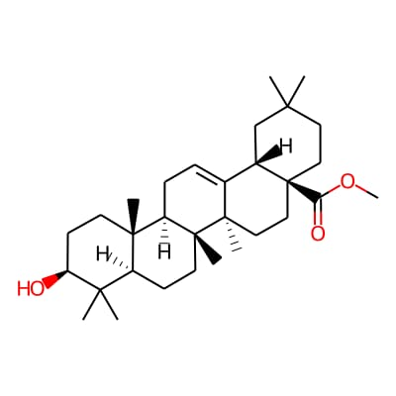 | 21) Oleanolic acid  (IMPHY011826)  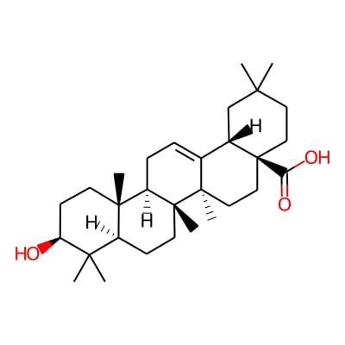
22)Ebelin lactone  (IMPHY007882)  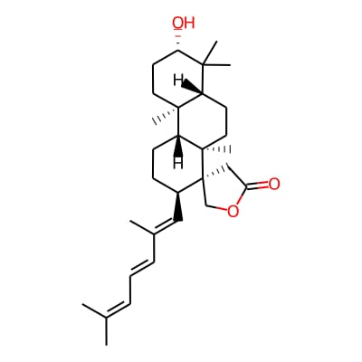 | 23) Pseudojujubogenin  (IMPHY002708)  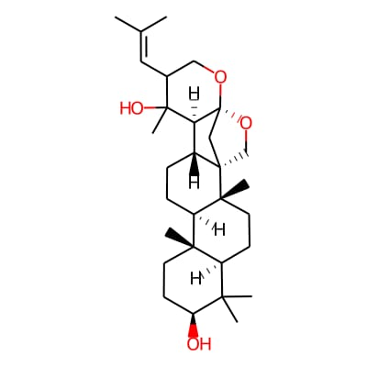 | 24) Ursolic acid  (IMPHY011880)  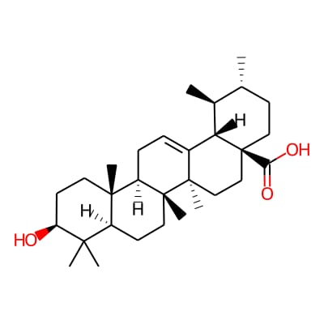

3.4 MOLECULAR DOCKING
Molecular docking was performed to investigate the possible binding interactions between the selected ligands and the PDK1 target structure. The docking calculations were carried out using AutoDock4, with AutoDockTools (ADT) used for receptor and ligand preparation and generation of the required docking input files. AutoDock4 employs a grid-based energy evaluation method together with a Lamarckian genetic algorithm to explore different orientations and conformations of the ligand within the receptor-binding region. The docking procedure therefore provides both predicted ligand poses and an estimated binding energy for each docking solution. (pubmed.ncbi.nlm.nih.gov)
Preparation of Protein for Molecular Docking
The selected PDK1 protein structure was obtained from the Protein Data Bank in PDB format. The downloaded protein–ligand complex was first examined using molecular visualization and preparation software. The crystallographic ligand present in the experimentally determined complex was removed from the receptor structure so that the PDK1 protein could be used as the receptor for docking the selected candidate ligands. The protein structure was subsequently prepared by adding the required hydrogen atoms and assigning appropriate atomic charges and AutoDock atom types before conversion into the docking-compatible format.
Preparation of Ligands for Molecular Docking
The selected ligand structures were prepared individually before docking. Each ligand was examined and converted into an appropriate three-dimensional molecular structure before preparation for AutoDock calculations. Hydrogen atoms and the required atomic charges were assigned, and the rotatable bonds of the ligands were defined to allow conformational flexibility during the docking search. The prepared ligand structures were subsequently converted into PDBQT format, which contains the molecular coordinates together with the information required by AutoDock regarding atom types, charges, and ligand flexibility. (pubmed.ncbi.nlm.nih.gov)
Conversion of Protein and Ligand to PDBQT Format
For AutoDock4 calculations, both the receptor and ligand structures were converted from their initial structural representations into PDBQT format using AutoDockTools. PDBQT is a modified PDB format that includes partial atomic charges and AutoDock-specific atom types, while also containing information required to represent ligand flexibility. The prepared receptor was therefore saved as a receptor PDBQT file, while each prepared ligand was saved separately as an individual ligand PDBQT file. These files served as the structural inputs for the subsequent docking calculations.

Definition of the Docking Grid
A three-dimensional grid box was defined around the region of interest in the PDK1 structure. The grid box determines the region of the receptor within which AutoDock evaluates the interaction energy between the receptor and ligand during docking. The grid center and grid dimensions were selected according to the binding region being investigated. During the initial broad docking analysis, a larger search region was used to allow the ligand to explore potential binding locations. Following identification of a favorable region, the grid parameters were adjusted to perform more focused docking around the selected binding site.
Generation of Grid Parameter File
The Grid Parameter File (GPF) was generated using AutoDockTools for the docking calculation. The GPF contains the parameters required by AutoGrid to calculate the interaction-energy maps used by AutoDock4. These parameters include information regarding the receptor, the ligand atom types being considered, the center and dimensions of the grid box, and the spacing of the grid points. The generated GPF was subsequently used with AutoGrid4 to calculate the required energy grids for the docking process.
Generation of Docking Parameter File
A Docking Parameter File (DPF) was generated for each docking calculation. The DPF contains the parameters required by AutoDock4 to perform the molecular docking search, including the receptor and ligand input files, the corresponding grid-map files, the docking algorithm and search parameters, and the number of docking runs. The DPF therefore defines the computational conditions under which the ligand conformational search and docking calculation are performed.
AutoGrid Calculation
Following generation of the GPF, AutoGrid4 was used to calculate the grid maps corresponding to the receptor and ligand atom types. These pre-calculated maps allow AutoDock4 to rapidly evaluate receptor–ligand interaction energies during the docking search. The calculated grid maps were subsequently used by AutoDock4 during the docking simulations defined by the corresponding DPF.
AutoDock4 Docking Runs
The prepared receptor and ligand PDBQT files, together with the generated grid maps and docking parameters, were used to perform the molecular docking calculations using AutoDock4. Multiple independent docking runs were performed to explore different ligand orientations and conformations within the defined search region. The Lamarckian genetic algorithm was used to perform the conformational search, allowing the docking program to explore different possible ligand poses and identify energetically favorable solutions. The

resulting docking poses were clustered and ranked according to their predicted binding energies and structural similarity. (pubmed.ncbi.nlm.nih.gov)
Analysis of Binding Energy
The docking solutions were evaluated according to their predicted binding energies. AutoDock4 estimates binding energy using an empirical free-energy model that considers different energetic contributions associated with the receptor–ligand complex. A more favorable, lower predicted binding-energy value generally indicates a stronger predicted interaction within the AutoDock scoring model. However, binding energy was not considered independently; the docking poses were also examined to determine the location and nature of the interactions formed between the ligand and the PDK1 binding region.
Analysis of Hydrogen-Bond Interactions
The predicted docking poses were further examined for hydrogen-bond interactions between the ligands and amino-acid residues of PDK1. Hydrogen bonds can contribute to the specificity and stability of protein–ligand recognition and were therefore considered together with the predicted binding energies when comparing docking solutions. The interacting residues and corresponding hydrogen-bond relationships were identified from the docked complexes and used to characterize the predicted ligand-binding mode.
Comparison of Docking Results
The candidate ligands were compared based on their predicted binding energies, docking poses, interaction patterns, and hydrogen-bond formation. In the present investigation, β-amyrin showed a predicted binding energy of −8.71 kcal/mol, while betulinic acid showed a predicted binding energy of −8.53 kcal/mol. Although these compounds produced highly favorable predicted binding energies, no hydrogen-bond interaction was observed in the selected docking poses. Therefore, the docking results were evaluated not solely according to binding energy but also according to the interaction pattern within the PDK1 binding region.
Selection of the Final Docked Complex
Among the candidate ligands, a ligand showing a predicted binding energy of −8.38 kcal/mol and one hydrogen-bond interaction with Val542 was selected for subsequent analysis. The reference ligand 4PT showed a predicted binding energy of −6.72 kcal/mol and formed five hydrogen-bond interactions. The selected ligand therefore provided a favorable combination of predicted binding energy and specific hydrogen-bond interaction with the PDK1 residue Val542. The resulting protein–ligand complex was subsequently selected for molecular dynamics simulation to investigate its conformational behavior and stability over time.

Name of the Ligand | Binding Energy(kcal per mole | No of H bonds | H Bond interactive amino acids | Hydrophobic Interactive Amino acids
Ebelin lactone | -8.38 | 1 | VAL542 | SER431; GLU432; PHE430; LYS435; GLY481; GLU480; PRO482; THR479; ARG546; GLN545; LEU458; LEU428
Beta Amyrin | -8.71 | 0 | None | GLY40; ASN41; ASP13; SER16; ASP15; PHE19; LEU33; GLN37; LYS36; ILE11; LEU21
Betulinic acid | -8.53 | 1 | GLN37 | ASP13; PHE19; GLY40; LYS36; ILE11; LEU21; LEU33; LEU51; ILE52; ASN41; ASN17; PRO42; SER16; MET55
Oleanolic acid | -8.05 | 1 | LYS36 | GLN37; GLY40; PHE19; ASN41; ASP13; SER16; ASP15; LEU21; LEU33; ILE11
Ursolic acid | -7.88 | 2 | LYS62; ARG116 | LYS60; THR118; ASN115; TYR81; LYS90; GLY91; GLU92; PRO94
Isoarborinol | -7.94 | 0 | None | LEU21; LEU33; ILE11; ASP13; LYS36; GLN37; ILE52; PHE19; ASN41; GLY40; MET55; PRO42; SER16
Lupeol Acetate | -6.49 | 0 | None | ASN41; GLY40; GLN37; ILE52; LEU51; ILE11; LEU33; PHE19; LYS36; ASP13; GLU8
Jujubogenin | -6.09 | 0 | None | TRP43; ASN17; SER16; ASP15; MET55; SER18; ASP13; GLN37; PHE19; ASN41; GLY40; PRO42
Friedelin | -6.47 | 0 | None | PRO114; GLU98; ARG100; HIS112; THR113; THR117; ARG116; ASN115; TYR119
Beta Amyrin Acetate | -6.01 | 1 | GLU98 | ARG100; HIS112; THR117; TYR119; ARG116; ASN115; THR113; PRO114
Dammarane | -6.29 | 0 | None | LEU21;LEU33; ILE52; GLN37; PHE19; LYS36; ASP13; SER16; PRO42; GLY40; ILE11; ASN41
Bacosine | -5.6 | 2 | THR117; ARG116 | ARG61; TYR119; GLY63; LYS62; LYS60
Erythrodiol | -5.34 | 2 | GLY63; ARG61 | LYS60; LYS62; ARG116; ASN115; THR113; PRO114; THR117; TYR119
Maslinic acid | -5.09 | 1 | LEU64 | LYS62; GLY63; ARG116; THR117; ARG61; TYR119
Lupeol | -5.85 | 0 | None | ARG132; HIS128; ALA103; CYS131; PRO101; GLN135; ARG100
Methyl oleanate | -5.48 | 0 | None | GLY76; PRO77; VAL137; ARG141; GLN140; LYS30; HIS145; ALA148; ALA149; VAL150
Retinol | -5.47 | 0 | GLN37 | PRO42; GLY40; PHE19; ASN41; LEU51; LEU33; ILE52; LYS36; ILE11; ASP13; MET55; SER16; TRP43; ASN17
Arjungenin | -4.66 | 2 | PRO114; THR117 | THR113; ARG61; TYR119; GLY63; ARG116; ASN115
Alpha amyrin acetate | -6.19 | 0 | None | GLY40; ILE11; ASN41; PHE19; GLN37; LYS36; ILE52; LEU51; LEU33; ASP13; GLU8
Arjunolic acid | -4.6 | 2 | THR117; ARG116 | TYR119; GLY63; ARG61; LYS60;TYR118
Alpha Amyrin | -5.75 | 0 | None | ARG132; ALA103; HIS128; CYS131; PRO101; ARG100; TRP138; GLN135
Arjunic acid | -5.07 | 0 | None | LYS62; ARG116; TYR119; GLY63; LEU64; ARG61; THR117
4PT | -6.72 | 0 | None | ARG472; LYS467; ARG474; LYS465; TYR486; ARG521; LYS495; ASN491; ASP488; VAL490

Selection of Protein–Ligand Complex for Molecular Dynamics
Following molecular docking, a representative protein–ligand complex was selected for further molecular dynamics investigation based on its docking score and interaction profile. The selected complex showed a favorable predicted binding energy together with a hydrogen-bond interaction involving Val542. The selected docked complex was subsequently used as the starting structure for molecular dynamics simulation to investigate its dynamic behavior and structural stability over time.
3.5 MOLECULAR DYNAMICS SIMULATION
Molecular dynamics simulation was performed to investigate the dynamic behavior of the docked PDK1–ligand complex. Unlike molecular docking, which provides a relatively static prediction of ligand orientation within a binding region, molecular dynamics allows the protein, ligand, solvent, and other components of the system to undergo time-dependent molecular movements. Analysis of the resulting trajectory can therefore provide additional information regarding conformational stability, flexibility, and compactness of the simulated complex.
Preparation of Protein–Ligand Complex for MD Simulation
The selected docked protein–ligand complex was prepared as the initial structure for molecular dynamics simulation. The protein and ligand components were separately examined and prepared for incorporation into the GROMACS simulation system. Protein topology information was generated using the appropriate GROMACS procedure, while ligand-specific topology and parameter information was prepared separately before incorporation into the complete protein–ligand topology.
System Preparation and Solvation
Following topology preparation, the protein–ligand complex was placed within a defined simulation box and solvated using an explicit water environment. Solvation provides an aqueous environment surrounding the biomolecular system and allows interactions between the protein, ligand, and solvent molecules to be represented during the simulation. Ions were subsequently incorporated into the system to neutralize the system charge and establish the required ionic conditions before molecular dynamics calculations.
Energy Minimization and Equilibration
Prior to the production simulation, the prepared molecular system was subjected to energy minimization to remove unfavorable steric contacts and high-energy configurations introduced during system construction. Energy minimization allows the molecular system to reach a more favorable local energy configuration before dynamic simulation. Following minimization, the system was equilibrated under the selected simulation conditions, allowing the solvent, ions, protein, and ligand to adjust to the simulation environment before generation of the production trajectory.

Production Molecular Dynamics
The equilibrated PDK1–ligand system was subjected to production molecular dynamics using GROMACS. GROMACS is a widely used molecular simulation package for biomolecular systems and provides tools for system preparation, trajectory generation, and subsequent trajectory analysis. The simulation generated a trajectory containing the time-dependent coordinates of the molecular system, which was subsequently processed and analyzed to investigate the structural and dynamic properties of the protein–ligand complex.
Trajectory Processing
The generated molecular dynamics trajectory was processed using GROMACS trajectory-conversion utilities before structural analysis. Trajectory processing is required to account for effects associated with periodic boundary conditions and to obtain an appropriately centered representation of the molecular system. The processed trajectory was subsequently used for calculation of structural parameters including root mean square deviation, radius of gyration, and root mean square fluctuation.
RMSD Analysis
Root mean square deviation (RMSD) was calculated to investigate the overall structural deviation of the PDK1–ligand complex during the molecular dynamics simulation. RMSD measures changes in the atomic positions of the analyzed structure relative to a reference conformation following structural alignment. An initial increase in RMSD may reflect conformational adjustment of the system from its starting structure, whereas subsequent fluctuations around a relatively consistent range may indicate maintenance of a comparatively stable global conformation during the later stages of the simulation.
Radius of Gyration Analysis
The radius of gyration (Rg) was analyzed to evaluate the overall compactness of the protein structure during the molecular dynamics simulation. Rg describes the distribution of the atoms of a molecular system around its center of mass and provides an indication of changes in the overall dimensions and compactness of the protein. A relatively stable Rg profile suggests that the global compactness of the protein is maintained during the simulation, whereas substantial changes may indicate conformational expansion, contraction, or rearrangement.
RMSF Analysis
Root mean square fluctuation (RMSF) was calculated to examine residue-level flexibility during the molecular dynamics simulation. Unlike RMSD, which provides information about

global structural deviation, RMSF identifies regions of the protein that exhibit relatively greater or lower positional fluctuations throughout the trajectory. Flexible loops and terminal regions may display higher RMSF values, whereas structurally constrained regions generally show lower fluctuations. RMSF analysis therefore provides information about the dynamic flexibility of individual regions of the PDK1 structure.
Overall Molecular Dynamics Analysis
The RMSD, radius of gyration, and RMSF analyses were considered together to characterize the dynamic behavior of the PDK1–ligand complex. RMSD provides information regarding overall structural deviation, radius of gyration reflects changes in global compactness, and RMSF provides information regarding residue-level flexibility. The combined interpretation of these parameters provides a more comprehensive assessment of the conformational behavior of the simulated protein–ligand system than any individual parameter alone.
4. RESULT
4.1 DOCKING ANALYSIS
Molecular docking was performed between the selected PDK1 target structure (PDB ID: 1W1G) and the selected candidate ligands using AutoDock4. The docking solutions were evaluated based on predicted binding energy and the interactions established between the ligands and the amino-acid residues within the selected binding region. Among the screened compounds, β-amyrin exhibited the most favorable predicted binding energy of −8.71 kcal/mol, followed by betulinic acid with a binding energy of −8.53 kcal/mol. However, no hydrogen-bond interaction was observed for either of these two ligands in their selected docking poses.
A ligand exhibiting a binding energy of −8.38 kcal/mol was subsequently selected because its docking pose showed a hydrogen-bond interaction with Val542. Although its predicted binding energy was slightly less favorable than those of β-amyrin and betulinic acid, the presence of a specific hydrogen-bond interaction with Val542 provided additional structural evidence for ligand recognition within the selected PDK1 binding region. The reference ligand 4PT exhibited a predicted binding energy of −6.72 kcal/mol and formed five hydrogen-bond interactions with the target protein. Thus, comparison of the docking results demonstrated that the selected ligand showed a more favorable predicted binding energy than the reference ligand together with a specific interaction involving Val542.
The selected protein–ligand complex was therefore carried forward for molecular dynamics simulation to investigate whether the docked binding mode remained structurally stable under dynamic conditions.

4.2 DYNAMIC SIMULATIONS ANALYSIS
The combined molecular dynamics analyses provide evidence regarding the conformational behavior of the simulated protein–ligand system. The RMSD profile demonstrated that the structures underwent an initial adjustment followed by comparatively stable fluctuations, while the RMSF profile revealed that flexibility was concentrated in specific regions rather than being distributed uniformly throughout the protein. The radius of gyration remained comparatively stable, indicating preservation of the overall compactness of the protein during the simulation.
Taken together, the RMSD, RMSF and Rg analyses indicate that the simulated system maintained its overall structural organization while undergoing normal conformational fluctuations. The absence of a continuous increase in RMSD and the relatively stable total radius of gyration suggest that the protein did not undergo a major structural destabilization during the analyzed trajectory. The localized RMSF peaks indicate that particular residues or structural regions remained more flexible than the rest of the protein, which is consistent with the dynamic nature of protein structures.
Overall Molecular Docking and Dynamics Interpretation
The molecular docking and molecular dynamics approaches provided complementary information about the selected protein–ligand interaction. Molecular docking was used to identify a favorable binding pose and estimate the energetic preference of ligand binding, whereas molecular dynamics simulation was used to examine whether the resulting complex maintained an overall stable structural behavior over time. This combination is useful because a favorable docking score alone does not establish that a complex will remain structurally stable under dynamic conditions.
The selected docked complex was therefore subjected to molecular dynamics analysis, and the resulting trajectory was evaluated through RMSD, RMSF and radius of gyration calculations. The relatively stable global RMSD behavior, localized residue-level fluctuations and comparatively constant total radius of gyration together indicate that the simulated structure maintained its overall integrity during the analyzed trajectory. These computational findings support the suitability of the selected docked complex for further investigation of protein–ligand interactions, although experimental validation would ultimately be required to confirm the predicted binding and biological activity.

