Descriptive study: The dataset

The chosen dataset has been the titanic sinking dataset. The ship once considered unsinkable which caused the death of 1502 out of 2224 passengers and crew on board on April 15, 1921.

The dataset contains very insightful information on the passengers. Let’s take the head of the dataset as an example:

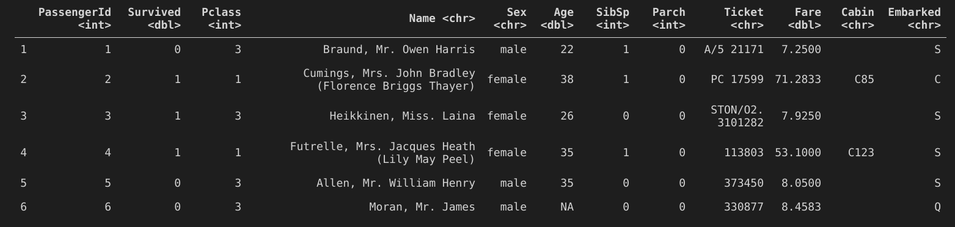

Variables present in the dataset:

Identification variables:

- PassengerId: a consecutive SQL-style ID that represents a passenger uniquely
- Name: the name of the passenger
- Ticket: the ticket number/ID of the passenger
- Cabin: the specific cabin the passenger boarded the titanic in

Categorical variables:

- Survived: specifies if the passenger survived the wreckage or not
- Pclass: specifies the class in which the passenger sailed, can be used as a measure of socio-economic status
- Sex: specifies the sex of the passenger
- SibSp: amount of siblings/spouses/step siblings of such person aboard the titanic
- Parch: amount of parents/children/step children of such person aboard the titanic
- Embarked: specifies the port in which the person embarked

Continuous variables:

- Age: specifies the age of the passenger
- Fare: specifies what the passenger paid for the ticket

For our specific description of the dataset we will go in detail regarding all the variables presented here, but with specific emphasis on how continuous variables play a role when seen from the scope of categorical variables by doing groupings and such.

Exploring continuous variables: Age

Histogram of Age
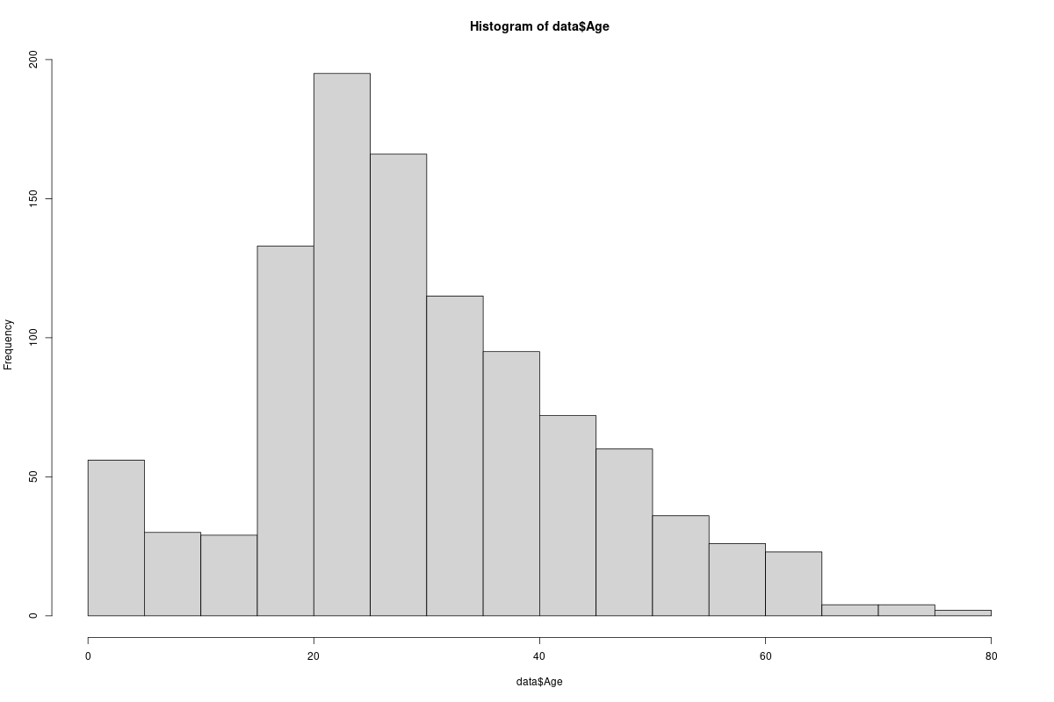
Figure 1

In Figure 1 we can perceive the shape of the data seems to resemble a bell curve. There’s a small but relatively long left tail and a larger but less long right tail. The mean age is between 20 and 25 years old. With the second largest group being 25 to 30 year olds.

Older folks (60+ years old) seem to be significantly less common than the rest of age groups, while children (between 0-15 years old) are more common, maybe given that they’re sons/daughters of a much more common age group (20+ year olds).

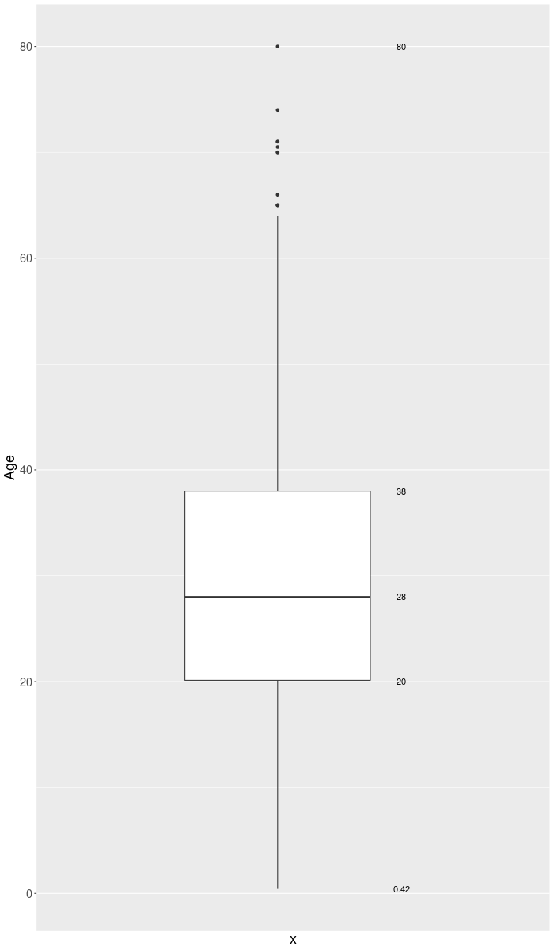
Boxplot of Age

In Figure 2 we have a boxplot of the Age variable. We can see that the maximum age among all passengers is 80

