Matthew Stockert & Dominic Retli

April 5, 2018

CIS 450-001

Professor Wang

P3

Table of Contents

Files Submitted 2

Implementation 2

tc.java 2

Car.java 2

Point.java 2

Points.java 2

Directions.java 2

Report 2

Screenshots 2

Report 3

Diagrams 3

Contribution 3

# Files Submitted

P3_450 – This report

tc.java – Main class

Car.java – Car object and thread for car

Point.java – Each Point on the intersection is an instance of this class

Points.java – A collection of Point.java

Directions.java – Each car will create an instance this class

# Implementation

## tc.java

## Car.java

## Point.java

## Points.java

## Directions.java

# Report

## Screenshots

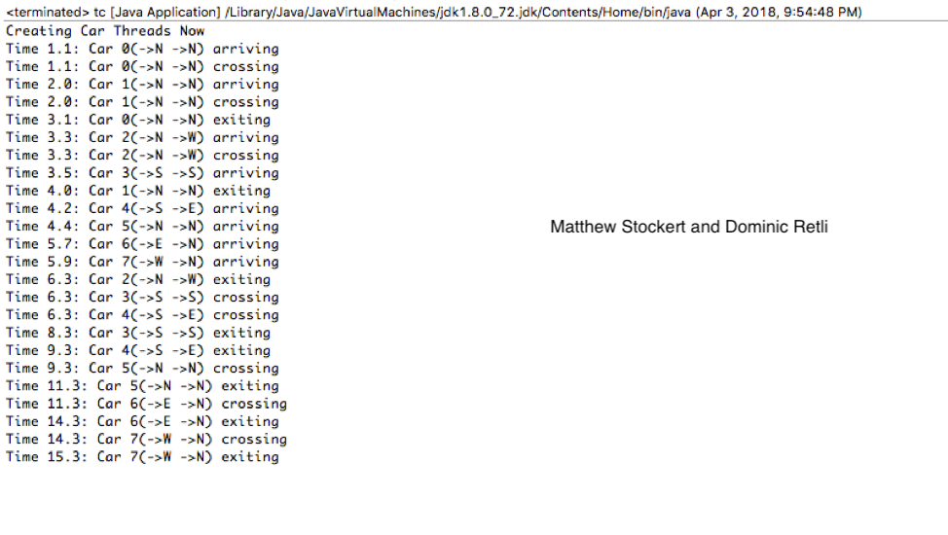

## Report

## Diagrams

# Contribution