Development of economic modification for the OpenTTD game

Samorodov Roman   
Department of Computer Systems and Technologies  
National Research Nuclear University MEPhI (Moscow Engineering Physics Institute)

Moscow, Russian Federation

roma.samorodov@list.ru

Nyasibullin Kamil

Department of Computer Systems and Technologies

National Research Nuclear University MEPhI (Moscow Engineering Physics Institute)

Moscow, Russian Federation jjensen8357@gmail.com

*Abstract*— The article is devoted to the study of the economic model of the OpenTTD game with a view to create own modification for generating the world. The main goal was to create the ability to change the basic parameters of the location of industries and other important enterprises. The second important goal of the work was to analyze the economic state of players after generating the world using the written modification. Moreover, both changes in specific parameters and the effect of several changed parameters on the overall difficulty of the game were investigated. The result is a working modification that changes the generation of the game world and its successful testing.

Keywords—OpenTTD, modification, API, world generation, squirrel

# Introduction

OpenTTD is a free-to-play transport campaign simulator. Although the creators with a large community are still working on the project, there are practically no existing works aimed at changing the generation of industries. The work is based on the study of the economic component of the game. This topic was considered on forums and various articles, for example: Studying algorithms in games [1], Studying the economic model of the OpenTTD game and creating artificial intelligence on it [2], Studying the economic model of the OpenTTD game [3], Algorithmization in games [4] , Analysis of the beneficial location of OpenTTD transport routes [5], Mirror architecture for OpenTTD using offloading computation [6], Game enhancement of logistics and supply chain management [7], Exploring artificial intelligence for OpenTTD [8]. Based on the studied data and our own analysis of the game source code, it becomes possible to create a modification that directly changes the economic component of the OpenTTD game. The idea of ​​the article is to directly create a mod that can generate the world the way the player wants to see it. The modification is based on the creation of the ability to change game characteristics by the type of distances between enterprises, their number, location features, etc., as well as further research of the economic state of players on the map with various combinations of parameters and changing constants separately.

# Research Materials And Methods

The first task was to study in detail the source code of the OpenTTD game, namely, the parameters affecting the generation of the world, and the original way of generating the map. To solve this problem, a successful method was to build the project in Ubuntu, a Linux distribution using a VMware Workstation virtual machine. The sources are taken from the official site. With the help of the documentation, I managed to compile the game project.

Then the official documentation on the source code of the game was examined, and the project was successfully compiled and launched with fulfilled obligations.

The next thing is to write the immediate modification code. Preferred Writing Environment Squirrel is an interpreted programming language specifically designed for use as a scripting language in real-time applications. For writing, the documentation of the language itself was studied in detail, as well as the style of the code, we recommend from the developers themselves.

The original idea was to implement a mod that took effect after the world was generated in a standard way, but this did not show the perfection and complexity of optimization.

Hence the second version of the version is the following method. In the game settings, there is a choice of the number of generated industries and among them there is an option "Build yourself". This opportunity became the main idea of ​​the project.

So, after creating a new world of the game, the built-in generator creates a landscape, water and cities, after which the created mod comes into operation, which, by cyclical analysis of the entire map, places an industry on it with the following variable parameters:

Industry build rate (months) - new industries generation period (from 1 to 5)

Industry build limit (per period) - the number of new industries for the period (from 1 to 5)

Debug: Log level (higher = print more) - the number of system messages during the operation of the mod (from 1 to 4)

Total industries - number of industries (from 10 to 90 in 20 increments)

Min industries%;

Max industries% - max. and min. the edge from the specified number of industries (so that the mod does not get stuck in a loop when generation difficulties arise) (from 25 to 75 and from 100 to 150 with a step of 5)

Primary industries proportion;

Secondary industries proportion;

Tertiary industries proportion;

Special industries proportion - the proportions of different types of industries (Primary industries, such as mines, provide resources without requiring anything. These resources are then transported by a transport company to the secondary industry. Sometimes secondary industries provide a resource that is either transported to cities or tertiary industry) industry names and their lists are taken from the game source code.

Primary industries spawning method;

Secondary industries spawning method;

Tertiary industries spawning method - the choice of a method for generating different types of industries between Scattered and Random, where Random is random generation, and Scattered with the possibility of personalization.

Scattered: Minimum distance from towns - the minimum distance of industries from the city (from 5 to 30 with a step of 5)

Scattered: Minimum distance from industries - minimum distance from other industries (from 5 to 30 in 5 steps)

Special: Minimum town pop for Banks- the minimum population of a city for a bank to be located in it (from 600 to 3000 in increments of 200)

Max distance from edge for Oil Refineries - the maximum distance from the oil refining industries to the edge of the map (from 12 to 48)

Minimum year for Oil Rigs - minimum in-game year for the possibility of the emergence of the oil industry (from 1900 to 2050)

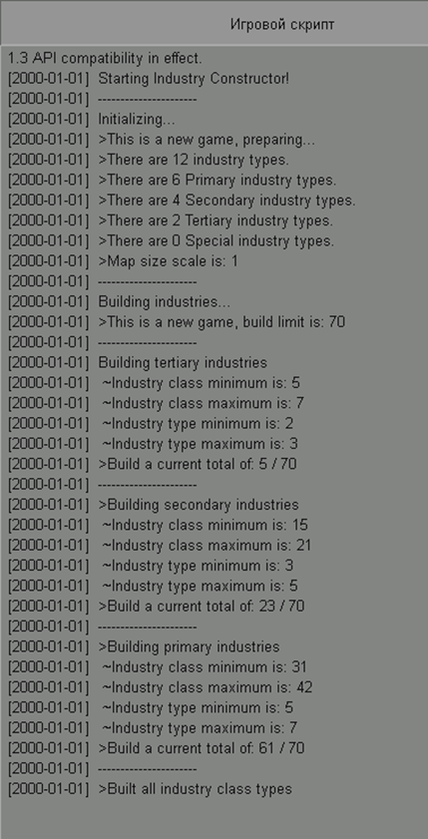

Fig. 1 An example of debug panel messages during modification work

1. Results

Thus, we have a stable version of the working modification, adapted for any operating system, and perfectly manifests itself in the latest versions of the OpenTTD game. To study its effect on gameplay, we monitored the state of players with different script settings. The AIs available in the game client itself are used as players for the reliability of experiments. This is how hypotheses were put forward, which were tested in practice. As a result of each of the hypotheses, the state of the AI ​​was taken into account in 5 game years after the start of the game of several generated cards with different parameters.

***1****)* ***Hypothesis:*** *when using a custom distance between industries, the map is generated more evenly than with a random one and the difficulty of the game is less.*

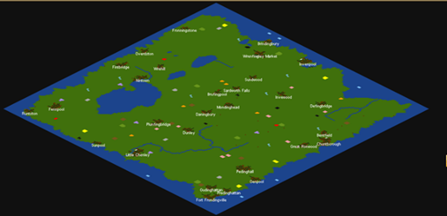

Fig. 2.1 Random generation of industries

When randomly generated, industries accumulate in heaps, which interferes with the construction of an organized transport system, and empty places are formed on the map, which makes this generation inconvenient.

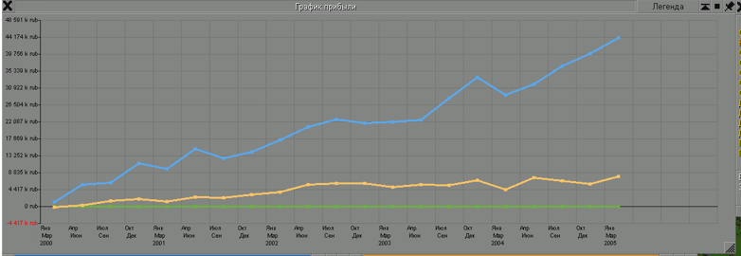

Fig. 2.2 The sum of the capitals of the two AI was 96,500,000 rub.

Next, we will consider the generation of the world using a custom distance between industries (in this example, it is equal to 20)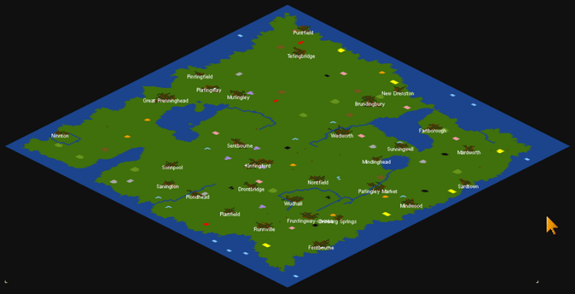

Fig. 3.1 Configurable industry generation

Despite the superiority of configurable distance, sometimes during generation some parts of the map can be empty due to poor water placement (can be corrected by reducing its amount)

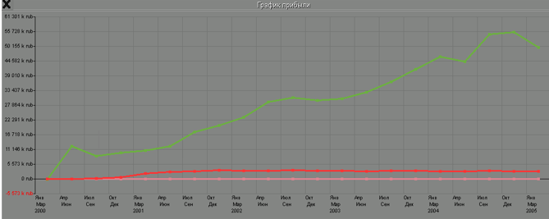

Fig. 3.2 The sum of the capitals of the two AI was 140 700 000 rub.

***Conclusion:*** *the hypothesis is correct, the use of a configurable distance simplifies the game, which can be seen from the uniformity of the location of industries and the sum of the states of two bots over 5 years of play.*

***2) Hypothesis****: with a large minimum distance of industries from cities, the map is generated unevenly and the difficulty of the game decreases.*

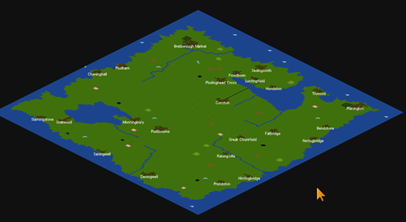

Fig. 4.1 Large minimum distance of industries from cities (in this case 20)

The map is not generated evenly, there are large empty spaces

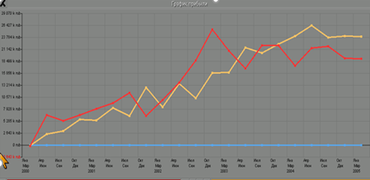

Fig. 4.2 The sum of the capitals of the two AI was 269 500 000 rub.

Next, consider the generation of a world with a small minimum distance of industries from cities (in this example, it is 5)

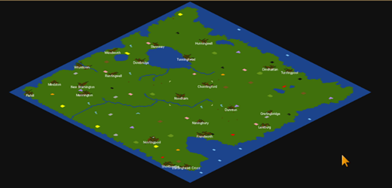

Fig. 5.1 Small minimum distance of industries from cities (in this case 5)

The map is generated uniformly

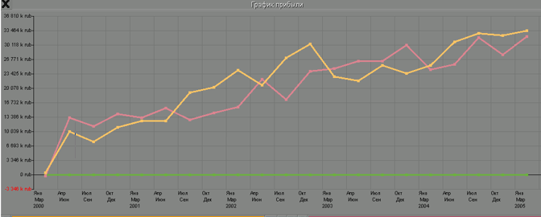

Fig. 5.2 The sum of the capitals of the two AI was 214 400 000 rub.

***Conclusion:*** *the hypothesis turned out to be correct, the unevenness of the map is compensated by the large distances between industries, which leads to an increase in companies' income. Thus, large distances between industries and cities give a slight advantage.*

***3) Hypothesis:*** *with a large maximum distance of refineries from the edges of the map, the game becomes easier*

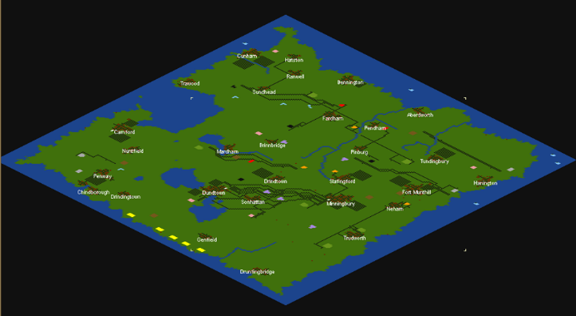

Fig. 6.1 With a small maximum distance of refineries from the edges of the map (in this case 12)

Because of the maximum distance to the edge of the map is small, refineries were generated in one possible place, being near

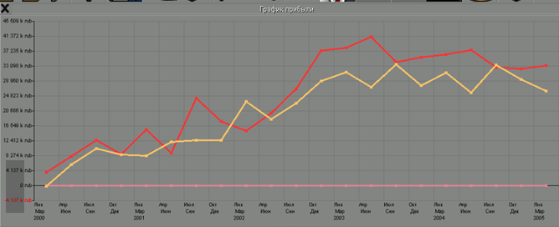

Fig. 6.2 The sum of the capitals of the two AI was 380 600 000 rub.

Next, consider the generation of the world at the maximum distance of refineries from the edges of the map (in this case 45)

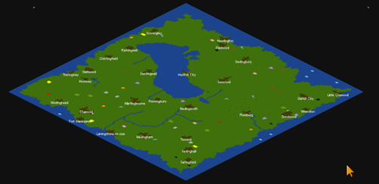

Fig. 7.1 With a large maximum distance of refineries from the edges of the map (in this case 45)

The map is generated uniformly.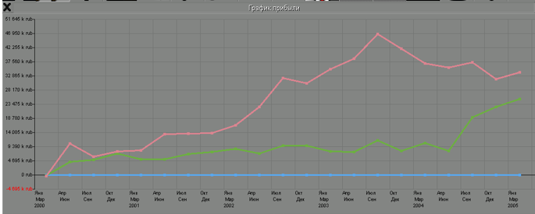

Fig. 7.2 The sum of the capitals of the two AI was 340 700 000 rub.

***Conclusion:*** *the hypothesis turned out to be incorrect, uneven generation at a small maximum distance led to the fact that all the oil on the map was delivered to one place, overcoming huge distances, which positively affected the profit of both companies*

1. Discussion And Conclusions

Thus, using this modification, it becomes possible to create the world the way the player sees it. Its functions both personalize and satisfy the game preferences of world generation and change the complexity of the game as a whole.

The main parameters were investigated above in hypotheses, but there are a huge number of sets of several changed parameters. Also, even with the same settings, the mod comes into operation only after the initial generation of the world built into the game, which prevents the generation of identical maps.

In the future, it is planned to add additional adjustable parameters, for example, the construction of industries by groups near cities or the addition of their own industries. It is also necessary to optimize the script for large maps, a large amount of water or snow, and maps with complex terrain.

##### References

[1] M. Bowling, J. Fürnkranz, T. Graepel, and R. Musick, “Machine learning and games,” Mach. Learn., Jun. 2006, doi: 10.1007/s10994-006-8919-x.J. Clerk Maxwell, A Treatise on Electricity and Magnetism, 3rd ed., vol. 2. Oxford: Clarendon, 1892, pp.68–73.

[2] M. Wisniewski and C. Witt, “Artificial Intelligence for the OpenTTD Game,” 2011. Accessed: Sep. 10, 2020. K. Elissa, “Title of paper if known,” unpublished.

[3] “Geert Konijnendijk MCTS in OpenTTD.”

[4] Introduction to Algorithms, Second Edition Cormen Charles E Leiserson Ronald L Rivest Clifford Stein TSan Francisco St Louis Y (2001)

[5] Planning of railway network for OpenTransport Tycoon Deluxe Mgr. Jakub Gemrot, Ph.D

[6] A mirroring architecture for sophisticated games using computation-offloading Jiang MVisser OPrasetya I et al.

[7] Game-based Enhancement of Teaching Logistics and Supply Chain Management

[8] trAIns: An Artificial Inteligence for OpenTTD Luis Henrique Oliveira Rios, Luiz Chaimowicz SBGAMES2009 - 8th Brazilian Symposium on Games and Digital Entertainment, (2009)