**Name:** Jessica Aubley and Drew Hoisington

**Lesson Plan Title:** Dr. Seuss Goes to War

**Describe audience, context, and constraints:**

This was taught to 9th grade World History students at Nordonia High School in Macedonia, Ohio. There were 38 students in the course. None of which are on IEPS and 1 is on 504s.

**Ohio Content Standards**The following standards will be the focus of this lesson...

**Content**

*Historical Thinking and Skills*Students apply skills by utilizing a variety of resources to construct theses and support or refute contentions made by others. Alternative explanations of historical events are analyzed and questions of historical inevitability are explored.

Content Statements:

1. The use of primary and secondary sources of information includes an examination of the credibility of each source.
2. Historians develop theses and use evidence to support or refute positions.
3. Historians analyze cause, effect, sequence, and correlation in historical events, including multiple causation and long- and short-term causal relations.

*Achievements and Crises (1900-1945)*The first half of the 20th century was one of rapid technological advances. It was a period when the tensions between industrialized nations resulted in World War I and set the stage for World War II. While World War II transformed the balance of world power, it was the most destructive and costly war in terms of human casualties and material resources expended.

Content Statements:

1. The consequences of World War I and the worldwide depression set the stage for the Russian Revolution, the rise of totalitarianism, aggressive Axis expansion and the policy of appeasement which in turn led to World War II.
2. Oppression and discrimination resulted in the Armenian Genocide during World War I and the Holocaust during World War II.

**ISTE Standard for Educators**The International Society for Technology in Education (ISTE) has established standards for evaluating the use of technology, or a technology tool, in a learning environment. These standards can be found at: [***http://www.iste.org/standards/for-educators***](http://www.iste.org/standards/for-educators).

**Content**

We reviewed our use of Thinglink with the ISTE standards. The ways the ISTE standards are applied through our use of Thinglink are given below:

*Leader 2a - Shape, advance and accelerate a shared vision for empowered learning with technology by engaging with education stakeholders.*Thinglink demonstrates how students can learn from a variety of technologies including images, video and written text.

*Citizen 3b - Establish a learning culture that promotes curiosity and critical examination of online resources and fosters digital literacy and media fluency.*Thinglink allows students the opportunity to critically evaluate contentions made by others by utilizing a variety of digital resources.

*Designer 5b - Design authentic learning activities that align with content area standards and use digital tools and resources to maximize active, deep learning.*The use of Thinglink allows the creation of a learning activity that involves videos, links to other websites and text descriptions. These allow the students to investigate the topics for deeper learning.

*Designer 5c - Explore and apply instructional design principles to create innovative digital learning environments that engage and support learning.*Thinglink allows us to use best practice principles of Universal Design for Learning to create an engaging lesson for the students. This lesson will work well for all types of learners since they have the option of exploring a variety of media tools.

**ISTE Standard for Students**The International Society for Technology in Education (ISTE) has established standards for Students to ensure the use of technology meets their needs. These standards can be found at: [***http://www.iste.org/standards/for-students***](http://www.iste.org/standards/for-students).

We reviewed our use of Thinglink with the ISTE standards. The ways the ISTE standards are applied through our use of Thinglink are given below:

*Empowered Learner 1c - Students use technology to seek feedback that informs and improves their practice and to demonstrate their learning in a variety of ways.*The students will be required to create their own ThingLink to show what they have learned from the lesson. This will allow them to also use a variety of tools to explain what they have learned.

**Content**

*Knowledge Constructor 3a - Students plan and employ effective research strategies to locate information and other resources for their intellectual or creative pursuits.*Students will be required to research the topic that was presented and create an interactive Thinglink that includes different resources they have located including video, images and websites.

# **The TPACK Model of Technology Integration** The usage of Thinglink allows us to apply the TPACK model to our lesson plan. Our goal is to effectively use technology as a teaching tool not a barrier. ***Technology***: Thinglink allows us to create an interactive experience for students through the use of imaging, audio, vidoes, websites and text. Advantages of using Thinglink include:

* Easy for teachers to use to create interactive learning experiences
* Embeds in the learning management system so students can quickly access and review
* Easy for students to learn how to use the software to create their own presentations
* Easy for students to share links of what they have created for grading
* Fun and engaging way of reviewing material on a particular subject

# ***Pedagogy:*** Thinglink allows the designer full control of the layout and design. This is ideal as a teacher can use it to develop a lesson plan in a way that their students can understand such as using a lot of video if they have a class of visual and auditory learners or adding website links for students to explore if they are promoting critical thinking and research on a subject matter. If a student is using Thinglink to present what they have learned, this is helpful also as they can start with the important details and add supporting items further down on their presentation. ***Content:*** The content is determined by the teacher or the student who is creating the Thinglink. This technology tool is a blank canvas where the designer has the opportunity to use whatever content they determine needed for learning the subject. This includes the usage of video, audio, static text, imaging and websites. Thinglink is very flexible when it comes to adding content. ***Knowledge:*** The teacher or students knowledge is critical when they are developing an interactive experience with Thinglink. They must understand what topics and resources to use in educating the user on their topic. Without extensive knowledge of their topic, they will not be able to create an engaging learning experience using Thinglink.

**Content**

# **The SAMR Model of Technology Integration** Our use of ThingLink reaches the *Redefinition* level of the SAMR model of technology integration. Below is a brief description of how this lesson progresses through the various models:

# ***Substitution:*** The students review this lesson in the learning management system and click on each part of the lesson to learn more. Prior to the creation of this lesson, they would be reviewing a PowerPoint presentation and links to materials that were listed in the course.

# ***Augmentation:*** Students are engaged with the image and the different elements they click on to review additional information. They do this from one screen instead of having to click on links loaded in the learning management system. ***Modification:*** The students will then create their own Thinglink to show what they have learned. In previous semesters, they have had to present a PowerPoint presentation in class showing what they learned. Using Thinglink allows them the opportunity to share different media such as websites and videos that they researched to further learn more about the topic. ***Redefinition:*** The student presentations allow the teacher to evaluate the students' understanding of the subject and provide them feedback on what they have learned. Since this is a technology presentation verses a written paper, it’s faster for the teacher to evaluate.

# **Prior Knowledge/Prerequisites** *List the prior knowledge students must have to be successful with this lesson.*

1. Students need to access the class on the learning management system.
2. Students need to review audio and videos.
3. Students need to understand prior content knowledge on the lead up to World War II.

**Identify and Discuss Pedagogical Decisions**

**Pedagogy**

**Pre-Assessment**Will you pre-assess? Why? How will data be used?

Pre-assessment is done through a political cartoon from a previous unit on Imperialism. Students work through the Cartoon Analysis document and show their understanding of the cartoonist’s perspective.

**Formative Assessments  
How will you evaluate the students?**

* ThingLink Presentation that includes the students recorded audio
* Exit ticket on persuasive techniques used

**Why have you chosen these methods?**

Students will show their understanding of the content and techniques being when they create their ThingLink presentation. Since classes have been moved online this was an ideal way for them to present what they have learned about a political cartoon.

**Is technology used for or included in the evaluation process?**Yes. Students will be viewing the political cartoons through a Google Slides presentation and completing a Cartoon Analysis document that will be shared with the members of their group.

**How will you share data with students/others and why?**Links to each students presentation will be posted for their classmates can review and learn from one another. Since the class has gone from face-to-face to online, this is an ideal way for students to share their knowledge.

**Summative Assessments**

**How will you evaluate the students?**

* ThingLink submission that include audio explainations

**Why have you chosen these methods?**Students will use the Thinglink platform as a model for their discussion of the political cartoon they chose. This assessment will allow for a deeper explanation and show of comprehension of their understanding of political cartoons. It will also allow each student to learn from one another.

**Pedagogy**

**Is technology used for or included in the evaluation process?**Yes. Students will complete an analysis of a political cartoon using Thinglink. This platform will allow students to show their analysis of certain items in the political cartoon.

**How will you share data with students/others and why?**Students will receive a grade for their assignment and it will be posted on our online gradebook. Feedback of their strengths and weaknesses will be provided to each student.

**Models of Instruction/Instructional Strategies***Identify the instructional models or strategies you will use for this plan.*

**Procedures/Activities***What activities have you planned? Include detailed description of the activities and how the resources are being used to support learning.*

Students will review a political cartoon from a previous unit on Imperialism. Students the work through Cartoon Analysis document and show their understanding of the cartoonist’s perspective. Then students will then use ThingLink to complete and analyze of a political cartoon.

# 

# **Identify and Discuss Technological Decisions**

**Technology/Resources**

**Resources  
What resources do you need to support the activities?**

* Chromebooks
* Google Slides
* Thinglink
* Cartoon Analysis Document

**How do the resources help students achieve the objectives?**Students use the presentation on Google Slides for their choices in political cartoons to analyze. Students will access these on the Chromebook and use the Thinglink platform to model their analysis for the presentation. Using the Cartoon Analysis document, students will be able to note specific items in their cartoon that they deem important for comprehension.

**Technology Resources**List technology resources and describe specifically why they were chosen, how the resources help students achieve the objectives and how the use will be evaluated.  
If technology is used for evaluation or data collection, describe how it will be used

* **Thinglink**: Students will choose one political cartoon and use this platform to explain their understanding and analysis of the cartoon to the class. The class will view their Thinglink presentation and be able to ask questions during the presentation to better   
  understand the group’s analysis.

**Alignment of Learning Objectives to Learning Activities and Assignments**

|  |  |  |
| --- | --- | --- |
| **Learning Objectives** | **Applicable**  **ISTE Standards:** | **Learning Activities/Assignments** |
| Explain the purpose of propaganda | A-3 | * Review PowerPoint with political cartoons from a previous unit on Imperialism that is located on Google Classroom labeled Dr. Seuss Goes to War. |
| Analyze propaganda from past and present day and how it’s used to persuade the viewer. | C-1 | * Complete Cartoon Analysis document and show understanding of the cartoonist’s perspective. * Use ThingLink to complete and analyze of a political cartoon. * Students will use the audio feature in ThingLink to present their findings. |

**Learning Activities/Assignments**

The directions and materials were posted to Google Classrooms. 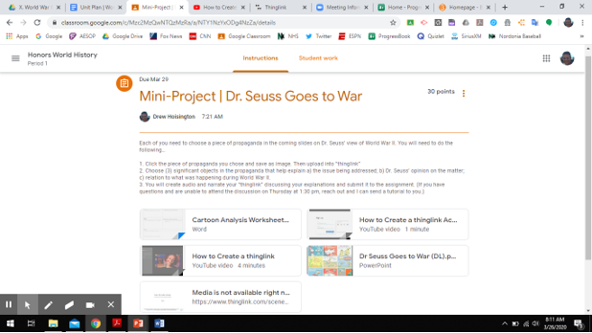  
1. Students will review the PowerPoint with political cartoons from a previous unit on Imperialism. This presentation is located on Google Classroom labeled Dr. Seuss Goes to War. It provides students with the learning objectives and instructions on how to analyze.  
  
Below are the slides from the PowerPoint:

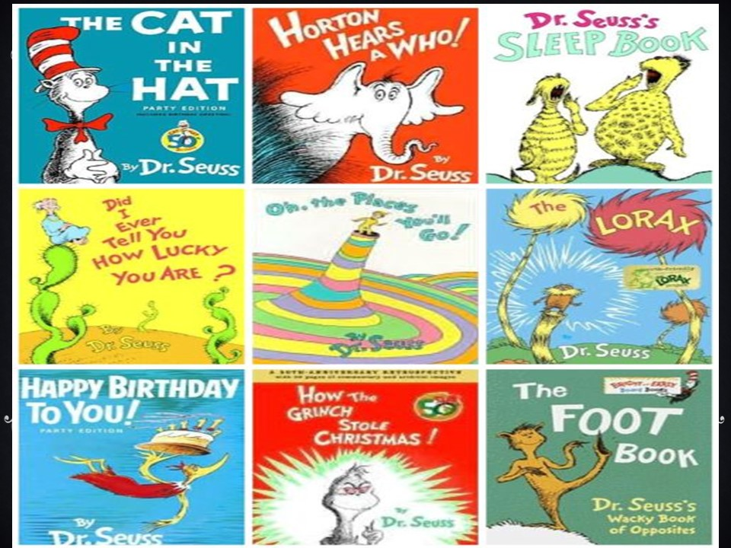

**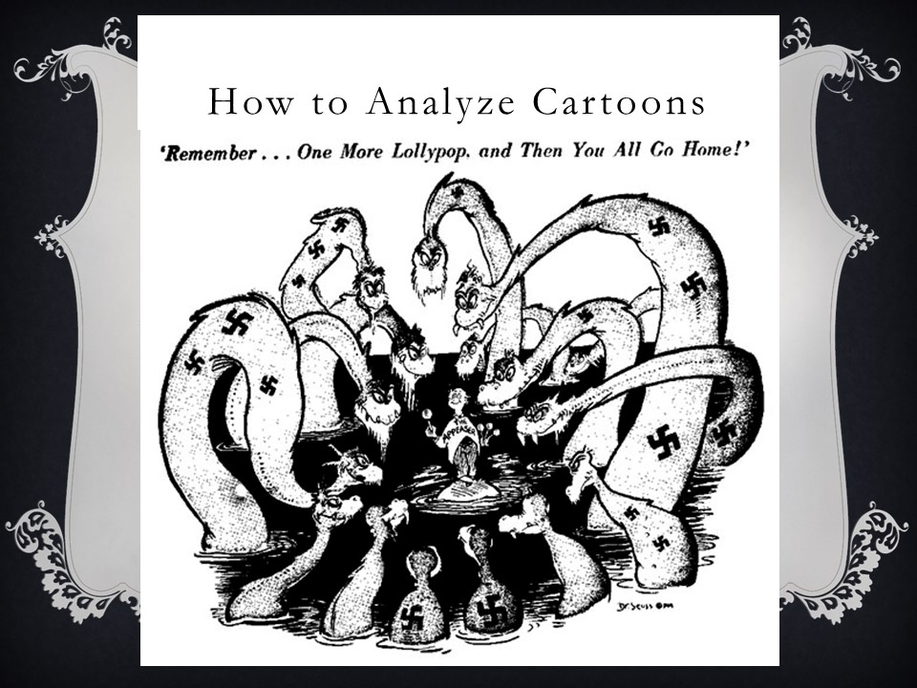  
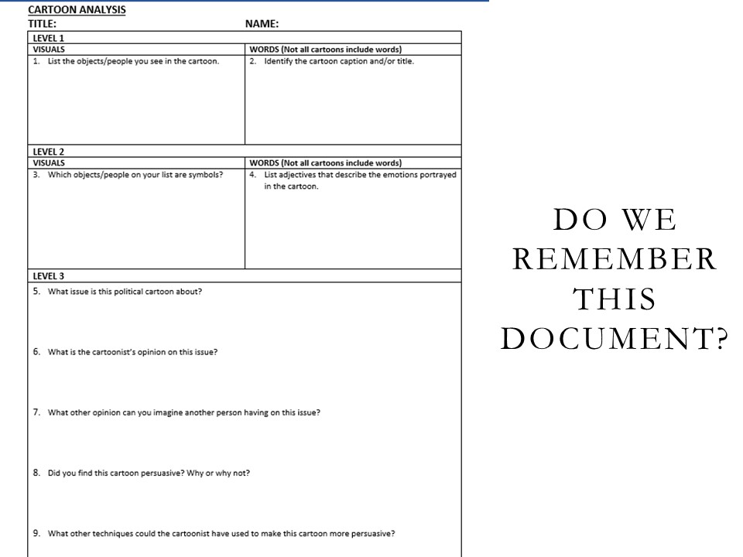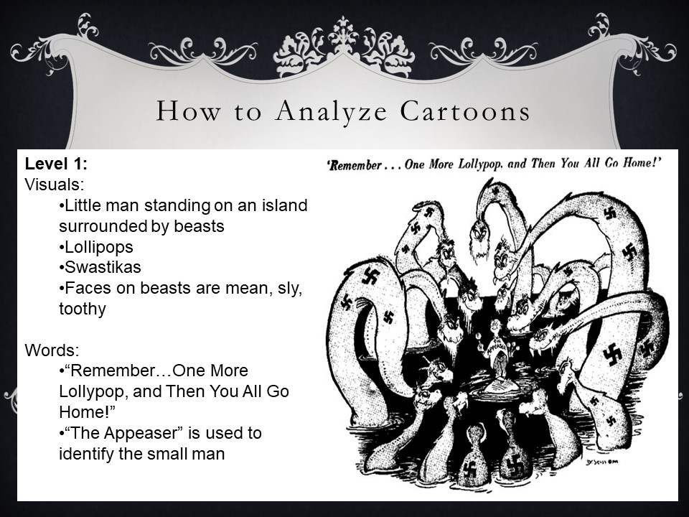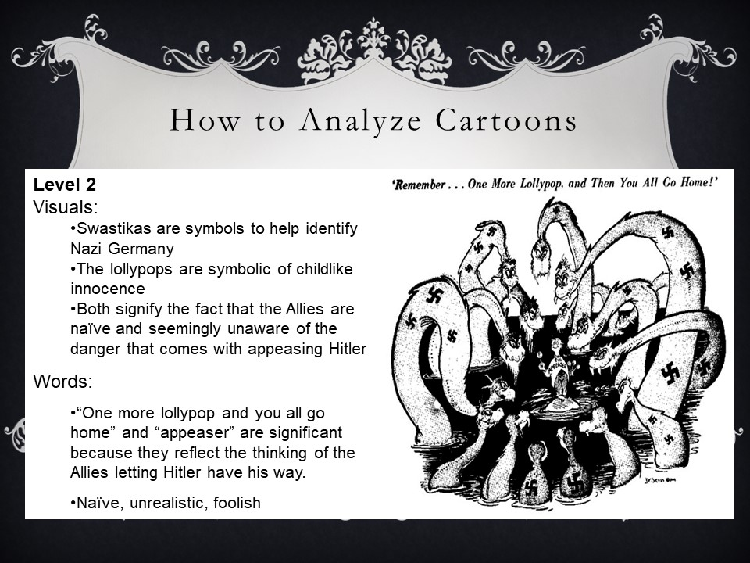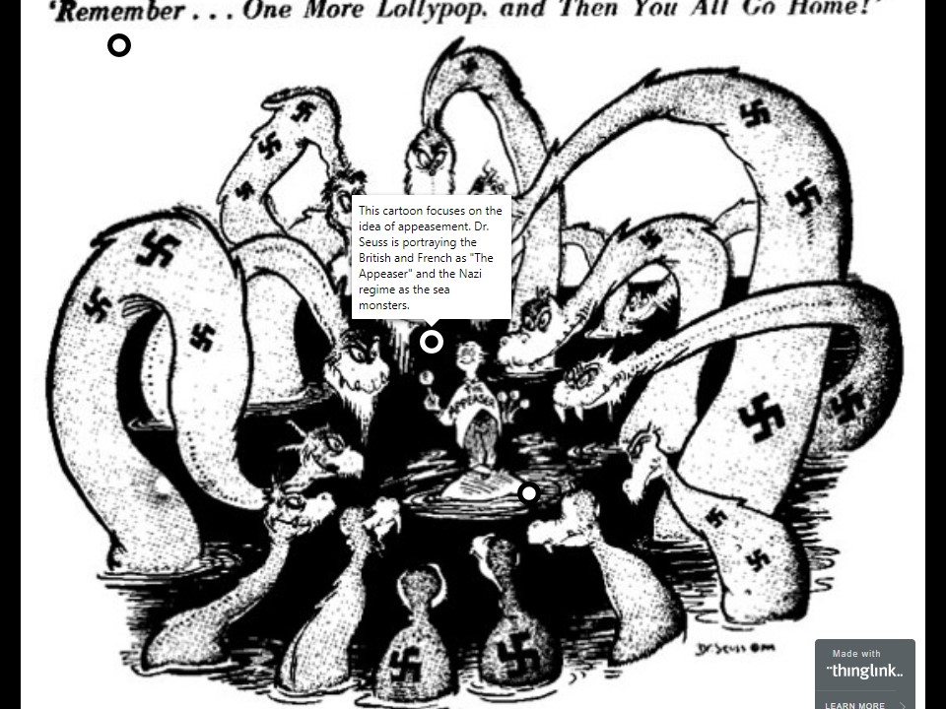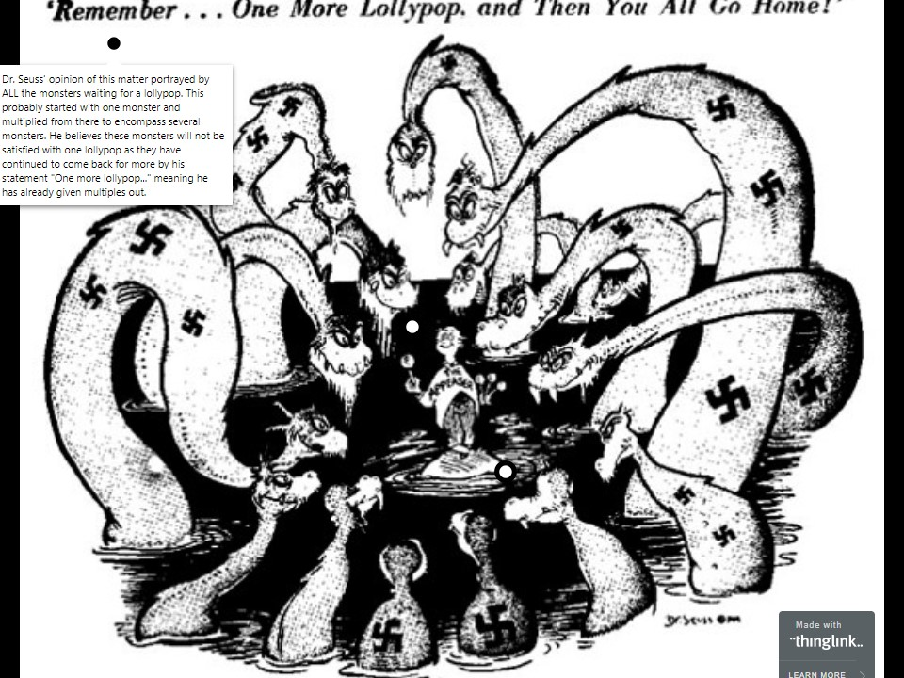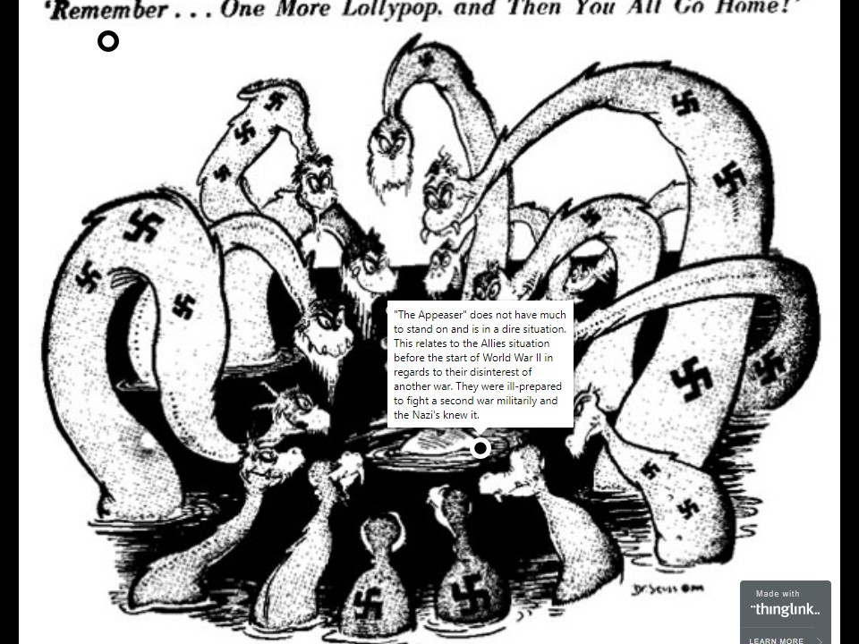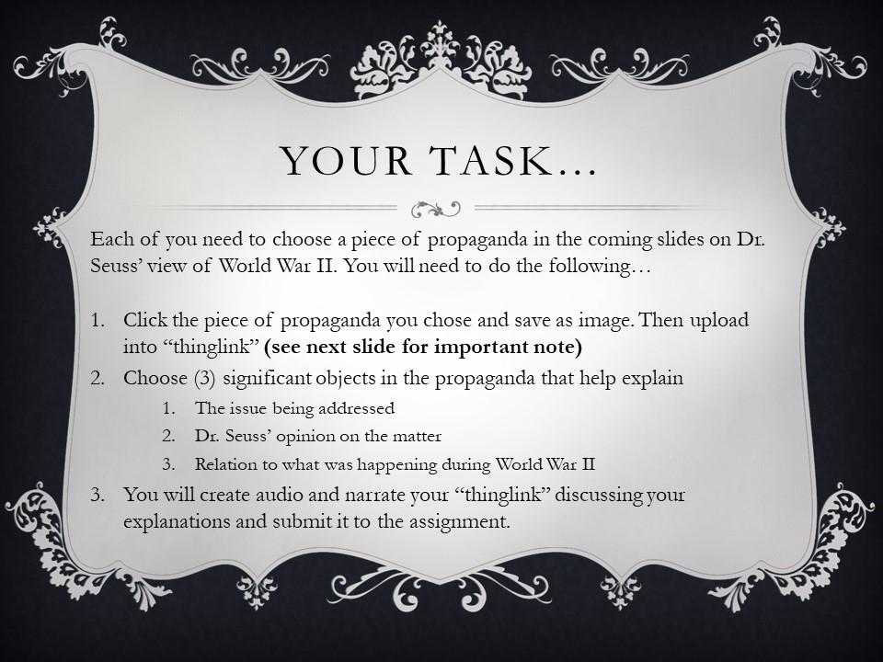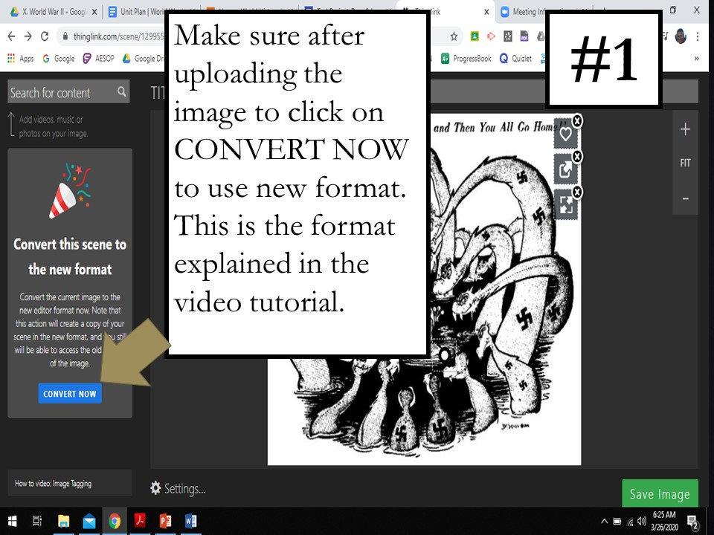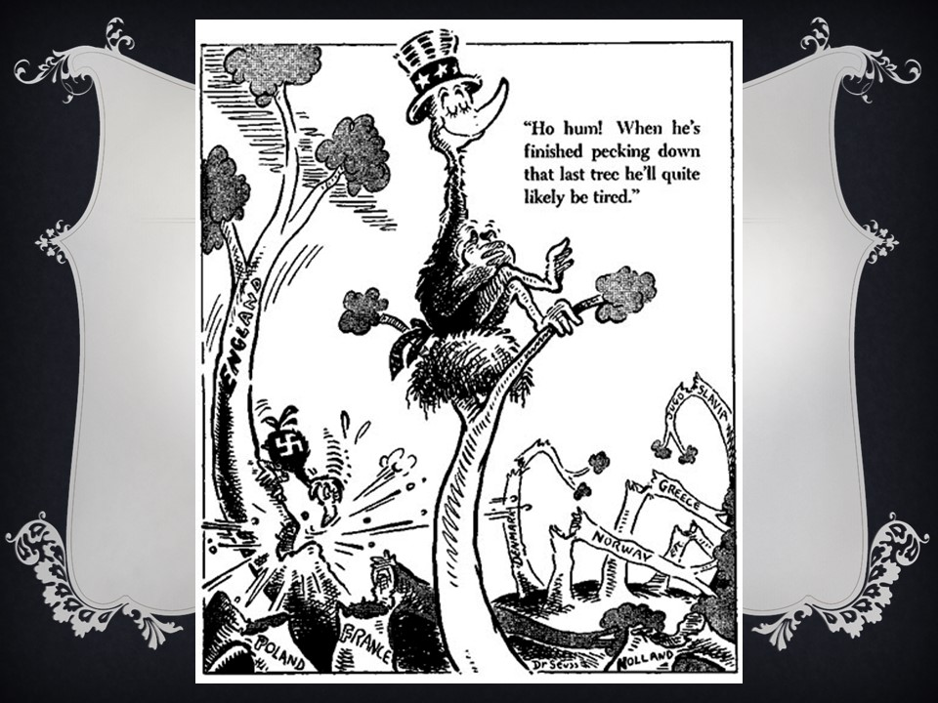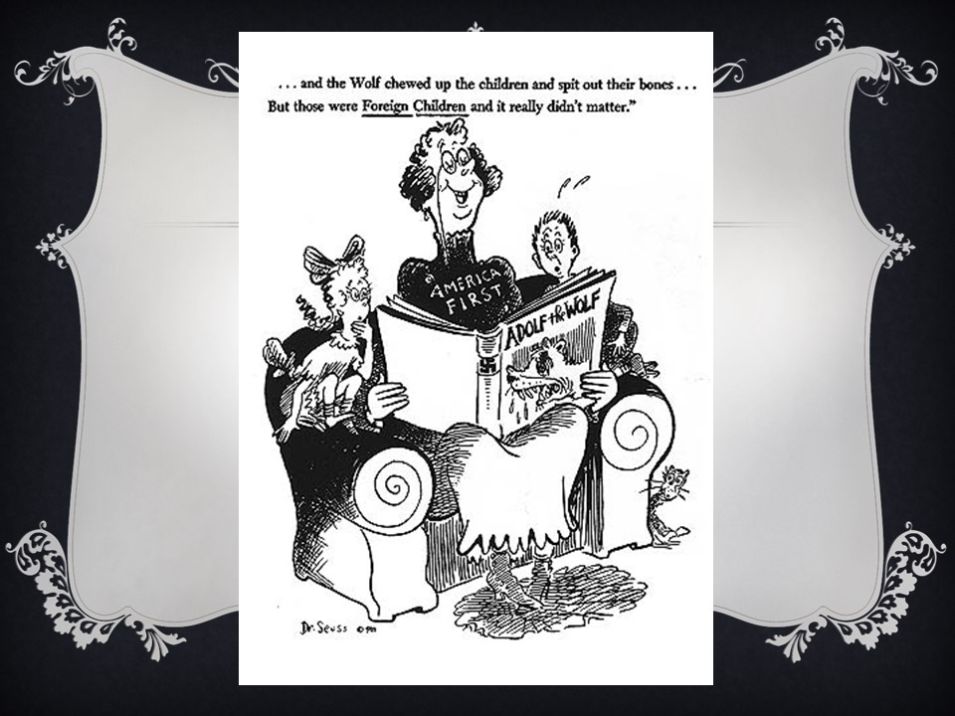**

2.Students selected a cartoon from the presentation to evaluate using this worksheet:

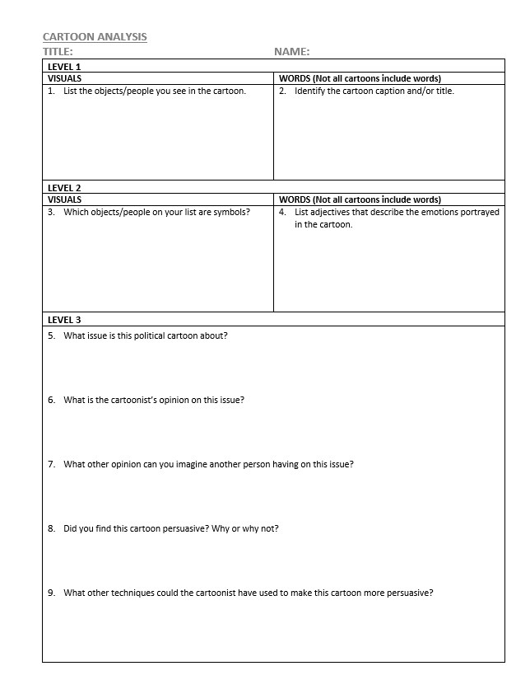

3.Each student created an interactive ThingLink using the cartoon they selected. They explained what issue the propaganda is describing and how it’s tried to persuade the reader. The use of ThingLink was taught during an online class session and students were provided a link to our Technology Project in case they needed a refresher on how to use it. [Click here to view the Technology project that was shared with students.](https://sites.google.com/view/techproject-drewjessica/welcome)   
  
This ThingLink example was provided for the students to review:  
  
[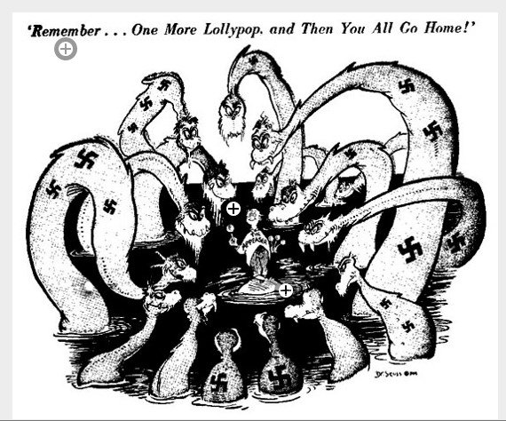](https://www.thinglink.com/scene/1299682120775499779)  
[Click here to review the live ThingLink example.](https://www.thinglink.com/scene/1299682120775499779)

**Lesson Reflection**This lesson was delivered virtually during the week of March 23, 2020. Originally, we had planned to deliver this in a face-to-face version but due to Coronavirus schools were closed. We found with a few alterations, this project was ideal to deliver virtually. The students have their Chromebooks and access to the internet so there was no challenge for them to access the materials or ThingLink.

The students were interested to learn about how cartoons are used as propaganda. They seemed a bit surprised to learn that Theodor Seuss Geisel was alive during World War II. These were comments that Drew received during his question and answer session he hosted virtually regarding the assignment.

They did a fantastic job on their presentations. Below are images of the submissions and links to their interactive presentations:

**Student Submission 1 –** [Click here to review the digital ThingLink submission.](https://www.thinglink.com/scene/1299763852375752705)[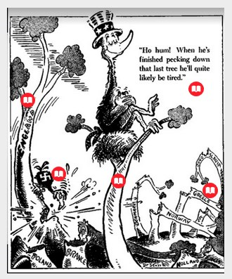](https://www.thinglink.com/scene/1299763852375752705)

**Student Submission 2 –** [Click here to review the digital ThingLink submission.](https://www.thinglink.com/scene/1300167998924914689)

[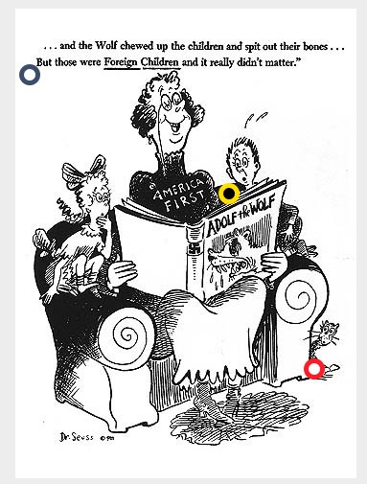](https://www.thinglink.com/scene/1300167998924914689)

**Student Submission 3 –** [Click here to review the digital ThingLink submission.](https://www.thinglink.com/scene/1301001209548636163)

[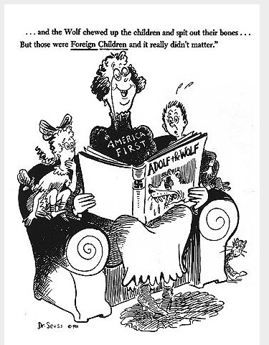](https://www.thinglink.com/scene/1301001209548636163)

**Student Submission 4 –** [Click here to review the digital ThingLink submission.](https://www.thinglink.com/scene/1300995546965606402)

[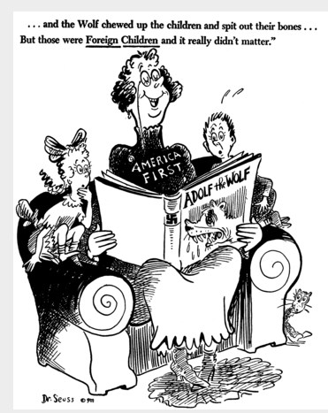](https://www.thinglink.com/scene/1300995546965606402)

***Discuss your thought process in the development of this lesson. After learning about TPACK how has this knowledge influenced the way you developed this lesson?***When developing this lesson plan, we wanted to create an engaging experience for the students. Since Nordonia High School supplies each student a Chromebook, we thought the integration of technology was ideal for this lesson. Utilizing the technology available is a goal of the teachers in this school district.

Since we kept the TPACK model in mind, we were able to make sure that we focused on the student’s current technological knowledge and the best way to teach the intended learning objectives and content. These students are all experienced using their Chromebooks and reviewing presentations so we knew we were presenting a lesson in a way that would work well for the students. We wanted to expand their thinking though so we felt that the addition of ThingLink for the assignment was a good way to introduce them to some of the fun things they can do with technology. To ensure that it was not a barrier for learning, Drew presented how to use ThingLink in class and provided the students with the tutorials we created for our Technology Project as an additional reference tool.

We believe that keeping the TPACK model in mind helped us ensure that technology was used in an efficient way and helped promote engagement with the content.

***How is the development of your planning with the use of technology changed in terms of how you integrate technology into your classroom?***

Implementation of technology in the classroom is a priority in regards to creating lessons. With that said, it is not a requirement when creating a lesson. Finding the appropriate technology for students to use and create is an important piece of lesson building.

For this project we wanted to make sure the technology we used would benefit learning. We had reviewed a couple alternative possible lesson plan ideas and determined that the use of technology would not be appropriate for those plans. This helped us understand that a teacher must be careful in how the integrate technology into a lesson. We cannot assume it will always be beneficial.

***How do you measure the impact that technology has on your students' learning?***

Most lessons that use some sort of technology are followed by surveys that ask students questions about the technology’s effectiveness. This gives the users an opportunity to provide feedback for the educator and this can be used to modify or implement new technologies in future lessons.