TEAM: DUNE!  
Members:   
Drew King  
Jake Hayes  
Justin Brehms (Captain)

Project Location: <https://github.com/drew-king82/proviso.git>

TDD Draft 1

Introduction:

Proviso is a hotel reservation site that provides users with the ability register and choose a date range for their vacation. They will have the options of selecting their size of room, the number of occupants, and which amenities they want to have during their stay. In addition, users will be able to review their booking and change it up to their check-in. Users have the option of being a member of the rewards program and can view their rewards from the online interface.

* 1. – Purpose: A program to register, edit and cancel vacation stays, keep track of bookings, track reward and choose different options for their stay.
  2. – Terminology:  
     Booking: A scheduled stay at the hotel with a date range.  
     Check-in: Date on which the reservation begins.  
     Check-out: Date on which the reservation ends  
     Amenities: Additional services in addition to schedule stay.  
     Guest: person who utilizes the program.  
     Rewards: Point value accrued with each stay  
     Room Size: Type of room configuration and bed count
  3. – User Personas CSD460 – Module 8

|  |  |  |
| --- | --- | --- |
| Employee badge  Picture & Name | Magnifying glass  Details | Checklist  Goals |
| What does the persona look like? What is its name? Choose a realistic and believable picture and name. | What are the persona’s relevant characteristics and behaviors? I.e.: demographics (age, gender, occupation, and income), psychographics (lifestyle, social class, and personality), and behavioral attributes (usage patterns, attitudes, and brand loyalty). Only list relevant details. | What problem does the persona want to solve or which benefit does the character seek? Why would the persona want to use or buy the product? |
| Jennifer Holland (@jennlholland) / Twitter  Jennifer K. | Age: 41  Gender: Female  Occupation: Sr. Software Developer  Income: $115,000/year  Lifestyle: Married, an avid traveler both for work and pleasure. She is an outdoor adventurer and shares her experiences via her social media part time as an influencer. | 1. Wants to be able to book her travel online 2. Prefers to use her laptop for booking so she doesn’t miss any fine print. 3. She wants to be able to update and track her travel itinerary 4. She wants to ensure she has a confirmation so that there aren’t any issues upon her arrival. 5. She also loves earning points toward her future travels. |
| Employee badge  Picture & Name | Magnifying glass  Details | Checklist  Goals |
| What does the persona look like? What is its name? Choose a realistic and believable picture and name. | What are the persona’s relevant characteristics and behaviors? I.e.: demographics (age, gender, occupation, and income), psychographics (lifestyle, social class, and personality), and behavioral attributes (usage patterns, attitudes, and brand loyalty). Only list relevant details. | What problem does the persona want to solve or which benefit does the character seek? Why would the persona want to use or buy the product? |
| Joe W. | Age: 28  Gender: Male  Occupation: Forman  Income: 88,000  Lifestyle:  Sam moves from site to site overseeing construction of emergency room facilities. Joe enjoys getting away from it all and surfing. He’s been planning a trip to Hawaii with two of his friends from work. | 1. Needs to change reservation incase another friends joins them 2. Wants to have three beds in the room without paying for a second room 3. Needs parking for his rental car 4. Wants hotels with full breakfast 5. Wants a hotel with beach access |
| Employee badge  Picture & Name | Magnifying glass  Details | Checklist  Goals |
| What does the persona look like? What is its name? Choose a realistic and believable picture and name. | What are the persona’s relevant characteristics and behaviors? I.e.: demographics (age, gender, occupation, and income), psychographics (lifestyle, social class, and personality), and behavioral attributes (usage patterns, attitudes, and brand loyalty). Only list relevant details. | What problem does the persona want to solve or which benefit does the character seek? Why would the persona want to use or buy the product? |
| Amari F. | Age: 30  Gender: Male  Occupation: Marketing Executive  Income: 152,000  Lifestyle:  Amari is a young marketing executive that frequently travels internationally for his job, securing contracts for his advertising company he build himself. When not travelling he is an avid boxer.  He has been anticipating a big match coming up and is working the advertising for the event. | 1. Needs gated parking for his vehicle 2. Must have active WiFi for work 3. Wants a site with frequent stay rewards 4. Wants electronic check-in 5. Needs to be able to modify his reservation from work to vacation. |

1.4 –   
**User Stories:**

Jennifer K.

As a software developer, I want a clean design for the booking sites I use.

As a high-stress business woman, I need the interface to be simple and easy to understand.

As a influencer of social media, I want to update my followers on where I’m staying and how long.

I want to see my rewards so that I can book more vacation stays.

Since I’m busy, I forget my plans. I need email reminders of my reservations.

Joe W.

As a surfer, I don’t want a complicated booking system, I just want to get my vacation booked.

My friends don’t want to spend extra money on multiple rooms, but we want individual beds.

Because we are on a budget, We want a hotel that offers at least one meal for a reasonable price.

We’ll probably get a rental and keep our boards on a roof rack, we want parking that keeps our equipment safe.

As a foreman, a job may go longer than expected, I need to be able to change my booking easily.

Amari F.

As a business owner that has meetings, I need to change my booking at a moment’s notice.

As a business owner, even vacations can have work and I need quality WIFI access.

I sometimes work and play on the same trip, I need to be able to extend my visit online.

As a business man, I want to utilize the rewards programs to save on cost.

I often drive a lot during my trips and I need a safe parking place for my vehicle.

1.5 – Work Estimations

User Interface - Initial design phase with prototype – 1 week

Functional prototype with display interactive model – 3 weeks

User Interface and basic program structure with test database – 8 weeks

Interface with Interaction with database and input of new information read for final testing - 20 weeks.

2.1 – Prototypes

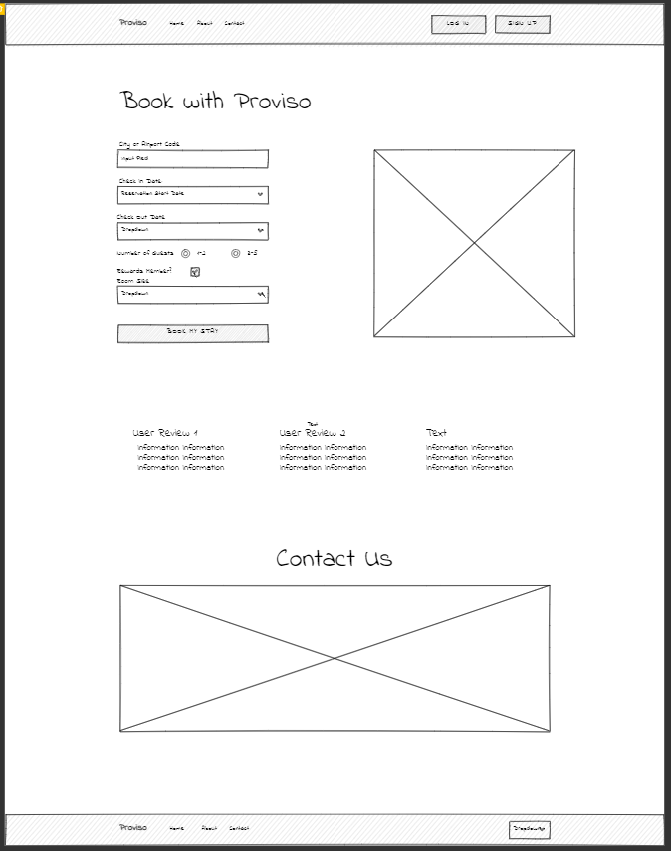

2.2 – ORD