Drew King

CSD340 Mod 2.2

Assignment: Building a Web Page Exercise, Part 1

3/20/21

Link to GitHub: https://github.com/drew-king82/csd-340/blob/main/module-2/King_EX1.html

Screenshot 1 Errors

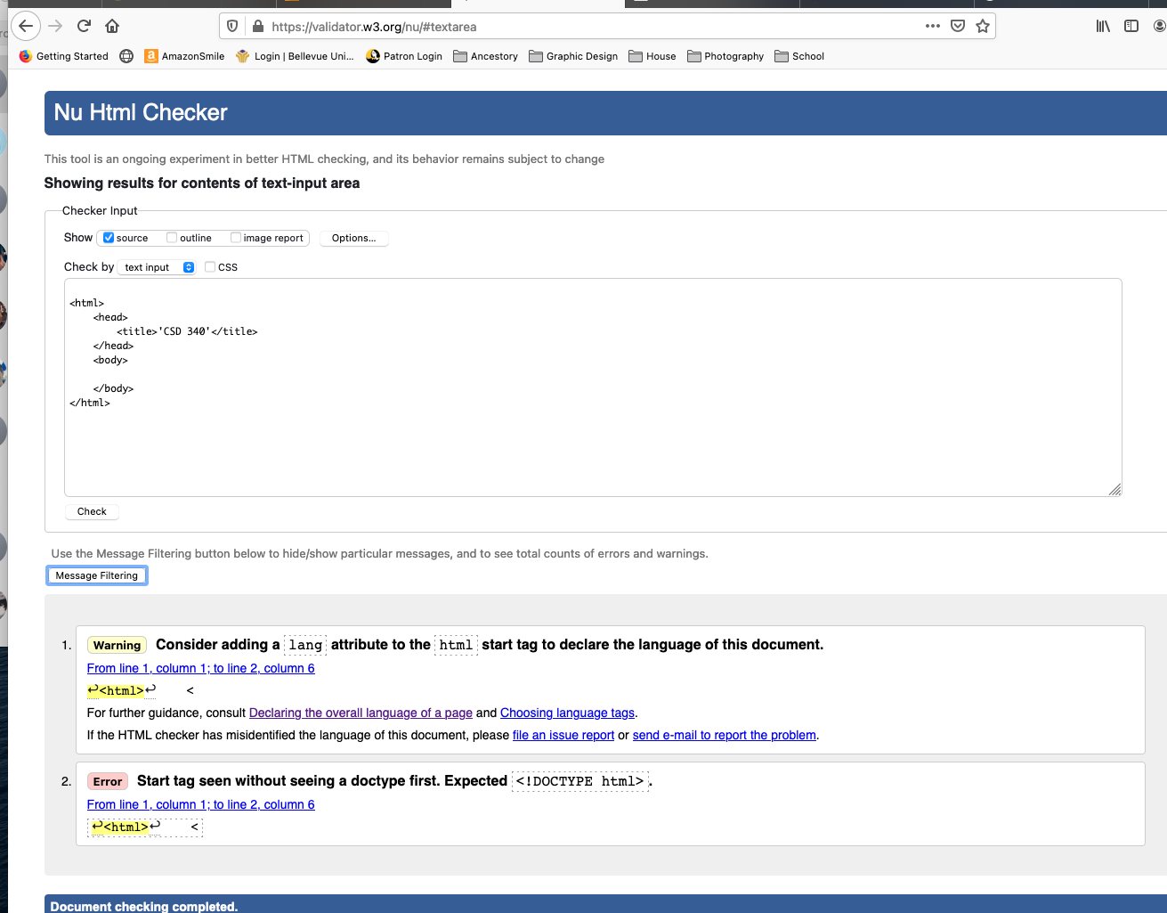

Screenshot 2 No Errors

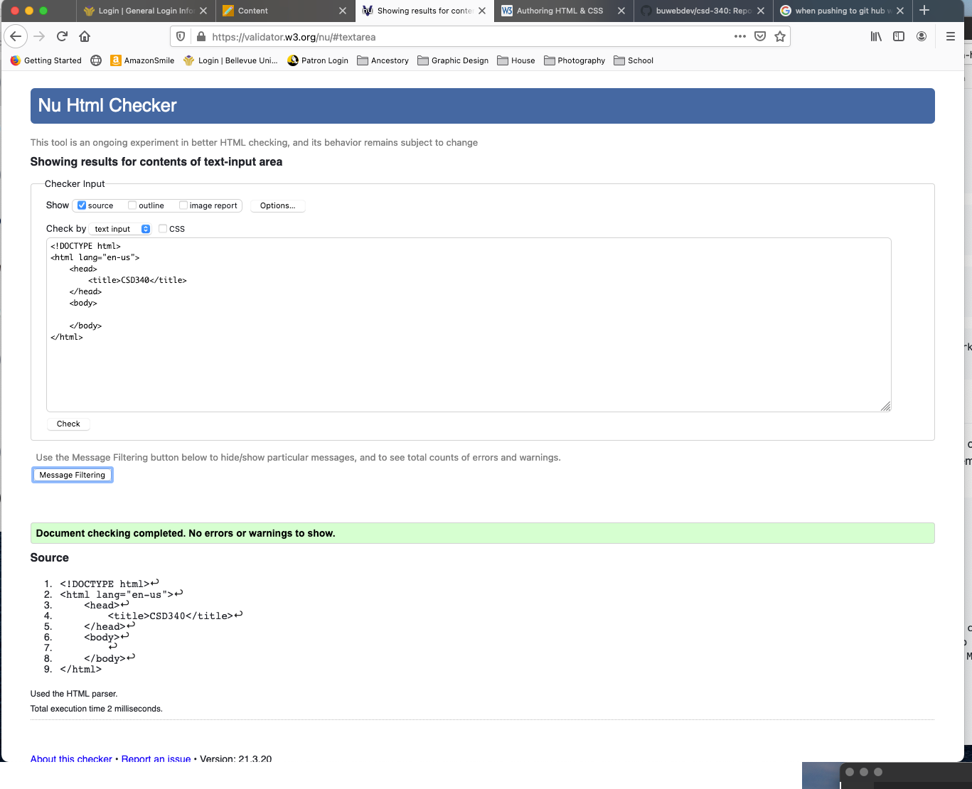

Screenshot 3 updates

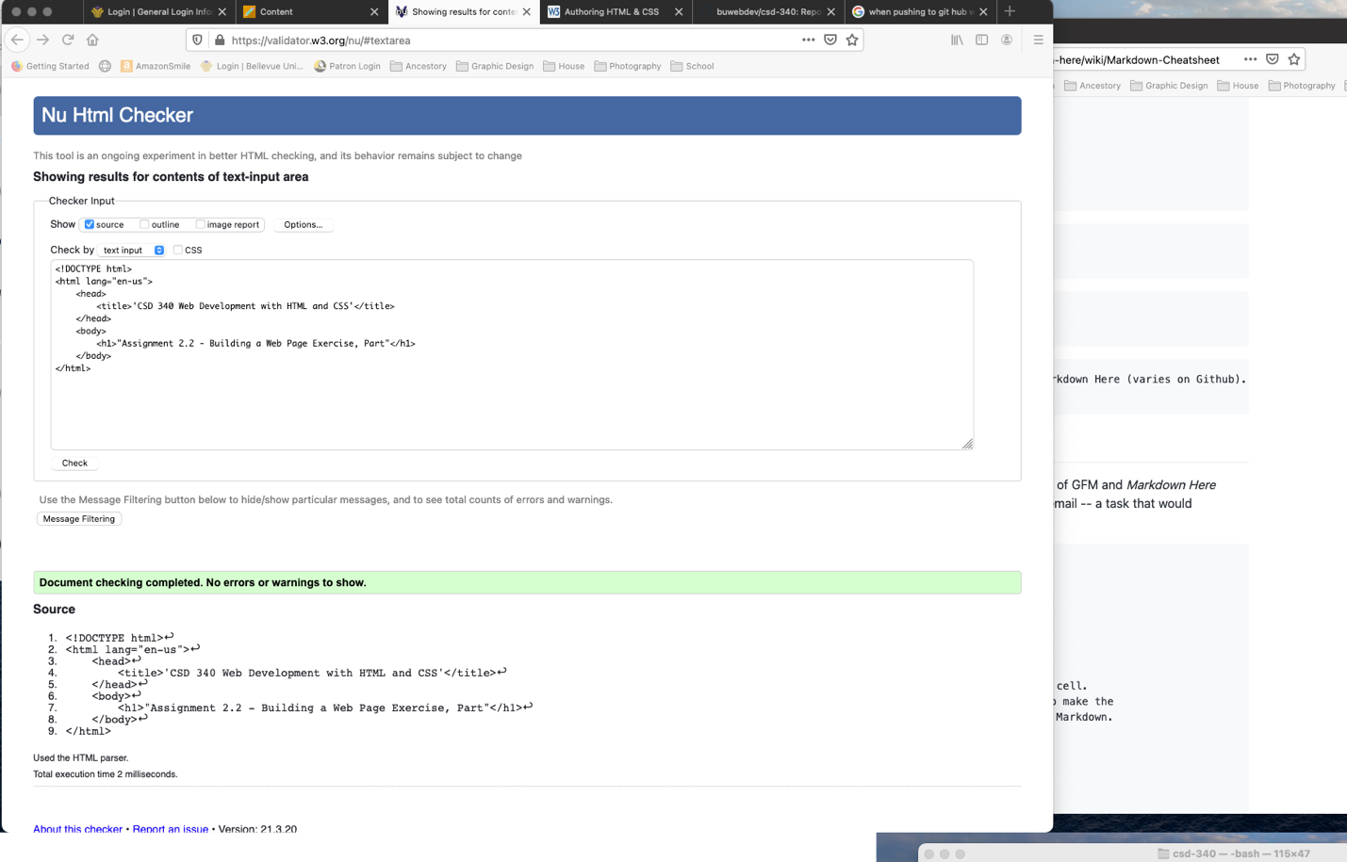

Screenshot 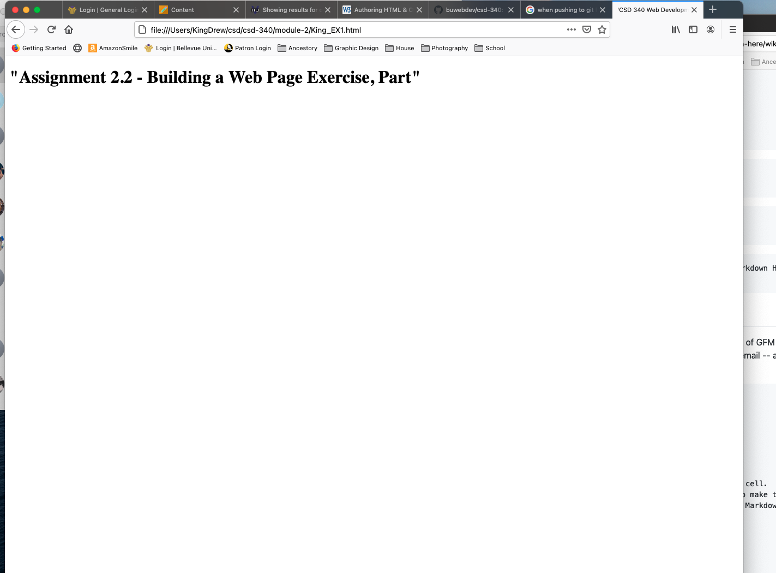4 Webpage Screenshot