**Building a Python Script for the TBA API**

**Introduction**

These instructions are intended for FIRST Robotics Competition (FRC) members already familiar with Python and creating Python scripts. The instructions will walk you through how to use Python to retrieve data from the The Blue Alliance (TBA) API. After retrieving and compiling the data it is up to the user to interpret it.

**Required Materials**

Desktop or Laptop running any standard OS (Windows, Mac OSX, or Linux

Disclaimer: This tutorial was written for a Windows 10 computer. Your computer may have slightly different steps.

**Importing Libraries**

There are two libraries needed for this program.

1. Download csv (standard python library)
2. Download tbapy (specific library for use with TBA API)
   1. Download this library from: <https://github.com/frc1418/tbapy>
   2. Credit to FRC Team 1418 for the library



1. Import these two libraries the same as any other Python library using the “import” keyword

**Acquiring and Using a TBA Auth Key**

A unique TBA Auth Key is required for any TBA API requests. This is so that TBA can track what data their users are requesting.

1. Visit: <https://www.thebluealliance.com/apidocs/v3>
2. Create an account
3. Follow the steps to find your unique Auth Key

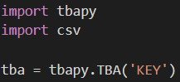

1. Create a tbapy.TBA object and pass in your key as an argument

Note: The object can be named anything, it was just named “tba” for convenience.

**Open and Write to a CSV File**

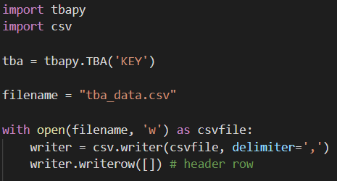

1. Create a file name e.g. “tba_data.csv”

Note: Any name is valid if it ends in “.csv”

1. Open the file

1

1. Create a “writer” object to help write to the file
2. Write out a header row to make the file more readable

3

4

2

Note: This row will depend on what data you are reading from the API

**Request the Team List of a Desired Event**

1. Visit: [https://www.thebluealliance.com/](https://www.thebluealliance.com/apidocs/v3)
2. Find the FRC event that you would like to pull data from
3. Use the TBA key for that event in your code (example: “2019ftcmp”)



1. Create an array of the team keys using “tba.event_teams(eventKey, keys=True)”

Note: The option “keys=True” is used to request team keys (think of them as team names). These keys will then be used to look up data later.

**Extract Data from All Teams**

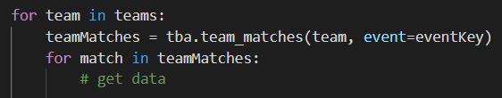

3

2

1

1. Loop over each team in the list of teams that was requested earlier from the API
2. Request a list of matches for each individual team
3. Loop over each match and extract data from them

Disclaimer: These instructions will not cover exactly what data to extract as this varies depending on the use case. Tutorials can be found at: <https://www.thebluealliance.com/apidocs/v3>

**Write Data to CSV File**



1. Compile data that was previously extracted into an array
2. Write this array to the CSV file opened previously using the “writerow()” function

Note: Depending on use case, it might be better to write data on a “per match” basis or on a “per team” basis.

Congratulations! You have successfully learned how to request and compile data from the TBA API using Python.

**Appendix: Full Sample Program**

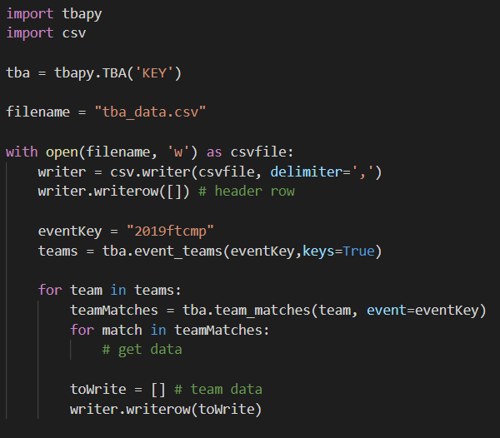

This screenshot shows the entire sample code used in these instructions. All previous screenshots were small snippets of code.