**Comparison of Ports for Use in OrangeCo Laptops**

**Introduction:**

Our company has been successful in the desktop computer market, but we have not ventured into the laptop market yet. Because our company seeks to provide products to as many consumers as possible, we need to start producing laptops. There are several things we can learn from other laptop manufacturers before deciding on our own laptop design. This report will focus on the type and location of physical laptop ports. Obviously having a large amount of different types of ports will allow the most flexibility, but it comes at a cost. A laptop with many ports is by necessity larger than a laptop with fewer ports, and because portability is important, this may cause consumers to prefer a laptop with fewer ports, simply for the portability increase. This report will focus on comparing laptops with only USB-C ports and laptops with USB-C plus other types of ports.

**History of USB-C Only:**

Some people might say that a laptop with only USB-C ports is a horrible product. Apple disproved this idea in 2016. Initially many people were unhappy that Apple decided to remove almost all other ports (Matney). It is possible that Apple was a few years too early cutting out other ports, but in 2020 USB-C is so common that it is extremely normal to cut out most (or all) other laptop ports. There are many types of devices moving to USB-C only. Laptops, phones, tablets, and more are all starting to embrace USB-C (Barrett). There are still considerations for laptops with more ports. This report aims to look at the pros and cons of both types of laptops for the purpose of deciding which product our company will produce.

**USB-C Only vs USB-C Plus Other Types of Ports:**

***- Thickness***

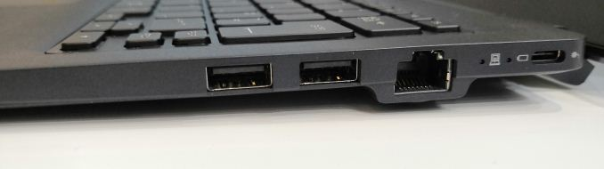

**Figure 1: Ethernet port thickness (Cutress)**

USB-C ports allow for the thinnest possible laptops. Figure 1 shows standard USB ports, an even wider ethernet port, and a much thinner USB-C port. The laptop shown in figure 1 would be thinner if the ethernet port was removed, and it could be thinner still if only the only port(s) were USB-C. USB-C only is the clear choice for ports if the thinnest possible laptop is desired, and it is possible to connect to almost anything using USB-C ports and external adapters (Nadel).

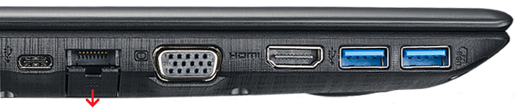

**Figure 2: Expandable Ethernet port (Expandable ethernet port on Acer laptops)**

It is possible to make a relatively thin laptop that also has several different types of ports, including an ethernet port. The best way to accomplish this is with an expandable ethernet port (Figure 2). This type of laptop is still thicker than an exclusively USB-C laptop, but not by much.

***- Convenience***

While it may seem like a USB-C only laptop will be the most convenient simply because it is the most portable, this is not always the case. For consumers that regularly use other ports, such as HDMI or ethernet, a laptop with those ports built in is more convenient, and arguably more portable as well. It is possible to use HDMI and/or ethernet devices on a USB-C only laptop, but only through a USB-C hub (Ackerman). Our customers would have to buy a hub on top of the laptop they are already purchasing, and they would have to carry the hub with them whenever they need to use other ports (Gartenberg). This issue changes based on the consumer, not all will need more ports regularly. With regards to consumer convenience, it is best to manufacture and sell both types of laptops, allowing consumers to choose whether they need extra ports, or whether they would prefer the extreme portability offered by our USB-C only laptops.

***- Durability***

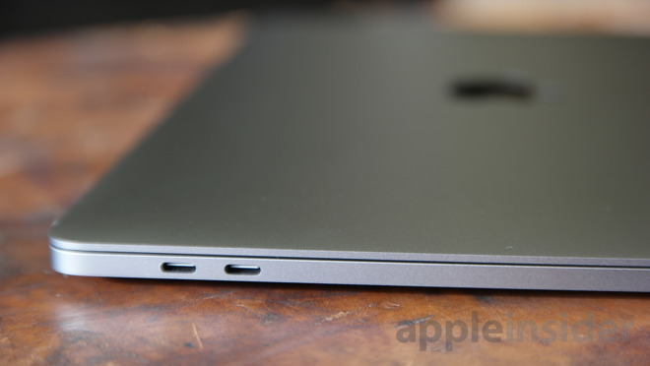Durability is not something that all customers consider when buying a laptop, but it is extremely important to people who use laptops in relatively hazardous environments such as construction sites or factory production lines. These customers might not need extra ports, but they will want a slightly less flimsy laptop. Ultra-thin USB-C only laptops (Figure 3) are easier to break when dropped or hit by something. These customers will absolutely prefer a slightly less portable laptop if it gives more durability.

**Figure 3: Ultra-thin USB-C only laptop (Hughes)**

**Conclusion:**

Our company strives to provide the best products for as many types of consumers as possible. This proposal recommends that we design and produce two different versions of laptops. One type that is ultra-thin with only USB-C ports, and another slightly thicker version with more ports. Producing both laptops will cost more initially to develop, but we will also be able to develop long-term consumer loyalty with more people. This better aligns with our company goals to be able to provide products for the maximum amount of consumer types possible.

References

Ackerman, D. (2015, April 9). How to survive with only one USB-C port on your new MacBook. Retrieved March 30, 2020, from https://www.cnet.com/news/how-to-survive-with-only-one-usb-c-port-on-your-new-macbook/

Barrett, B. (n.d.). USB-C Has Finally Come Into Its Own. Retrieved May 8, 2020, from https://www.wired.com/story/usb-c-surface-pro-kindle-ps5-iphone-standard/

Cutress, I. (2018, September 13). Toshiba's Portégé X30T: An Uncanny Mix of Clamshell and Tablet. Retrieved March 30, 2020, from https://www.anandtech.com/show/13351/toshibas-portege-x30t-an-uncanny-mix-of-clamshell-and-tablet

Expandable ethernet port on Acer laptops. (2018, June 3). Retrieved March 30, 2020, from https://za.answers.acer.com/app/answers/detail/a_id/42946/~/expandable-ethernet-port-on-acer-laptops

Gartenberg, C. (2018, June 1). The best USB-C hub for your new laptop. Retrieved March 30, 2020, from https://www.theverge.com/this-is-my-next/2018/6/1/17413728/the-best-usb-c-hub-for-laptops-macbook-pro

Hughes, N. (n.d.). No, Apple did not switch to USB-C on its new MacBook Pros to profit from dongle & adapter sales. Retrieved March 30, 2020, from https://appleinsider.com/articles/16/12/23/no-apple-did-not-switch-to-usb-c-on-its-new-macbook-pros-to-profit-from-dongle-adapter-sales

Matney, L. (2016, October 27). Apple's new MacBook Pro kills off most of the ports you probably need. Retrieved May 8, 2020, from https://techcrunch.com/2016/10/27/apples-new-macbook-pro-just-killed-off-most-of-the-ports-you-probably-need/

Nadel, B. (2018, March 28). USB-C explained: How to get the most from it (and why it's great). Retrieved March 30, 2020, from https://www.computerworld.com/article/2488194/usb-c-explained-how-to-get-the-most-from-it-and-why-its-great.html