Audience: VP of Facilities Management

4/19/2020

Dear Mr. Tomlinson:

I am a ECS student here at UTD. After spending some time on campus late at night I have observed that we leave a lot of lights on all night. This is a waste of energy and money. I have spent some time researching a possible solution and I have attached my findings.

As you are well aware, ECSS is most busy from 8am – 8pm. My proposal does not expect we will save any energy during this time. I want to install occupancy sensors that will allow us to save energy from 8pm – 8am (also weekends and holidays). We can save as much as 40% of the energy spent on lighting, which amounts to roughly $17,000 per year in ECSS alone. This is described in detail in my report.

My proposal is attached. I am available during normal business hours to answer any questions you many have. Thank you for your consideration.

Sincerely,

Drew Pulliam

(555) 555-5555

Dtp180003@utdallas.edu

**USING OCCUPANCY SENSORS TO REDUCE ENERGY CONSUMPTION IN ECSS**

Presented to:

Doug Tomlinson, Associate Vice President

Facilities Management, UT Dallas

Presented by:

Drew Pulliam

Presentation Date: April 19, 2020

**INTRODUCTION**

Energy is an incredibly valuable resource, and a large expense at UTD. Efforts made to conserve energy will both save money and carbon emissions. This proposal will focus on electricity used in campus lighting.

The majority of classes at UTD are from 8am to 8pm. This leaves 12 hours of very little facility usage. During this time indoor lights are left on constantly. This is a huge waste of energy. The most energy and cost-efficient use of lights is to only leave them on while there are people nearby who need them to see. This is easily accomplished by installing occupancy sensors. Through intelligent use of occupancy sensors, indoor lights will only turn on when there are people near.

This proposal will describe how to implement occupancy sensors to reduce UTD energy costs by as much as 40-50% (Office Design). ECSS can be used as a test building, with the potential to expand to all UTD campus buildings later. Switching to this energy efficient option is also extremely cost efficient, with the total investment being saved in just 3.5 years from reduction in energy cost.

**SCOPE OF PROBLEM**

ECSS has 4400 fluorescent lights that use 14 Watts each. Number of lights calculated using estimated square footage of 200,000 and roughly 0.02 fluorescent lights per square foot (Wampler). Currently these lights are on 24 hours a day, 7 days a week, 365 days a year (except for minor breaks for repairs). The total cost of energy for the ECSS building can be determined using simple multiplication.

**ESTIMATED ENERGY COST FOR 4400X14-WATT LIGHT BULBS:**

14 Watts x 4400 bulbs x 24 hours = 1,478,400 Wh/Day = 1,478 kWh/Day

1,478 kWh/Day x 365 Days = 539,616 kWh annually.

Average Texas commercial energy cost is 8 cents per kWh (Texas State Energy Profile).

Total current yearly energy cost for ECSS lightbulbs is 539,616 kWh x $0.08 = $43,169.

**SOLUTION**

**OVERVIEW**

In an effort to reduce energy expenditure in ECSS this proposal recommends occupancy sensors. Using occupancy sensors will allow lights to be turned off when there are no people near. During 8am – 8pm when ECSS is busiest the lights can be set to always on mode. During 8pm – 8am the occupancy sensors will be used to determine whether any specific lights should be turned on or off.

**SAVINGS BY USING OCCUPANCY SENSORS**

Nothing will change with energy consumption during 8am - 8pm Monday – Friday because the lights will always be on still. During 8pm – 8am a conservative estimate would be that the lights will be off 30% of the time. This allows for a 30% energy savings on weekdays, with even greater savings on weekends and holidays. Overall, this proposal believes that an estimate of 40% energy savings is realistic. Given the previously calculated $43,169 per year a saving of 40% would result in a saving of $17,267 per year.

**IMPLEMENTATION**

**PASSIVE INFRARED SENSORS**

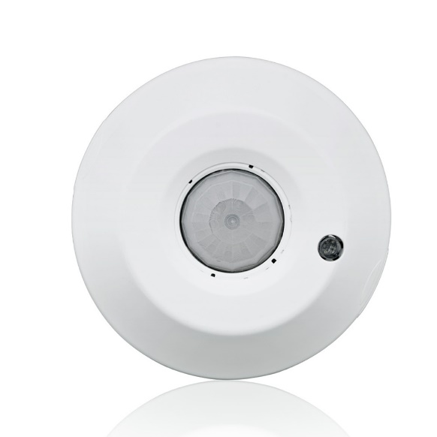One of the options for occupancy sensors that is widely available is passive infrared sensors (PIR). These sensors use infrared to detect heat signatures (usually human bodies) and turn on lights when there is enough heat present in the room. These sensors work best in areas that they have clear line of sight as they cannot see infrared light around corners (Sajip). This is why it will work exceptionally well when installed as ceiling sensors in hallways around ECSS.

Figure 1: Ceiling mount PIR sensor

Figure 1 is an example of a PIR ceiling mount sensor (Occupancy and Vacancy Sensors).

**ULTRASONIC SENSORS**

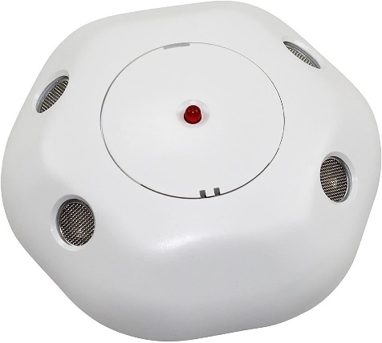The second common option for occupancy sensors is ultrasonic sensors. Ultrasonic sensors use a high-frequency sound to detect movement. These sensors work better when there is no clear line of sight, but they do not work when people are stationary (e.g. sitting at a table doing work). It is for this reason that this proposal recommends PIR sensors over Ultrasonic sensors.

Figure 2: Ceiling mount Ultrasonic sensor

Figure 2 is an example of an Ultrasonic ceiling mount sensor (Occupancy and Vacancy Sensors).

**INSTALLATION**

An important consideration is how much the installation will cost. Average hourly rate for electricians is 75$. Each sensor takes and average of 30 minutes to install, which results in 445 sensors / 2 per hour = 222.5 hours. 222.5 hours x $75 per hour = $16,687 total install cost.

**BUDGET**

The PIR ceiling mount sensor mentioned previously costs $100 and covers 450 square feet. Given ECSS as a 200,000 square feet building, UTD would need to purchase 200,000 square feet / 450 square feet per sensor = 445 sensors. This would result in a price of 445 sensors x $100 = $44,500. Adding on the install cost of $16,687, this results in a total initial investment of $44,500 + $16,687 = $61,187

While this is a sizeable investment, it would very quickly be returned through energy cost savings. Earlier this report shows how this method will save UTD $17,267 per year. This results in the initial investment being returned in just 3.5 years. $61,187 / $17,267 per year = 3.5 years. These calculations can be easily seen in Table 1 below.

|  |  |  |  |
| --- | --- | --- | --- |
| Cost to buy Sensors | Sensor Install Cost | Yearly Energy Savings | Years until Investment returned |
| $44,500 | $16,687 | $17,267 | 3.5 years |

Table 1: Budget Overview

**BENEFITS**

**FULL CAMPUS EXPANSION**

Although this proposal only focuses on adding occupancy sensors to ECSS, this could be implemented in all buildings across UTD campus. Given an estimated 4,000,000 square feet across all campus buildings (and similar amounts of fluorescent lights), the total energy savings per year could be $345,340. This is a long term goal that will ideally be accomplished after testing this plan on ECSS only.

**COUNTERARGUMENTS**

One argument against leaving lights off most of the time is that they are a possible crime deterrent. While this is true, this proposal does not recommend applying this approach to outdoor lighting, only indoor. This makes this problem much less likely.

Another possible problem with using automatic sensors is the risk of false positives and negatives (lights turning on with nobody around or turning off with people still there). While this could be a problem, it is extremely mitigated by also using a timer and always leaving the lights on from 8am – 8pm. This reduces the amount of false negatives and positives to the hours when campus is less busy (and as a result less problems will be caused).

**CONCLUSION**

The 40% energy savings afforded by installing occupancy sensors is a huge amount of energy and money savings possible. This seems like the best possible option for ECSS and possible UTD campus as a whole.

While there is no real savings during normal business hours from 8am – 8pm this strategy will allow a huge amount of energy saving during far less busy nights, weekends, and holidays. Simply installing sensors will allow UTD to save 40% of the electricity spent on lighting. UTD will need to invest an initial $61,187, but the investment will be paid off in just 3.5 years. After this short 3.5 year period, the energy savings will be “free”.

This proposal believes that there is no real argument against this idea. While UTD does have to invest an initial $61,187, they will also save that same money very quickly with the energy savings they will afford.

**REFERENCES**

Occupancy and Vacancy Sensors. (n.d.). Retrieved from https://www.leviton.com/en/products/commercial/lighting-controls/occupancy-sensors-and-vacancy-sensors

Office Design. (n.d.). Retrieved from https://sustainablebuildingsinitiative.org/toolkits/emissions-reduction-toolkits/energy-efficiency/office-design/?toolkit=224

Sajip, J. (n.d.). Reducing Lighting Energy Consumption with Occupancy Sensors. Retrieved from <https://www.ny-engineers.com/blog/lighting-occupancy-sensors>

Texas State Energy Profile. (n.d.). Retrieved from <https://www.eia.gov/state/print.php?sid=TX>

Wampler, L. (2017, July 17). How to Figure Spacing for Fluorescent Fixtures. Retrieved from https://www.hunker.com/13416374/how-to-figure-spacing-for-fluorescent-fixtures