Group Proposal Team 1 - Drew Pulliam

800 W Campbell Rd

Richardson, TX 75080-3021

May 5, 2020

Doug Tomlinson, Associate Vice President of Facilities Management

The University of Texas at Dallas

800 W Campbell Rd

Richardson, TX 75080-3021

Dear Mr. Tomlinson:

We are pleased to submit a new proposal to install solar panels and solar windows at the new Arts and Performance Complex. This proposal will explain how to integrate solar power into the new building and the associated costs and benefits. Using solar power is the best way to power buildings on campus as it will save the University money while being environmentally friendly at the same time.

While there is an initial investment to install solar power, discussed later in this report, this investment will quickly be earned back through energy savings. The University will be able to completely earn back their investment in only 2.5 years. After this 2.5-year period, the solar-powered building will continue to save $138,426 per year on electricity costs. This is 48% of the new building’s total yearly electricity costs.

In addition to the monetary savings offered by installing solar power, there are several other benefits. Installing solar power significantly reduces the amount of greenhouse gases used by UTD (directly or indirectly). There are also typically incentives offered to Universities who utilize solar power. A perfect example of this is that UTD itself received $203,722 from Oncor for installing solar panels on the JSOM Parking Structure. These solar panels are already a tested method that the University can earn money. This proposal is simply asking for the University to do it again.

We hope that you will consider this proposal seriously and as a potential plan for the University to implement. Do not hesitate to contact us with any further questions about our proposal or if and information is needed.

We look forward to hearing from you.

Sincerely,

Group Proposal Team 1

800 W Campbell Rd

Richardson, TX 75080-3021

# Introduction and Scope of Problem - Mitchell

**Introduction**

Fossil fuels and coal that are being burned by these major industries cause a copious amount of greenhouse gases in our atmosphere. As concerns for a changing climate garner more attention, renewable energy sources become a more enticing option to generate electricity. One of these renewable energy sources would especially be an ideal candidate to invest in solar energy. Recently, solar energy has been aided by increased research and private investment. This has resulted in solar panels producing energy more efficiently and a decreasing production cost.

The objective of this proposal is to install solar panels and solar windows at the new Arts and Performance Complex. This is a 110,000 gross square foot building that has only recently been approved for construction. This ideal opportunity allows for UTD to integrate with the latest solar technology and to become energy neutral.

**Scope of Problem**

There is more carbon dioxide in the atmosphere now more than ever. For the last 800,000 years the carbon dioxide level topped out at 300 parts per million (NASA). Since the Industrial Revolution, the carbon dioxide level has now exceeded 410 parts per million (NASA). NASA says, “it is extremely likely to be the result of human activity since the mid-20th century.” The increase of carbon dioxide has caused rapid climate change, and this has resulted in the global temperature rising. The evidence for this can be seen around the world. Since the late 19th century, Earth’s average surface temperature has risen 1.62 degrees Fahrenheit (NASA). The top 2,300 feet of ocean increased by 0.4 degrees Fahrenheit since 1969 (NASA). Sea levels have risen 8 inches in the last century (NASA). There is no question the increased levels of greenhouse gases have caused global warming.

The United States generated 82.4% of its electricity from non-renewable energy sources in 2019 (EIA). The issue with this reliance is these resources will eventually run out. As the world turns away from fossil fuels, greener energy sources like solar and wind will replace it. These greener energy sources will be important as society begins to solve the environmental problems caused by decades of polluting our air with greenhouse gases. Solar energy can solve this problem. Vasilis Fthenakis, an environmental engineer at Brookhaven National Laboratory in Upton, N.Y., said “if we compare direct emissions from production of cadmium telluride cells with coal power plants, toxic emissions would be up to 300 times lower.” Additionally, solar is also guaranteed to last as long as mankind, due to the energy coming from the biggest source in the solar system: the sun. This means that for as long as the sun exists, solar energy will be a viable option.

The construction of the Arts and Performance Complex is the perfect opportunity to meet UTD strategic plan goal #1 and #2, and one of the universities initiatives as outlined in the Campus Site Development Plan. The first strategic plan goal is “to be a first-rank public research university with focused centers of excellence, prepared to meet the challenges of a rapidly changing, technology-driven global society.” The installation of solar panels and solar windows will accomplish this goal by acting as a catalyst for productive interaction and collaboration. Solar windows are very new and few, if any, other academic institutions have them installed. The second goal, “to be a global force in innovative, transdisciplinary research and education in emerging areas of technology, science, and learning,” will be completed by giving UTD professors and students the opportunity to learn about solar energy. The university's fourth initiative is “securing the safety of the future,” and within it they state that “the University will contribute to addressing the region’s critical energy needs, and ameliorating environmental impacts related to energy production and use.” UTD will be one step closer to achieving this initiative by demonstrating a means of low-carbon energy production to the Dallas-Fort Worth metroplex.

Throughout the 21st century, the efficiency of capturing solar energy has gone up while the cost has gone down.

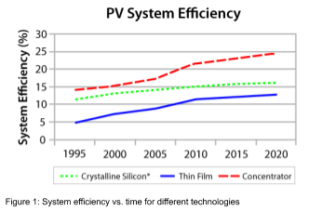 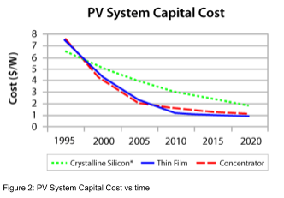

Figure 1: System efficiency vs. time for different technologies Figure 2: PV System Capital Cost vs. time

Figure 1 and Figure 2 show the average solar photovoltaics system’s efficiency and the capital costs for three different photovoltaic materials. One of the biggest issues with solar energy is the high initial cost for installation. Because of the high price, it is generally not a good investment for the average household. However, the past decade saw, on average, a 70% price reduction on solar installation (SEIA). It is for this reason that solar energy will continue to grow and become crucial to society.

**Solution and Benefits - Jerry**

**Solution**

In alignment with UTD’s emphasis on energy neutral design, as outlined in the UTD campus development plan (The University of Texas at Dallas, 2010), power requirements for future buildings should be met through renewable energy sources. A natural choice for sustainably covering power requirements for a new arts building is harnessing the 6 kW, on average, of solar power (UT Solar Energy Laboratory, 2003) that is irradiated from the sun within each square meter of the Dallas area. Effective use of photovoltaic cell arrays within the 110000 square foot space (The University of Texas System, 2019) allotted for the Arts and Performance Complex has the potential of reaching energy neutrality for the building, possibly even an energy positive footprint, where more energy is produced than required such that it can be siphoned off to other buildings.

The task of establishing solar energy generation is traditionally accomplished by allocating space on the rooftop of the respective building for an installation of the standard, black solar cell arrays present on many commercial and residential buildings. However, the novel technology (CNN, 2020) of photovoltaic windows developed by the Silicon Valley based startup, Ubiquitous Energy, presents an unobtrusive solution that takes advantage of the building’s vertical surface area. By creating a photosensitive film on the surface of the window, the technology produces up to 66% of the power produced by traditional solar arrays while still passing 70% of light in the visible spectrum. This means that electricity can be produced passively by absorbing Ultraviolet and Infrared radiation hitting each window while remaining mostly transparent, as summarized in Figure 1.

Since vertical windows make up approximately 75% of the vertical surface area of the previously constructed West Engineering and Computer Science building, a building constructed in alignment with the same core values as the building of interest, despite the lower efficiency of these transparent solar cells, the total amount of solar power produced by these windows may be many times that of rooftop solar arrays. Since this technology operates independently of rooftop solar arrays, the two solutions may be used concurrently.

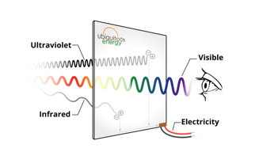

Figure 3: Solar window energy creation

The UTD campus development plan also specifies an emphasis on utilizing windows to decrease energy requirements via the inclusion of natural lighting. By combining the standard opaque photovoltaic cells with these novel transparent options, the new building’s solar energy production can be maximized with most future building surfaces contributing to the total solar capacity of the campus.

**Benefits**

Reducing greenhouse gas emissions is of the utmost importance for combatting the rising issues of climate change and global warming. As illustrated in Figure 2, fossil fuel-based energy generation emits at least 400% more greenhouse gasses when compared with photovoltaic based sources. A study conducted by the US Department of Energy's National Renewable Energy Laboratory (NREL, 2012) projects that by 2050, 80 percent of the country’s electricity supply can feasibly be produced by renewable sources which will result in reduced emissions of up to 81%. Preparing the University’s buildings for this transition helps UTD play its part in establishing public energy consciousness and sets a precedent to be followed by neighboring companies and institutions.

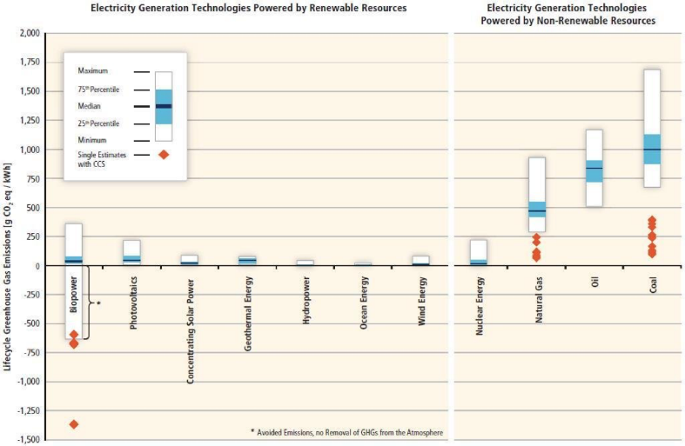By decreasing dependence on fossil fuels via the use of solar energy, UTD will be reducing its carbon footprint which will contribute to the maintenance of a healthy environment for decades to come. This will generally improve public health as shown by (EPA, 2019) that the expected number of carbon monoxide particles and other airborne pollutants, generally produced by the burning of fossil fuels such as coal and natural gas, per cubic meter of air, decreased up to 20% when energy neutral areas were compared with those primarily relying on fossil fuels.  A study conducted by (Lave, 1973) finds a directly proportional relationship between mortality rates due to Bronchitis and the air pollution index with a coefficient of determination of 0.77 among a random sample of males within 26 counties in Illinois.

Figure 4: Lifetime fossil fuel emissions of each category

In addition to the positive environmental impact, opting for photovoltaic cell installations in the past has proven to be lucrative for the UT Dallas as private and governmental entities grant monetary awards to institutions that increase their reliance on solar energy. In 2013, UTD received $203,722 from the Texas energy monolith, Oncor, for installing solar panels on the JSOM Parking Structure that now produce 220 kW of power annually (Office of Media Relations, 2012). By making further upgrades to building efficiency by replacing older air conditioning systems, Oncor endowed an additional $98,371 to the institution. These incentives have since been reinvested to create the UT Dallas Energy Efficiency Revolving Fund, a fund continuously refilled by savings incurred on monthly power bills, established for the purpose of supporting future projects related to energy efficiency and power management. Thus, savings produced via the proposed inclusions of solar arrays may facilitate further developments in the future.

**Implementation and budget – Trent**

**Implementation:**

Since the Arts and Performance Complex building has yet to be built, the solar panels and windows will be implemented along with the initial construction of the building, requiring no additional work to modify an existing building.  The building will still be linked to the main power grid for additional needed electricity. The Tesla Solar Roof was chosen for its aesthetics, efficiency, and durability.

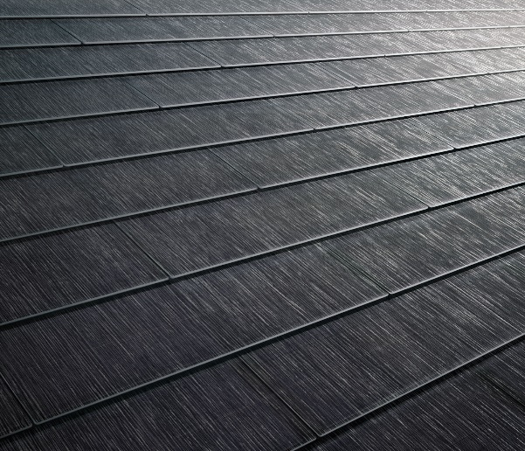Only the roof will have solar panels installed, as “Vertical solar panels are sub-optimal for solar production” (understandsolar.com, 2018).  However, solar windows will be installed along with the solar roof.  ClearView Power windows from Ubiquitous Energy “can produce up to two-thirds of the energy that traditional panels do” and “cost about 20% more to install than a regular window” (Iyengar, 2020).

Figure 5: Solar Roof

**Budget:**

At 110,000 gross square feet (utdallas.edu/facilities), the new Arts and Performance Complex will be 55% the size of the 200,000 square foot ECSW building and 59% the size of the new Science Building (UT Dallas Office of Media Relations, 2018).

At 4 stories, each having one-quarter of the total gross square footage of 110,000 square feet, each story will have (110,000 square feet)/(4 stories) = 27,500 square feet.  This will be the area of the roof where the solar panels will be installed.  Unlike the windows, which will replace the ordinary windows, the solar roof will be in addition to the ordinary roof price.  The Tesla solar roof costs $5.60 per square foot (Tesla).  The (additional) cost of the solar roof will be ($5.60/square foot)(27,500 square feet) = $154,000.

At 4 stories and each story having an average height of 14 feet (theskydeck.com), the total height of the building will be (4 stories)(14 feet)=56 feet high.  Given the lack of information on the shape of the new building, it will be estimated as a cube.  The width of each side of the building can be estimated as the square root of the area of the roof/each story, and √27,500 = 166 feet wide.  Each side of the building will thus be (166 feet)(56 feet) = 9,296 square feet.  If each side of the building is 50% glass, each side will have 4,648 square feet of glass, for a total of (4,648 square feet)(4 sides) = 18,592 square feet of glass on the exterior of the building.  The normal price of a glass wall is $50 per square foot, giving ($50)(18,592 square feet) = $929,600.  This is the price already included in a non-solar-powered building.  Since solar windows cost 20% more (Iyengar, 2020), the total price for the solar glass is ($929,600)(120%) = $1,115,520.  The difference between the ordinary price of the glass and the cost for the solar glass is $1,115,520 - $929,600 = $185,920 extra for the solar glass.

Between the solar roof and the solar glass, it will take $154,000 + $185,920 = $339,920 to make the new Arts and Performance Complex building solar-powered.  However, the saved money must also be taken into account.

The average cost of electricity for a square foot of a building is $2.10 per square foot, and the average kilowatt-hours per square foot is 22.5 kWh (iotacommunications.com, 2019).  UT Dallas uses Oncor, Texas’ largest regulated electric delivery business, for its electricity (UT Dallas Office of Media Relations, 2012).  In January 2019, the average price per kWh in Texas was $0.1165/kWh (paylesspower.com, 2020).  (110,000 square feet)(22.5 kWh/square foot/year) = 2,475,000 kWh used per year.  The total price of this is (2,475,00 kWh)($0.1165/kWh) = $288,338/year spent on electricity.

One square foot of solar panel generates about 30 kWh per year (McKenzie, 2013).  For 27,500 square feet of solar panels, the roof will produce (30 kWh/square foot/year)(27,500 square feet) = 825,000 kWh/year produced by the roof.  Since the building will consume 2,475,000 kWh/year, the roof will produce 825,00 kWh/2,475,000 kWh = 33% of the energy consumed by the building.  Given that paying for all of the electricity without solar energy is $288,388/year, 33% of this cost eliminated by solar power means $95,168 will be saved per year by installing the roof alone.  The cost of the roof being $154,000, ($154,000)/($95,168/year) = 1.6 years for the roof alone to pay for itself.

Since ClearView Power windows produce 2/3 the energy that solar panels do (as stated in the implementation section), they will produce (2/3)(30 kWh/square foot/year) = 20 kWh per square foot per year.  At 18,592 square feet of glass, the solar windows will produce (20 kWh/square foot/year)(18,592 square feet) = 371,840 kWh/year.  371,840 kWh/2,475,000 kWh = 15% of the energy used by the building could come from the windows.  Again, since all of the electricity for the building costs $288,388/year, (15%)($288,388/year) = $43,258 saved per year.  Since the windows cost $185,920, ($185,920)/($43,258/year) = 4.3 years for the windows alone to pay for themselves.

Combining the two, $95,168 saved per year by the roof, and $43,258 saved per year by the windows, $95,168 + $43,258 = $138,426 saved per year by the combined roof and windows.  The combined cost of the roof and windows being $154,000 + $185,920 = $339,920, ($339,920)/($138,426/year) = 2.5 years for the additional solar-powered costs to pay for themselves.  After these 2.5 years, the solar power of the building will continue to produce 33% + 15% = 48% of the building’s electricity and will continue to save $138,426 per year on electricity costs.

**Counter-Arguments and Conclusion – Kelden**

**Counter arguments:**

While the benefits of solar energy are prevalent, the implementation of solar windows and roof panels is not without drawbacks. As seen in the budget, these forms of energy are costly early on and can take time to begin to be financially beneficial. Also, solar energy is not always the most feasible and efficient energy option, as the time of day and storage of energy must be considered. Lastly, adequate space is required to efficiently produce power for a building.

The upfront cost of solar energy can be taxing. As shown in the budget, solar windows cost about 20% more to install than regular windows, which is no small amount when the windows of the building alone cost over $900,000. While solar panels have been around for some time, the overall cost of this energy source has not been economically prudent for companies and people to use until recently. In 2009, the cost of solar panel installation was $8.50 per watt (Matasci, 2019). Over time though, through the improvement of the manufacturing process and the efficiency of the installation, this price has dropped to $2.96 per watt. While this is much more economical, the system will still require a few years to pay for itself, which is a sacrifice that must be considered.

The efficiency of solar panels has increased over the past decade as well, reaching nearly 30% efficiency ratings (Matasci, 2019). Researchers have been able to produce panels that have achieved 46 percent efficiency, but these panels require materials that are generally expensive and would not be used by companies or residents, which would include the University. The roof panels require a decent amount of space to produce enough energy for the panels to be worth the cost and implementation to compete with other energy sources (Randall, 2018). The new arts complex has 27,500 square feet of space on the roof, which is considerable, but as shown in the budget, this is not enough to meet the power requirements of the building. Also, solar panels only create power when the sun is out, which must be considered unless a storage system/ alternate energy system is available for rainy seasons. The Tesla Powerwall solar battery, for instance, can store unused solar energy, but this kind of technology is expensive (Sendy, 2020). According to Weather Atlas, is rains in Dallas an average of 80.7 days out of the year. These are days that the solar panels and windows would not collect sunlight for energy and the building would have to rely on either stored energy or alternative energy sources.

**Conclusion:**

The new Arts and Performance Complex that is to be built by the University provides the school the opportunity to make an economically and environmentally prudent decision that could set a precedent for future projects. As of now, the university has extensive plans of expanding, as outlined in the Campus Master Plan Update (2018), and these plans include implementing “green building” strategies. The university is looking to contribute towards the shift in the direction of environmentally friendly practices that do not exacerbate the issue and implications of climate change. Solar energy provides a means to accomplish this strategic plan goal. Also, the novelty of solar windows would assert the university as a technology forerunner amongst other universities.

The proposed solution is for the new Arts and Performance Complex to be built with the implementation of solar panels and solar windows that will contribute to powering the building. The solar panels will be installed on the roof to provide for maximal sunshine and surface area, and all windows that are proposed in the building plans will be solar windows. The solar panels on the roof will produce 33% of the energy needed to power the building, and the solar windows will provide 15% of the power as well. This means that about half of the building’s power requirements can be covered by the installation of these solar technologies. These energy sources also do not produce the pollution that standard natural gas systems do, as fossil fuel systems produce CO2 into the atmosphere (Randall, 2018). Finally, this solution is an economically prudent decision for the university in the long run, as the panels and windows require little maintenance and last for a considerably long time (Sendy, 2020). The windows and panels will financially cover their own additional expenses within five years, and then they will continue to save the university money in the future. The success of these solar energy solutions will also allow the university to gauge how they want to approach powering the remaining projects of the Campus Master Plan as well, which could compound these benefits extensively.

# Works Cited

2020 Electricity Rates By State (Updated April 2020). (2020, April 24). Retrieved from https://paylesspower.com/blog/electric-rates-by-state/

Cathy, Jayden, & McIver, R. (n.d.). Retrieved from https://sites.lafayette.edu/egrs352-sp14-pv/technology/history-of-pv-technology/

Choi, C. Q. (2008, February 27). Solar Power's Greenhouse Emissions Measured. Retrieved from https://www.livescience.com/2324-solar-power-greenhouse-emissions-measured.html

Climate Change Evidence: How Do We Know? (2019, December 30). Retrieved from https://climate.nasa.gov/evidence/

Do Vertical Solar Panels Make Financial Sense? (2018, April 27). Retrieved from https://understandsolar.com/vertical-solar-panels/

Gaughan, R. (2019, March 2). The Case for & Against Solar Energy. Retrieved from https://sciencing.com/case-against-solar-energy-19638.html

How Tall is a Storey in Feet?: Storeys to Feet. (n.d.). Retrieved from https://theskydeck.com/how-tall-is-a-storey-in-feet/

How the pros and cons of solar power have changed in 2020. (2020, March 30). Retrieved from https://www.solarreviews.com/blog/pros-and-cons-of-solar-energy

Iyengar, R. (2020, March 30). This company wants to turn your windows into solar panels. Retrieved May 3, 2020, from https://www.cnn.com/2020/03/30/tech/solar-windows-ubiquitous-energy-california/index.html

Iyengar, R. (2020, March 30). This company wants to turn your windows into solar panels. Retrieved from https://www.cnn.com/2020/03/30/tech/solar-windows-ubiquitous-energy-california/index.html

Lave, L. B., & Seskin, E. (1973). Air pollution and human health. *Readings in Biology and Man*, *169*, 294.

Matasci, S. (2020, January 8). How Solar Panel Cost & Efficiency Change Over Time: EnergySage. Retrieved from https://news.energysage.com/solar-panel-efficiency-cost-over-time/

McKenzie, D. (2013, November 16). Retrieved from http://www.lightsonsolar.com/solar-basics-kw-and-kwh/

National Renewable Energy Laboratory (NREL). 2012. Renewable Electricity Futures Study. Volume 1, pg. 210.

Office of Media Relations (2012, May 2). Campus Energy Initiatives Earn Efficiency Rewards. Retrieved May 3, 2020, from https://www.utdallas.edu/news/campus-community/campus-energy-initiatives-earn-efficiency-rewards/

Office of Media Relations Aug. 16, 2018 S. (n.d.). New Engineering Building, Housing, Dining Options Will Make Fall Debut. Retrieved from https://www.utdallas.edu/news/campus-community/new-engineering-building-housing-dining-options-wi/

Office of Media Relations May 2, 2012 S. (n.d.). Campus Energy Initiatives Earn Efficiency Rewards. Retrieved from https://www.utdallas.edu/news/campus-community/campus-energy-initiatives-earn-efficiency-rewards/

Order your Solar Roof. (n.d.). Retrieved from https://www.tesla.com/solarroof/design

Solar Industry Research Data. (n.d.). Retrieved from https://www.seia.org/solar-industry-research-data

The University of Texas System - The Office of Facilities Planning and Construction. (2019, November 20). 302-1254 Arts and Performance Complex. Retrieved May 3, 2020, from https://www.utdallas.edu/facilities/download/OFPC_Managed_Project_302-1254_APC_20191120.pdf

U.S. EPA. Integrated Science Assessment (ISA) for Particulate Matter (Final Report, 2019). U.S. Environmental Protection Agency, Washington, DC, EPA/600/R-19/188, 2019.

UT Solar Energy Laboratory. (2003). Texas Solar Radiation Database. Retrieved May 3, 2020, from https://www.me.utexas.edu/~solarlab/tsrdb/tsrdb.html

What Is The Average Utility Cost Per Square Foot Of Commercial Property?: Iota. (2019, May 14). Retrieved from https://www.iotacommunications.com/blog/average-utility-cost-per-square-foot-commercial-property/

Yu Media Group. (n.d.). Dallas, TX - Detailed climate information and monthly weather forecast. Retrieved from https://www.weather-us.com/en/texas-usa/dallas-climate#daylight_sunshine