Drew Pulliam – DTP180003

CS3345.0U1

Assignment 5

1. 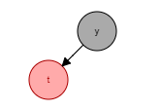

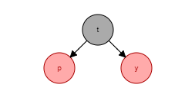

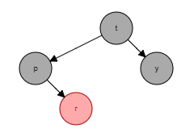

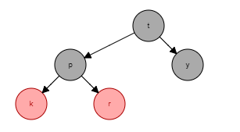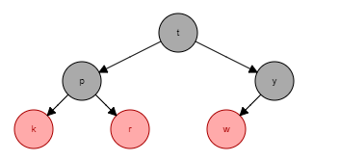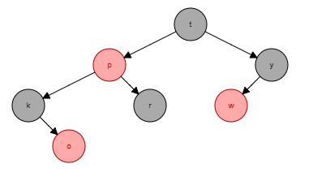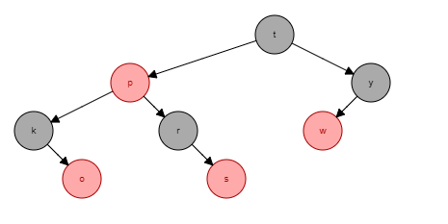

------------------------------------------------------------------------------------------------------------------------------------------

1. 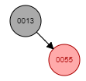

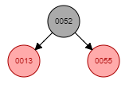

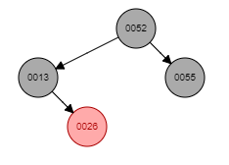

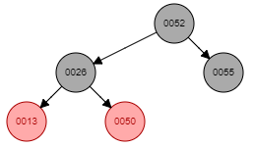

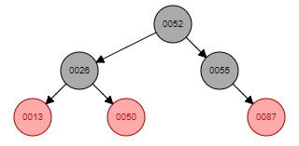

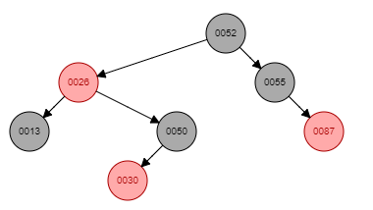

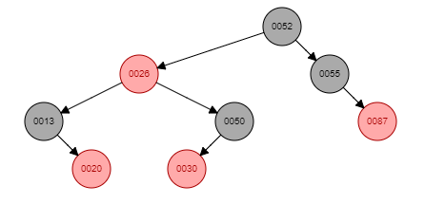

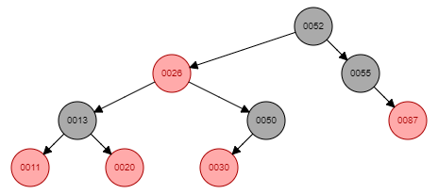

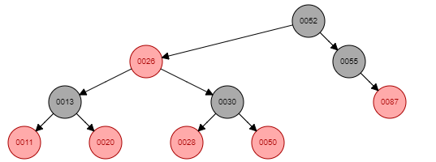

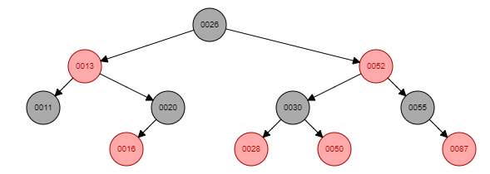

------------------------------------------------------------------------------------------------------------------------------------------

1. 2-3-4 B-tree

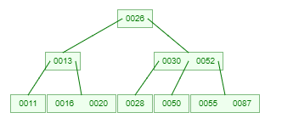

------------------------------------------------------------------------------------------------------------------------------------------

1. Separate chaining

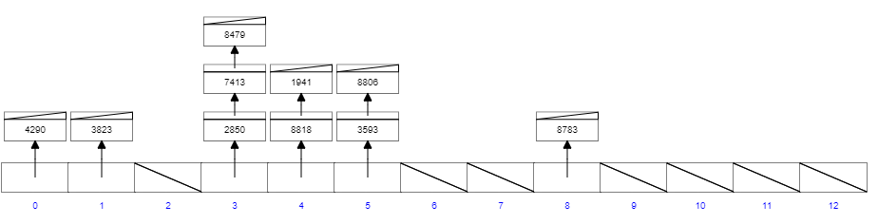

------------------------------------------------------------------------------------------------------------------------------------------

1. Linear Probing

0 – 4290

1 – 3823

2 – nothing

3 – 8479

4 – 1941

5 - 8818

6 – 7413

7 – 8806

8 – 8783

9 – 2850

10 – 3593

11 – nothing

12 – nothing

------------------------------------------------------------------------------------------------------------------------------------------

1. Quadratic Probing

0 – 4290

1 – 3823

2 – nothing

3 – 8479

4 – 1941

5 – 8818

6 – 8806

7 – 7413

8 – 8783

9 – 3593

10 – nothing

11 – nothing

12 – 2850

------------------------------------------------------------------------------------------------------------------------------------------

1. Double Hashing

0 – 4290

1 – 3823

2 – nothing

3 – 8479

4 – 1941

5 – 8806

6 – 2850

7 – 7413

8 – 8783

9 – 8818

10 – nothing

11 – nothing

12 – 3593

------------------------------------------------------------------------------------------------------------------------------------------

------------------------------------------------------------------------------------------------------------------------------------------

1. Cuckoo Hashing

Table 1

|  |  |
| --- | --- |
| 0 | B |
| 1 |  |
| 2 | E |
| 3 |  |
| 4 | C |

Table 2

|  |  |
| --- | --- |
| 0 | D |
| 1 | A |
| 2 |  |
| 3 |  |
| 4 |  |

------------------------------------------------------------------------------------------------------------------------------------------

------------------------------------------------------------------------------------------------------------------------------------------