Drew Pulliam – DTP180003

CS3345.0U1

Assignment 6

1. 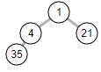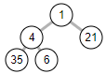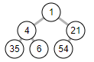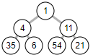

------------------------------------------------------------------------------------------------------------------------------------------

1. [ empty/null, 1, 4, 11, 35, 6, 54, 21 ]

------------------------------------------------------------------------------------------------------------------------------------------

1. 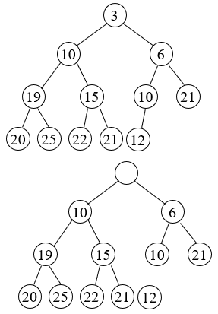

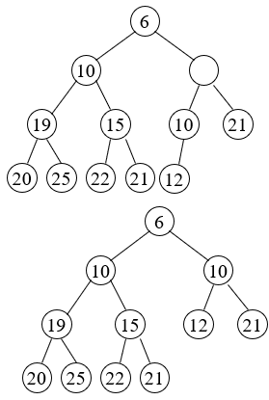

------------------------------------------------------------------------------------------------------------------------------------------

1. 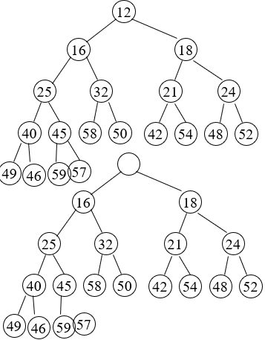

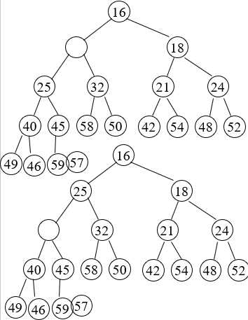

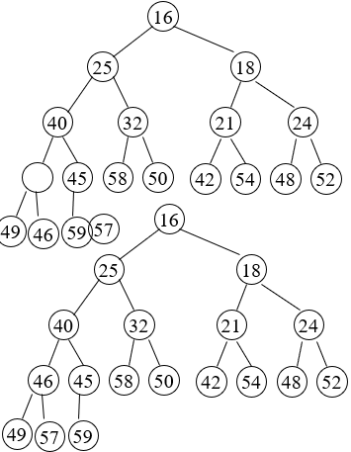

------------------------------------------------------------------------------------------------------------------------------------------

1. 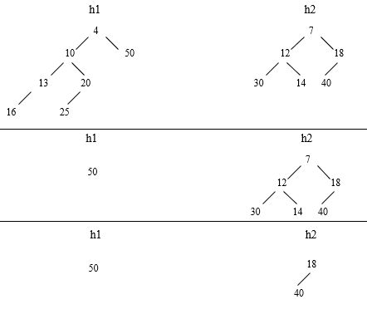

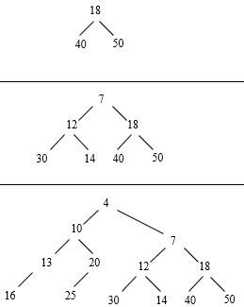

------------------------------------------------------------------------------------------------------------------------------------------

1. 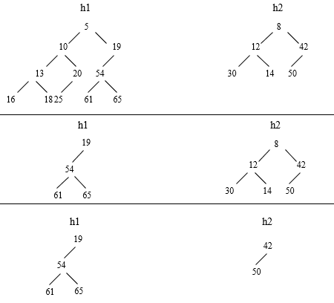

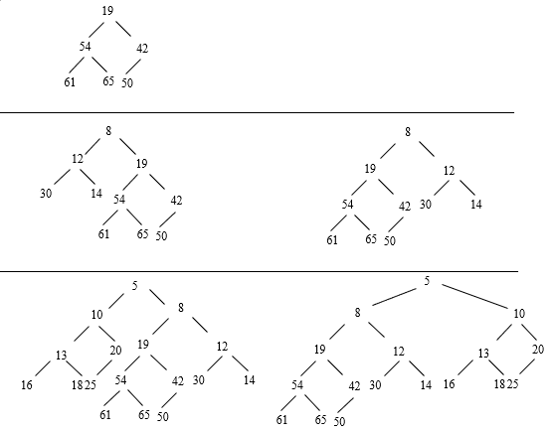

The last two rows are leftist violations (just swap left and right subtrees).

------------------------------------------------------------------------------------------------------------------------------------------

1. 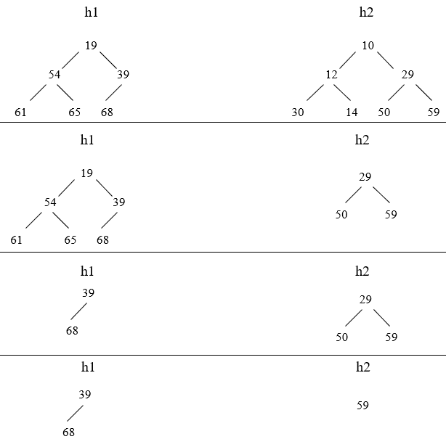

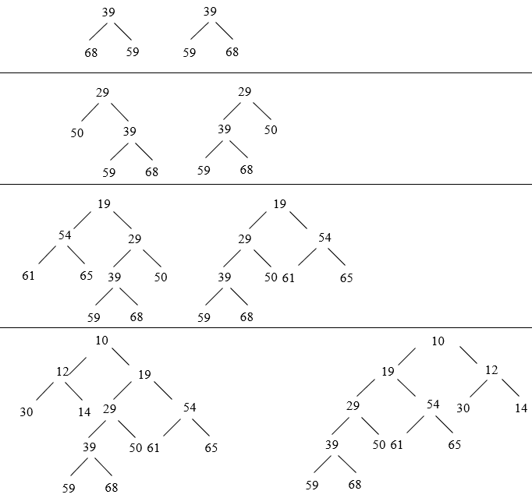

------------------------------------------------------------------------------------------------------------------------------------------

1. 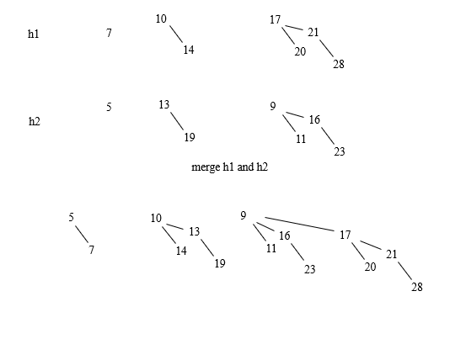

------------------------------------------------------------------------------------------------------------------------------------------

1. 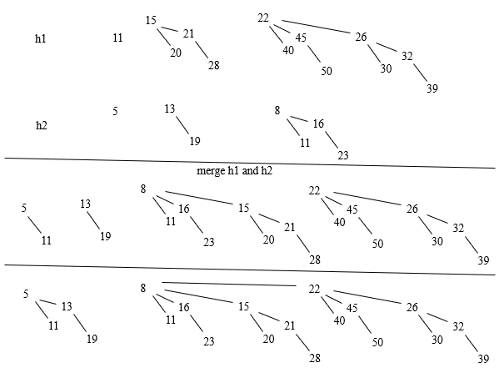

------------------------------------------------------------------------------------------------------------------------------------------

1. [ empty/null, 1, 2, 3, 5, 4, 7, 10, 13, 15, 6, 8, 17, 12, 11, 9 ]

Left child = 3i -1, Middle = 3i, Right = 3i + 1

Parent = i / 3

------------------------------------------------------------------------------------------------------------------------------------------