Drew Pulliam – DTP180003

CS3345.0U1

Assignment 7

1. 46, 96, 55, 68, 12, 64, 32, 79, 83, 67

a. Insertion Sort (slide 5)

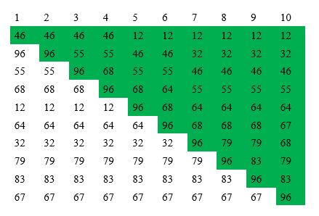

The green shading shows what has already been sorted on each iteration.

b. Shell sort with sequence 5,3,1 (slides 14, 15, 16)

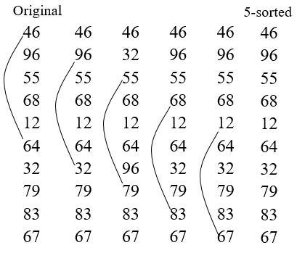

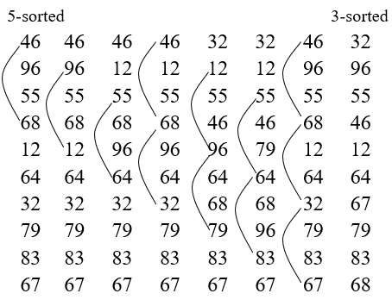

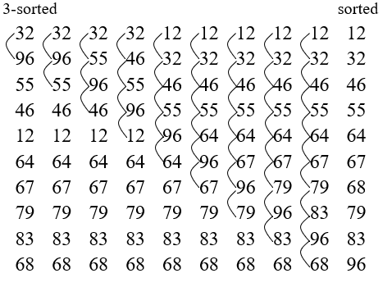

c. Merge sort (as slide 30)

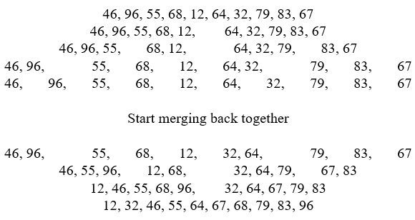

d. Quick sort (as slide 45). Use median-of-three and continue until the list is sorted. If a partition size is <= 4, just put the partition in sorted order.

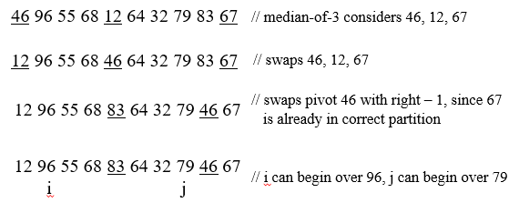

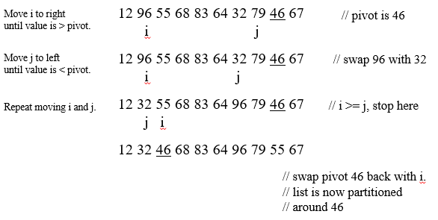

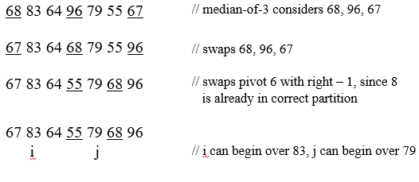

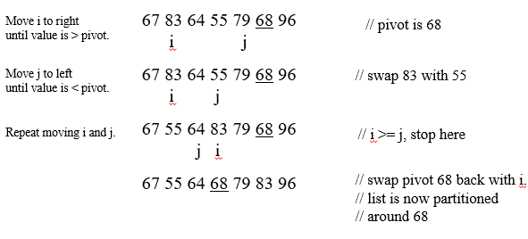

Doing partitions <=4 automatically to save space, sorted list is 12, 32, 46, 55, 64, 67, 68, 79, 83, 96

e. Radix sort (as slide 59)

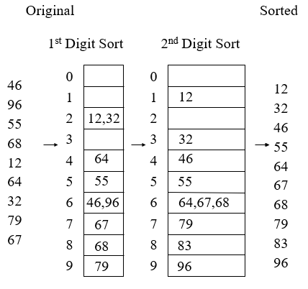

------------------------------------------------------------------------------------------------------------------------------------------

1. 5, 2, 4, 5, 7, 8, 8, 7, 4, 2, 5

Bucket sort (as slide 57)

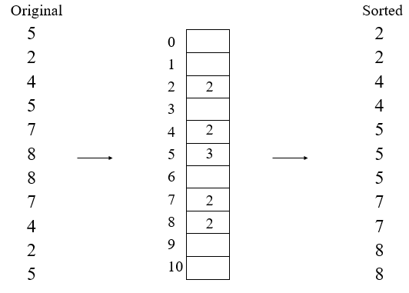

------------------------------------------------------------------------------------------------------------------------------------------

1. 6, 8, 4, 10, 6, 6, 2, 4, 1, 8, 7, 3, 4, 1, 2, 1, 10, 1, 5, 2

External sort (as slide 61). Use a run size of 5.

6,8,4,10,6 -- 6,2,4,1,8 -- 7,3,4,1,2 -- 1,10,1,5,2

4,6,6,8,10 -- 1,2,4,6,8 -- 1,2,3,4,7 -- 1,1,2,5,10

1,2,4,4,6,6,6,8,8,10 -- 1,1,1,2,2,3,4,5,7,10

1, 1, 1, 1, 2, 2, 2, 3, 4, 4, 4, 5, 6, 6, 6, 7, 8, 8, 10, 10

------------------------------------------------------------------------------------------------------------------------------------------

1. For the list below, what runs would be created if M=3 using replacement selection?

1, 8, 7, 10, 1, 5, 2, 6, 8, 4, 10, 6, 6, 2, 4,

1, 7, 8, 10

1, 2, 5, 6, 8

4, 6, 6, 10

2, 4

------------------------------------------------------------------------------------------------------------------------------------------