Drew Pulliam – DTP180003

CS3345.0U1

Assignment 9

1. A, B, D, C, E, F, G

------------------------------------------------------------------------------------------------------------------------------------------

1. 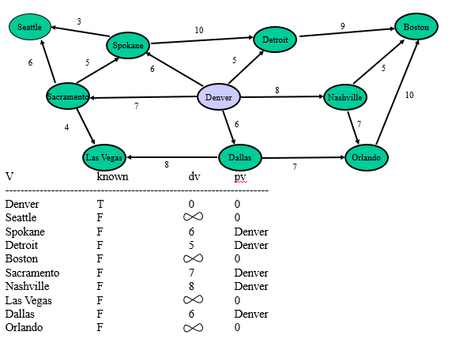

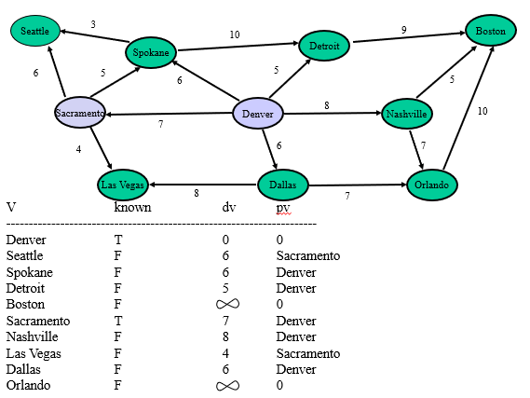

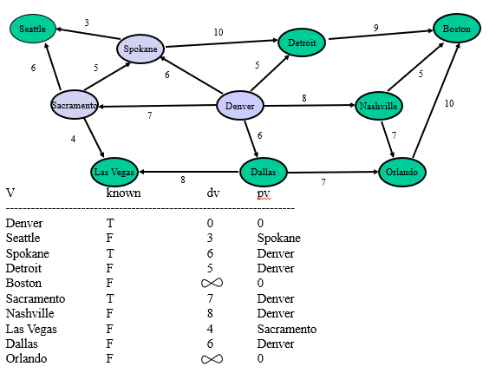

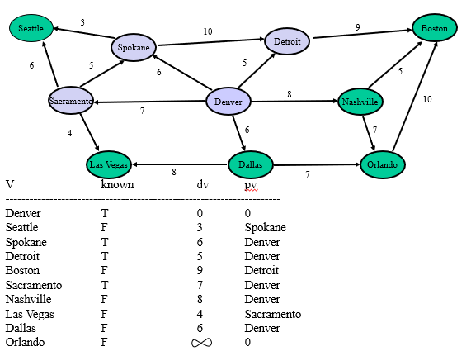

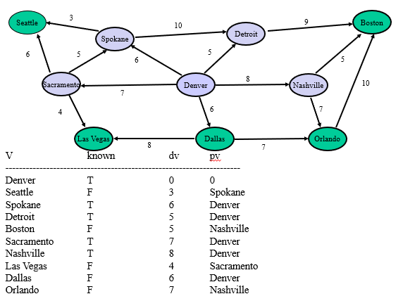

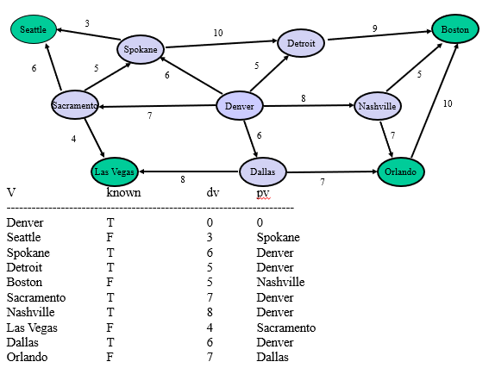

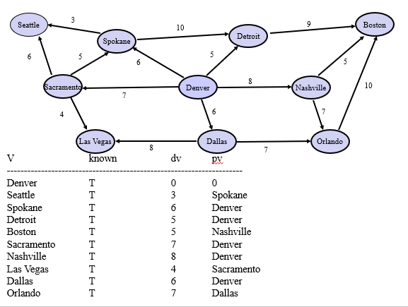

------------------------------------------------------------------------------------------------------------------------------------------

1. 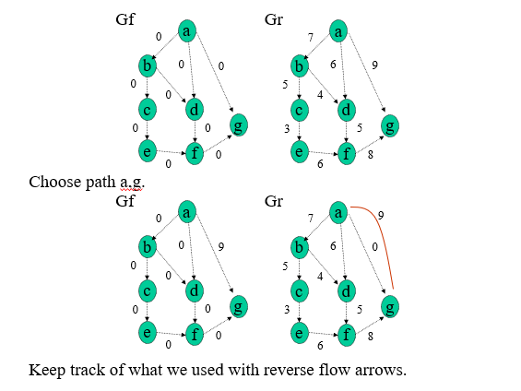

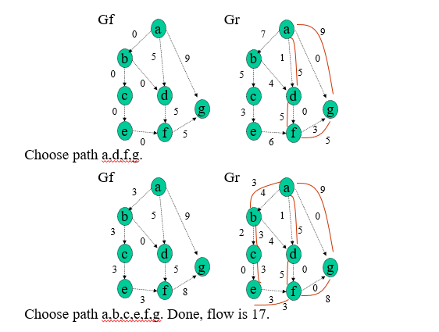

------------------------------------------------------------------------------------------------------------------------------------------

1. 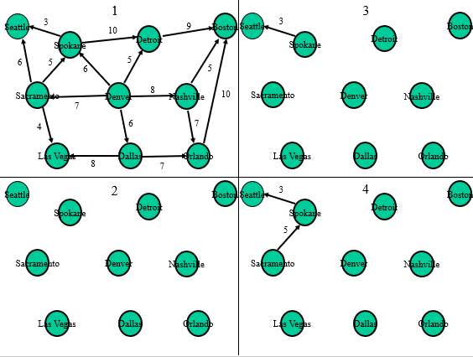

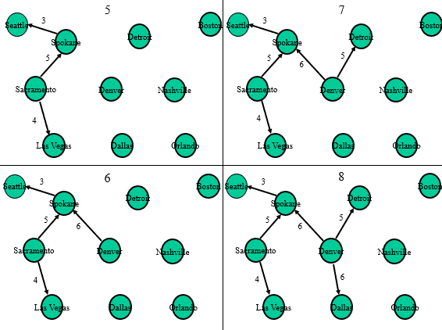

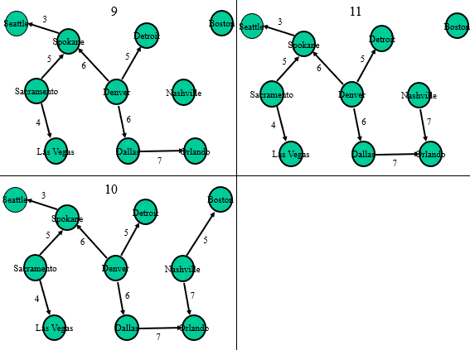

------------------------------------------------------------------------------------------------------------------------------------------

1. 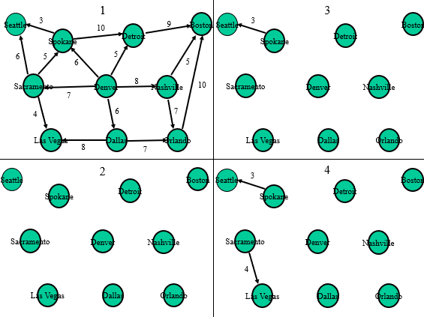

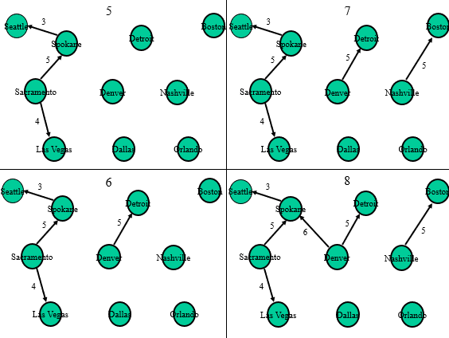

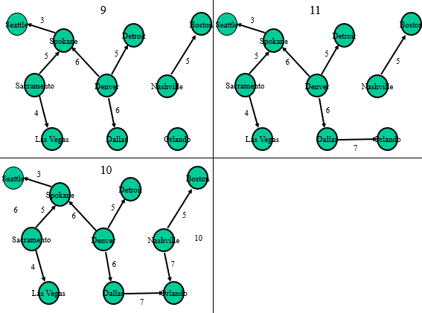

------------------------------------------------------------------------------------------------------------------------------------------

1. 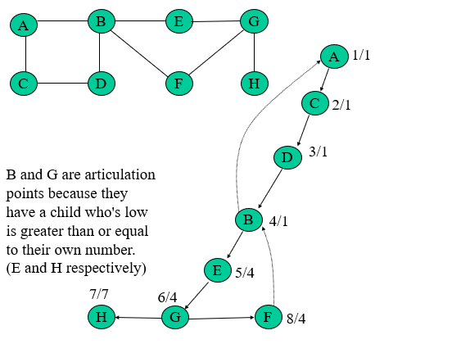

------------------------------------------------------------------------------------------------------------------------------------------

1. Total Graph: Euler Circuit: H, G, E, B, A, C, D, B, F, G

Euler Path: N/A

Remove Node H: Euler Circuit: G, E, B, A, C, D, B, F, G

Euler Path: G, E, B, A, C, D, B, F, G

------------------------------------------------------------------------------------------------------------------------------------------