CS3345 Exam 1

Question 8

Drew Pulliam – DTP18003

Show how the following would be inserted into an AVL tree.

20,50,30,60,70

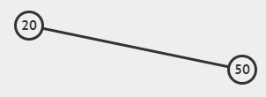

black = 20, red = 50

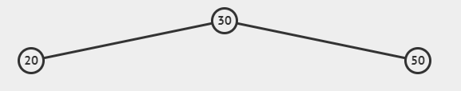

black = 30, red = 20,50

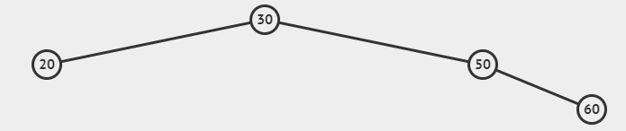

Black = 20,30,50, red =60

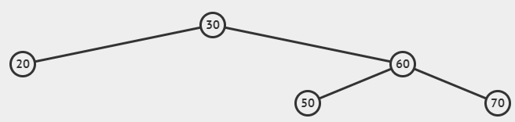

Black = 20,30,60, red = 50,70