Drew Pulliam – DTP180003

Week 5 Essay

APUE 4.14 File Systems tutorial

There are several different implementations of file systems in UNIX. Solaris (which supports different types of disk file systems), UFS, PCFS, and HSFS (reads CD file systems). Each file system has different features.

Disk drives are divided into partitions. Each partition may contain its own file system (Figure 4.13).

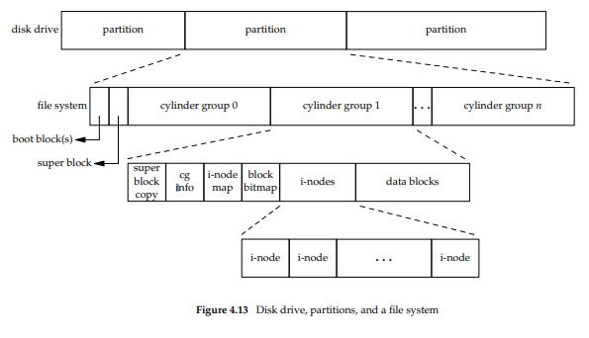

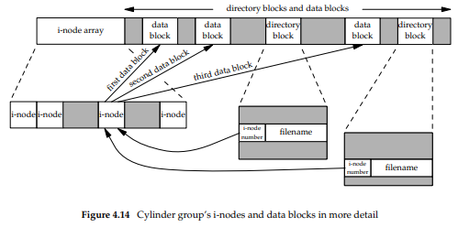

Examining i-nodes and data blocks in more detail results in Figure 4.14.

* Two directory entries point to the same i-node. Every i-node has a count of the number of links that point to it, and it can only be deleted when the count is at 0 (nothing is pointing to the i-node).
* Another type of link is a symbolic link. The actual contents of the file store the name of the file that the link points to. This means that a symbolic link is actually just a file that contains the name of the file it links to.
* The i-node contains info about the file it is associated with. File type, access permissions, size, and more. The only information stored in the directory entry is the filename and the i-node number (basically it just points to the i-node for all the information).
* The i-node number in the directory will always point to an i-node in the same file system. The stops it from pointing to i-nodes in different file systems.
* If you wish to rename a file without changing file systems, the actual file does not need to be moved. Instead all you need to do is add a new directory entry that points to the same i-node and unlink the old directory entry. (this works because the filename is stored in the directory entry not the i-node)

Figure 4.15 shows the result of making a new directory inside the working directory (mkdir testdir). The i-node 2549 is a directory with a link count of 2. Leaf directories always have link counts of 2. This is because the two links are the name of the directory and the entry for dot.

